;l

Foundations of Programming

Assignment No. : 01

PROBLEM STATEMENT:
Write a program in C to check whether a given year is a Leap Year

OBJECTIVE:

- To understand the use of conditional statements in C programming.
- To implement logical conditions for solving real-world problems.
- To develop problem-solving skills using decision control structures.

THEORY:
- Theory for conditional statements with syntax (if , if-else, if-else ladder) are used in C programming
- An if statement is used to execute a block of code only when a condition is true.
Syntax: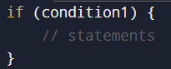
In this program:
It is used to check whether the year is divisible by 400, which is the strongest condition for a leap year.
Example: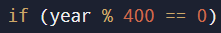

- if-else Statement
- An if-else statement is used when there are two possible outcomes. One block executes if the condition is true, and another block executes if the condition is false.

Syntax: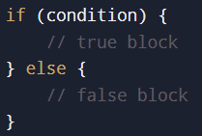
In this program:
The else part is used to print that the year is not a leap year when all conditions fail.
Example: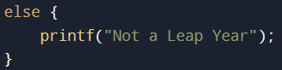

- if-else Ladder
-An if-else ladder is used to check multiple conditions one after another.
Syntax: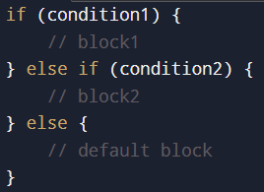
- Theory for a Leap Year - year that contains 366 days instead of the usual 365 days.
Rules:
• A year is a leap year if it is divisible by 400, OR
• A year is a leap year if it is divisible by 4 but not divisible by 100.

Algorithm
- Start
- Input year
- Check if year is divisible by 400
- Else check if year is divisible by 4 and not divisible by 100
- Else it is not a leap year
- Display result
- Stop

C PROGRAMMING CODE-
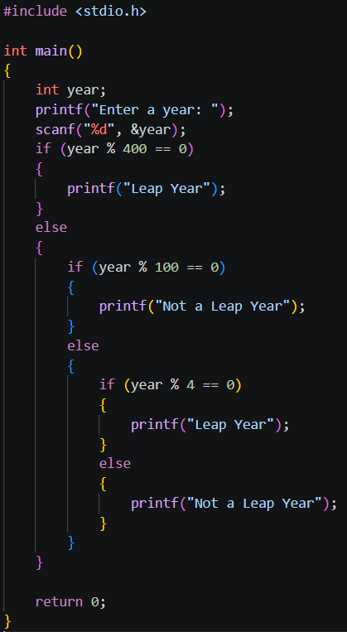
PLATFORM: Linux

INPUT: 2024

OUTPUT: Displays whether the entered year is a Leap Year or Not a Leap Year.
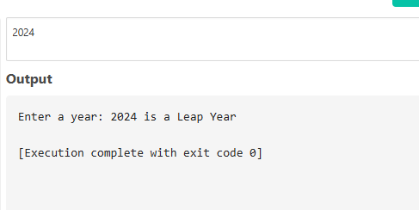
Sample Input
2024
Sample Output
2024 is a Leap Year
CONCLUSION: Thus, the program successfully checks whether a given year is a Leap Year using conditional statements in C.

