

Foundations of Programming

Lab Assignment No. : 03

PROBLEM STATEMENT:
Write a program in C to generate multiplication tables for a given number.
OBJECTIVES:
- To understand the use of looping statements in C.
- To generate multiplication tables using loops.
- To improve program logic and execution flow understanding.
THEORY:
Syntax for “for” loop example program
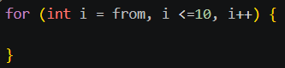
Syntax for while loop example program
Syntax for do while loop example program
ALGORITHM:
Step 1: Start
Step 2: Declare integer variables: a, i, prod
Step 3: Read the input value for 'a' from the user
Step 4: Set the initial value of 'i' to 1
Step 5: Repeat Step 6 and Step 7 while i <= 10
Step 6: Calculate prod = a * i
Step 7: Print the values of a, i, and prod, then increment i by 1
Step 8: Stop
Type Program (Multiplication table)
PLATFORM:
Linux
INPUT:
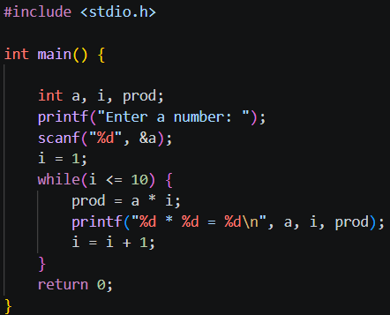
Choice of operation and two numbers

OUTPUT:
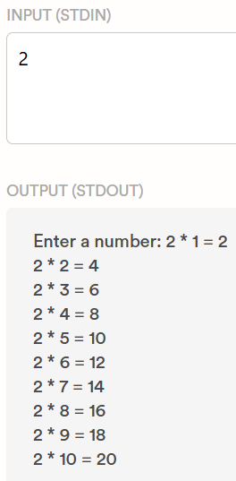
Displays the result of the selected arithmetic operation
CONCLUSION:
Thus, the menu driven program in C successfully performs basic arithmetic operations using switch–case statements.

