;l

Foundations of Programming


Assignment No. : 4

PROBLEM STATEMENT: Write a C Program to calculate the salary of an employee given his basic pay (taken as input from the user). Calculate gross salary of employee. Let HRA be 10 % of basic pay and TA be 5% of basic pay. Let employees pay professional tax as 2% of total salary. Calculate net salary payable after deductions.

OBJECTIVE:

- To understand the importance of flowchart for any programming model.
- To learn simple flowchart symbols and arrows to define relationships.
- To understand and develop visual representations of flow of data.

THEORY:
- Define Algorithm.
An algorithm is a step-by-step procedure to solve a problem.
- What are the different characteristics of an algorithm.
- Finite – Must have a limited number of steps
- Definite – Steps must be clear and unambiguous
- Input – Takes input values
- Output – Produces output
- Effective – Steps must be simple and executable

PLATFORM: Linux

Algorithm:
- Start
- Input basic salary
- Calculate HRA = 10% of basic
- Calculate TA = 5% of basic
- Calculate Gross Salary = basic + HRA + TA
- Calculate Tax = 2% of gross salary
- Calculate Net Salary = gross - tax
- Display results
- Stop

C Program:
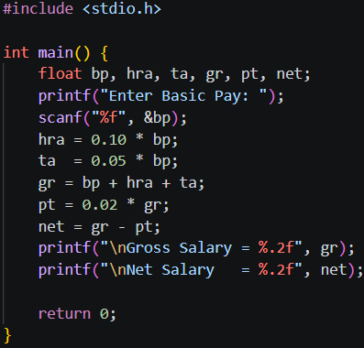

INPUT:
10000
OUTPUT:
Sample Output:
HRA = 1000.00
TA = 500.00
Gross Salary = 11500.00
Professional Tax = 230.00
Net Salary = 11270.00
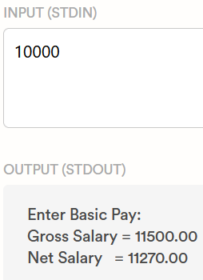
CONCLUSION: Thus, we have learned to write algorithms and to draw its representation in terms of flowchart.

