
;l

Foundations of Programming

Assignment No: 8

PROBLEM STATEMENT:
Write a program in C to accept marks of five courses of a student and compute the result. A student is considered PASS if he/she scores 40 marks or more in each course. If the student passes, calculate the aggregate percentage and assign the grade as follows:
- Aggregate ≥ 75% : Distinction
- Aggregate ≥ 60% and < 75% : First Division
- Aggregate ≥ 50% and < 60% : Second Division
- Aggregate ≥ 40% and < 50% : Third Division

OBJECTIVE:
- To understand the use of conditional statements in C
- To apply logical operators for decision making
- To calculate total, percentage, and grade of a student
- To enhance problem-solving skills using real-life scenarios

THEORY:
In academic evaluation systems, student performance is assessed based on individual subject marks as well as overall aggregate performance. In C programming, such evaluation systems can be implemented using conditional statements like if, else if, and else. Logical operators help in checking multiple conditions simultaneously. Percentage calculation involves arithmetic operations, and grading logic is implemented based on predefined ranges. This program demonstrates structured programming and decision-making in C.

Student Result System:
In academic systems, performance is evaluated based on:
- Individual subject marks
- Overall percentage
Conditional statements are used to:
- Check PASS/FAIL
- Assign grades

PASS CONDITION:
A student is PASS only if:
- Marks in all subjects ≥ 40
If any subject < 40 → FAIL

Grade System:
Aggregate Percentage:
≥ 75 → Distinction
≥ 60 and < 75 → First Division
≥ 50 and < 60 → Second Division
≥ 40 and < 50 → Third Division

ALGORITHM:

Start

Input marks of 5 subjects

Calculate total = sum of marks

Calculate percentage = total / 5

Check:

If any subject < 40 → FAIL

Else → PASS

If PASS:

Assign grade using if-else ladder

Display total, percentage, result, grade

Stop

PLATFORM: Linux
PROGRAM
#include <stdio.h>
int main() {
int m1, m2, m3, m4, m5;
int total;
float percentage;
printf("Enter marks of 5 subjects: ");
scanf("%d %d %d %d %d", &m1, &m2, &m3, &m4, &m5);
total = m1 + m2 + m3 + m4 + m5;
percentage = total / 5.0;
if (m1 < 40 || m2 < 40 || m3 < 40 || m4 < 40 || m5 < 40) {
printf("Total Marks = %d\n", total);
printf("Percentage = %.2f%%\n", percentage);
printf("Result: FAIL\n");
}
else {
printf("Total Marks = %d\n", total);
printf("Percentage = %.2f%%\n", percentage);
printf("Result: PASS\n");
if (percentage >= 75) {
printf("Grade: Distinction\n");
}
else if (percentage >= 60) {
printf("Grade: First Division\n");
}
else if (percentage >= 50) {
printf("Grade: Second Division\n");
}
else {
printf("Grade: Third Division\n");
}
}
return 0;
}

INPUT:
The user enters marks of five subjects.
: 78 65 70 80 75
Paste Screen Shot
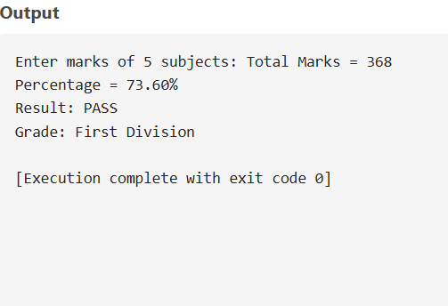

OUTPUT: The program displays the total marks, percentage, result, and grade.
Example Output:
Total Marks = 368
Percentage = 73.60%
Result: PASS
Grade: First Division

CONCLUSION: Thus, the program to calculate student result and grade based on marks was successfully implemented using C programming. This program demonstrates the effective use of conditional statements, logical operators, and arithmetic operations.

