DBMS MINI-PROJECT REPORT

CYBERSECURITY INCIDENT AND
THREAT MANAGEMENT DATABASE
(BATCH-1 DIV-13 CSF PANEL-A)

ABHINAV CHAVAN-1262251966
KRISHNANUNNI KURUP-1262250827
DECLAN PO-1262250688

Abstract
The Cybersecurity Incident and Threat Management Database is designed to store and organize information about cybersecurity incidents, threat types, affected assets, security analysts, evidence, response actions, and comments. The database provides a structured way to record incidents reported by users, assign incidents to analysts, associate threats and assets, and track the progress of investigations.
The project is implemented using MySQL and demonstrates core Database Management System (DBMS) concepts, including relational tables, primary keys, foreign keys, constraints, data manipulation queries, joins, nested queries, aggregate functions, a stored procedure with a cursor, a function, and a trigger. These features support consistent storage and retrieval of incident-related data.

Keywords
Cybersecurity, incident management, threat tracking, MySQL, relational database, SQL, DBMS.

Project Objectives
- Maintain structured records of reported cybersecurity incidents.
- Connect each incident with its reporter and assigned security analyst.
- Record threat types, affected assets, evidence, comments, and response actions.
- Retrieve useful incident summaries through SQL queries.
- Demonstrate primary/foreign keys, joins, nested queries, aggregates, procedures, functions, and triggers.

1. Introduction

1.1 Background
Organizations may encounter phishing, malware, ransomware, SQL injection, denial-of-service, unauthorized login attempts, and data breaches. If incident details are maintained manually or in disconnected files, it can be difficult to identify the affected asset, understand the threat, assign responsibility, preserve evidence, and monitor resolution.

1.2 Problem Statement
The project addresses the need for an organized database to manage cybersecurity incident information. It stores incident details, reporter information, analyst assignments, threat records, affected assets, evidence, comments, and response actions in related tables. SQL queries can then be used to search, filter, update, and summarize the stored information.

1.3 Scope
- Create and maintain records for users, security analysts, incidents, threats, threat categories, and assets.
- Connect incidents to threats and assets using junction tables for many-to-many relationships.
- Record evidence collected for an incident and actions taken during response.
- Store comments and provide queries for critical incidents, analyst assignments, and incident counts.
- Use a trigger to record the resolution timestamp when an incident changes to RESOLVED or CLOSED.

1.4 Technology
Component | Use
MySQL | Relational database and SQL execution environment
SQL DDL | Create tables and define keys/constraints
SQL DML | Insert, update, delete, and retrieve records
Joins and aggregate queries | Combine related data and produce summaries
Procedure, function, cursor, trigger | Demonstrate stored-program features

2. ER Diagram
The ER model represents the main entities and their relationships. The Chen-style ER diagram below is included from the supplied project material. The relational schema supplied with the project is also included in the next section for table-level implementation.
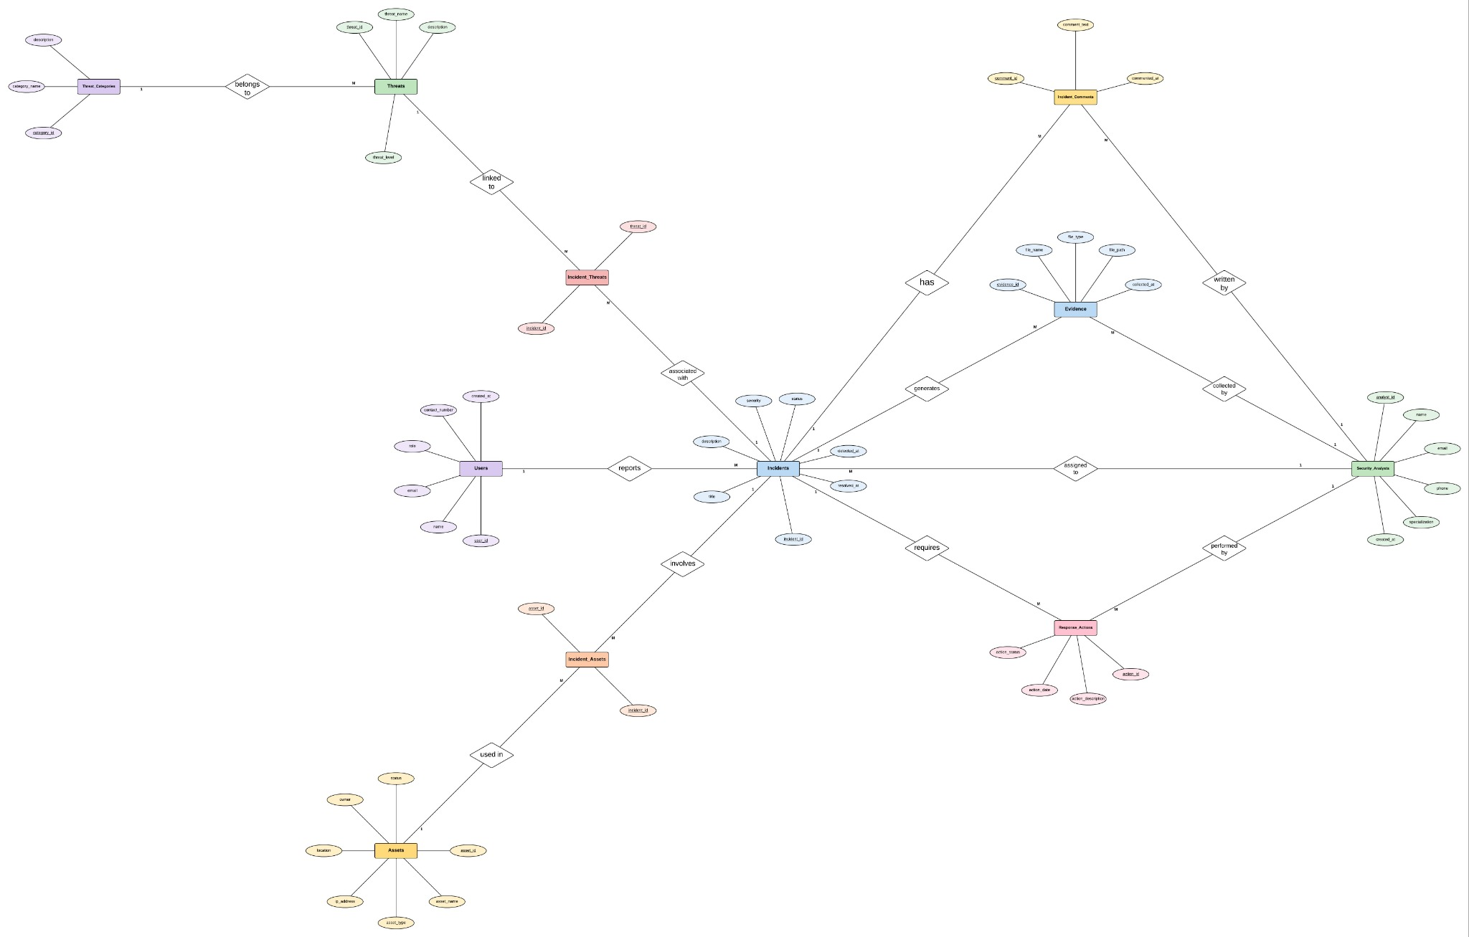
Figure 1. Chen ER diagram supplied with the project

2.1 Main Relationships
- Users report incidents: one user may report multiple incidents; each incident stores its reporter through reported_by.
- Security analysts are assigned incidents through assigned_to.
- Incidents and threats are connected through Incident_Threats, allowing multiple threats per incident and multiple incidents per threat.
- Incidents and assets are connected through Incident_Assets, allowing an incident to involve multiple assets.
- Incidents may have multiple evidence records, comments, and response actions.
- Threats are grouped under threat categories in the conceptual model.
Implementation note: the supplied Chen diagram and the supplied relational schema are not perfectly identical in every attribute/relationship. The table definitions below follow the SQL schema in the sample PDF, while the ER diagrams are reproduced as supplied.

3. Table Schema
The following tables and attributes are based on the DDL section in the supplied sample report. PK means Primary Key and FK means Foreign Key.
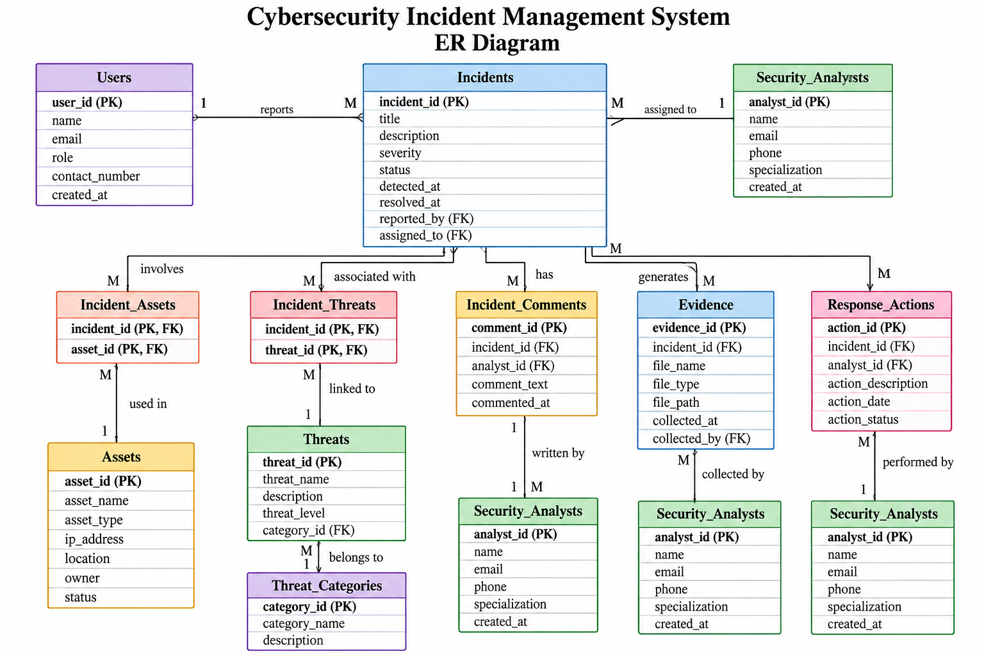

3.1 Referential Integrity
Foreign keys ensure that an incident references an existing user and analyst, and that dependent records refer to existing incidents, threats, assets, or users. The composite primary keys in Incident_Threats and Incident_Assets prevent duplicate pairs of the same incident-threat or incident-asset association.

3.2 Important alignment note
The supplied relational ER image contains some attributes not present in the sample PDF's DDL (for example, contact_number and created_at in Users, resolved_at in Incidents, and category_id in Threats). The sample PDF DDL is used as the authoritative table schema in this report. The resolved_at field is added later for the trigger demonstration. If the instructor expects the image schema exactly, these differences should be reconciled before final submission.

4. Application and SQL Operations
The database can be used by employees to report incidents and by security analysts to investigate and document them. The SQL operations below are representative examples taken from the supplied sample report.

4.1 Example: Retrieve critical incidents
SELECT incident_id, title, severity, status
FROM Incidents
WHERE severity = 'CRITICAL';
Purpose: lists incidents whose severity is marked CRITICAL.

4.2 Example: Show assigned analyst
SELECT i.incident_id, i.title, i.severity,
a.name AS analyst
FROM Incidents i
JOIN Security_Analysts a
ON i.assigned_to = a.analyst_id;
Purpose: combines incident and analyst records using a JOIN.

4.3 Example: Count incidents by severity
SELECT severity, COUNT(*) AS total_incidents
FROM Incidents
GROUP BY severity;
Purpose: summarizes the number of incidents in each severity category.

4.4 Example: Find phishing-related incidents
SELECT *
FROM Incidents
WHERE incident_id IN (
SELECT incident_id
FROM Incident_Threats
WHERE threat_id = (
SELECT threat_id
FROM Threats
WHERE threat_name = 'Phishing'
)
);
Purpose: demonstrates a nested query through the incident-threat relationship.

4.5 Stored procedure and cursor
Generate_Analyst_Report accepts an analyst ID, opens a cursor over incidents assigned to that analyst, and returns each incident's ID, title, severity, and status.
CALL Generate_Analyst_Report(1);

4.6 Function
Get_Analyst_Incident_Count returns the number of incidents assigned to a particular analyst.
SELECT Get_Analyst_Incident_Count(1) AS Total_Incidents;

4.7 Trigger
The Incident_Status_Update trigger sets resolved_at to the current timestamp when an incident changes to RESOLVED or CLOSED. The sample SQL first adds the resolved_at column to Incidents.
ALTER TABLE Incidents ADD COLUMN resolved_at DATETIME;

UPDATE Incidents
SET status = 'RESOLVED'
WHERE incident_id = 1;

5. Future Improvements
- Develop a web-based dashboard with role-based login for employees and security analysts.
- Add email or in-app notifications when a critical incident is reported or assigned.
- Introduce a more detailed audit trail for changes to incident status, ownership, and evidence.
- Add validation rules or lookup tables for severity and status values to avoid inconsistent entries.
- Improve evidence handling with secure file storage, access control, and integrity hashes.
- Add reporting dashboards for incident trends, response time, recurring threats, and analyst workload.
- Align the final SQL schema with every attribute shown in the chosen ER diagram and add suitable indexes for frequent searches.

6. Conclusion
The Cybersecurity Incident and Threat Management Database demonstrates how a relational database can organize cybersecurity incident information and connect it with users, analysts, threats, assets, evidence, comments, and response actions. Primary and foreign keys help maintain data integrity, while SQL queries and joins support retrieval and analysis. The stored procedure, cursor, function, and trigger further demonstrate DBMS programming features. The project provides a foundation that could be extended into a complete incident-management application.
7. References
- DBMSprj.pdf, supplied sample mini-project report: project description, SQL DDL/DML, queries, procedure, function, and trigger.
- Cybersecurity Incident Management ER Diagram.png, supplied relational ER schema image.
- Cybersecurity Incident Management System - Chen ER Diagram (v2).jpeg, supplied Chen-style ER diagram image.
- Oracle. MySQL 8.4 Reference Manual. https://dev.mysql.com/doc/refman/8.4/en/
Note: The diagrams and sample SQL definitions in this report are based on the supplied files. The report does not claim that SQL was executed in a live MySQL instance.

8. Snapshot of Execution
The following screenshots were captured from the MySQL command-line session and show the database tables, JOIN query results, stored procedure execution, and trigger execution.

8.1 Database Table List
The SHOW TABLES command confirms that the database contains 11 tables.
.
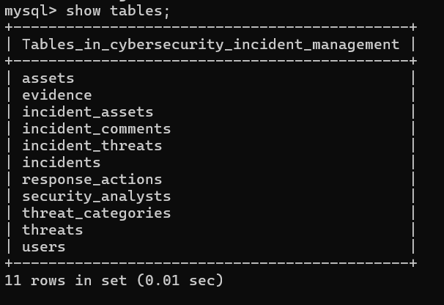

8.2 JOIN Query — Incidents with Reporters
This query joins Incidents with Users using reported_by and user_id to display each incident's reporter.
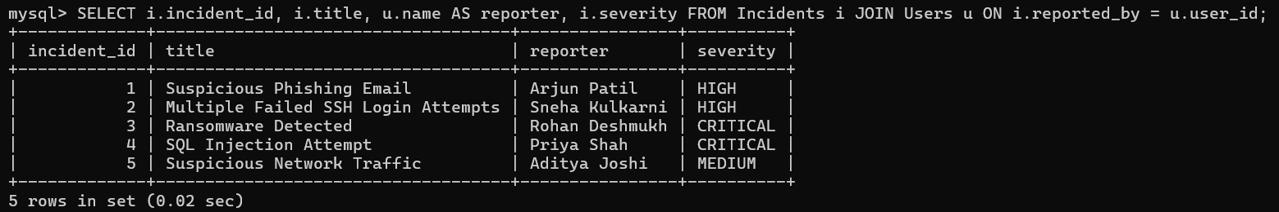

8.3 JOIN Query — Incidents with Assigned Analysts
This query joins Incidents with Security_Analysts using assigned_to and analyst_id to show the analyst responsible for each incident.

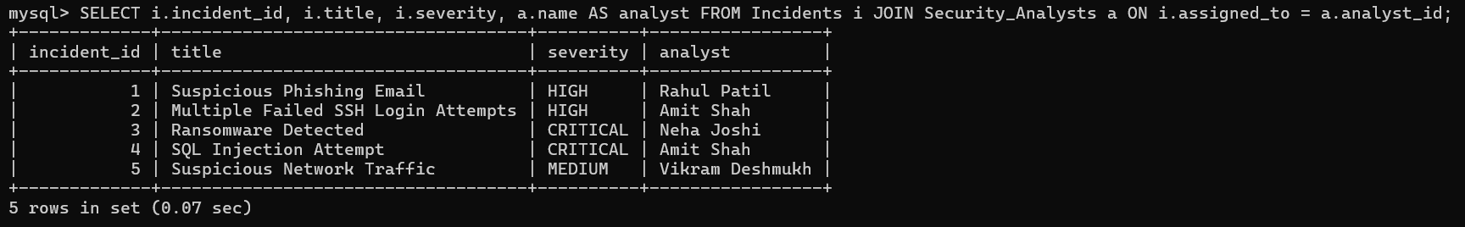

8.4 Stored Procedure and Cursor Execution
The Generate_Analyst_Report procedure uses a cursor to return the incidents assigned to analyst ID 1.

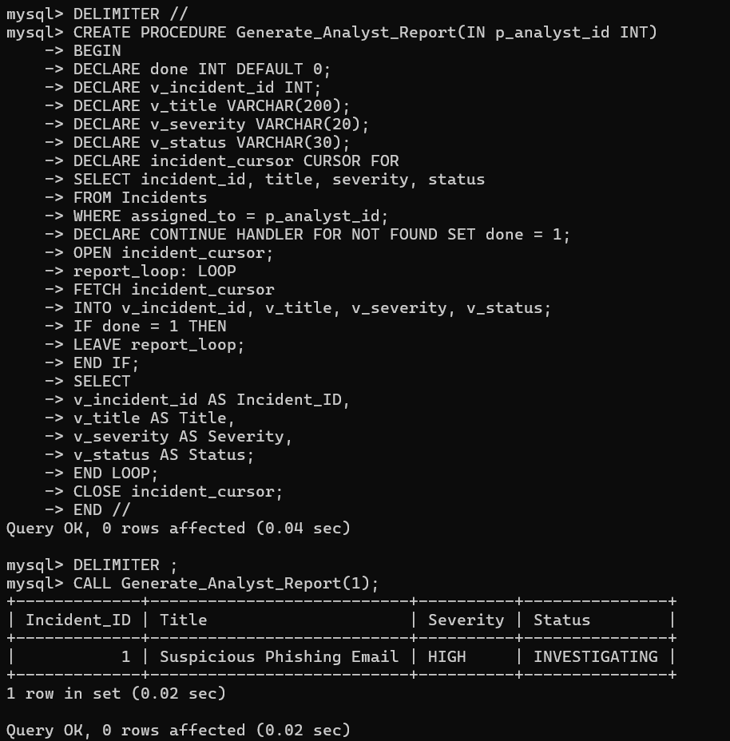

8.5 Trigger Execution — Automatic Resolution Timestamp
The trigger is created successfully. The UPDATE statement changes incident 1 to RESOLVED, and MySQL reports one row changed. This confirms the status update ran; to verify the timestamp itself, execute SELECT resolved_at FROM Incidents WHERE incident_id = 1;

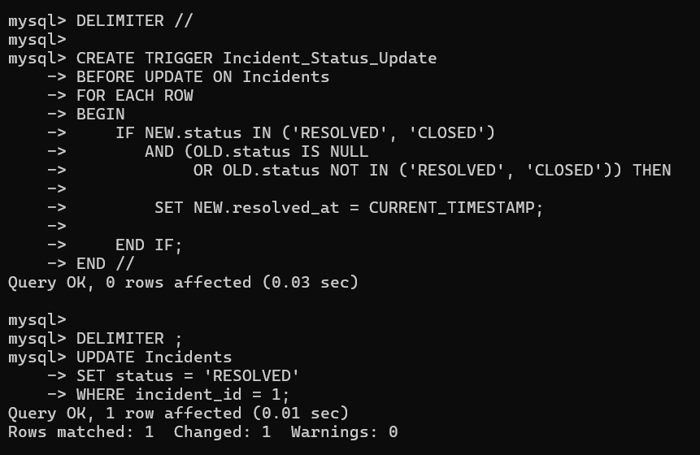
Figure 8.5: Successful trigger creation and incident status update.

8.6 Function 2 — Calculate Incident Risk Score
