

OBJECT ORIENTED PROGRAMMING USING C++
MINI PROJECT REPORT
Project Title: LogScope — Log File Anomaly Detection System

Submitted by
Group ID: Not provided

PROJECT TEAM MEMBERS
Sr. No. | PRN Number | Student Name
1 | 1262250827 | KRISHNANUNNI J KURUP
2 | 1262251966 | ABHINAV CHAVAN
3 | 1262250688 | DECLAN PO

Under the Guidance of
MUGDHA JOSHI

Department of Computer Engineering and Technology
Dr. Vishwanath Karad MIT World Peace University, Pune – 411 038
Maharashtra, India
Academic Year 2026–2027

DEPARTMENT OF COMPUTER ENGINEERING AND TECHNOLOGY

CERTIFICATE

This is to certify that
1262250827 | KRISHNANUNNI J KURUP
1262251966 | ABHINAV CHAVAN
1262250688 | DECLAN P

students of Second Year B. Tech. Computer Science and Engineering (Cybersecurity and Forensics), have completed the mini project entitled “LogScope — Log File Anomaly Detection System” and submitted this report as part of the requirements for the course CSF20210: Object Oriented Programming Laboratory during the academic year 2026–2027.

Date: 23rd October 2026
Place: Pune

MUGDHA JOSHI
Course Teacher
Department of Computer Eng. and Tech.
MIT WPU, Pune

ACKNOWLEDGEMENT

I express my sincere gratitude to Mugdha Joshi, Course Teacher, for guidance during the Object Oriented Programming mini project. I thank the Department of Computer Engineering and Technology and Dr. Vishwanath Karad MIT World Peace University, Pune, for the academic environment and resources. I also acknowledge the open technical documentation cited in this report. The project implementation and report are based on the supplied LogScope source files.

Date: 23rd Oct 2026

ABSTRACT
LogScope is a local access-log investigation system that helps a user review Apache/Nginx common or combined logs through a browser dashboard. The application accepts a plain-text log, validates and parses entries, groups activity by source IP and endpoint, and reports rule-based indicators for repeated HTTP 401 responses, high request rates, repeated 403/404 responses, SQL-injection-like request targets and directory-traversal-like targets. A Python standard-library HTTP service connects the interface to a C++14 analyzer when a compatible executable is available; a Python analyzer is the fallback. The report presents aggregate findings, endpoint counts, IP statistics and timelines. The C++ engine demonstrates encapsulation, abstraction, inheritance and runtime polymorphism through a common detector interface. The system is designed for local educational investigation; access-log indicators do not prove successful exploitation, identity or authentication outcome. Port scanning is outside scope because access logs do not contain destination-port information. The source includes dependency-free engine and API integration checks; those checks were not run during preparation of this report.

Keywords: access-log analysis, C++, object-oriented programming, anomaly detection, HTTP logs, cybersecurity

TABLE OF CONTENTS
Certificate 2
Acknowledgement 3
Abstract 4
List of Figures 6
List of Tables (if applicable) 6
List of Abbreviations (if applicable)

Chapter / section navigation (page numbers are listed in the contents table below).
1. Introduction 7
1.1 Motivation . . . . . . . . . . . . . . . . . . . . . . . . . . . . . . . . .
1.2 Objectives . . . . . . . . . . . . . . . . . . . . . . . . . . . . . . . . . 8
2. Problem Definition and Objectives —
3. Requirements, Tools and Technologies —
4. System Design and Architecture —
5. Implementation and User Interface —
6. Methodology 13
7. Algorithms and Testing 14
8. Conclusion and Future Scope 15
References 16
Appendices —

LIST OF FIGURES
Figure No. | Figure Caption | Page No.
4.1 | Figure 4.1 LogScope system architecture | 10
4.2 | Figure 4.2 Log analysis workflow | 10

LIST OF TABLES
Table No. | Table Caption | Page No.
7.1 | Representative engine/API test plan | 14

CHAPTER 1
INTRODUCTION

1.1 Background and Motivation
Web servers record requests as access-log lines containing source address, time, request target, status and response size [1][2]. Reviewing these records manually becomes difficult when an analyst needs to correlate repeated responses, bursts and suspicious request targets across many lines. LogScope was selected to make those patterns visible in a local, explainable dashboard while using C++ object-oriented design for the core analyzer.

1.2 Problem Statement
Given a supported Apache/Nginx common or combined access log, provide a local way to parse valid records, group them by IP and endpoint, and surface configurable, explainable indicators without claiming that an indicator proves an attack or compromise.

1.3 Objectives
1. Parse supported access-log records and count malformed lines.
2. Aggregate requests, statuses and timelines by IP and endpoint.
3. Detect configurable 401 bursts and request-rate spikes, repeated 403/404 responses, and heuristic SQL/traversal patterns.
4. Present findings and IP details in a browser UI through a local API.
5. Demonstrate C++ encapsulation, abstraction, inheritance and polymorphism.
6. Document input limits, unsupported inferences and a reproducible test plan.

1.4 Scope and Limitations
Scope: local upload and analysis of UTF-8 .log/.txt access logs up to 10 MiB; common/combined format; per-IP and per-endpoint aggregation; browser review of findings, log health, timelines and IP details. Thresholds are configurable. Limitations: no packet data, destination ports, identity, reputation lookup, login-success semantics or proof of exploitation. Request-target rules are heuristic and can produce false positives. Only the latest report is kept in process memory.

1.5 Report Organisation
Chapter 2 defines the problem and requirements. Chapter 3 lists technologies and runtime needs. Chapter 4 describes architecture, workflow, classes and data. Chapter 5 explains modules, selected C++ code and the interface. Chapter 6 records the development and integration process. Chapter 7 presents algorithms and a source-based test plan, with execution status stated explicitly. Chapter 8 concludes with limitations and future work.

CHAPTER 2
PROBLEM DEFINITION AND OBJECTIVES

2.1 Problem Definition
Access logs provide useful request-level evidence but do not by themselves tell an analyst which source IPs merit closer review. Manual counting across time windows is error-prone, and simple string matches can be mistaken for proof of an attack. The project therefore focuses on transparent aggregation and bounded indicators over the fields available in the log.

2.2 Existing System and Its Limitations
The baseline workflow is manual inspection with text search, filtering or ad-hoc scripts. Such approaches require repeated counting and correlation, offer limited per-IP context and can be difficult to reproduce. LogScope automates these summaries, but remains limited to the evidence present in supported access logs; it is not a SIEM, packet monitor or authentication system.

2.3 Proposed Solution
A browser uploads a validated log to a local Python HTTP server. The service invokes the C++ analyzer when compatible, otherwise its dependency-free Python analyzer. The engine parses records, aggregates per-IP and endpoint statistics, runs detector strategies and returns JSON. The interface renders summary counts, findings, log health and IP timelines.

2.4 Functional and Non-Functional Requirements
Functional: upload .log/.txt (maximum 10 MiB); set 401 count/window and request-rate thresholds; parse supported log entries; report malformed lines; detect five indicator classes; inspect IP and endpoint summaries; show timelines; expose health and analysis endpoints. Non-functional: local operation on loopback, no third-party Python dependencies, readable explanations, bounded input size, input validation and fallback operation when native C++ is unavailable. No database or network lookup is required.

CHAPTER 3
REQUIREMENTS, TOOLS AND TECHNOLOGIES

3.1 Hardware Requirements
A general-purpose computer capable of running Python 3.9+ and a modern browser is sufficient. No dedicated GPU, server, database or network access is required. Actual hardware used for development was not specified in the supplied project files.

3.2 Software Requirements
Operating system: Windows, Linux or macOS. Runtime: Python 3.9 or later and a modern browser. The C++ reference engine targets C++14; it is used only when a compatible executable is available. Otherwise the built-in Python analyzer is used. The API uses Python standard-library modules; no third-party Python packages are required.

3.3 Programming Language and Technologies
C++14 implements parsing, typed log records, IP aggregation and detector strategies. Python standard library provides the HTTP server, upload validation, API, and portable analysis fallback. The frontend uses HTML, CSS and JavaScript. JSON transfers analysis results from the engine/API to the browser. Access-log fields follow common/combined conventions described by Apache and NGINX documentation [1][2].

3.4 Development Environment
The project is organized into `cpp_engine/main.cpp`, `backend/app.py`, `backend/analyzer.py`, `frontend/`, `sample_logs/` and `tests/test_engine.py`. Start from the project root with `python backend/app.py`, then open `http://127.0.0.1:5000`. Choose `sample_logs/investigation.log` for a bundled suspicious-pattern example. A compatible C++ executable is optional because the Python fallback is included.

CHAPTER 4
SYSTEM DESIGN AND ARCHITECTURE

4.1 System Architecture
The browser interface sends a log upload and thresholds to the local API. The API validates the request and chooses the compatible C++ engine or Python fallback. The analyzer returns structured JSON, which the UI uses for aggregate findings and drill-down views. The C++ temporary input copy is removed after analysis; the Python fallback analyzes validated content in memory. Figure 4.1 summarizes the components.
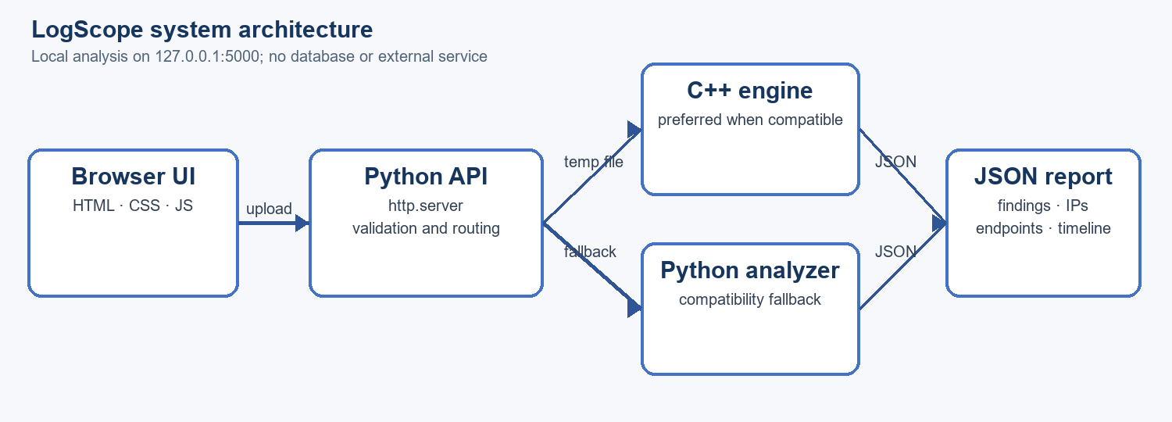
Figure 4.1: LogScope system architecture

4.2 Use-Case / Flowchart / Data-Flow Diagram
The principal user is an analyst or student reviewing a supplied access log. The user selects a file, adjusts thresholds, starts analysis, reviews findings and opens an IP timeline. Figure 4.2 shows the processing sequence from upload through review. Invalid/unsupported input is rejected or malformed rows are counted; no valid rows produce an error.
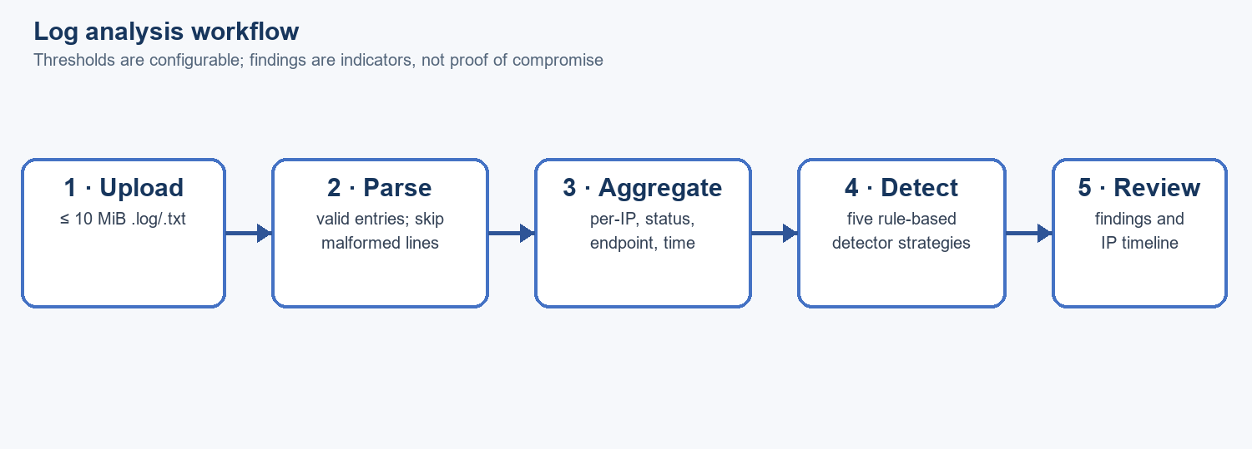
Figure 4.2: Log analysis workflow

4.3 Class Diagram and Object-Oriented Design
`LogEntry` stores parsed fields. `LogParser` converts lines to entries. `AnomalyEngine` aggregates entries and coordinates detectors. Abstract `AttackDetector` defines a virtual `analyze` operation; `BruteForceDetector`, `TrafficDetector`, `HttpErrorDetector`, `SQLInjectionDetector` and `DirectoryTraversalDetector` specialize it. The engine stores detector instances as `vector<unique_ptr<AttackDetector>>`, so concrete algorithms run through one interface [3].

4.4 Data Design (if applicable)
A `LogEntry` contains IP, timestamp, method, request target, status, response bytes and epoch time. Per-IP `IPStats` stores pointers to entries and status counts. `Finding` stores IP, type, severity, reason, evidence, count, rate and time bounds. Standard containers include vectors, unordered maps, ordered maps and sets. The API returns summary, supported-feature flags, findings, endpoints and IP timeline data as JSON. The latest result remains in process memory.

CHAPTER 5
IMPLEMENTATION AND USER INTERFACE

5.1 Module Description
Frontend: file selection/upload, threshold controls, overview, findings, IP investigation, timeline and log-health views. API (`backend/app.py`): serves assets, validates upload/thresholds and exposes health, analyze and IP routes. C++ engine: parses, aggregates and detects when compatible. Python analyzer: portable compatibility fallback. Sample logs: reproducible example inputs. Test script: dependency-free engine/API checks (not executed for this report).

5.2 Key Implementation Details
The parser applies a regular expression to each line, converts timestamp/status/bytes, and counts malformed entries. `AnomalyEngine` builds IP and status aggregates. Detector objects share `AttackDetector::analyze`; findings are combined into the JSON report. The 401 and traffic detectors sort per-IP events and use a moving left boundary to select a qualifying time window. `main` validates thresholds and reports exceptions to stderr with a nonzero return code. Selected source excerpts are reproduced in Appendix A.

5.3 User Interface / Console Screenshots
The web interface is served at `http://127.0.0.1:5000` and presents a LogScope overview with navigation for Overview, Findings, IP Analysis, Timeline and Log Health. The upload panel accepts a log file; threshold controls configure the 401 count, time window and request rate. After analysis, the dashboard exposes aggregate findings and drill-down context. UI elements are documented from the supplied frontend source; a captured screenshot was not included in the supplied project files.

5.4 Object-Oriented Programming Concepts Used
Encapsulation: `LogEntry`, `LogParser` and `AnomalyEngine` group data and operations. Abstraction: pure virtual `AttackDetector::analyze` defines detector behavior. Inheritance: concrete detectors derive from `AttackDetector`. Polymorphism: the engine iterates a vector of base-class smart pointers and dispatches virtual calls. Constructors initialize the engine and detector objects; a virtual destructor supports safe deletion. STL containers and algorithms support aggregation and ordering. `unique_ptr` expresses exclusive ownership [3].

5.5 Sample Input and Output
Sample input (from `sample_logs/investigation.log`): repeated `POST /login` records for `198.51.100.23` return HTTP 401 at one-second intervals. With a threshold of 10 responses in 300 seconds, the intended report includes a “Brute Force Activity” indicator for that IP, with count and observed time bounds. This is an access-log pattern only; it does not establish failed credentials or malicious intent. The repository also includes normal traffic and other investigation examples.

CHAPTER 6
METHODOLOGY

6.1 Development Approach
The repository follows a modular, incremental approach: define supported log input and limits; implement parsing and rule-based analysis; connect the analyzer to a local API; add a browser dashboard; document OOP concepts and complexity; provide sample logs and a dependency-free test script. The C++ engine is the primary OOP implementation, while Python keeps the application portable.

6.2 Workflow / Process
1. Select a supported text log and thresholds. 2. Validate file type, size and threshold values. 3. Parse lines and count malformed records. 4. Aggregate by IP, endpoint and status. 5. Run five detector strategies. 6. Serialize summary, findings and timelines as JSON. 7. Render the result and allow IP-level inspection. See Figure 4.2.

6.3 Module Integration
The browser uses HTTP endpoints on loopback. The server serves frontend assets, accepts multipart uploads, validates values and invokes an analyzer. Native execution receives a temporary file; fallback analysis uses the validated upload contents. Both paths produce the same JSON-shaped report expected by the UI. The IP endpoint reads the most recent in-memory report.

CHAPTER 7
ALGORITHMS AND TESTING

7.1 Algorithms / Pseudocode
Parsing: for each line, match the supported access-log pattern; if unmatched or conversion fails, increment malformed count; otherwise create a `LogEntry`. Aggregation: add each record to its IP bucket, status counts and endpoint totals. Window detection: sort relevant per-IP records by epoch; advance the right boundary; move the left boundary while elapsed time exceeds the configured window; retain the largest qualifying range. Compare its count/rate with the threshold and emit a finding. Pattern detectors scan request targets with heuristic regular expressions.

7.2 Test Plan and Test Cases
The repository test source defines engine and API checks. Table 7.1 summarizes representative cases and expected behavior. Execution status for all cases is “Not run for this report”; the status is not a pass/fail result. Source: `tests/test_engine.py`.
TC-01 | Normal sample log | No suspicious finding for normal requests | Not run
TC-02 | 12 HTTP 401 responses in window | Brute Force Activity finding | Not run
TC-03 | Fast per-IP request burst | Traffic Spike finding with measured rate | Not run
TC-04 | Five HTTP 404 responses | Repeated HTTP Errors finding | Not run
TC-05 | SQL-like / traversal request targets | Corresponding heuristic indicator | Not run
TC-06 | Malformed lines and empty input | Skip malformed rows; error if no valid rows | Not run
TC-07 | Upload and IP investigation API | Valid JSON summary and IP details | Not run

7.3 Results and Discussion
The submitted source implements the parser, five detector classes, local API, dashboard and fallback analyzer described above. Bundled sample logs and test cases provide demonstration inputs. No test suite or independent performance benchmark was run while preparing this report, so runtime results and measured accuracy are not asserted. Heuristic findings require human review; timezone consistency and supported input format affect time-window interpretation.

CHAPTER 8
CONCLUSION AND FUTURE SCOPE

8.1 Conclusion
LogScope combines a C++ object-oriented analysis engine with a local Python API and browser dashboard to summarize supported access logs. Its detector interface demonstrates abstraction, inheritance and polymorphism, while aggregation provides per-IP and endpoint context. The source also makes key limits explicit: indicators are heuristic and the log format cannot support port-scan conclusions or authentication identity claims.

8.2 Limitations
Supported format is restricted to Apache/Nginx common or combined access-log shape and uploads are limited to 10 MiB. Pattern checks can produce false positives or miss variants. HTTP 401 does not prove a failed login; 2xx/3xx does not prove authentication. No destination ports, packet context, identity or IP reputation are available. The report is kept in memory and only the latest analysis is retained. Native C++ compatibility varies by host; Python is the fallback.

8.3 Future Scope
Possible extensions include configurable log-format adapters, exportable reports, persistent multi-session case storage, detector calibration against labeled datasets, richer timeline filtering, optional structured audit trails and separately configured reputation or alert integrations. Each extension should preserve local-first behavior and clearly distinguish evidence from inference.

REFERENCES
[1] Apache Software Foundation, “Log Files,” Apache HTTP Server Documentation. https://httpd.apache.org/docs/current/logs.html (accessed 15 Oct. 2026).
[2] NGINX, “Module ngx_http_log_module,” NGINX Documentation. https://nginx.org/en/docs/http/ngx_http_log_module.html (accessed 15 Oct. 2026).
[3] cppreference.com, “std::unique_ptr,” C++ standard library reference. https://en.cppreference.com/w/cpp/memory/unique_ptr (accessed 15 Oct. 2026).
[4] LogScope project source and documentation: README.md, OOP_DOCUMENTATION.md, cpp_engine/main.cpp, backend/app.py, backend/analyzer.py, frontend/, sample_logs/ and tests/test_engine.py; supplied project directory, accessed 15 Oct. 2026.

APPENDICES (IF APPLICABLE)
Appendix A — Selected C++ engine code snapshots

A.1 Parsed access-log record
struct LogEntry {
std::string ip, timestamp, method, path;
int status = 0;
long long bytes = 0;
std::time_t epoch = 0;
};

A.2 Common detector interface
class AttackDetector {
public:
virtual ~AttackDetector() {}
virtual std::vector<Finding> analyze(
const std::unordered_map<std::string, IPStats>&,
int, int, double) const = 0;
};

A.3 Moving-window boundary
for (size_t r = 0; r < v.size(); r++) {
while (v[r]->epoch - v[l]->epoch > window) ++l;
if (r - l + 1 > bestR - bestL) {
bestL = l;
bestR = r + 1;
}
}

A.4 Polymorphic detector dispatch
std::vector<std::unique_ptr<AttackDetector>> ds;
ds.emplace_back(new BruteForceDetector);
ds.emplace_back(new TrafficDetector);
ds.emplace_back(new HttpErrorDetector);
ds.emplace_back(new SQLInjectionDetector);
ds.emplace_back(new DirectoryTraversalDetector);
for (auto& d : ds) {
auto x = d->analyze(ips, fail, window, rps);
fs.insert(fs.end(), x.begin(), x.end());
}

Appendix B — Operation notes
From the project root, run `python backend/app.py` and open `http://127.0.0.1:5000`. Select a supported .log or .txt file up to 10 MiB. The bundled `sample_logs/investigation.log` provides a representative repeated-401 example. Stop the local server with Ctrl+C.

