

Foundations of Programming

Assignment No.: 01

- PROBLEM STATEMENT:
Write a program in C to check whether a given year is a Leap Year

OBJECTIVE:

- To understand the use of conditional statements in C programming.
- To implement logical conditions for solving real-world problems.
- To develop problem-solving skills using decision control structures.

THEORY:
Conditional statements are decision-making statements used to execute different blocks of code based on whether a given condition is true or false. They help control the flow of a program.
In C, the main conditional statements are:
- if statement
- if-else statement
- if-else ladder
1] If statement :
The if statement executes a block of code only when a specified condition is true.
Example :
if (condition)
{
// statements to be executed if condition is true
}
If the condition evaluates to true (non-zero), the code inside the block executes.
If the condition is false (zero), the block is skipped.

2] If- else statement :
The if-else statement executes one block of code when the condition is true and another block when the condition is false.
Example:
if (condition)
{
// statements executed if condition is true
}
else
{
// statements executed if condition is false
}
If the condition is true, the if block executes.
If the condition is false, the else block executes.

3] If – else ladder:
The if-else ladder is used when there are multiple conditions to be checked one after another.
Example:
if (condition1)
{
// statements executed if condition1 is true
}
else if (condition2)
{
// statements executed if condition2 is true
}
else if (condition3)
{
// statements executed if condition3 is true
}
else
{
// statements executed if none of the above conditions are true
}
Conditions are checked from top to bottom.
The first true condition’s block is executed.
If none of the conditions are true, the else block executes.

Leap Year
A leap year is a special calendar year that contains 366 days instead of the usual 365 days. The extra day is added to the month of February, making it 29 days long instead of 28 days.
Leap years are introduced to keep the calendar year synchronized with the Earth's revolution around the Sun.
A year is considered a leap year if it satisfies any one of the following conditions:
- The year is divisible by 400
→ Then it is a leap year.
- The year is divisible by 4 but not divisible by 100
→ Then it is a leap year.
If a year does not satisfy either of the above conditions, it is not a leap year.

Algorithm
- Start the program.
- Declare an integer variable year.
- Read the value of year from the user.
- If the year is divisible by 400, then display "Leap Year".
- Else if the year is divisible by 4 and not divisible by 100, then display "Leap Year".
- Else display "Not a Leap Year".
- Stop the program.

PLATFORM: Linux

INPUT/OUTPUT:
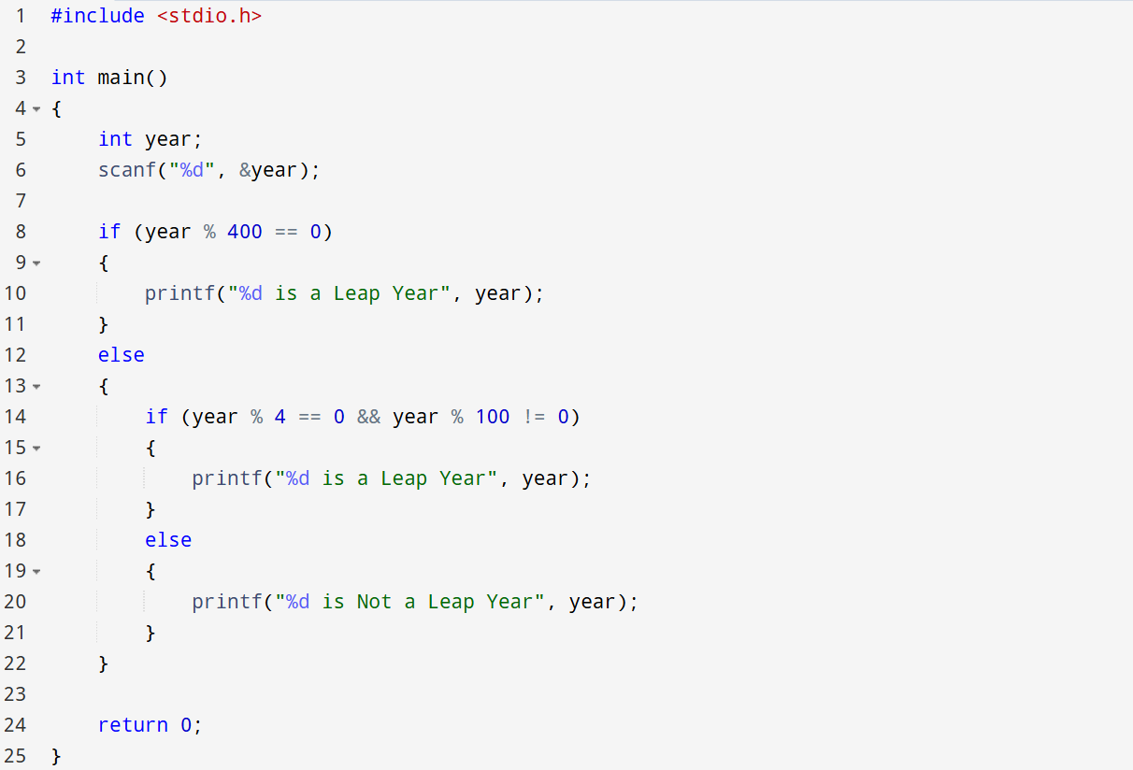
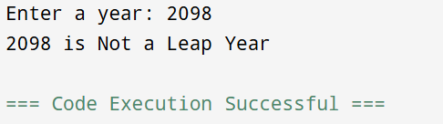

CONCLUSION: Thus, the program successfully checks whether a given year is a Leap Year using conditional statements in C.

