

Foundations of Programming
Assignment No. : 9

PROBLEM STATEMENT:
Write a program in C to check whether the given number is an Armstrong number or not.
An Armstrong number is an integer with three digits such that the sum of the cubes of its digits is equal to the number itself.
Example: 371

OBJECTIVE:
• To understand the concept of Armstrong numbers.
• To practice arithmetic operations in C.
• To develop logical thinking using loops and conditional statements.

THEORY:
An Armstrong number, also known as a narcissistic number, is a number that is equal to the sum of the cubes of its digits. This concept is commonly used in programming to demonstrate the use of loops, arithmetic operations, and conditional statements.
For a three-digit number, let the digits be a, b, and c. The number is said to be an Armstrong number if the following condition is satisfied:
$$a^{3}+b^{3}+c^{3}=abc$$
Explanation
- Each digit of the number is separated
- The cube of each digit is calculated
- The cubes are added together
- If the sum is equal to the original number, the number is an Armstrong number
Example
Consider the number 371:
- Digits: 3, 7, and 1
- Cubes:
  - $3^{3}=27$
  - $7^{3}=343$
  - $1^{3}=1$
$$27+343+1=371$$
Since the sum of the cubes of its digits is equal to the original number, 371 is an Armstrong number.
Importance in Programming
- Helps in understanding digit extraction using modulus (%) and division (/)
- Demonstrates the use of while or for loops
- Illustrates decision-making using if statements

PLATFORM:
Linux

ALGORITHM:
- Start
- Declare variables num, temp, digit, sum
- Accept and read a three digit number from user
- Store a number in temporary variable
- Initialise sum is equal to 0.
- Repeat until temp becomes 0
Extract last digit of number using digit = temp%10
Add cube of the digit to sum
Remove the last digit using temp + temp/10
- Compare sum with original number
If num = sum then display number is an Armstrong number
Else display number is not an Armstrong number
- Stop

C PROGRAM:
#include <stdio.h>
int main() {
int num, temp, digit;
int sum = 0;

printf("Enter a three-digit number: ");
scanf("%d", &num);
temp = num;
while (temp != 0) {
digit = temp % 10;
sum = sum + (digit * digit * digit);
temp = temp / 10;
}
if (num == sum)
printf("%d is an Armstrong number", num);
else
printf("%d is not an Armstrong number", num);
return 0;
}

INPUT/ OUTPUT:
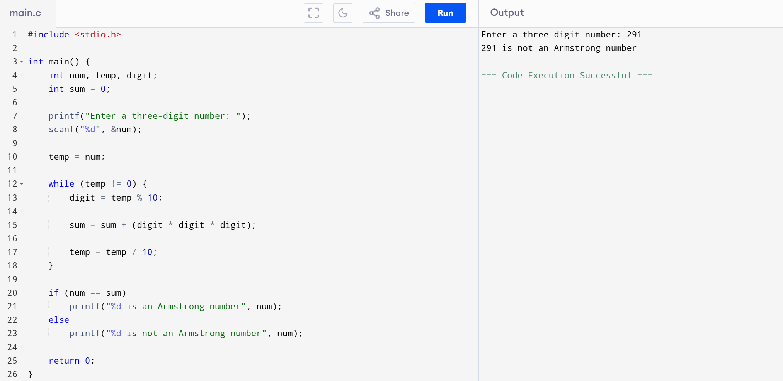
Enter a three-digit number.
Example Input:
371
Example Output:
371 is an Armstrong number.

CONCLUSION:
Thus, we have successfully written a C program to check whether a given number is an Armstrong number using loops and arithmetic operations.

