

Foundations of Programming
Assignment No. : 10

PROBLEM STATEMENT:
Write a program in C to simulate a simple calculator that performs basic arithmetic operations such as addition, subtraction, multiplication, and division. The calculator should also perform special operations like computing xʸ (power) and x! (factorial).

OBJECTIVE:
• To understand the use of switch-case statements in C.
• To perform basic arithmetic and special mathematical operations.
• To enhance problem-solving skills using menu-driven programs.

THEORY:
A calculator is a basic computing device used to perform arithmetic operations. In C programming, a simple calculator can be implemented using conditional or switch-case statements. Arithmetic operations like addition, subtraction, multiplication, and division are fundamental operations. Special operations such as power (xʸ) and factorial (x!) require loops for repeated calculations.

PLATFORM:
Linux

ALGORITHM:
- Start
- Display a menu with calculator operations
- Read the user’s choice
- If the choice is addition, subtraction, multiplication, division:
Read numbers from user; perform selected operations
If choice is power
Read base and exponent; Compute result using a loop
If choice is factorial
Read a number and compute factorial using loop
- Check if user chooses a divisor as zero then display “Error”
- Else display result of operation
- Stop

C PROGRAM:

INPUT:
User selects an operation from the menu and enters required values.
Example Input:
Choice: 1
Numbers: 10 20

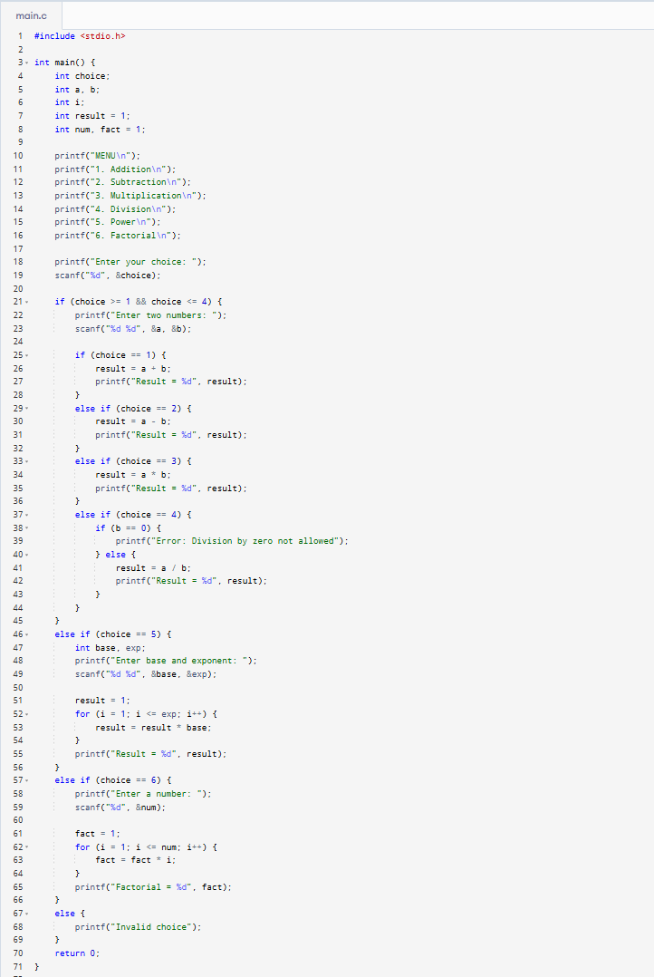

OUTPUT:
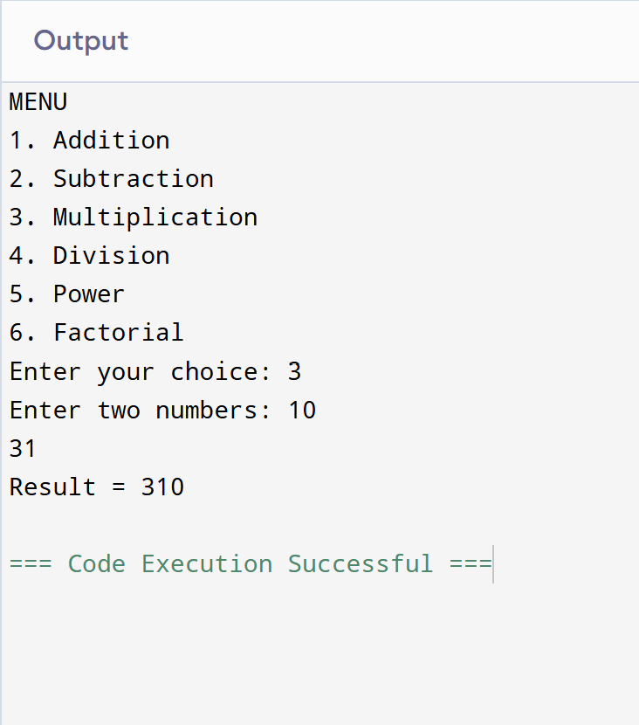
Example Output:
Result = 30.00

CONCLUSION:
Thus, a simple calculator program was successfully implemented using C programming. The program demonstrates the use of switch-case statements, loops, and arithmetic operations.

