**Practical14**

* **Index.html and Design.css**

/*

To change this license header, choose License Headers in Project Properties.

To change this template file, choose Tools | Templates

and open the template in the editor.

*/

/*

Created on : 18 Sep, 2020, 6:46:31 PM

Author : Hp

*/

table{

background-color: background;

border:5px solid greenyellow;

}

input-type{

background-color: background;

}

body{

background-color: paleturquoise;

}

#buttoncolor

{

background-color: darkgray;

}

textarea

{

border:1px solid;

background: transparent;

}

a

{

background-color: yellowgreen;

border: solid blue;

}

h3

{

color:darkorange;

}

.index input[type="text"],input[type="number"],input[type="Date"]

{

border:none;

border-bottom:1px solid;

background: transparent;

}

Output:-

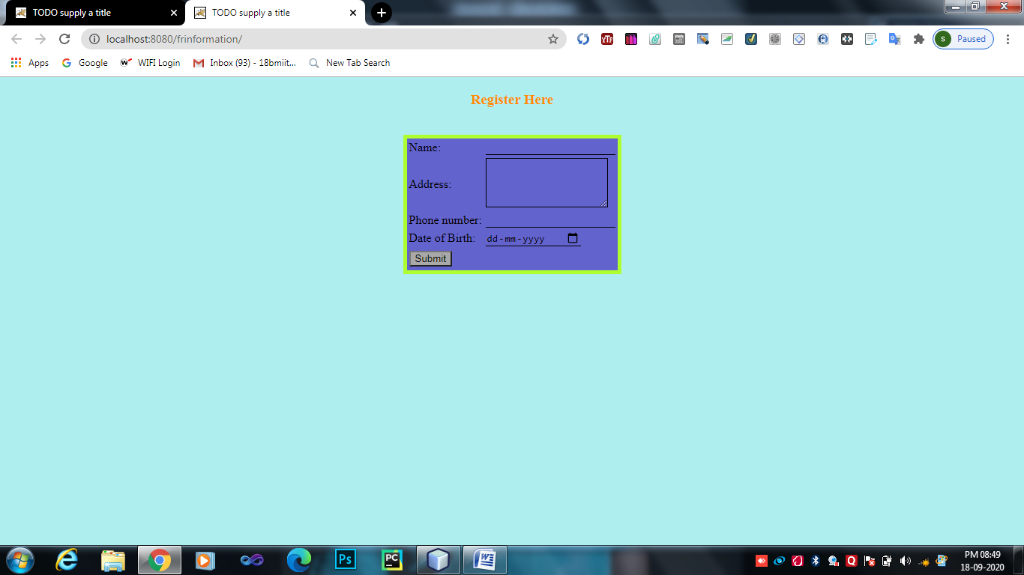

* **friend.java**

/*

* To change this license header, choose License Headers in Project Properties.

* To change this template file, choose Tools | Templates

* and open the template in the editor.

*/

import java.io.IOException;

import java.io.PrintWriter;

import java.text.ParseException;

import java.text.SimpleDateFormat;

import java.util.Date;

import java.util.logging.Level;

import java.util.logging.Logger;

import javax.servlet.RequestDispatcher;

import javax.servlet.ServletException;

import javax.servlet.http.Cookie;

import javax.servlet.http.HttpServlet;

import javax.servlet.http.HttpServletRequest;

import javax.servlet.http.HttpServletResponse;

/**

*

* @author Hp

*/

public class friend extends HttpServlet {

private int reqcount;

public void init() {

reqcount = 0;

}

public void service(HttpServletRequest req,HttpServletResponse res)throws IOException,ServletException

{

//PrintWriter pw=res.getWriter();

/*String Name=req.getParameter("name");

String Address=req.getParameter("address");

long Phoneno=Long.parseLong(req.getParameter("phonenumber"));

String dob=req.getParameter("birthdate");

SimpleDateFormat sdf=new SimpleDateFormat("dd-mm-yyyy");*/

PrintWriter pw=res.getWriter();

String name = req.getParameter("name");

reqcount++;

Cookie ckhit = new Cookie("hitcount", Integer.toString(reqcount));

Cookie ckname = new Cookie("name", name);

res.addCookie(ckhit);

res.addCookie(ckname);

ckhit.setMaxAge(60 * 60 * 7);

RequestDispatcher rd = req.getRequestDispatcher("message");

rd.forward(req, res);

}

}

* **message.java**

/*

* To change this license header, choose License Headers in Project Properties.

* To change this template file, choose Tools | Templates

* and open the template in the editor.

*/

import java.io.IOException;

import java.io.PrintWriter;

import javax.servlet.ServletException;

import javax.servlet.http.Cookie;

import javax.servlet.http.HttpServlet;

import javax.servlet.http.HttpServletRequest;

import javax.servlet.http.HttpServletResponse;

/**

*

* @author Hp

*/

public class message extends HttpServlet {

private int hitcount;

public void init()

{

hitcount=0;

}

public void service(HttpServletRequest req,HttpServletResponse res)throws IOException,ServletException

{

PrintWriter pw=res.getWriter();

pw.println("<link rel='stylesheet' type='text/css' href='Design.css'>");

hitcount++;

Cookie[] c = req.getCookies();

res.setContentType("text/html");

String name = "";

for (Cookie ck : c) {

if (ck.getName().equals("name")) {

name = ck.getValue();

}

if (ck.getName().equals("visit")) {

hitcount = Integer.parseInt(ck.getValue());

}

}

if (hitcount == 1)

{

pw.println("Thank you for registering my friend<br>");

pw.println("Dear friend " + name + ", you are first to register");

}

else

{

pw.println("Thank you for registering my friend<br>");

pw.println("Total visit:"+ hitcount+"<br>");

}

pw.println("<br><a href='./index.html'>Register more -> go back!!</a>");

pw.println("<br><a href='./remove'>click here to leave</a>");

pw.println("<script>");

pw.println("window.history.forward()");

pw.println("</script>");

}

public void destroy()

{

}

}

Output:-

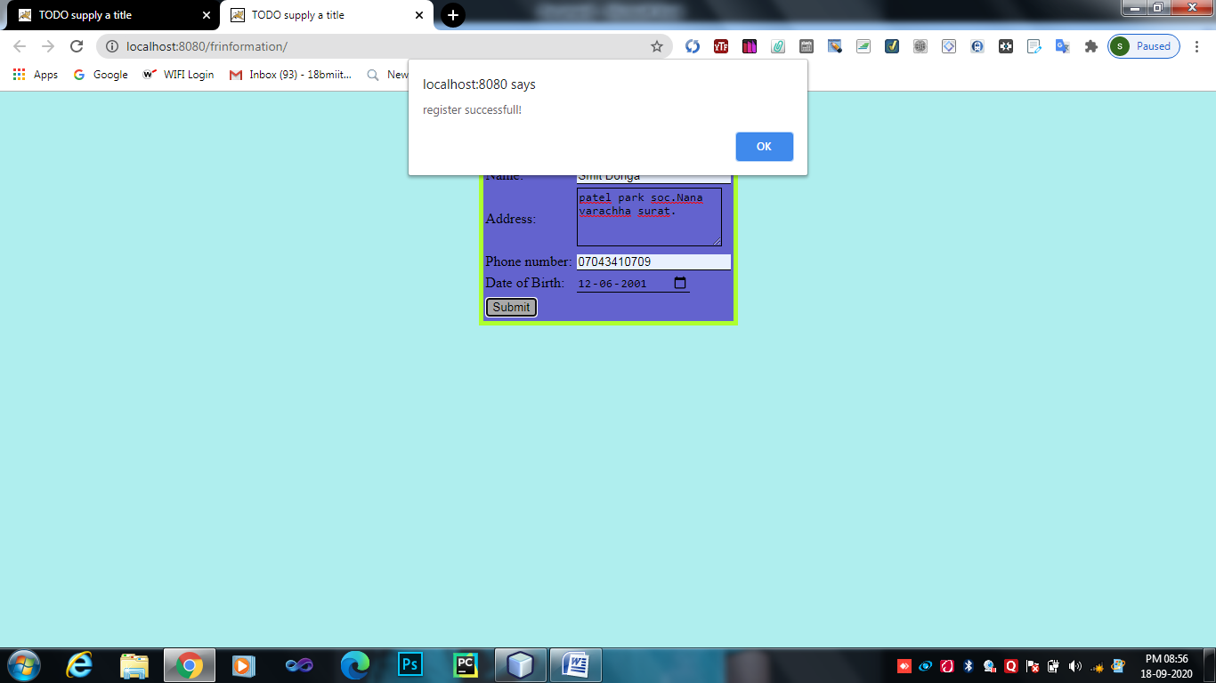

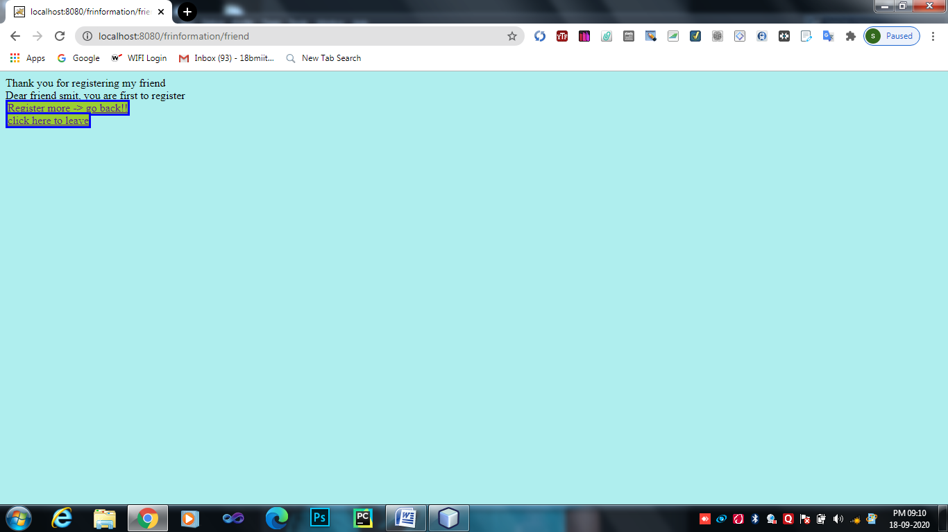

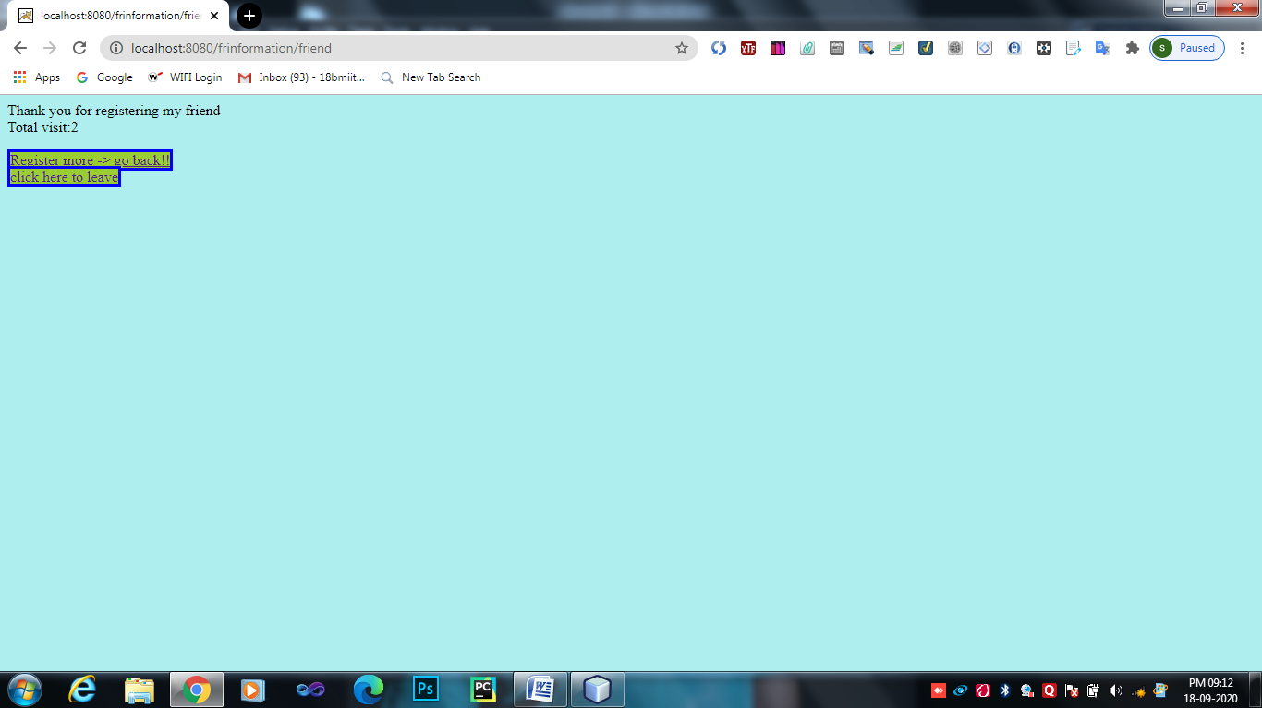

* **remove.java**

