**Practical-13**

->index.html

Output:->

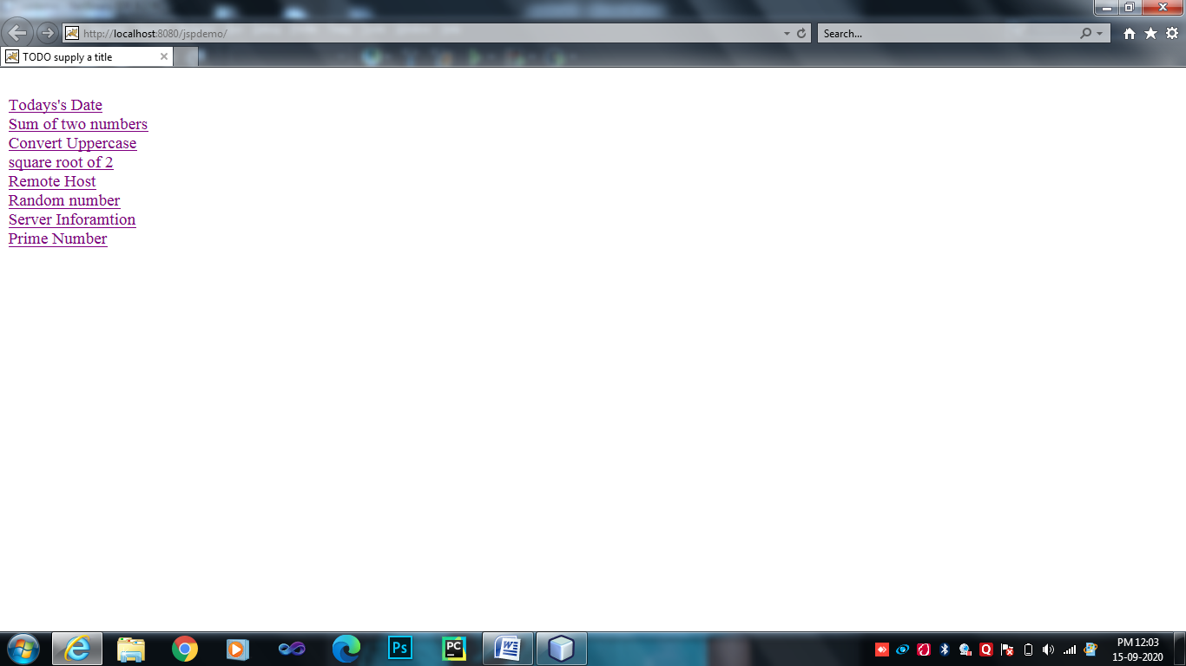

1. Displays the Current date on your Web page.

<%--

Document : CurrentDate

Created on : 15 Sep, 2020, 9:52:21 AM

Author : Hp

--%>

<%@page import="java.text.SimpleDateFormat"%>

<%@page import="java.util.Date"%>

<%@page contentType="text/html" pageEncoding="UTF-8"%>

<!DOCTYPE html>

<html>

<head>

<meta http-equiv="Content-Type" content="text/html; charset=UTF-8">

<title>Current Date</title>

</head>

<%

Date date=new Date();

SimpleDateFormat ft=new SimpleDateFormat("yyyy.MM.dd");

out.print("<h3>Today's Date is="+ft.format(date)+"</h3>");

%>

</html>

->Output:-

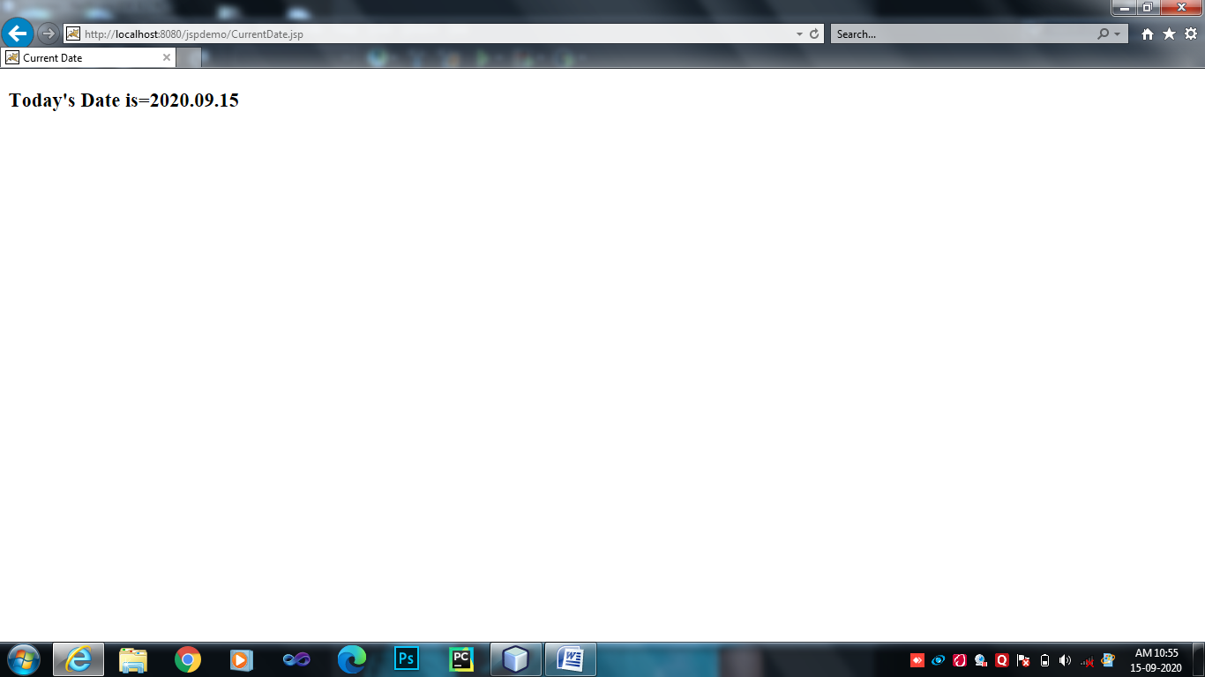

1. Takes input of two numbers and displays the sum of it.

<%--

Document : sum

Created on : 15 Sep, 2020, 9:58:51 AM

Author : Hp

--%>

<%@page contentType="text/html" pageEncoding="UTF-8"%>

<!DOCTYPE html>

<html>

<head>

<meta http-equiv="Content-Type" content="text/html; charset=UTF-8">

<title>JSP Page</title>

</head>

<%=

"<h3>the sum is:"+ (Integer.parseInt(request.getParameter("n1"))+Integer.parseInt(request.getParameter("n2")))

+"</h3>"

%>

</html>

-> sum.html Output:

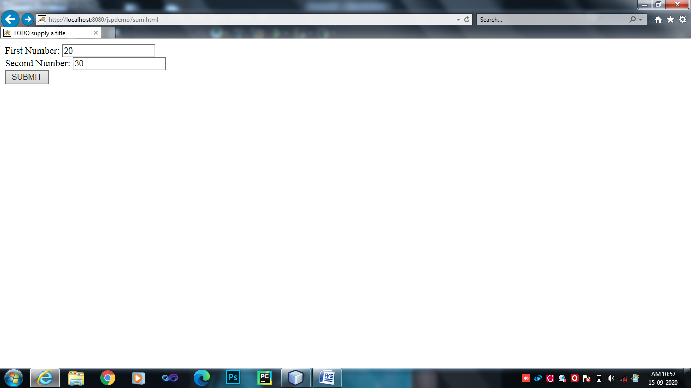

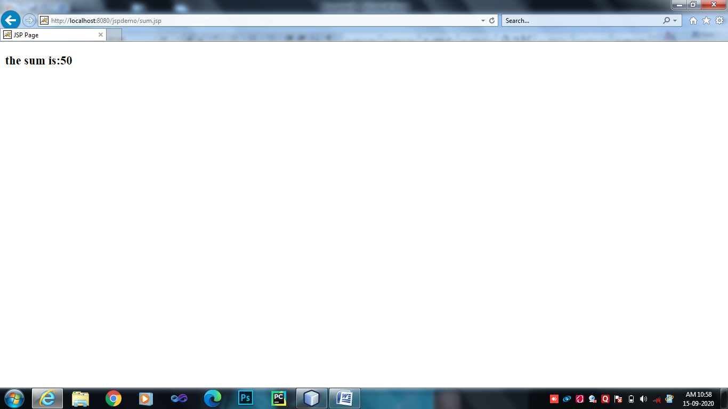

1. Create a user define a function that takes your name as an input and convert it into upper case.

<%--

Document : Userdefined

Created on : 15 Sep, 2020, 10:04:23 AM

Author : Hp

--%>

<%@page contentType="text/html" pageEncoding="UTF-8"%>

<!DOCTYPE html>

<html>

<head>

<meta http-equiv="Content-Type" content="text/html; charset=UTF-8">

<title>Uppercase</title>

</head>

<%!

String name="smit Donga";

String upper=name.toUpperCase();

public String myname()

{

StringBuffer sf = new StringBuffer(upper);

return ("uppercase string :"+sf.toString());

}

%>

<%=

myname()

%>

</html>

->Output:-

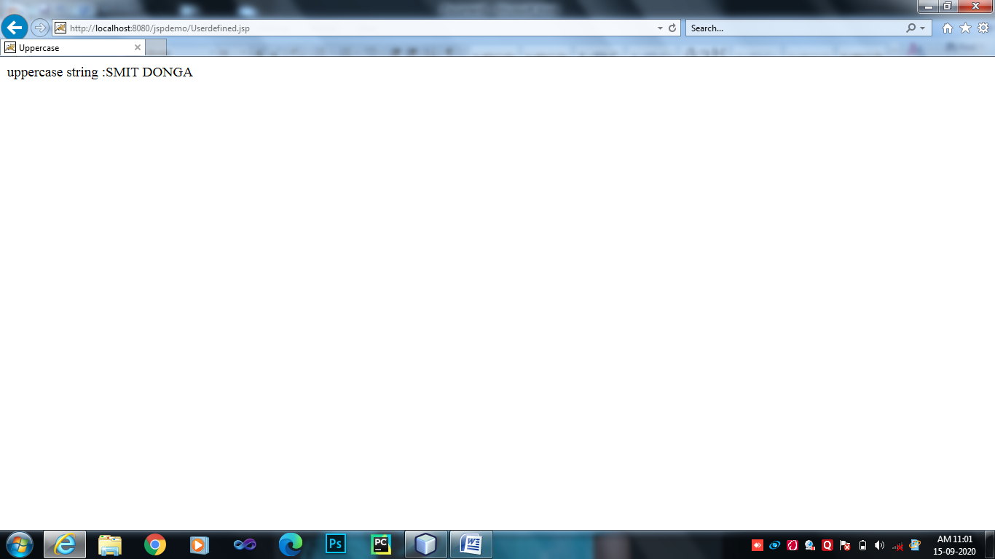

1. Display square root of 2

<%--

Document : squareroot

Created on : 15 Sep, 2020, 10:06:55 AM

Author : Hp

--%>

<%@page contentType="text/html" pageEncoding="UTF-8"%>

<!DOCTYPE html>

<html>

<head>

<meta http-equiv="Content-Type" content="text/html; charset=UTF-8">

<title>Square root</title>

</head>

<%!

int a=2,b=a*2;

%>

<%

out.print("square root is:"+b);

%>

</html>

->Output:-

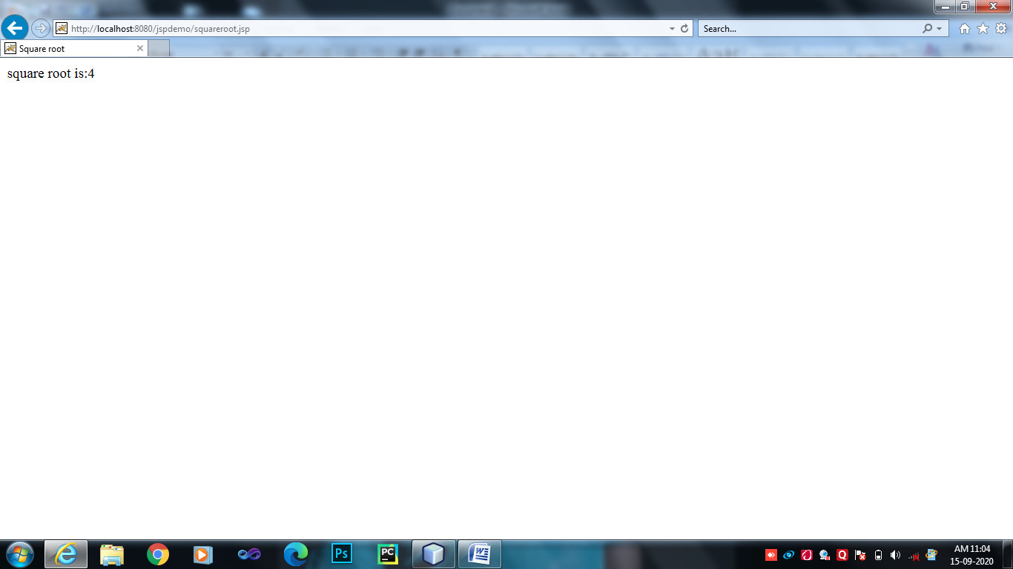

1. Display remote host on your Webpage.

<%--

Document : remotehost

Created on : 15 Sep, 2020, 10:09:16 AM

Author : Hp

--%>

<%@page contentType="text/html" pageEncoding="UTF-8"%>

<!DOCTYPE html>

<html>

<head>

<meta http-equiv="Content-Type" content="text/html; charset=UTF-8">

<title>Remote Host</title>

</head>

<%

/*Locale locale=request.getLocale();

out.println(locale);*/

String remote=request.getRemoteHost();

int portno=request.getServerPort();

out.print("<br>");

out.print("Remote host:"+remote);

out.print("<br>");

out.print("portnumber="+portno);

out.print("<br>");

%>

</html>

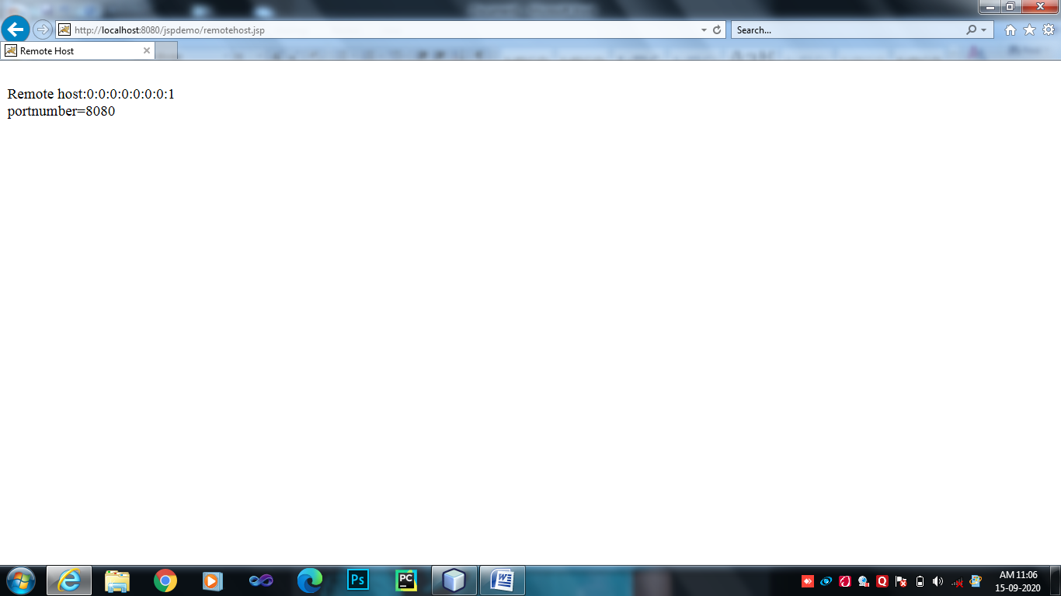

1. Display any five random numbers on the web page.

<%--

Document : random number

Created on : 15 Sep, 2020, 10:12:15 AM

Author : Hp

--%>

<%@page import="java.util.Random"%>

<%@page contentType="text/html" pageEncoding="UTF-8"%>

<!DOCTYPE html>

<html>

<head>

<meta http-equiv="Content-Type" content="text/html; charset=UTF-8">

<title>Random Number</title>

</head>

<%! Random rn=new Random();

%>

<%

for(int count=0;count<5;count++)

{

out.print("random number is:"+count+rn.nextInt(50)+"<br>");

}

%>

</html>

->Output:-

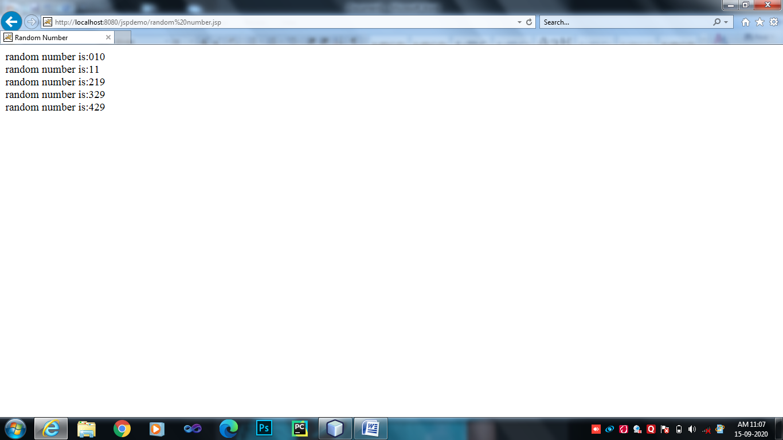

1. Display the server Information on the web page.

<%--

Document : serverinfo

Created on : 15 Sep, 2020, 10:17:25 AM

Author : Hp

--%>

<%@page import="java.util.Enumeration"%>

<%@page contentType="text/html" pageEncoding="UTF-8"%>

<!DOCTYPE html>

<html>

<head>

<meta http-equiv="Content-Type" content="text/html; charset=UTF-8">

<title>Server Information</title>

</head>

<%

Enumeration hn=request.getHeaderNames();

String servername=request.getServerName();

int serverport=request.getServerPort();

out.println("servername is:"+servername+"<br>"+"server port is:"+serverport);

while(hn.hasMoreElements())

{

String paramname=(String)hn.nextElement();

out.println("HaderName:"+paramname+"<br><br>");

String paramvalue=request.getHeader(paramname);

out.println("Hadervalue="+paramvalue+"<br><br>");

}

out.println("servername is:"+servername+"<br>"+"server port is:"+serverport);

%>

</html>

->Output:

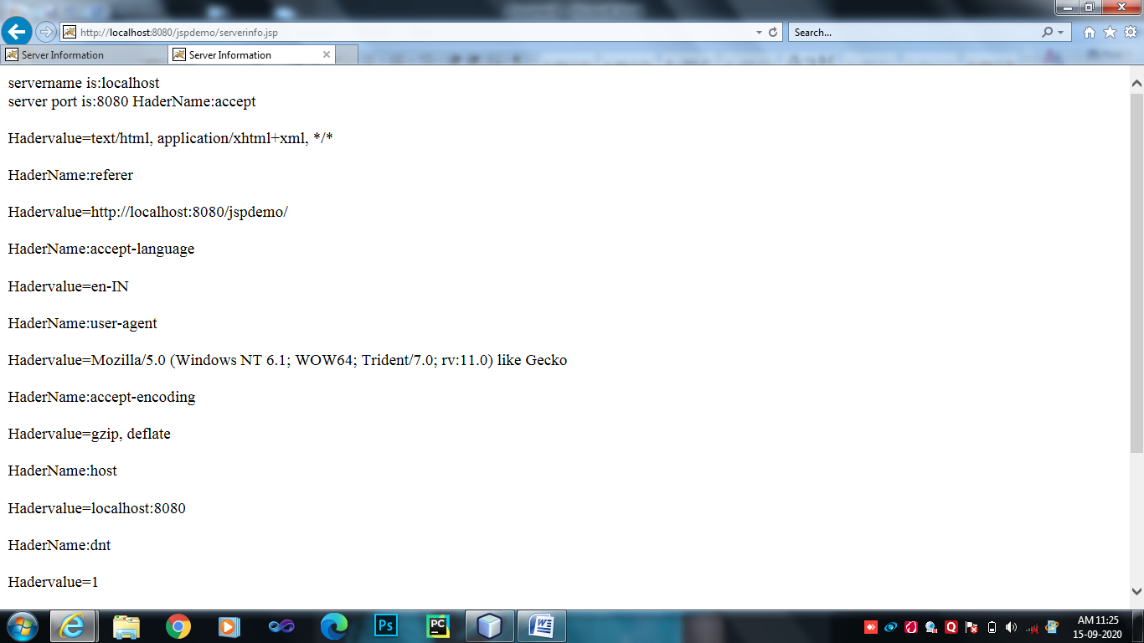

1. Display prime number series from 0-30.

<%--

Document : primenumber

Created on : 15 Sep, 2020, 10:24:32 AM

Author : Hp

--%>

<%@page contentType="text/html" pageEncoding="UTF-8"%>

<!DOCTYPE html>

<html>

<head>

<meta http-equiv="Content-Type" content="text/html; charset=UTF-8">

<title>Prime Number</title>

</head>

<%

int n=0;

int i=0;

String prime="";

out.println("<h4>Prime Number<h4>");

for(i=1;i<=30;i++)

{

int count=0;

for(n=i;n>=1;n--)

{

if((i%n)==0)

{

count=count+1;

}

}

if(count==2)

{

prime=prime+i+",";

}

}

out.print(prime);

%>

</html>

->Output:-

