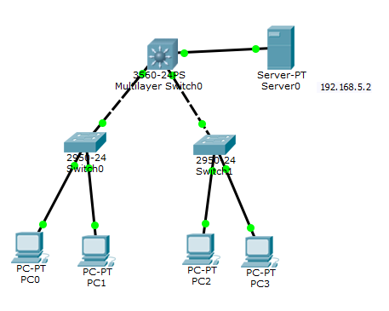

1. 二层上创建以及配置vlan

Switch(config)#int f0/1

Switch(config-if)#switchport access vlan 2

% Access VLAN does not exist. Creating vlan 2

1. 三层上创建以及配置vlan

Switch(config)#vlan 2

Switch(config-vlan)#name VLAN2

Switch(config-vlan)#vlan 3

Switch(config-vlan)#name VLAN3

Switch(config-vlan)#vlan 4

Switch(config-vlan)#name VLAN4

Switch(config-vlan)#vlan 5

Switch(config-vlan)#name VLAN5

Switch(config-vlan)#exit

Switch(config)#int vlan 2

Switch(config-if)#

%LINK-5-CHANGED: Interface Vlan2, changed state to up

%LINEPROTO-5-UPDOWN: Line protocol on Interface Vlan2, changed state to up

Switch(config-if)#ip address 192.168.1.1 255.255.255.0

Switch(config-if)#exit

Switch(config)#int vlan 3

Switch(config-if)#

%LINK-5-CHANGED: Interface Vlan3, changed state to up

%LINEPROTO-5-UPDOWN: Line protocol on Interface Vlan3, changed state to up

Switch(config-if)#ip address 192.168.2.1 255.255.255.0

Switch(config-if)#exit

Switch(config)#int vlan 4

Switch(config-if)#

%LINK-5-CHANGED: Interface Vlan4, changed state to up

%LINEPROTO-5-UPDOWN: Line protocol on Interface Vlan4, changed state to up

Switch(config-if)#ip address 192.168.3.1 255.255.255.0

Switch(config-if)#exit

Switch(config)#int vlan 5

Switch(config-if)#

%LINK-5-CHANGED: Interface Vlan5, changed state to up

%LINEPROTO-5-UPDOWN: Line protocol on Interface Vlan5, changed state to up

Switch(config-if)#ip address 192.168.4.1 255.255.255.0

1. 三层上配置trunk

Switch(config)#int f0/1

Switch(config-if)#switchport trunk encapsulation dot1q

Switch(config-if)#switchport mode trunk

4．二层上配置trunk

Switch(config)#int f0/3

Switch(config-if)#switchport mode trunk

5．三层上设定其它不能访问PC0，PC0可以访问其它（总经理访问其他部门，其他部门不能访问总经理）

Switch(config)#ip access-list extended VLAN2

Switch(config-ext-nacl)#deny icmp 192.168.1.0 0.0.0.255 any echo-reply

Switch(config-ext-nacl)#permit icmp 192.168.1.0 0.0.0.255 any echo

Switch(config-ext-nacl)#exit

Switch(config)#int vlan 2

Switch(config-if)#ip access-group VLAN2 in

Switch(config-if)#exit

6．三层上设定PC1不被其它访问，但可被PC0访问（财务部不被其他访问，只被总经理访问）

Switch(config)#ip access-list extended VLAN3

Switch(config-ext-nacl)#deny icmp 192.168.2.0 0.0.0.255 192.168.3.0 0.0.0.255

Switch(config-ext-nacl)#deny icmp 192.168.2.0 0.0.0.255 192.168.4.0 0.0.0.255

Switch(config-ext-nacl)#permit ip any any

Switch(config-ext-nacl)#exit

Switch(config)#int vlan 3

Switch(config-if)#ip access-group VLAN3 in

Switch(config-if)#exit