5.1节练习
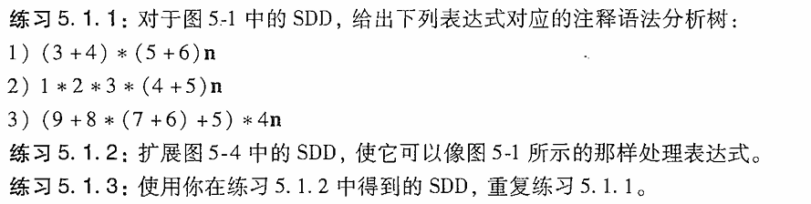

练习5.1.1
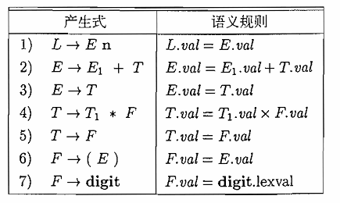

（1）(3 + 4) * (5 + 6) n
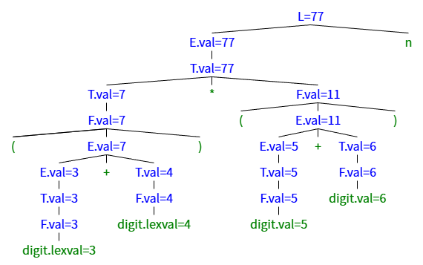

(2)1 * 2 * 3 * (4 + 5) n
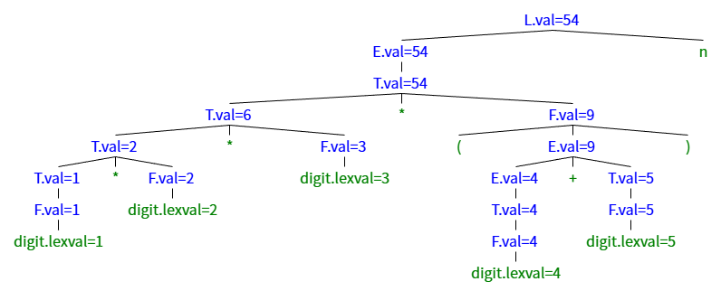

(3)(9+8*(7+6)+5)*4n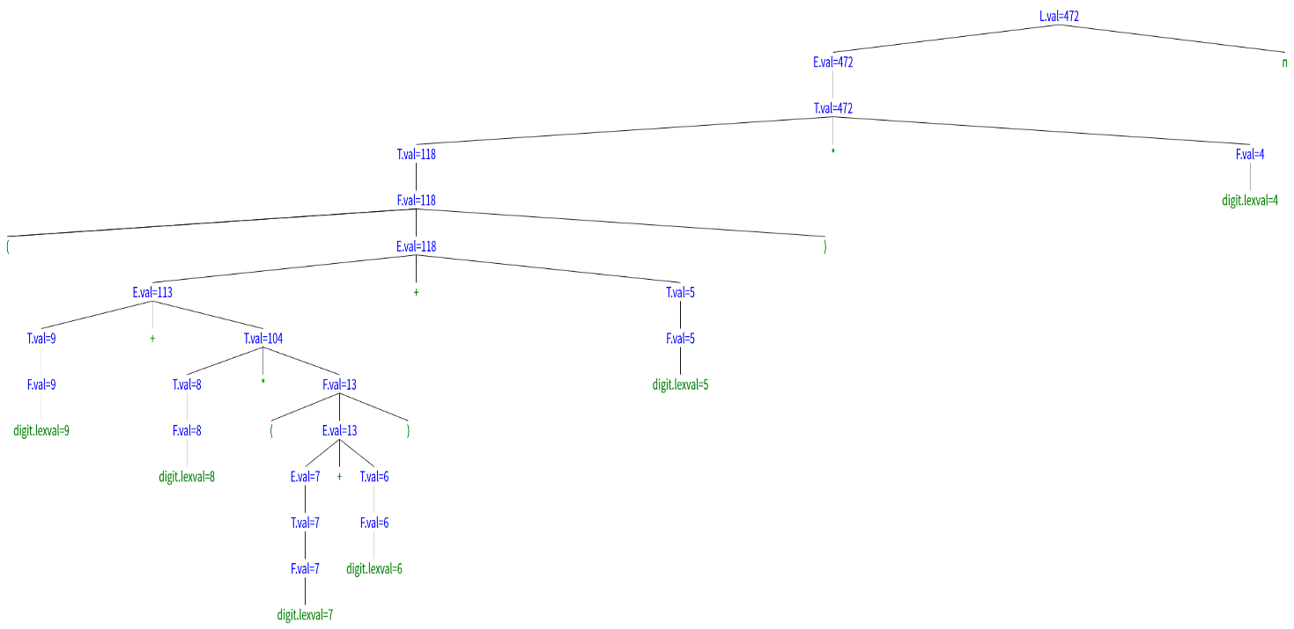

练习5.1.2扩展图中的SDD，使它可以像上一题那样处理表达式。

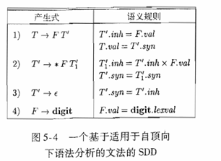
产生式 | 语义规则
0)L->En | L.val = E.val
1)E->TE’ | E.val = E’.syn  E’.inh = T.val
2)E’->+TE₁’ | E₁’.inh = E’.inh + T.val  E’.syn = E₁’.syn
3)E’->ε | E’.syn = E’.inh
4)T->FT’ | T.val = T’.syn  T’.inh = F.val
5)T’->*FT₁’ | T₁’.inh = T’.inh * F.val  T’.syn = T₁’.syn
6)T’->ε | T’.syn = T’.inh
7)F->(E) | F.val = E.val
8)F->digit | F.val = digit.lexval

解答这种构造一个适用于自顶向下分析的SDD的一般套路：

步骤
0.消除左递归
1.Head(E->TE’):
E’.inh = T.val
E.val = E’.syn
2.Body(E’->op TE₁’)
E’.syn = E₁’.syn
E1’.inh = E’.inh op T.val
3.Tail(E’->ε)
E’.syn = E’.inh

属性流动方向：
T.val -> E’.inh ->
E₁’.inh -> E₁’.syn ->E’.syn -> E.val
T.val ->

练习5.1.3使用你在练习5.1.2中得到的SDD，重复练习5.1.1

（1）（3 + 4）*（5+6）n
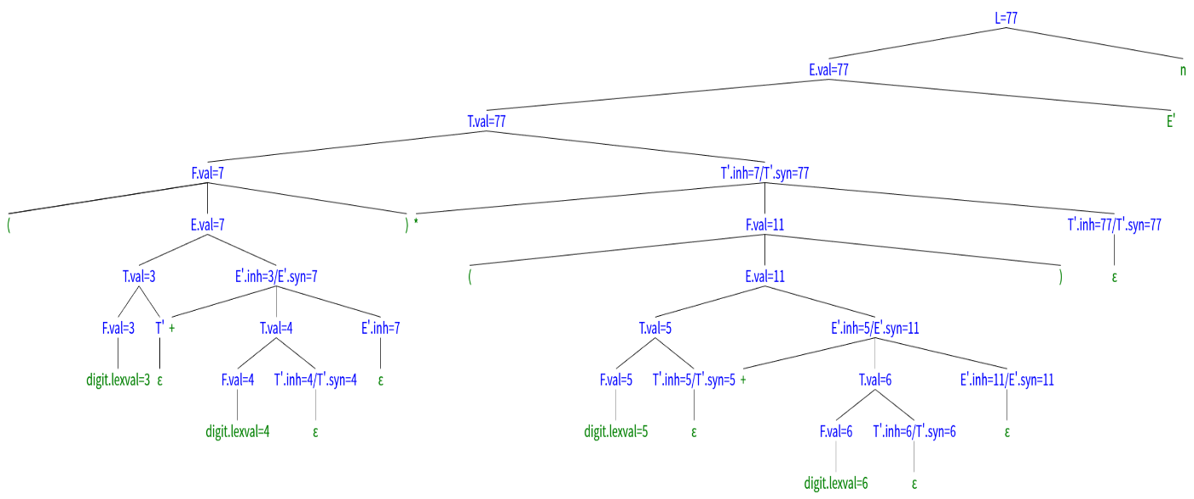

（2）1 * 2 * 3 *（4+5）n
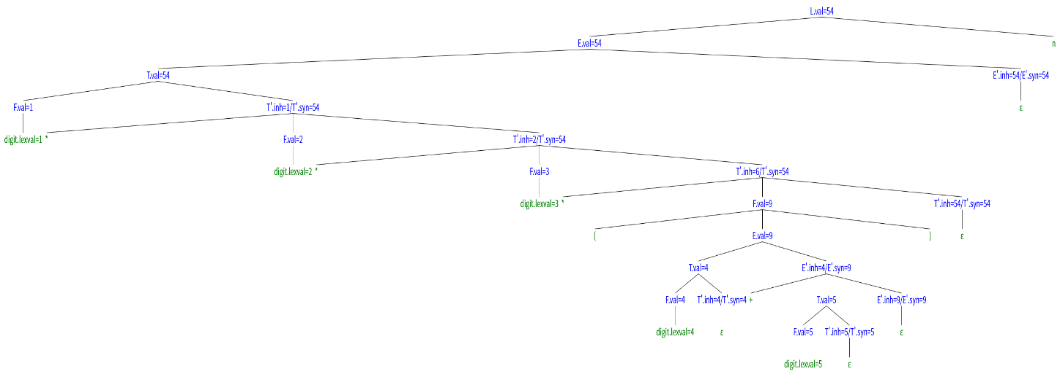
图片网址：
https://mshang.ca/syntree/?i=%5BL.val%3D54%5BE.val%3D54%5BT.val%3D54%5BF.val%3D1%5Bdigit.lexval%3D1%5D%5D%5BT'.inh%3D1%2FT'.syn%3D54%5B*%5D%5BF.val%3D2%5Bdigit.lexval%3D2%5D%5D%5BT'.inh%3D2%2FT'.syn%3D54%5B*%5D%5BF.val%3D3%5Bdigit.lexval%3D3%5D%5D%5BT'.inh%3D6%2FT'.syn%3D54%5B*%5D%5BF.val%3D9%5B(%5D%5BE.val%3D9%5BT.val%3D4%5BF.val%3D4%5Bdigit.lexval%3D4%5D%5D%5BT'.inh%3D4%2FT'.syn%3D4%5B%CE%B5%5D%5D%5D%5BE'.inh%3D4%2FE'.syn%3D9%5B%2B%5D%5BT.val%3D5%5BF.val%3D5%5Bdigit.lexval%3D5%5D%5D%5BT'.inh%3D5%2FT'.syn%3D5%5B%CE%B5%5D%5D%5D%5BE'.inh%3D9%2FE'.syn%3D9%5B%CE%B5%5D%5D%5D%5D%5B)%5D%5D%5BT'.inh%3D54%2FT'.syn%3D54%5B%CE%B5%5D%5D%5D%5D%5D%5D%5BE'.inh%3D54%2FE'.syn%3D54%5B%CE%B5%5D%5D%5D%5Bn%5D%5D

（3）(9+8*(7+6)+5)*4n

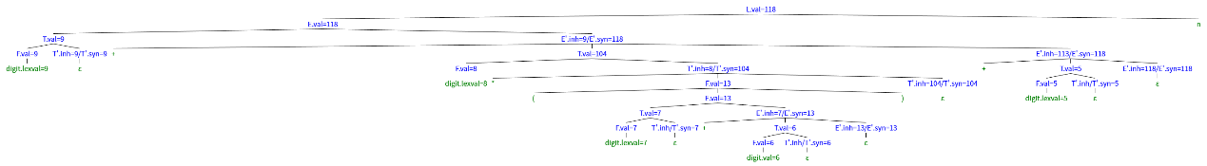
https://mshang.ca/syntree/?i=%5BL.val%3D118%5BE.val%3D118%5BT.val%3D9%5BF.val%3D9%5Bdigit.lexval%3D9%5D%5D%5BT'.inh%3D9%2FT'.syn%3D9%5B%CE%B5%5D%5D%5D%5BE'.inh%3D9%2FE'.syn%3D118%5B%2B%5D%5BT.val%3D104%5BF.val%3D8%5Bdigit.lexval%3D8%5D%5D%5BT'.inh%3D8%2FT'.syn%3D104%5B*%5D%5BF.val%3D13%5B(%5D%5BE.val%3D13%5BT.val%3D7%5BF.val%3D7%5Bdigit.lexval%3D7%5D%5D%5BT'.inh%2FT'.syn%3D7%5B%CE%B5%5D%5D%5D%5BE'.inh%3D7%2FE'.syn%3D13%5B%2B%5D%5BT.val%3D6%5BF.val%3D6%5Bdigit.val%3D6%5D%5D%5BT'.inh%2FT'.syn%3D6%5B%CE%B5%5D%5D%5D%5BE'.inh%3D13%2FE'.syn%3D13%5B%CE%B5%5D%5D%5D%5D%5B)%5D%5D%5BT'.inh%3D104%2FT'.syn%3D104%5B%CE%B5%5D%5D%5D%5D%5BE'.inh%3D113%2FE'.syn%3D118%5B%2B%5D%5BT.val%3D5%5BF.val%3D5%5Bdigit.lexval%3D5%5D%5D%5BT'.inh%2FT'.syn%3D5%5B%CE%B5%5D%5D%5D%5BE'.inh%3D118%2FE'.syn%3D118%5B%CE%B5%5D%5D%5D%5D%5D%5Bn%5D%5D

