LAB Logbook
Name: Yalamati Mahima Mani
SID:2530200
Lab1
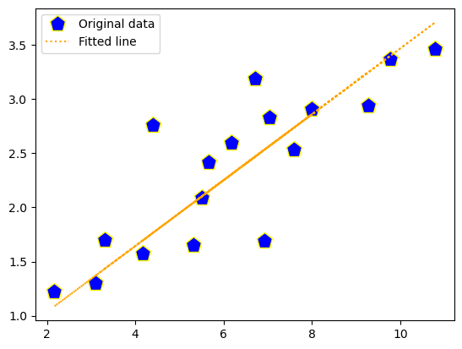
Lab2
1.The accuracy of the model is 0.918
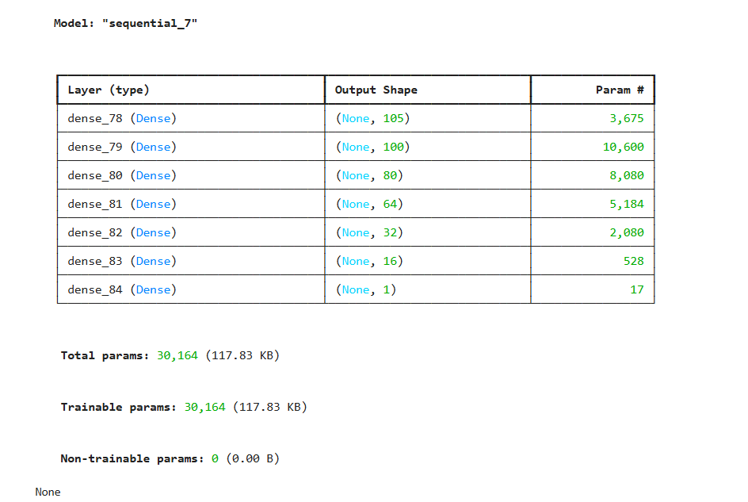

3.
O1=0.8287
O2=0.8287

Lab3
The accuracy of model is 0.89010

