# 创建maven项目

webapp不要选错。。。

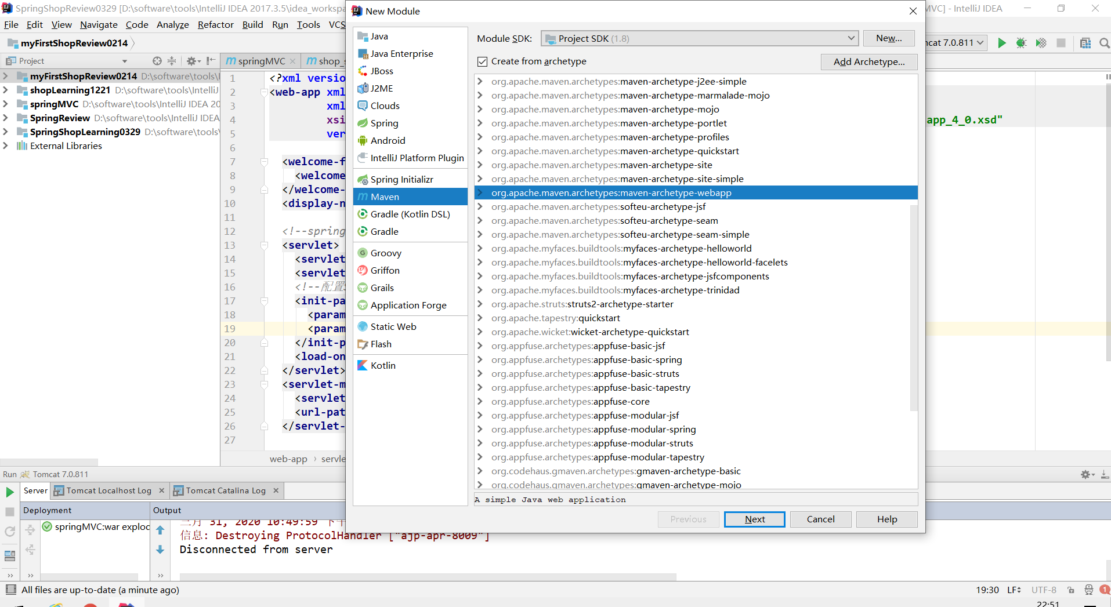

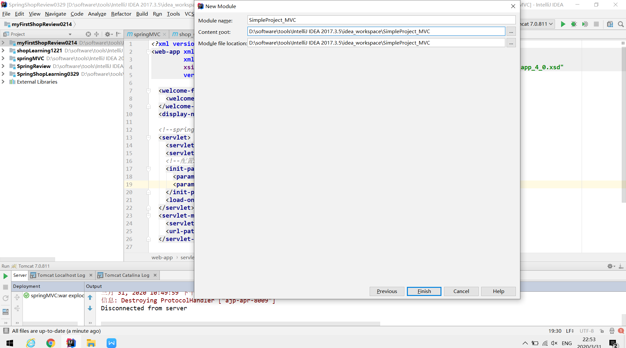

引入相关依赖以及配置

1、依赖的版本要一致。。。

2、*加载对应位置的配置文件一般要写上，不然有时候编译无法加载部分文件*

|  |
| --- |
| *<?***xml version="1.0" encoding="UTF-8"***?>* <**project xmlns="http://maven.apache.org/POM/4.0.0" xmlns:xsi="http://www.w3.org/2001/XMLSchema-instance"  xsi:schemaLocation="http://maven.apache.org/POM/4.0.0 http://maven.apache.org/xsd/maven-4.0.0.xsd"**>  <**modelVersion**>4.0.0</**modelVersion**>   <**groupId**>com.igeek</**groupId**>  <**artifactId**>SimpleProject_MVC</**artifactId**>  <**version**>1.0-SNAPSHOT</**version**>  <**packaging**>war</**packaging**>   <**name**>SimpleProject_MVC Maven Webapp</**name**>  *<!--* ***FIXME change it to the project's website*** *-->* <**url**>http://www.example.com</**url**>   <**properties**>  <**project.build.sourceEncoding**>UTF-8</**project.build.sourceEncoding**>  <**maven.compiler.source**>1.7</**maven.compiler.source**>  <**maven.compiler.target**>1.7</**maven.compiler.target**>  </**properties**>   <**dependencies**>   *<!-- https://mvnrepository.com/artifact/org.codehaus.jackson/jackson-core-asl -->* <**dependency**>  <**groupId**>com.fasterxml.jackson.core</**groupId**>  <**artifactId**>jackson-databind</**artifactId**>  <**version**>2.5.0</**version**>  </**dependency**>   <**dependency**>  <**groupId**>com.fasterxml.jackson.core</**groupId**>  <**artifactId**>jackson-core</**artifactId**>  <**version**>2.5.0</**version**>  </**dependency**>   <**dependency**>  <**groupId**>com.fasterxml.jackson.core</**groupId**>  <**artifactId**>jackson-annotations</**artifactId**>  <**version**>2.5.0</**version**>  </**dependency**>    *<!-- https://mvnrepository.com/artifact/commons-logging/commons-logging -->* <**dependency**>  <**groupId**>commons-logging</**groupId**>  <**artifactId**>commons-logging</**artifactId**>  <**version**>1.2</**version**>  </**dependency**>   *<!-- https://mvnrepository.com/artifact/org.springframework/spring-webmvc -->* <**dependency**>  <**groupId**>org.springframework</**groupId**>  <**artifactId**>spring-webmvc</**artifactId**>  <**version**>4.3.19.RELEASE</**version**>  </**dependency**>    *<!-- https://mvnrepository.com/artifact/org.mybatis/mybatis-spring -->* <**dependency**>  <**groupId**>org.mybatis</**groupId**>  <**artifactId**>mybatis-spring</**artifactId**>  <**version**>1.3.2</**version**>  </**dependency**>    *<!-- https://mvnrepository.com/artifact/org.mybatis/mybatis -->* <**dependency**>  <**groupId**>org.mybatis</**groupId**>  <**artifactId**>mybatis</**artifactId**>  <**version**>3.4.6</**version**>  </**dependency**>    *<!-- https://mvnrepository.com/artifact/aopalliance/aopalliance -->* <**dependency**>  <**groupId**>aopalliance</**groupId**>  <**artifactId**>aopalliance</**artifactId**>  <**version**>1.0</**version**>  </**dependency**>   *<!-- https://mvnrepository.com/artifact/org.aspectj/aspectjweaver -->* <**dependency**>  <**groupId**>org.aspectj</**groupId**>  <**artifactId**>aspectjweaver</**artifactId**>  <**version**>1.9.2</**version**>  </**dependency**>   <**dependency**>  <**groupId**>org.springframework</**groupId**>  <**artifactId**>spring-aspects</**artifactId**>  <**version**>4.3.19.RELEASE</**version**>  </**dependency**>  *<!-- https://mvnrepository.com/artifact/commons-dbcp/commons-dbcp -->* <**dependency**>  <**groupId**>commons-dbcp</**groupId**>  <**artifactId**>commons-dbcp</**artifactId**>  <**version**>1.4</**version**>  </**dependency**>    *<!-- https://mvnrepository.com/artifact/org.springframework/spring-web -->* <**dependency**>  <**groupId**>org.springframework</**groupId**>  <**artifactId**>spring-jdbc</**artifactId**>  <**version**>4.3.19.RELEASE</**version**>  </**dependency**>  *<!-- https://mvnrepository.com/artifact/org.springframework/spring-web -->* <**dependency**>  <**groupId**>org.springframework</**groupId**>  <**artifactId**>spring-tx</**artifactId**>  <**version**>4.3.19.RELEASE</**version**>  </**dependency**>  *<!-- https://mvnrepository.com/artifact/org.springframework/spring-web -->* <**dependency**>  <**groupId**>org.springframework</**groupId**>  <**artifactId**>spring-aspects</**artifactId**>  <**version**>4.3.19.RELEASE</**version**>  </**dependency**>   *<!-- https://mvnrepository.com/artifact/org.springframework/spring-web -->* <**dependency**>  <**groupId**>org.springframework</**groupId**>  <**artifactId**>spring-aop</**artifactId**>  <**version**>4.3.19.RELEASE</**version**>  </**dependency**>   *<!-- https://mvnrepository.com/artifact/org.springframework/spring-web -->* <**dependency**>  <**groupId**>org.springframework</**groupId**>  <**artifactId**>spring-test</**artifactId**>  <**version**>4.3.19.RELEASE</**version**>  </**dependency**>   *<!-- https://mvnrepository.com/artifact/org.springframework/spring-web -->* <**dependency**>  <**groupId**>org.springframework</**groupId**>  <**artifactId**>spring-web</**artifactId**>  <**version**>4.3.19.RELEASE</**version**>  </**dependency**>     *<!-- https://mvnrepository.com/artifact/org.springframework/spring-context -->* <**dependency**>  <**groupId**>org.springframework</**groupId**>  <**artifactId**>spring-context</**artifactId**>  <**version**>4.3.19.RELEASE</**version**>  </**dependency**>    *<!-- https://mvnrepository.com/artifact/org.springframework/spring-beans -->* <**dependency**>  <**groupId**>org.springframework</**groupId**>  <**artifactId**>spring-beans</**artifactId**>  <**version**>4.3.19.RELEASE</**version**>  </**dependency**>   *<!-- https://mvnrepository.com/artifact/org.springframework/spring-core -->* <**dependency**>  <**groupId**>org.springframework</**groupId**>  <**artifactId**>spring-core</**artifactId**>  <**version**>4.3.19.RELEASE</**version**>  </**dependency**>    *<!-- https://mvnrepository.com/artifact/javax.servlet/jstl -->* <**dependency**>  <**groupId**>javax.servlet</**groupId**>  <**artifactId**>jstl</**artifactId**>  <**version**>1.2</**version**>  </**dependency**>   <**dependency**>  <**groupId**>junit</**groupId**>  <**artifactId**>junit</**artifactId**>  <**version**>4.12</**version**>  <**scope**>test</**scope**>  </**dependency**>   *<!-- https://mvnrepository.com/artifact/commons-dbutils/commons-dbutils -->* <**dependency**>  <**groupId**>commons-dbutils</**groupId**>  <**artifactId**>commons-dbutils</**artifactId**>  <**version**>1.6</**version**>  </**dependency**>  *<!-- https://mvnrepository.com/artifact/javax.servlet/javax.servlet-api -->* <**dependency**>  <**groupId**>javax.servlet</**groupId**>  <**artifactId**>javax.servlet-api</**artifactId**>  <**version**>4.0.1</**version**>  <**scope**>provided</**scope**>  </**dependency**>  *<!-- https://mvnrepository.com/artifact/commons-beanutils/commons-beanutils -->* <**dependency**>  <**groupId**>commons-beanutils</**groupId**>  <**artifactId**>commons-beanutils</**artifactId**>  <**version**>1.8.3</**version**>  </**dependency**>   *<!-- https://mvnrepository.com/artifact/com.alibaba/fastjson -->* <**dependency**>  <**groupId**>com.alibaba</**groupId**>  <**artifactId**>fastjson</**artifactId**>  <**version**>1.2.58</**version**>  </**dependency**>   *<!-- https://mvnrepository.com/artifact/mysql/mysql-connector-java -->* <**dependency**>  <**groupId**>mysql</**groupId**>  <**artifactId**>mysql-connector-java</**artifactId**>  <**version**>5.1.18</**version**>  </**dependency**>    *<!-- https://mvnrepository.com/artifact/com.mchange/c3p0 -->* <**dependency**>  <**groupId**>com.mchange</**groupId**>  <**artifactId**>c3p0</**artifactId**>  <**version**>0.9.5.2</**version**>  </**dependency**>  *<!-- https://mvnrepository.com/artifact/redis.clients/jedis -->* <**dependency**>  <**groupId**>redis.clients</**groupId**>  <**artifactId**>jedis</**artifactId**>  <**version**>3.0.1</**version**>  </**dependency**>  <**dependency**>  <**groupId**>javax.mail</**groupId**>  <**artifactId**>mail</**artifactId**>  <**version**>1.4.7</**version**>  </**dependency**>  *<!-- https://mvnrepository.com/artifact/junit/junit -->* <**dependency**>  <**groupId**>junit</**groupId**>  <**artifactId**>junit</**artifactId**>  <**version**>4.12</**version**>  <**scope**>test</**scope**>  </**dependency**>  <**dependency**>  <**groupId**>org.junit.jupiter</**groupId**>  <**artifactId**>junit-jupiter-api</**artifactId**>  <**version**>RELEASE</**version**>  </**dependency**>  *<!-- log4j -->  <!-- https://mvnrepository.com/artifact/log4j/log4j -->* <**dependency**>  <**groupId**>log4j</**groupId**>  <**artifactId**>log4j</**artifactId**>  <**version**>1.2.17</**version**>  </**dependency**>   </**dependencies**>   <**build**>  <**finalName**>SimpleProject_MVC</**finalName**>   *<!-- 加载对应位置的配置文件,因为默认情况下，maven项目只会加载resources目录下的资源 -->* <**resources**>  <**resource**>  <**directory**>src/main/java</**directory**>  <**includes**>  <**include**>**/*.xml</**include**>  <**include**>**/*.properties</**include**>  </**includes**>  </**resource**>  <**resource**>  <**directory**>src/main/resources</**directory**>  <**includes**>  <**include**>**/*.xml</**include**>  <**include**>**/*.properties</**include**>  <**include**>**/*.ini</**include**>  </**includes**>  </**resource**>  </**resources**>   <**pluginManagement**>*<!-- lock down plugins versions to avoid using Maven defaults (may be moved to parent pom) -->* <**plugins**>  <**plugin**>  <**artifactId**>maven-clean-plugin</**artifactId**>  <**version**>3.1.0</**version**>  </**plugin**>  *<!-- see http://maven.apache.org/ref/current/maven-core/default-bindings.html#Plugin_bindings_for_war_packaging -->* <**plugin**>  <**artifactId**>maven-resources-plugin</**artifactId**>  <**version**>3.0.2</**version**>  </**plugin**>  <**plugin**>  <**artifactId**>maven-compiler-plugin</**artifactId**>  <**version**>3.8.0</**version**>  </**plugin**>  <**plugin**>  <**artifactId**>maven-surefire-plugin</**artifactId**>  <**version**>2.22.1</**version**>  </**plugin**>  <**plugin**>  <**artifactId**>maven-war-plugin</**artifactId**>  <**version**>3.2.2</**version**>  </**plugin**>  <**plugin**>  <**artifactId**>maven-install-plugin</**artifactId**>  <**version**>2.5.2</**version**>  </**plugin**>  <**plugin**>  <**artifactId**>maven-deploy-plugin</**artifactId**>  <**version**>2.8.2</**version**>  </**plugin**>  </**plugins**>  </**pluginManagement**>  </**build**> </**project**> |

# 创建相关目录

a.主要是resources目录和java目录，并设置为对应的文件夹格式。

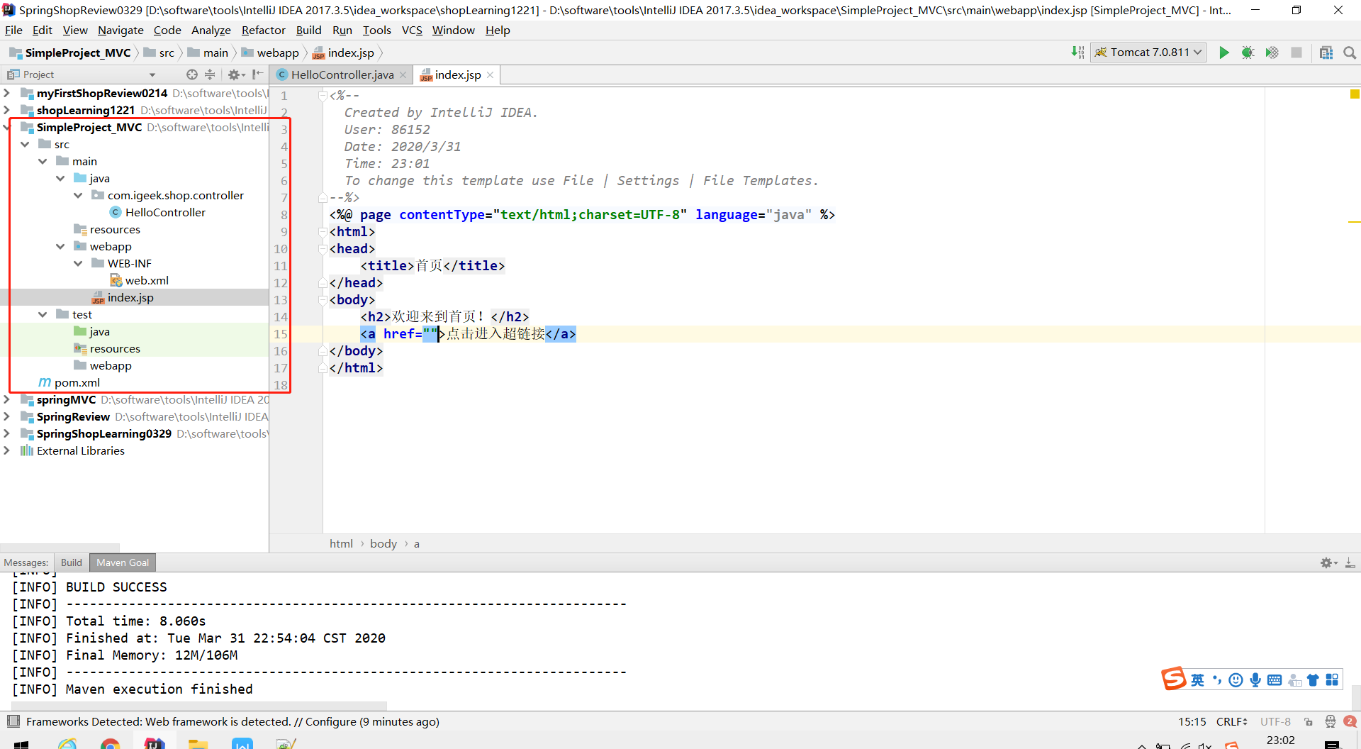

# 准备相关jsp以及简单的controller控制器

@RequestMapping(path = **"/sayHello"**)

@RequestMapping(value= **"/sayHello"**)

@RequestMapping(**"/sayHello"**) 单个属性

三种写法都可以。

|  |
| --- |
| 1、HelloController控制器 |
| **package** com.igeek.shop.controller;  **import** org.springframework.stereotype.Controller; **import** org.springframework.web.bind.annotation.RequestMapping;  @Controller @RequestMapping(path = **"/test"**) **public class** HelloController {   @RequestMapping(path = **"/sayHello"**)  **public** String doSayHello () {  System.***out***.println(**"*******************hello! good luck!"**);  **return "success"**;  } } |

|  |
| --- |
| 1. index.jsp 页面   当我们使用此种方式配置时，不要在访问 URL 前面加/，否则无法找到资源。  也可以：  <**a href="${**pageContext.request.contextPath**}/test/sayHello"**>点击进入超链接</**a**> |
| *<%--  Created by IntelliJ IDEA.  User: 86152  Date: 2020/3/31  Time: 23:01  To change this template use File | Settings | File Templates. --%>* <%@ **page contentType**="**text/html;charset=UTF-8**" **language**="**java**" %> <**html**> <**head**>  <**title**>首页</**title**> </**head**> <**body**>  <**h2**>欢迎来到首页！</**h2**>  <**a href="test/sayHello"**>点击进入超链接</**a**> </**body**> </**html**> |
| 3、成功跳转的页面 success.jsp |
| *<%--  Created by IntelliJ IDEA.  User: 86152  Date: 2020/3/31  Time: 23:08  To change this template use File | Settings | File Templates. --%>* <%@ **page contentType**="**text/html;charset=UTF-8**" **language**="**java**" %> <**html**> <**head**>  <**title**>成功页面</**title**> </**head**> <**body**>  <**h2**>恭喜你，跳转成功！</**h2**> </**body**> </**html**> |

# 配置web.xml以及mvcController.xml

|  |
| --- |
| 1、首先配置了springmvc-config.xml  **/WEB-INF/pages/ 前后都要有/** |
| *<?***xml version="1.0" encoding="UTF-8"***?>* <**beans xmlns="http://www.springframework.org/schema/beans"  xmlns:mvc="http://www.springframework.org/schema/mvc"  xmlns:context="http://www.springframework.org/schema/context"  xmlns:xsi="http://www.w3.org/2001/XMLSchema-instance"  xsi:schemaLocation=" http://www.springframework.org/schema/beans http://www.springframework.org/schema/beans/spring-beans.xsd http://www.springframework.org/schema/mvc http://www.springframework.org/schema/mvc/spring-mvc.xsd http://www.springframework.org/schema/context http://www.springframework.org/schema/context/spring-context.xsd"**>    *<!--1、首先是一个包扫描-->* <**context:component-scan base-package="com.igeek.shop"**/>    *<!--2、视图解析器：在controller返回String类型的值(即jsp页面名称)，自动拼接下列路径即可-->* <**bean id="internalResourceViewResolver" class="org.springframework.web.servlet.view.InternalResourceViewResolver"**>  <**property name="prefix" value="/WEB-INF/pages/"**/>  <**property name="suffix" value=".jsp"**/>  </**bean**>    *<!--3、加载驱动、各种适配器-->* <**mvc:annotation-driven**/>   </**beans**> |
| 2、然后配置了web.xml |
| *<?***xml version="1.0" encoding="UTF-8"***?>* <**web-app xmlns="http://xmlns.jcp.org/xml/ns/javaee"  xmlns:xsi="http://www.w3.org/2001/XMLSchema-instance"  xsi:schemaLocation="http://xmlns.jcp.org/xml/ns/javaee http://xmlns.jcp.org/xml/ns/javaee/web-app_4_0.xsd"  version="4.0"**>   <**display-name**>Archetype Created Web Application</**display-name**>   *<!--1、配置默认加载的jsp-->* <**welcome-file-list**>  <**welcome-file**>index.jsp</**welcome-file**>  </**welcome-file-list**>   *<!--2、监听器-->* <**servlet**>  <**servlet-name**>dispatcherServlet</**servlet-name**>  <**servlet-class**>org.springframework.web.servlet.DispatcherServlet</**servlet-class**>   *<!--3、初始化加载的配置文件-->* <**init-param**>  <**param-name**>contextConfigLocation</**param-name**>  <**param-value**>classpath:springmvc-config.xml</**param-value**>  </**init-param**>  *<!--4、对象随着服务器开启创建-->* <**load-on-startup**>1</**load-on-startup**>   </**servlet**>  <**servlet-mapping**>  <**servlet-name**>dispatcherServlet</**servlet-name**>  <**url-pattern**>/</**url-pattern**>  </**servlet-mapping**>  </**web-app**> |

# 5、加入tomcat，开启服务即可开启简单项目。