RequestParam
Required=true是默认的，也就是说username这个属性必传，否则会进行报错！
@RequestMapping(value = "/testRequestMappingLearning")
public String testRequestMappingLearning(@RequestParam(name = "username") String name ){
System.out.println("前端传过来的值：============="+name);
return "success";
}

<a href="param/testRequestMappingLearning?username=哈哈">testRequestMappingLearning</a>

前端传过来的值：=============哈哈

RequestBody
获取请求体，只能获取post，因为get没有请求体

@RequestMapping(value = "/requestBodyTest")
public String requestBodyTest(@RequestBody String body ){
System.out.println("前端传过来的值：============="+body);
return "success";
}

<form action="param/requestBodyTest" method="post">
用户名：<input type="text" name="username" id="username" /> <br/>
密码：<input type="text" name="password" id="password" /> <br/>
日期：<input type="text" name="birthday" id="birthday" /> <br/>
<input type="submit" value="确认">
</form>

前端传过来的值：=============username=%E5%B0%B9%E5%90%9B&password=123&birthday=2020-2-2

3、pathVariable学习。结合restful设计风格
@RequestMapping(value = "/pathVariableTest/{sid}")
public String pathVariableTest(@PathVariable(name = "sid") String id ){
System.out.println("前端传过来的id值：============="+id);
return "success";
}

<a href="param/pathVariableTest/10">pathVariableTest</a>

前端传过来的id值：=============10
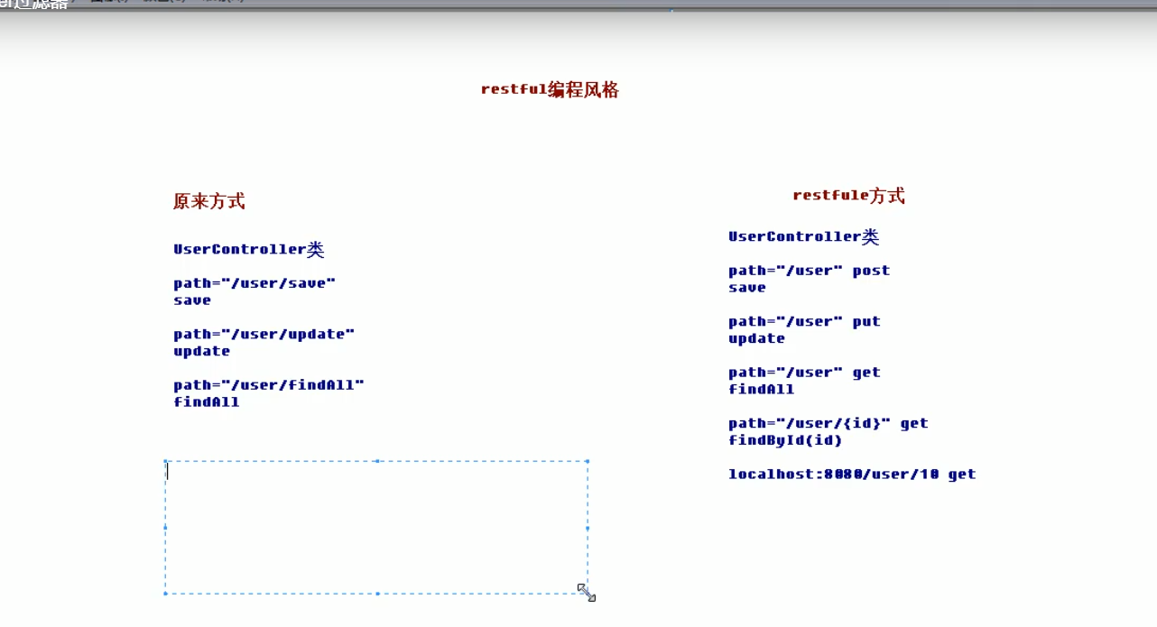

4、requestHeader(value=”Accept”)

5、cookieValue(value=”username”)

6、modelAttribute()加在方法之前可以先执行此方法，并把当前封装的值结合前端值传给真正的方法。

7、SessionAttributes 主要是加在类名上让请求对象自动放入session中

@Controller
@RequestMapping(path = "/param")
@SessionAttributes(value = {"name"})
public class AnnotationController {

