- 基本原理：在前端控制器上配置异常处理器组件，避免将错误直接抛给了用户浏览器。
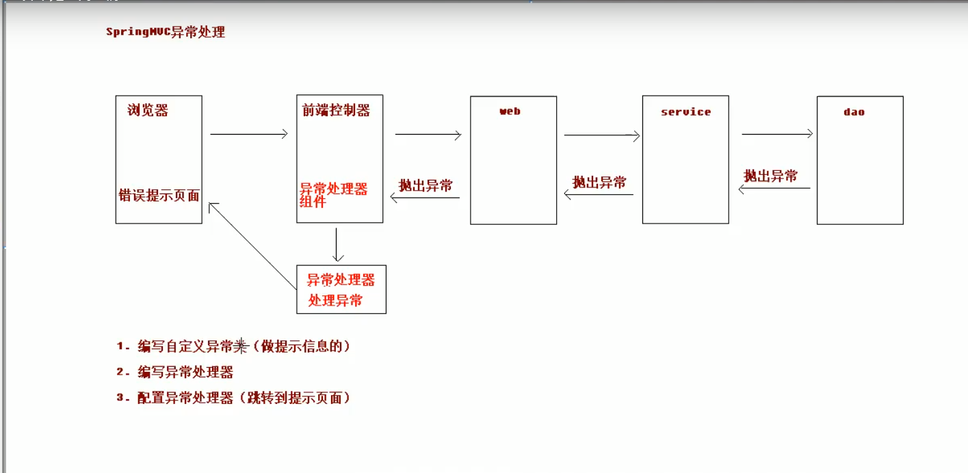
- 首先创建一个ExceptionSchema对象，用来存放抛来的异常信息message。
package com.igeek.shop.exception;
import java.io.Serializable;
public class ExceptionSchema extends Exception implements Serializable {
//存储错误提示信息
private String message;
public String getMessage() {
return message;
}
public void setMessage(String message) {
this.message = message;
}
public ExceptionSchema(String message) {
this.message = message;
}
}

- 自定义异常处理器

package com.igeek.shop.exception;
import org.springframework.web.servlet.HandlerExceptionResolver;
import org.springframework.web.servlet.ModelAndView;
import javax.servlet.http.HttpServletRequest;
import javax.servlet.http.HttpServletResponse;
/*
* 异常处理器
* */
public class MySysExceptionResolver implements HandlerExceptionResolver {
@Override
public ModelAndView resolveException(HttpServletRequest httpServletRequest, HttpServletResponse httpServletResponse, Object o, Exception e) {
//获取异常对象
ExceptionSchema myExceptionSchema = null;
if (e instanceof ExceptionSchema) {
myExceptionSchema = (ExceptionSchema)e;
} else {
myExceptionSchema = new ExceptionSchema("系统正在维护，想稍后进行操作！");
}
//创建modelandview对象
ModelAndView modelAndView = new ModelAndView();
modelAndView.addObject("errorMsg",myExceptionSchema.getMessage());
modelAndView.setViewName("error");
return modelAndView;
}
}

4、在springMVC-config.xml中配置配置自定义异常解析器
<bean id="mySysExceptionResolver" class="com.igeek.shop.exception.MySysExceptionResolver"></bean>

- 编写jsp页面
a href="user/testException">异常测试。。</a>
- 模拟异常controller
/*
* 异常处理器
* */
public class MySysExceptionResolver implements HandlerExceptionResolver {
@Override
public ModelAndView resolveException(HttpServletRequest httpServletRequest, HttpServletResponse httpServletResponse, Object o, Exception e) {
//获取异常对象
ExceptionSchema myExceptionSchema = null;
if (e instanceof ExceptionSchema) {
myExceptionSchema = (ExceptionSchema)e;
} else {
myExceptionSchema = new ExceptionSchema("系统正在维护，想稍后进行操作！");
}
//创建modelandview对象
ModelAndView modelAndView = new ModelAndView();
modelAndView.addObject("errorMsg",myExceptionSchema.getMessage());
modelAndView.setViewName("error");
return modelAndView;
}
}

- 根据视图解析器的路径以及 controller返回的页面，编写即将展示给用户的错误页面。
<%--
Created by IntelliJ IDEA.
User: 86152
Date: 2020/4/4
Time: 15:53
To change this template use File | Settings | File Templates.
--%>
<%@ page contentType="text/html;charset=UTF-8" language="java" %>
<html>
<head>
<title>异常跳转页面</title>
</head>
<body>
<h1 style="color: #FF0000;">
${requestScope.errorMsg}
</h1>
</body>
</html>

