Bibliosoft Installation Manual

Step 0: Hardware Minimum Requirements

Operating System Version: CentOS 7.5 64-bit.

Core: 1

RAM: 2GB

Network: 1Mbps

URL: Registered Domain Name

Install Node.js and NPM

Run following code to automatically download and install the Node.js and NPM:



When installation is completed, run following code to examine if the specified version of Node.js has been successfully installed.



Create Working Directory

Run following code to create a directory which our back-end project is located in.



Run following code to enter this working directory:



Create file named app.js under the directory to specify the back-end business. Following work will be based on this file.

Install PM2

PM2 is a process management module for Node.js, it is used to control the process, examine logs and so on. Run following code in terminal to install this tool:



When installation is completed, use following command to start process app.js:



Run following code to show process logs:



Run following code to restart this process:



Install MongoDB

Run following code to install MongoDB:



When installation is completed, use following code to show the version of MongoDB.

Create Storage Directory

Run following code to create the directory for storing all data and logs of MongoDB.



Start MongoDB

Run following code to start MongoDB process:



Add MongoDB User

Open the command line interface of MongoDB using following code:



Create a MongoDB user by using following code:



Install External Packages

Run following code to install external packages “socket.io”, “emailjs”, “mongodb”, “request-json”, “assert” and “node-schedule”.

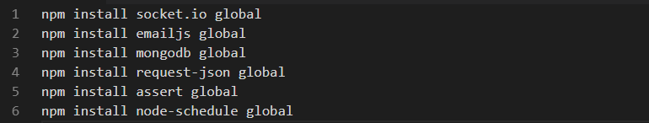

Restart Process

When everything is done, copy the code from app.js of the back-end directory to your app.js, you can also change the sending email by replacing the username and password defined in app.js. run following code to restart the process:



Deploy Project

Install Nginx

Nginx is a famous web server, run following code to install it:



Use web browser to visit your server to examine if Nginx is successfully installed.

Upload File

Upload all files via FTP protocol to usr/share/nginx/html/.

Open nginx configuration file etc/nginx/nginx.conf, Modify the root directory to /usr/share/nginx/html/XDU-SPM-Project/code/front-end.

Restart web service via following code:



then use web browser to visit your server to examine if the project is successfully deployed on the web server.