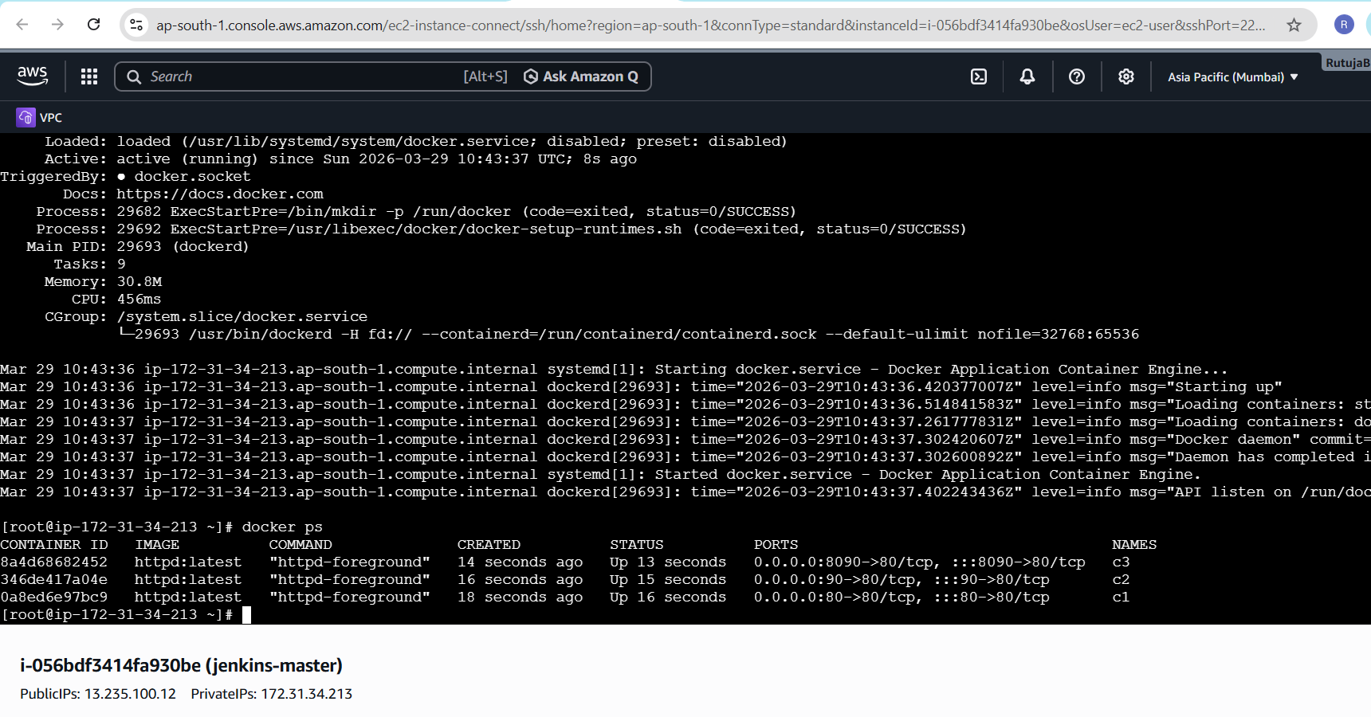
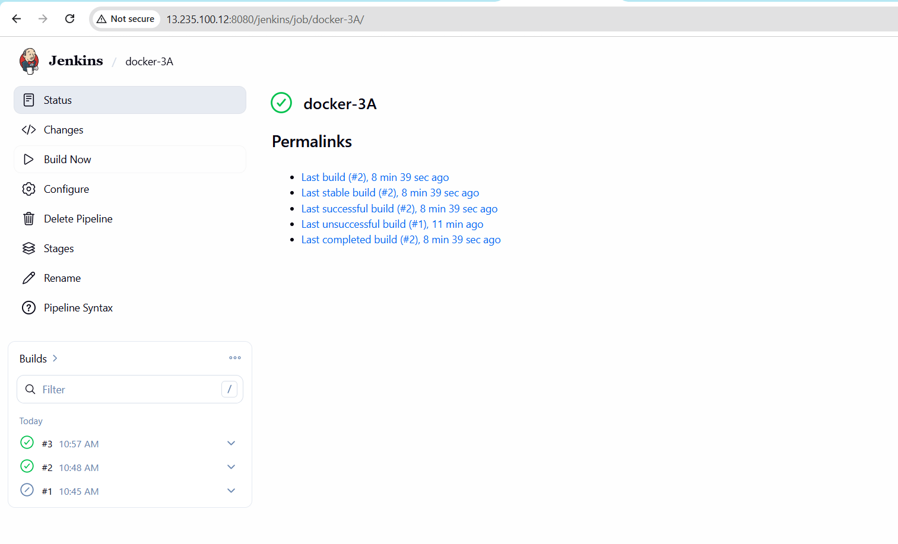
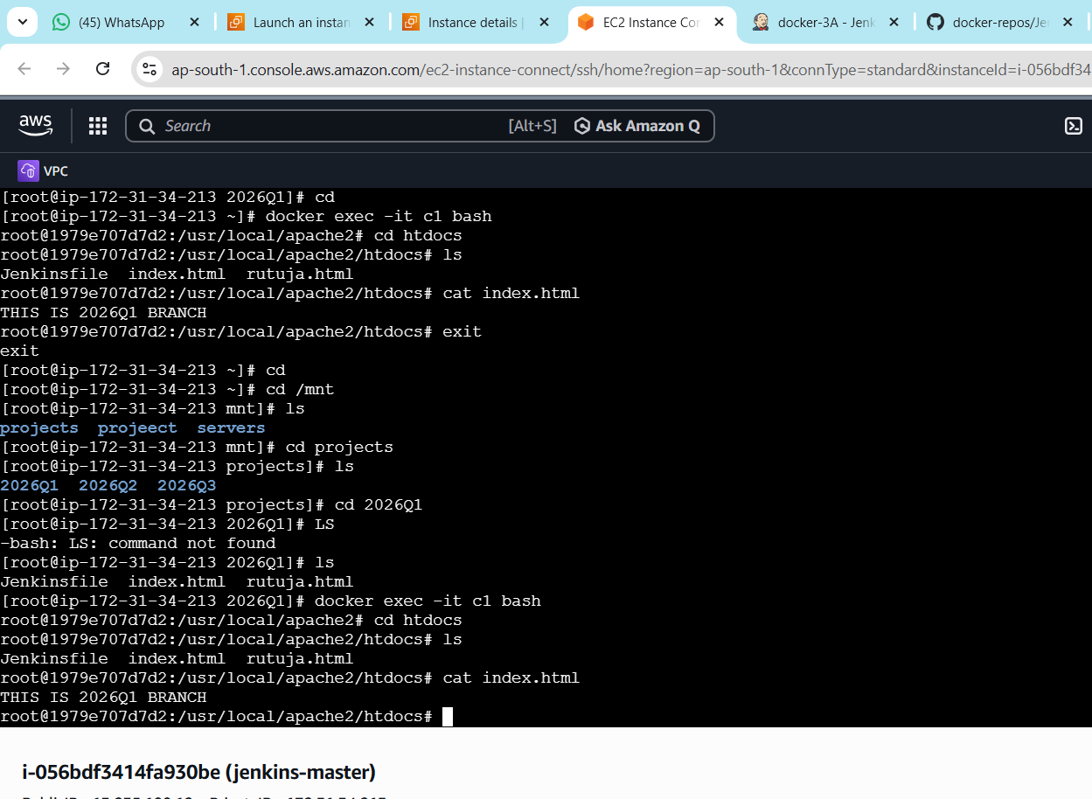
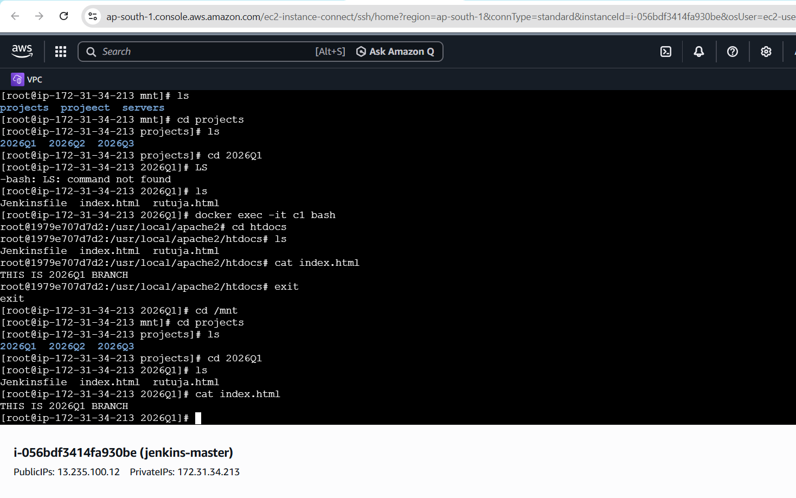
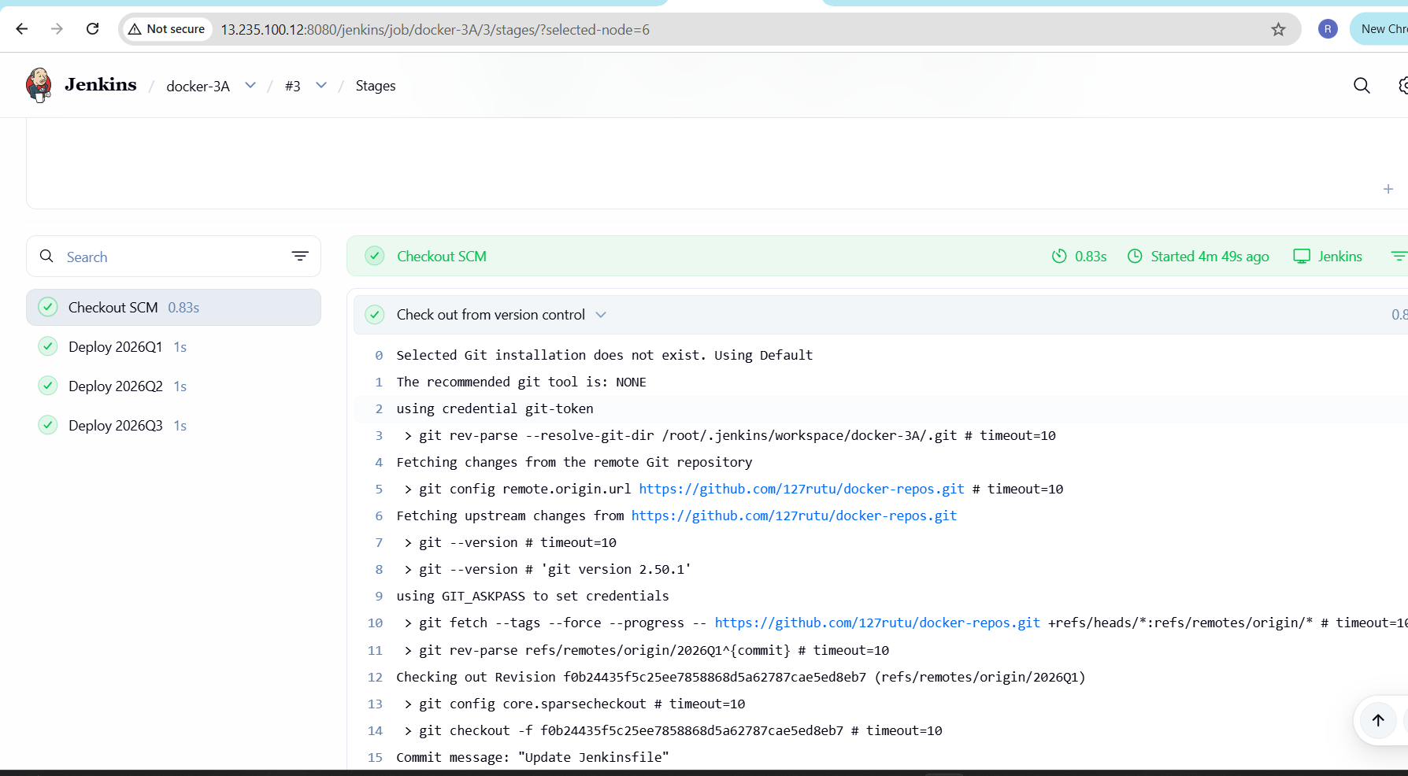
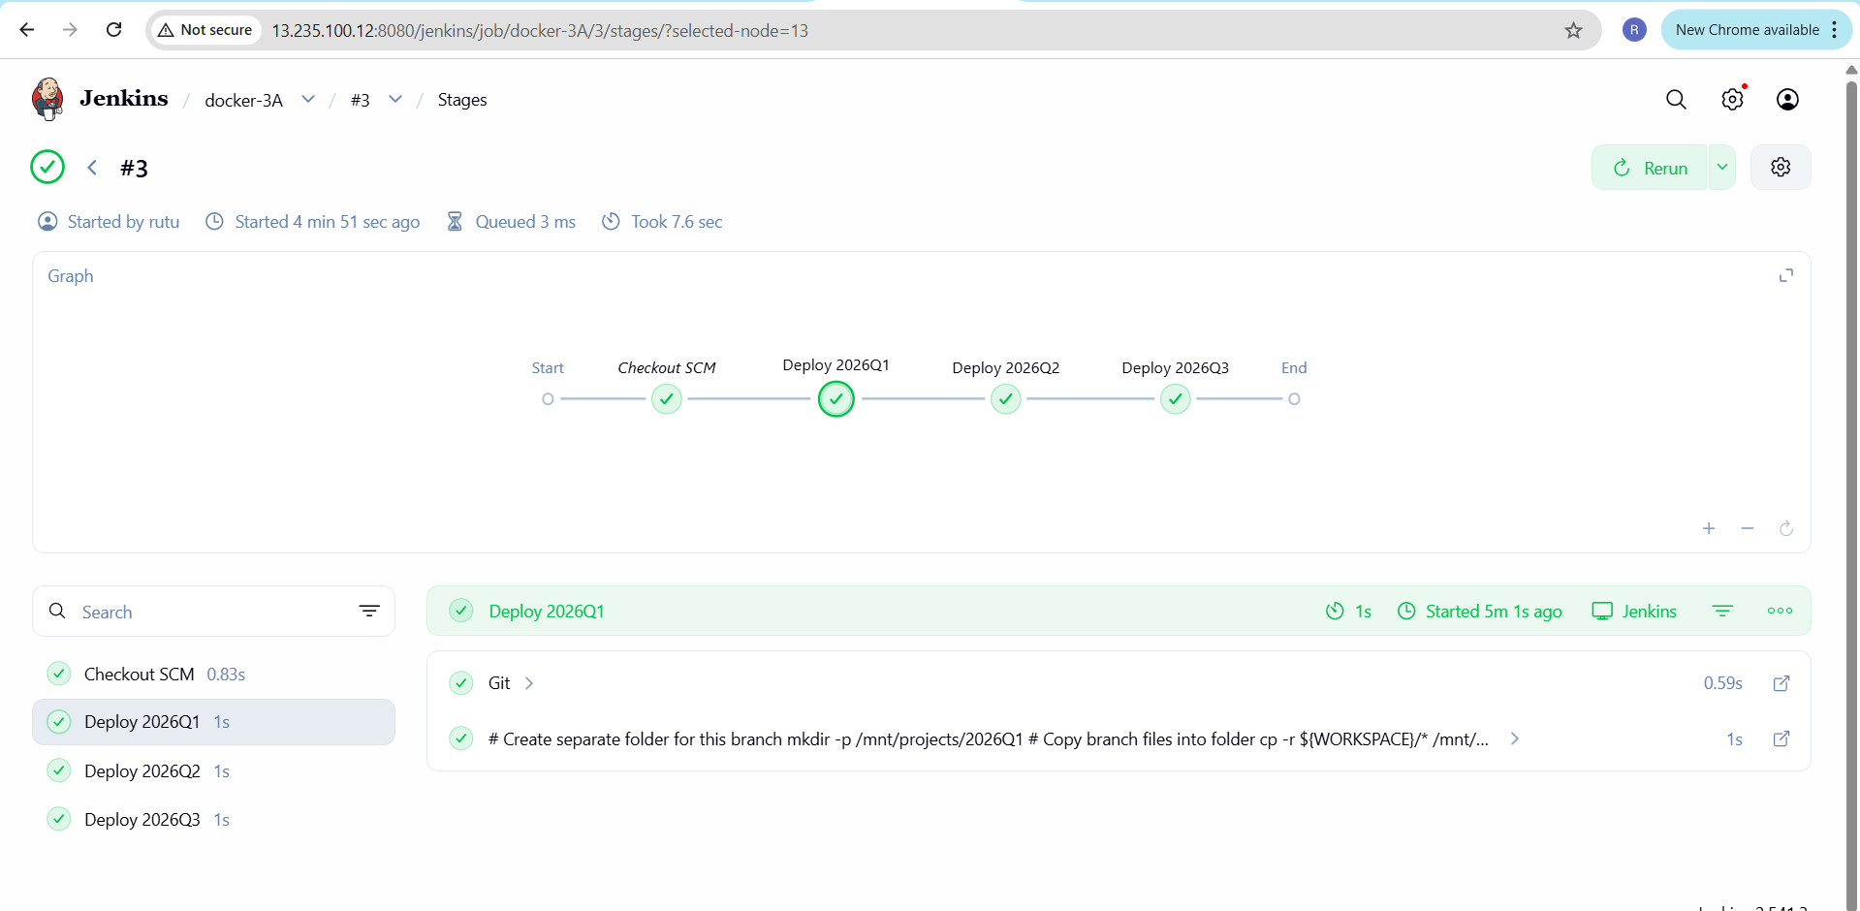
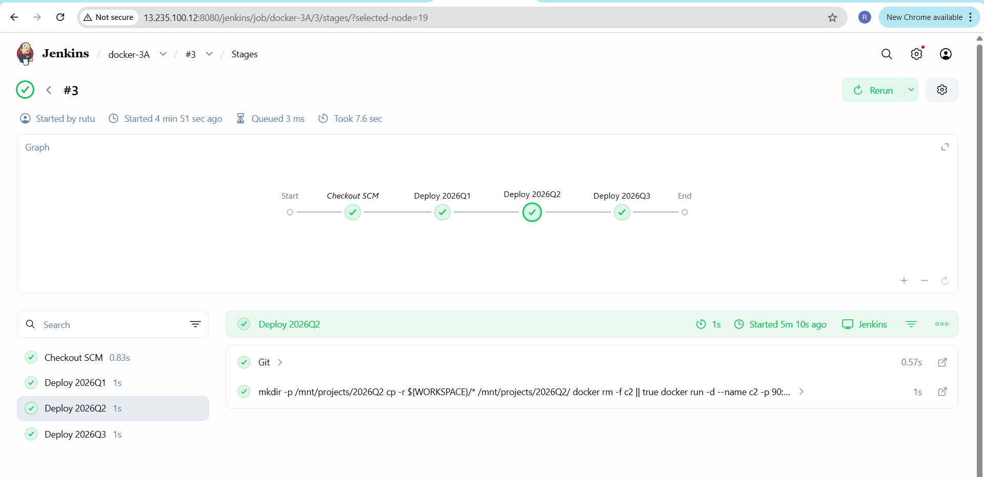
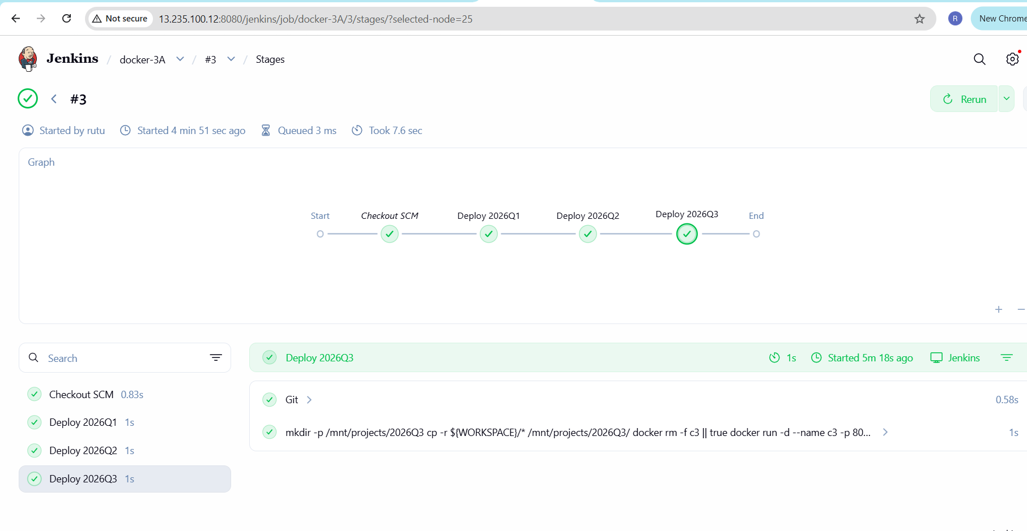

pipeline {
agent any // runs on Jenkins master

stages {

stage('Deploy 2026Q1') {
steps {
git branch: '2026Q1', url: 'https://github.com/127rutu/docker-repos.git'
sh '''
# Create separate folder for this branch
mkdir -p /mnt/projects/2026Q1
# Copy branch files into folder
cp -r ${WORKSPACE}/* /mnt/projects/2026Q1/

# Remove old container if exists
docker rm -f c1 || true

# Run container with bind mount
docker run -d --name c1 -p 80:80 \
-v /mnt/projects/2026Q1:/usr/local/apache2/htdocs/ \
httpd:latest
'''
}
}

stage('Deploy 2026Q2') {
steps {
git branch: '2026Q2', url: 'https://github.com/127rutu/docker-repos.git'
sh '''
mkdir -p /mnt/projects/2026Q2
cp -r ${WORKSPACE}/* /mnt/projects/2026Q2/

docker rm -f c2 || true

docker run -d --name c2 -p 90:80 \
-v /mnt/projects/2026Q2:/usr/local/apache2/htdocs/ \
httpd:latest
'''
}
}

stage('Deploy 2026Q3') {
steps {
git branch: '2026Q3', url: 'https://github.com/127rutu/docker-repos.git'
sh '''
mkdir -p /mnt/projects/2026Q3
cp -r ${WORKSPACE}/* /mnt/projects/2026Q3/

docker rm -f c3 || true

docker run -d --name c3 -p 8090:80 \
-v /mnt/projects/2026Q3:/usr/local/apache2/htdocs/ \
httpd:latest
'''
}
}

}
}

