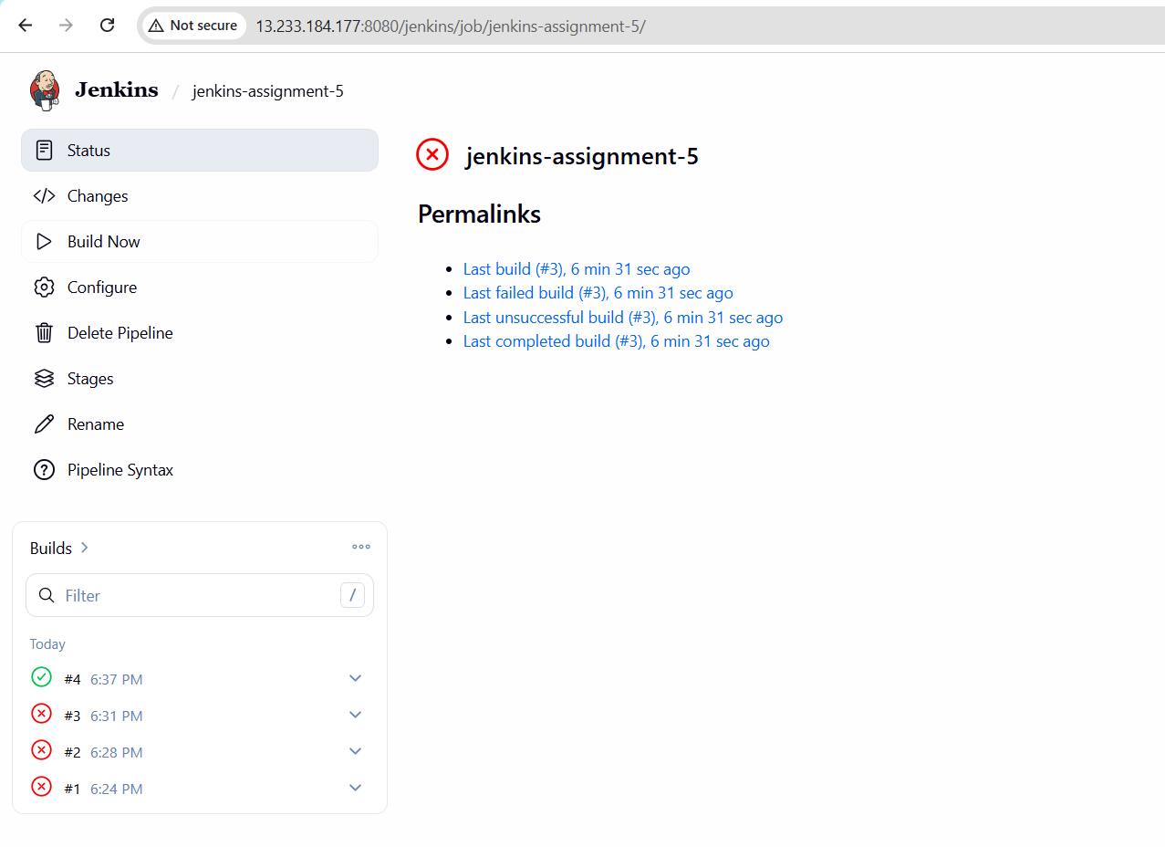
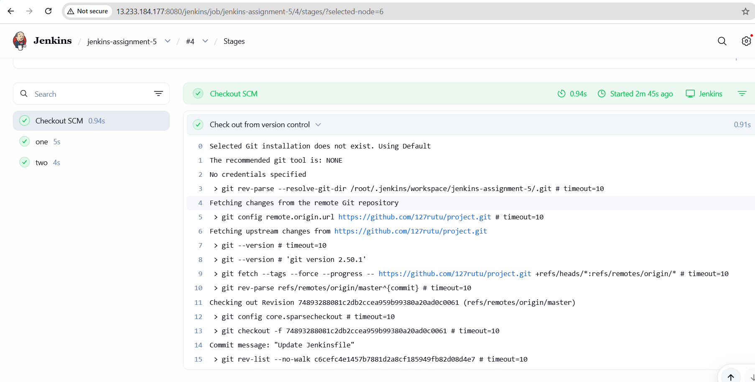
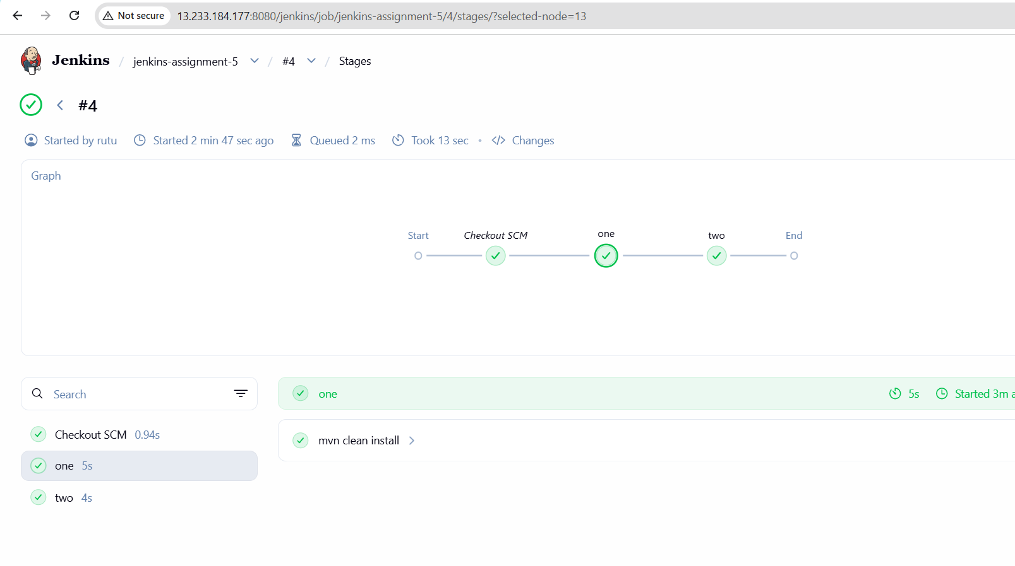
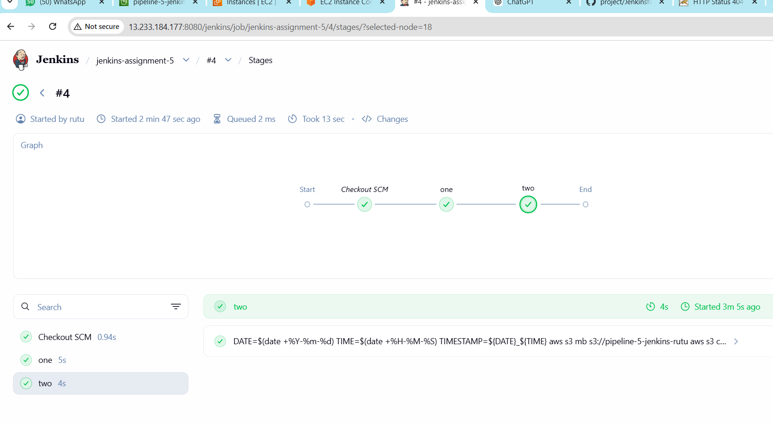
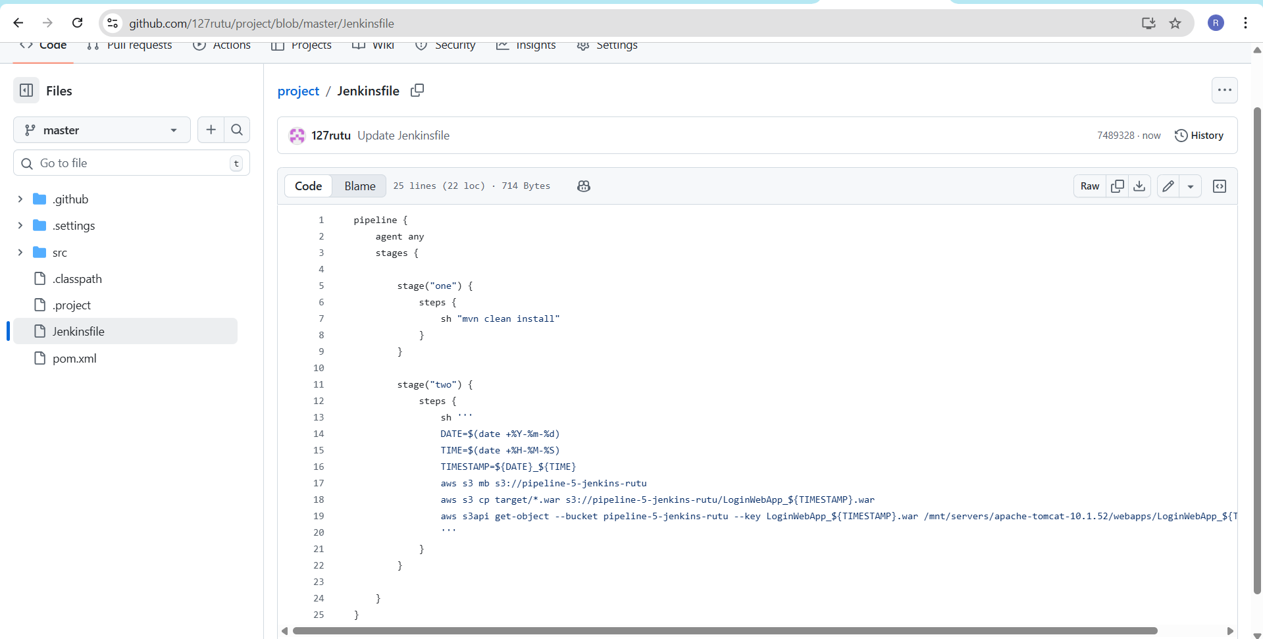
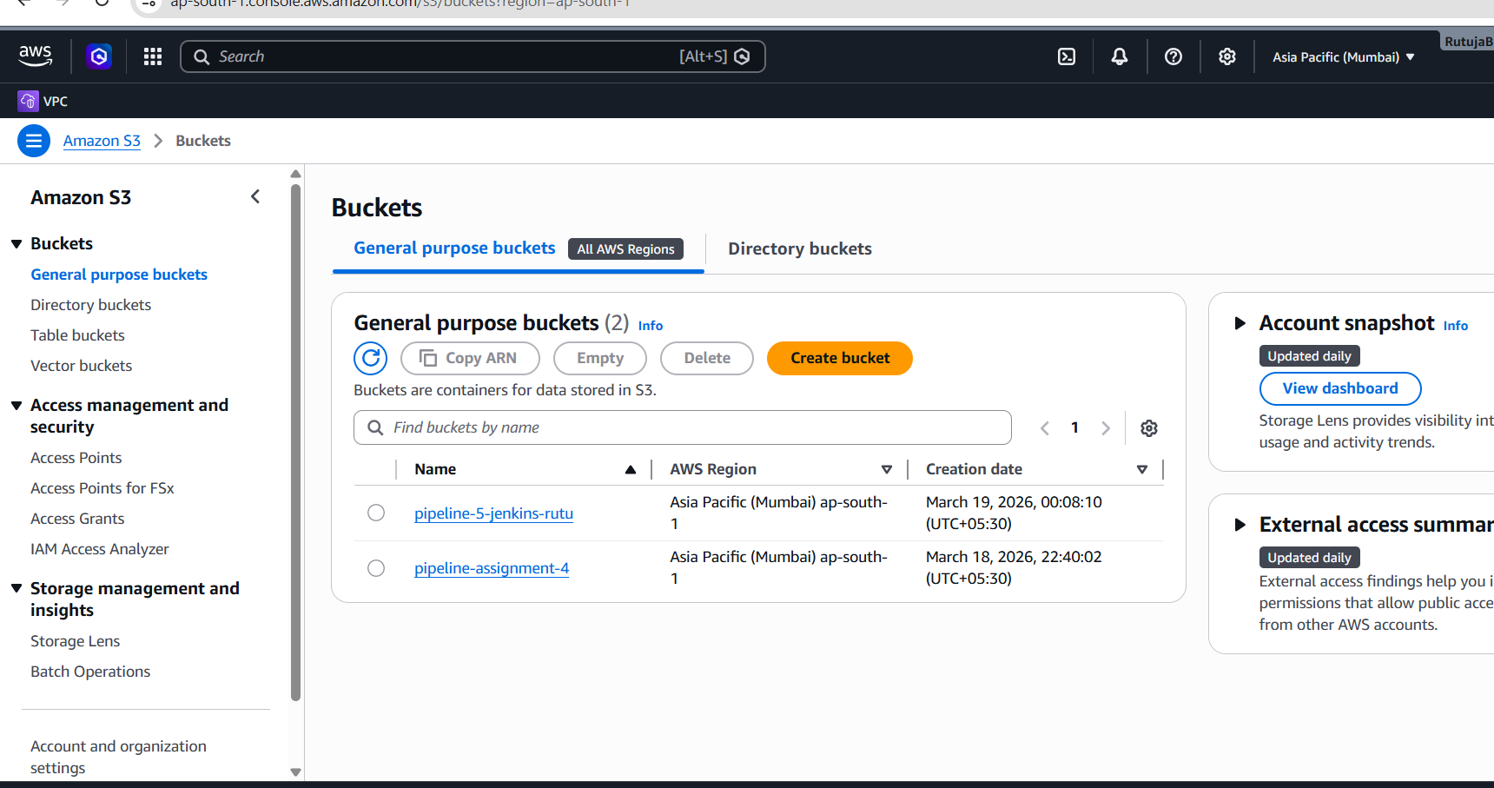
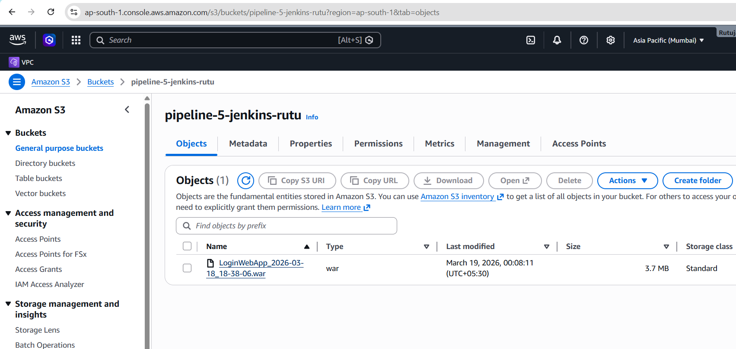
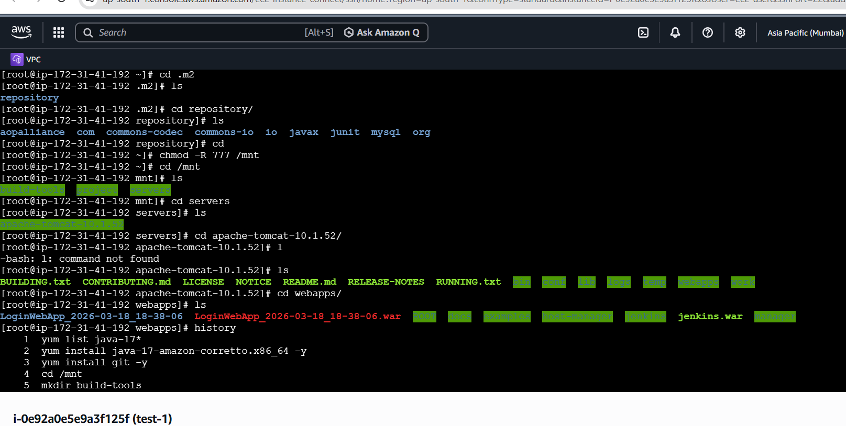

pipeline {
agent any
stages {

stage("one") {
steps {
sh "mvn clean install"
}
}

stage("two") {
steps {
sh '''
DATE=$(date +%Y-%m-%d)
TIME=$(date +%H-%M-%S)
TIMESTAMP=${DATE}_${TIME}
aws s3 mb s3://pipeline-5-jenkins-rutu
aws s3 cp target/*.war s3://pipeline-5-jenkins-rutu/LoginWebApp_${TIMESTAMP}.war
aws s3api get-object --bucket pipeline-5-jenkins-rutu --key LoginWebApp_${TIMESTAMP}.war /mnt/servers/apache-tomcat-10.1.52/webapps/LoginWebApp_${TIMESTAMP}.war
'''
}
}

}
}

