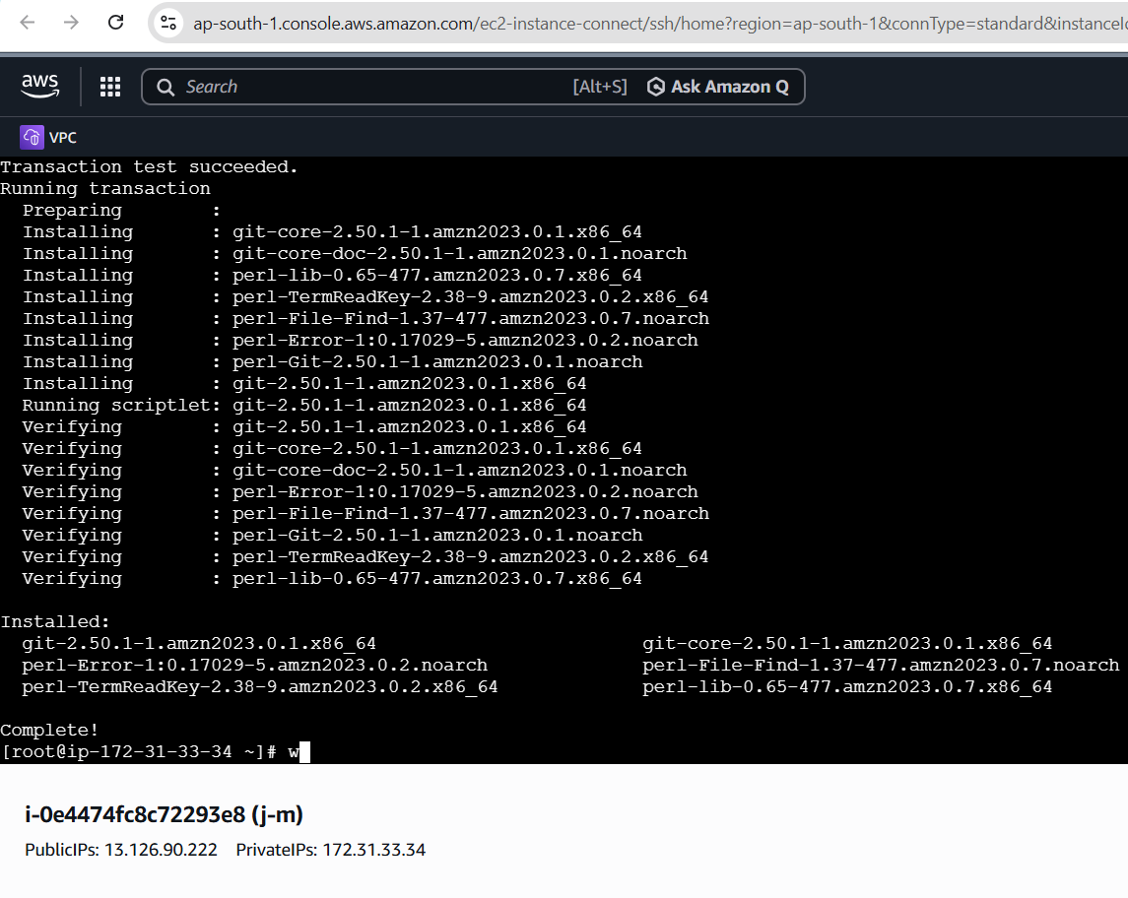
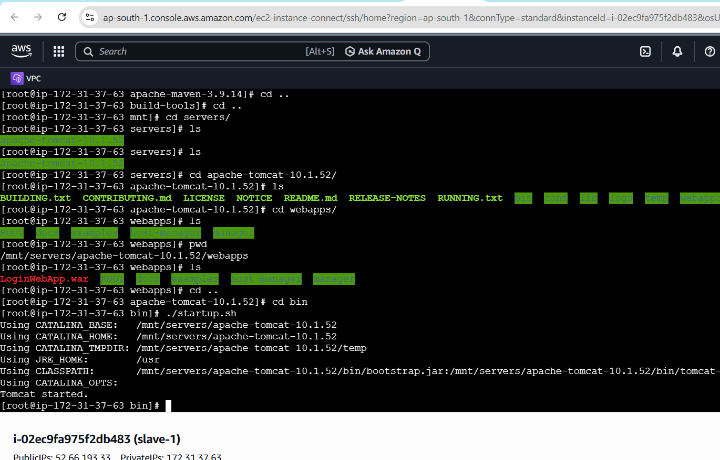
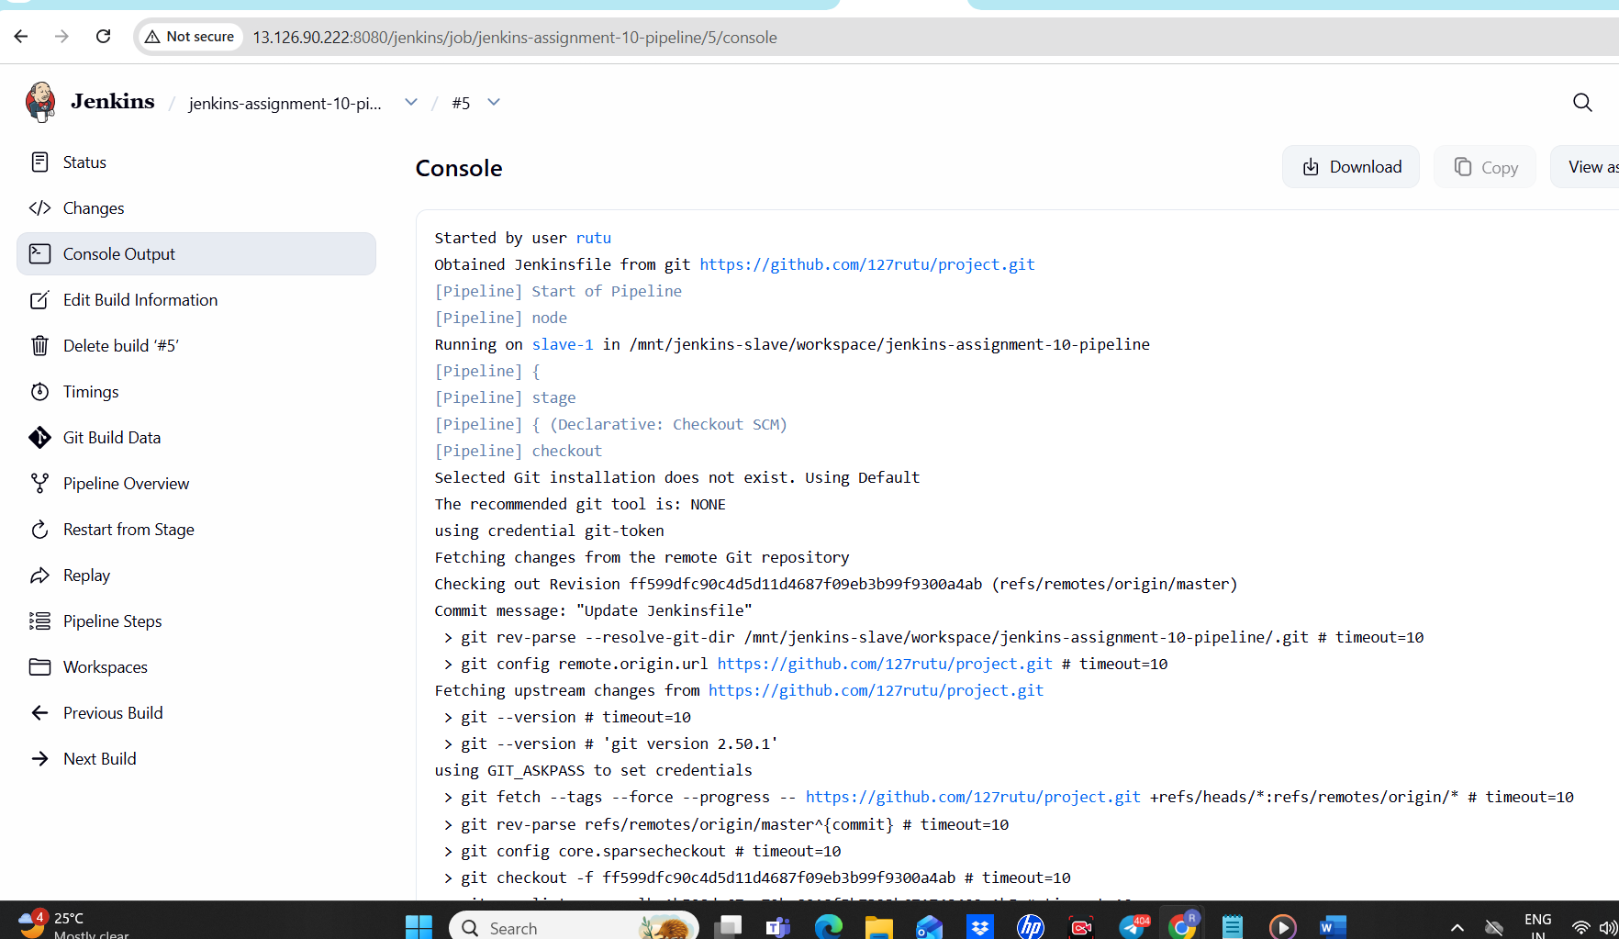
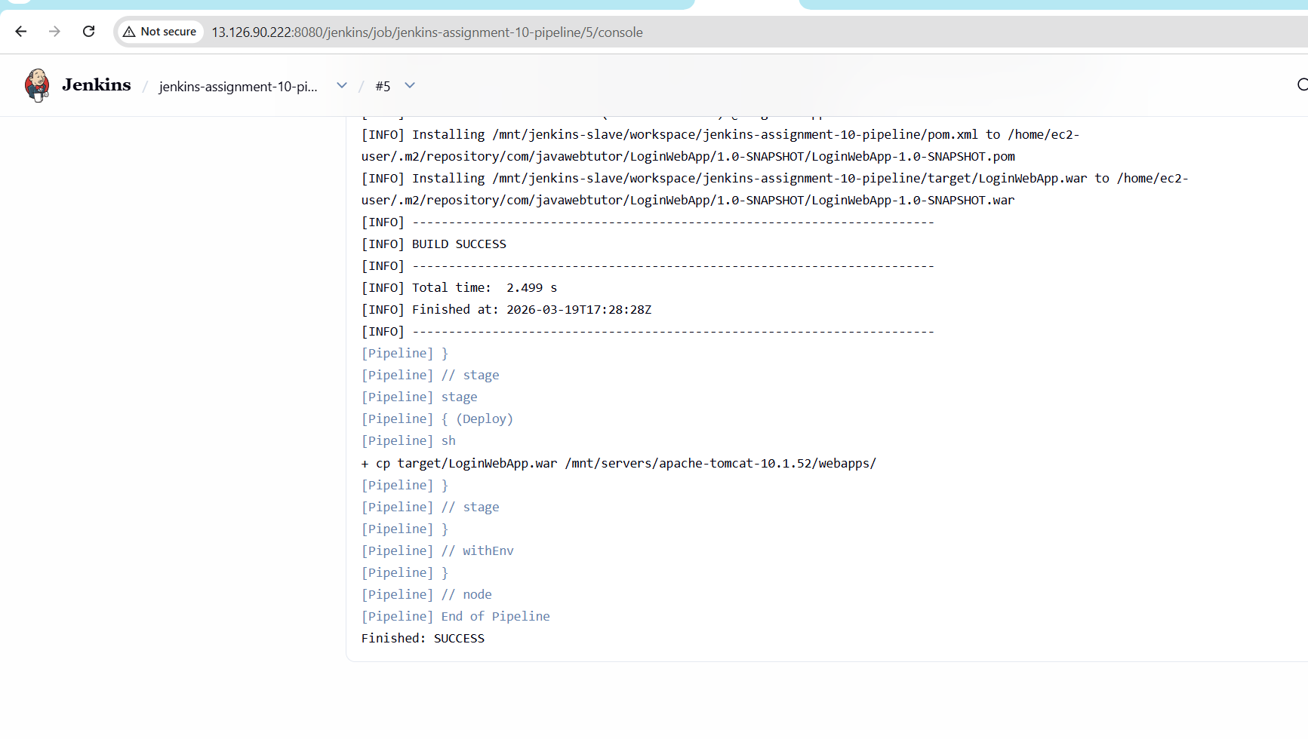
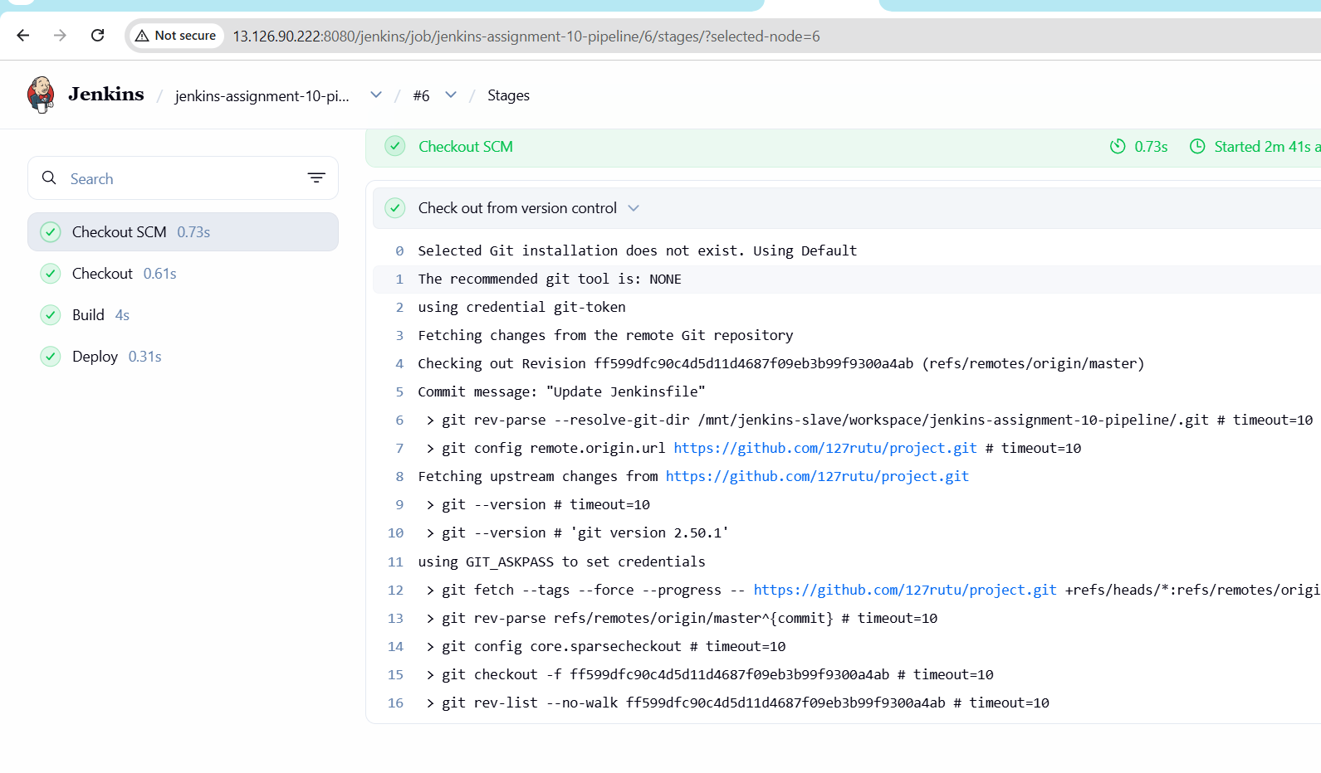
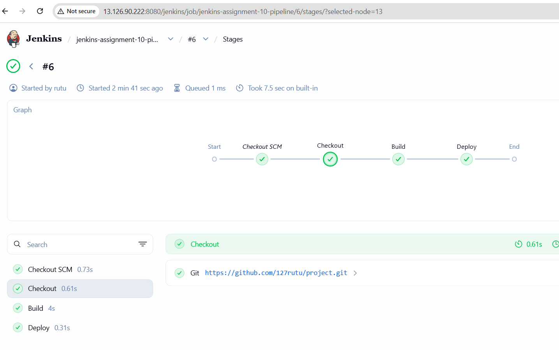
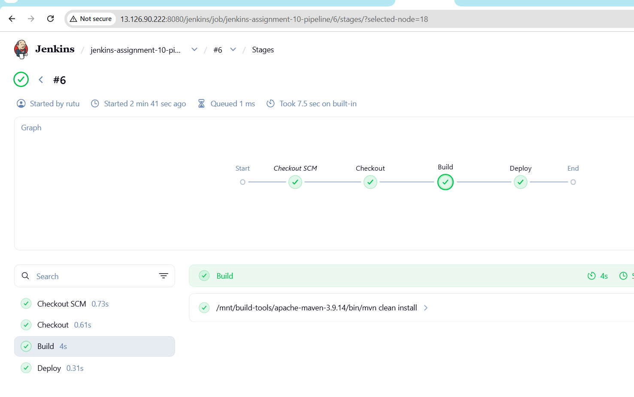
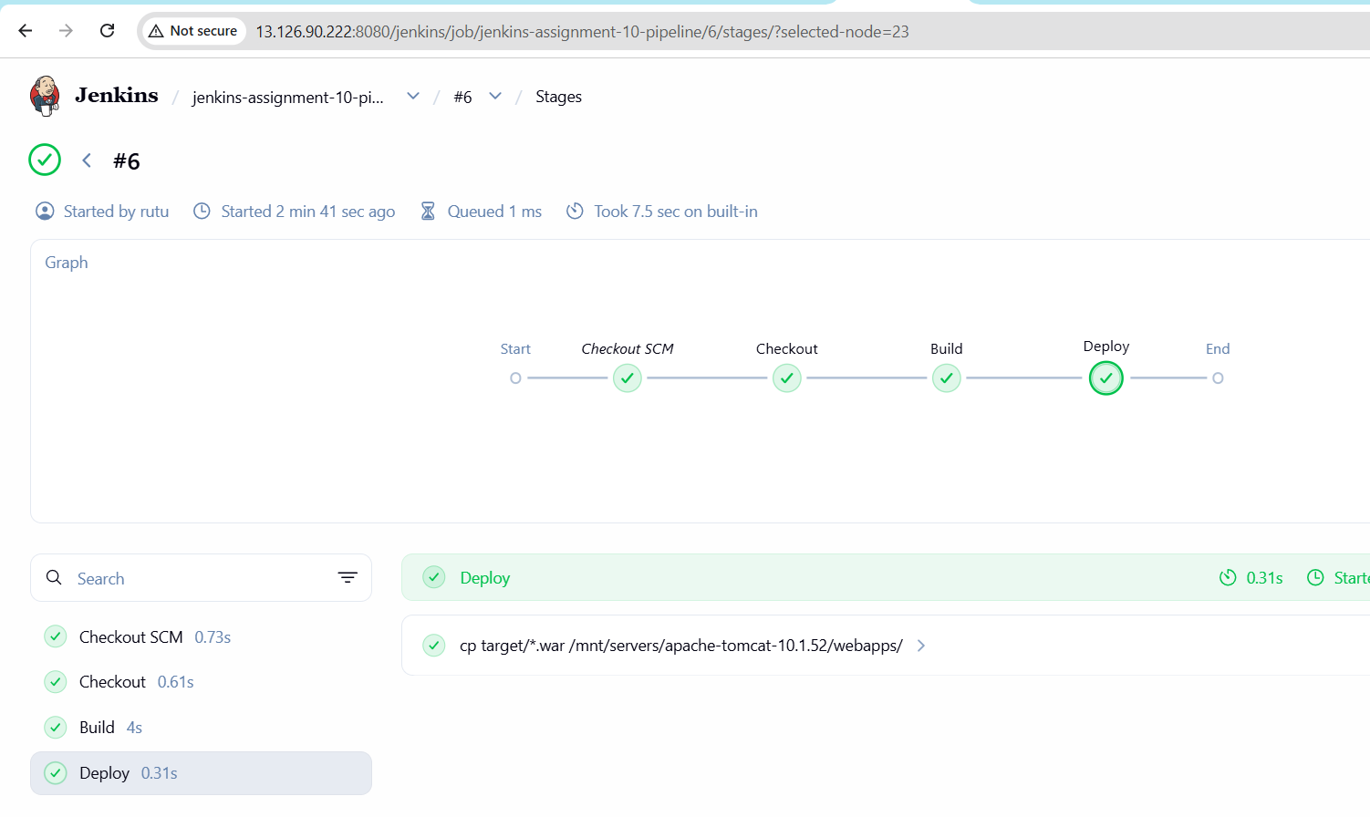
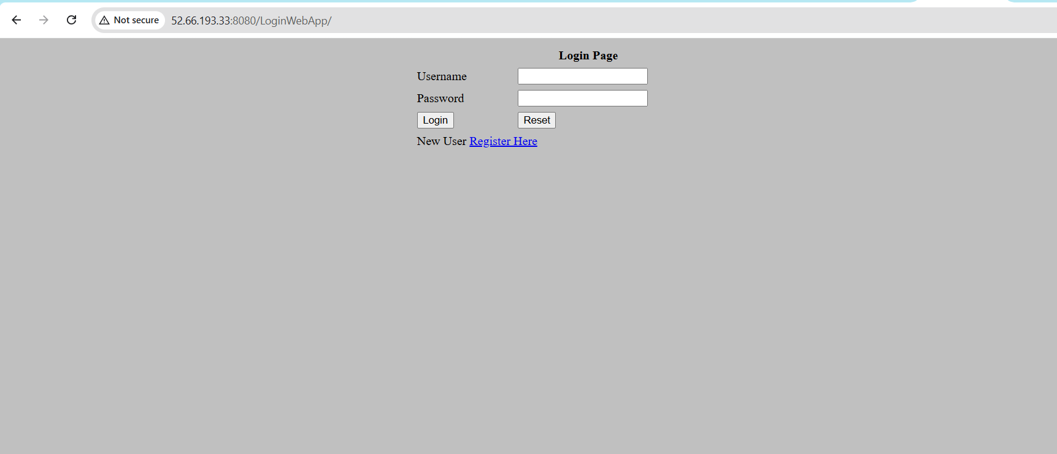
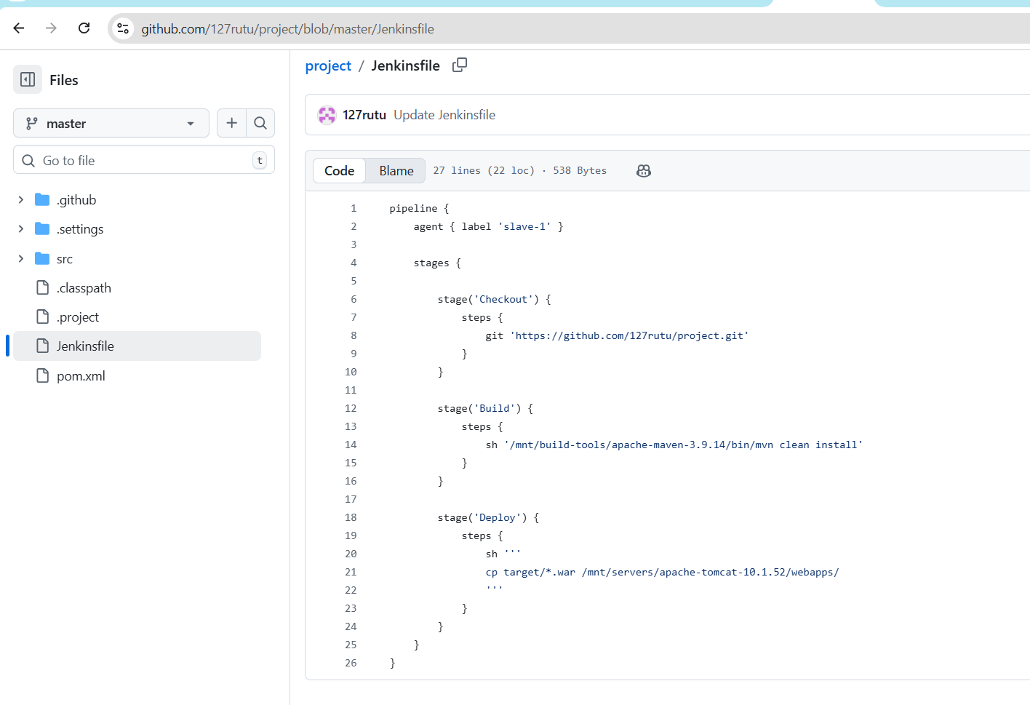
pipeline {
agent { label 'slave-1' }

stages {

stage('Checkout') {
steps {
git 'https://github.com/127rutu/project.git'
}
}

stage('Build') {
steps {
sh '/mnt/build-tools/apache-maven-3.9.14/bin/mvn clean install'
}
}

stage('Deploy') {
steps {
sh '''
cp target/*.war /mnt/servers/apache-tomcat-10.1.52/webapps/
'''
}
}
}
}

