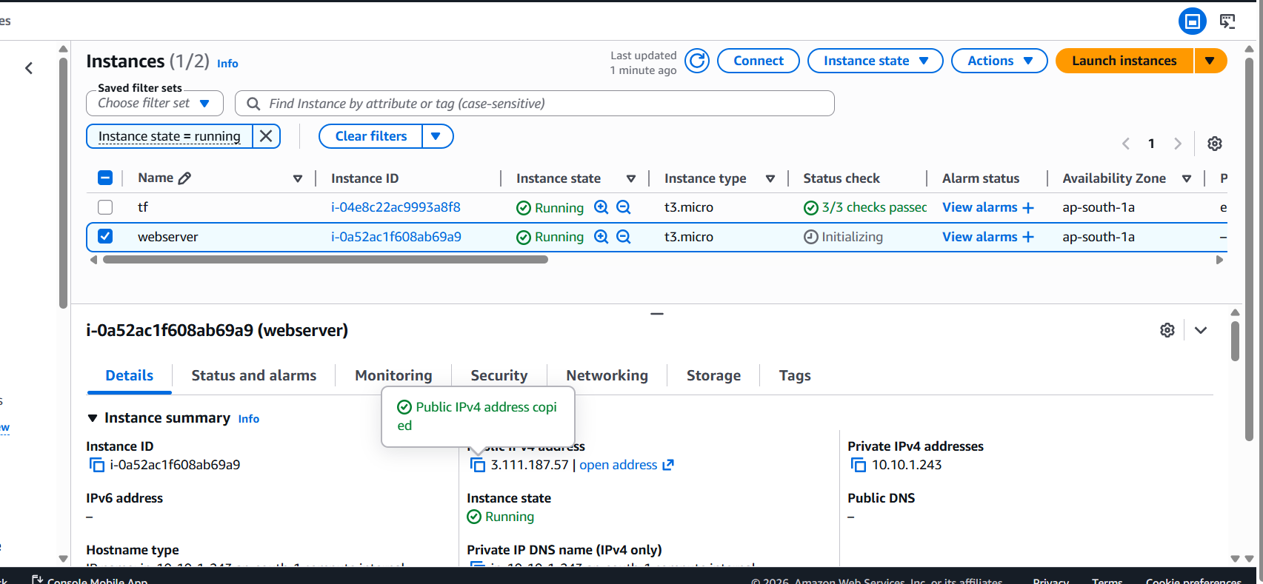
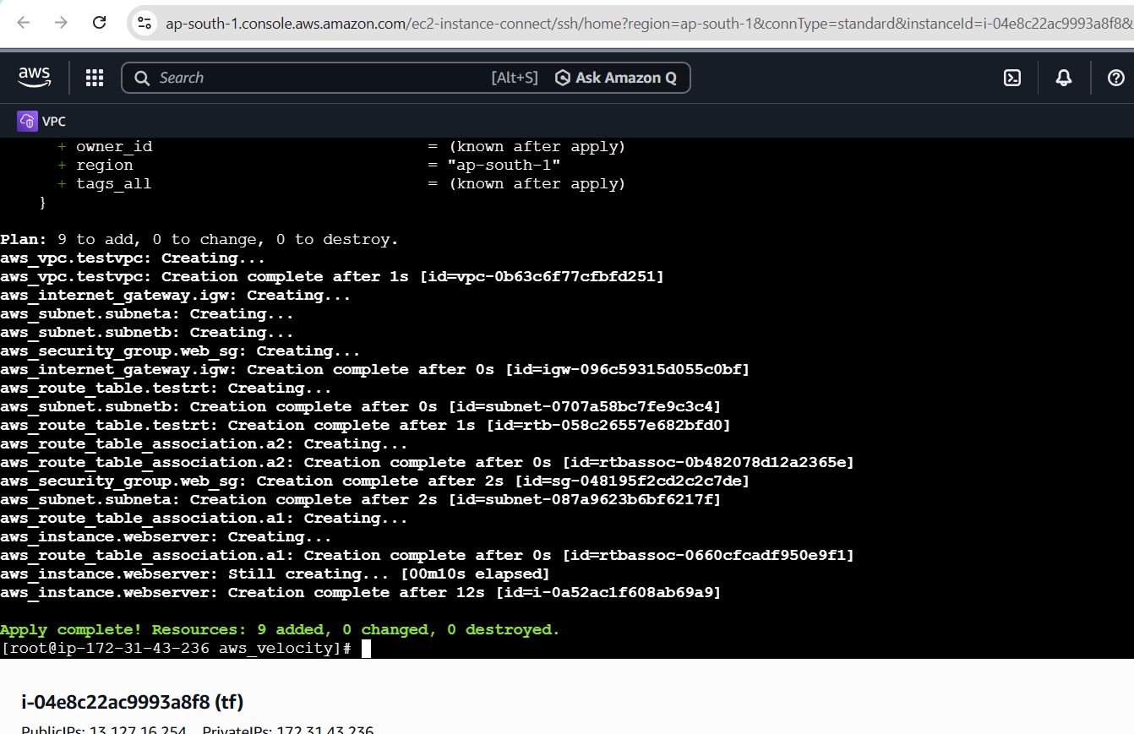
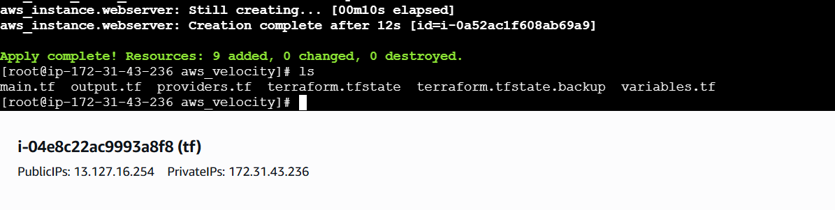
#creating vpc
resource "aws_vpc" "testvpc" {
cidr_block = "10.10.0.0/16"
}
#creating subnets
resource "aws_subnet" "subneta" {
cidr_block = "10.10.1.0/24"
vpc_id = aws_vpc.testvpc.id
availability_zone = "ap-south-1a"
}
resource "aws_subnet" "subnetb" {
cidr_block = "10.10.2.0/24"
vpc_id = aws_vpc.testvpc.id
availability_zone = "ap-south-1b"
}
#creating IGW
resource "aws_internet_gateway" "igw" {
vpc_id = aws_vpc.testvpc.id
}
#creating routetable
resource "aws_route_table" "testrt" {
vpc_id = aws_vpc.testvpc.id
route {
cidr_block = "0.0.0.0/0"
gateway_id = aws_internet_gateway.igw.id
}
}
#rt association
resource "aws_route_table_association" "a1" {
subnet_id = aws_subnet.subneta.id
route_table_id = aws_route_table.testrt.id
}
resource "aws_route_table_association" "a2" {
subnet_id = aws_subnet.subnetb.id
route_table_id = aws_route_table.testrt.id
}
resource "aws_security_group" "web_sg" {
name = "web-sg"
description = "Allow HTTP and SSH"
vpc_id = aws_vpc.testvpc.id

ingress {
description = "Allow HTTP"
from_port = 80
to_port = 80
protocol = "tcp"
cidr_blocks = ["0.0.0.0/0"]
}

ingress {
description = "Allow SSH"
from_port = 22
to_port = 22
protocol = "tcp"
cidr_blocks = ["0.0.0.0/0"]
}

egress {
from_port = 0
to_port = 0
protocol = "-1"
cidr_blocks = ["0.0.0.0/0"]
}

tags = {
Name = "web-sg"
}

}
resource "aws_instance" "webserver" {

ami = "ami-0e12ffc2dd465f6e4"
instance_type = "t3.micro"
key_name = "mumbai-key"
subnet_id = aws_subnet.subneta.id
associate_public_ip_address = true
vpc_security_group_ids = [aws_security_group.web_sg.id]
user_data = <<-EOF
#!/bin/bash
yum update -y
yum install -y httpd
systemctl start httpd
systemctl enable httpd
echo "Hello Rutuja" > /var/www/html/index.html
EOF
tags = {
Name = "webserver"
domain = "telecom"
}
}

[root@ip-172-31-43-236 aws_velocity]#

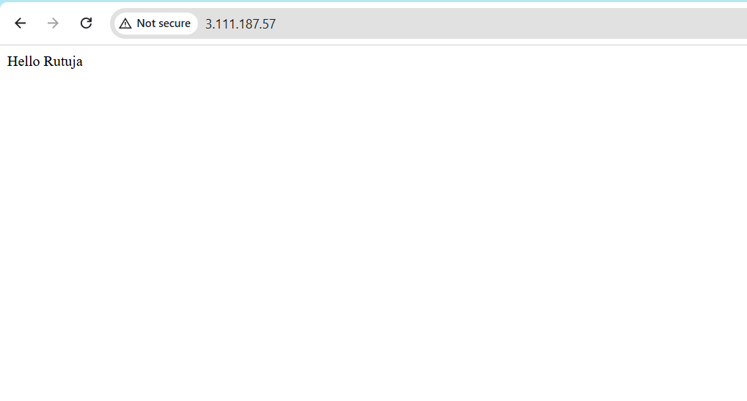
Used user data to login inside the instance and do the set for httpd while c reating instance via terraform

Pushed in github
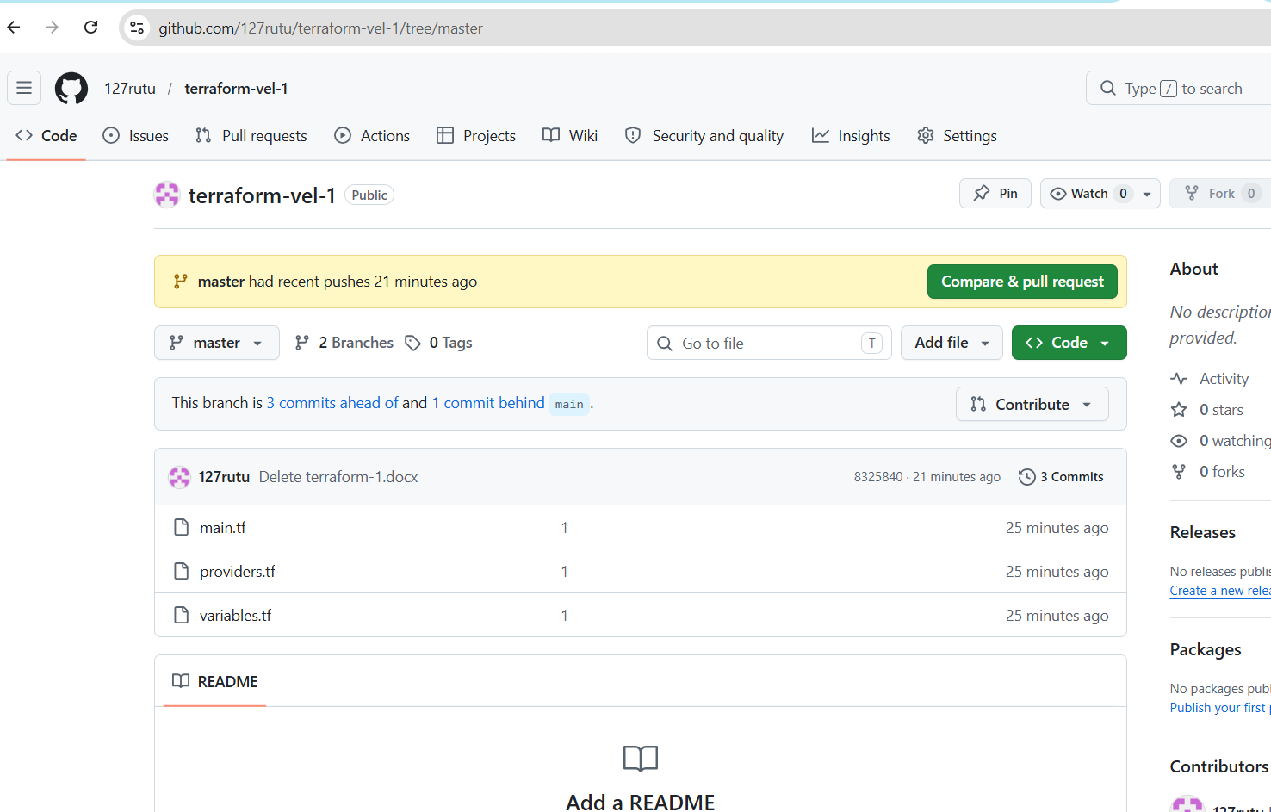
cloned in same instance another folder
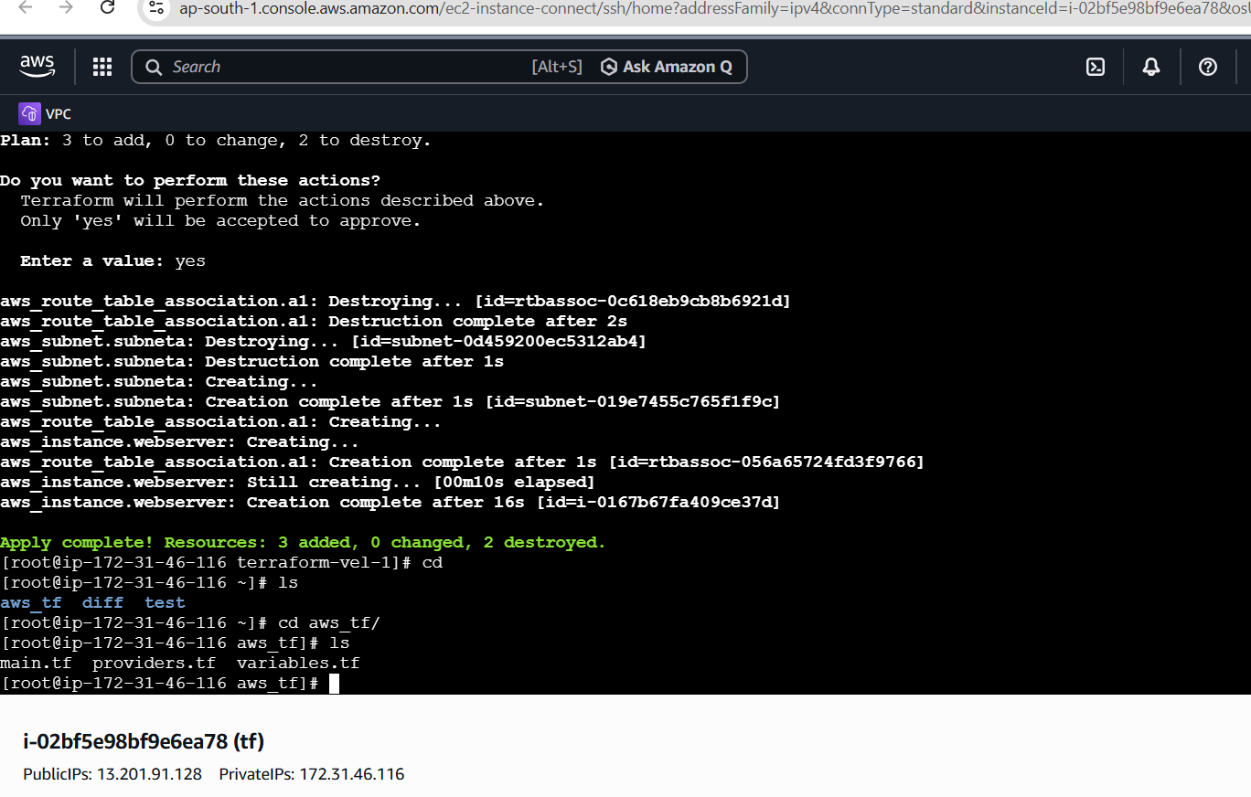
Made this all infra in diff region as in verginia
