**Vidhya C**

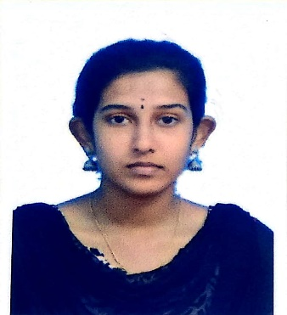

|  |  |
| --- | --- |
| **Title:** | Analyst/Software Engineer |
| **Location:** | Tuticorin, Tamilnadu, India |
| **Languages:** | Tamil (native),English |

# Experience Summary

The 90 days training at Capgemini provided a great foundation for any kind of real time projects. Quickr project was developed using agile methodology and an end to end application was delivered in which the front end validations were done using Angular which connected to the Spring Boot application for the backend implementation and that would also interact with the NOSQL database MongoDB.

**KEY SKILLS:**

* **Functional:** Team Building, Time Management, Strategic/Tactical Planning, Excellent Communication and Interpretation skills
* **Technical:** Core Java, Advanced Java, Spring framework, Spring Boot, Microservices, Angular, Mongo DB, JavaScript, SQL, HTML, CSS.

# Experience

I have developed a dummy Quickr project with front end using Angular, back end using Spring Boot Microservices and Mongo DB as a database

|  |  |  |
| --- | --- | --- |
|  | **Type of Industry:** | Software Development |
|  | **Project Description:** | An end to end web application for buying & selling products using spring boot microservices architecture with spring features like spring security, swagger, Mockito, hystrix and spring cloud interacting with the database MongoDB. |
|  | **Role/Title:** | Java Developer |
|  | **Project Duration:** | 3 weeks |
|  | **Responsibilities:** | * Created model, repository, services and controller classes for each micro services using Spring boot and MongoDB. * Implemented Hystrix and Spring Security. * Implemented Spring Cloud by including Eureka Server, Netflix Zuul Proxy * Validations in Angular * Integrated Angular with spring boot. |
|  | **Operating Systems:** | Windows 10 |
|  | **Software/Languages:** | Java, Spring, Angular, MongoDB |
|  | **Special Tools:** | Spring Tool Suite, Postman, RoboMongo |

##### 

# Training, Certifications & Affiliations

* Full stack Jee Cloud Native development training from Capgemini.

# Higher Education

* St.Aloysius Girls’ Higher Secondary School, Tuticorin(S.S.C)
* St.Aloysius Girls’ Higher Secondary School, Tuticorin(H.S.C)
* National Engineering College(Autonomous), Affiliated to Anna University, Kovilpatti,Tamilnadu(B.E)