**1.1. Total Spent per Category**

To find the total amount spent in each category:

```sql

SELECT category, SUM(amount) AS total_spent

FROM expenses

GROUP BY category;

```

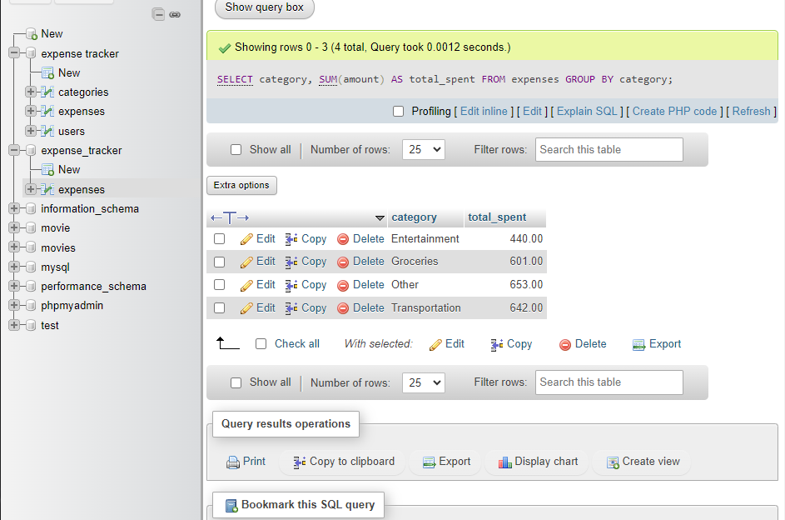

**1.2. Average Expense per Category**

To find the average expense amount for each category:

```sql

SELECT category, AVG(amount) AS average_expense

FROM expenses

GROUP BY category;

```

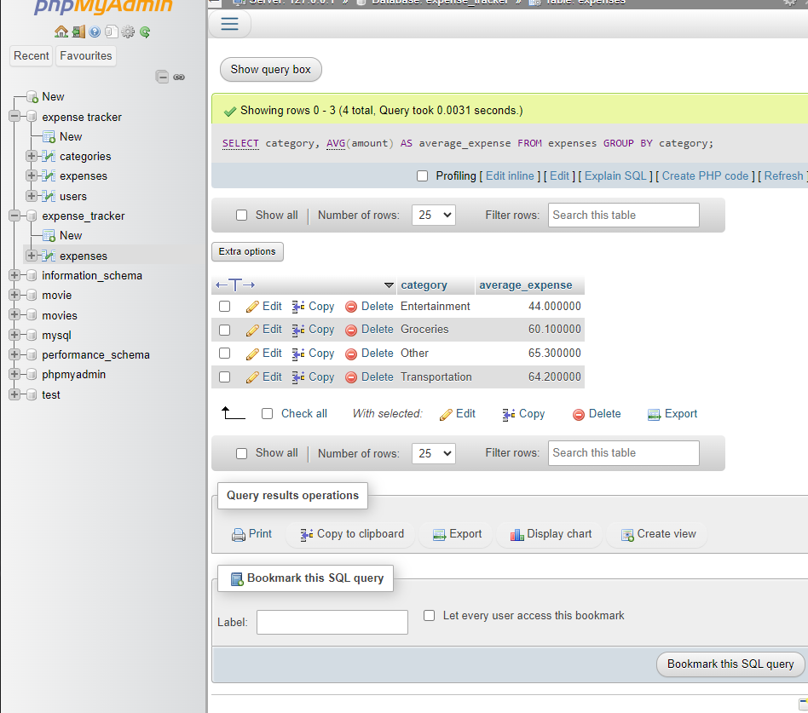

**Bonus Challenge: Top Spending Categories**

To find the top 3 categories where you spend the most, you first calculate the total spent per category and then sort and limit the results:

```sql

SELECT category, SUM(amount) AS total_spent

FROM expenses

GROUP BY category

ORDER BY total_spent DESC

LIMIT 3;

```

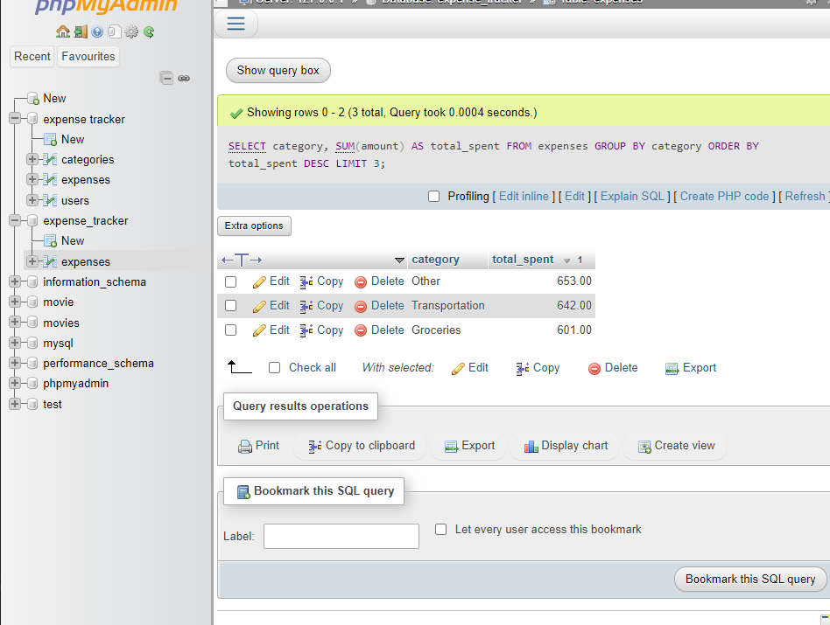

Explanation

- `GROUP BY category`: This groups the results by each category.

- `SUM(amount)`: Calculates the total amount spent in each category.

- `AVG(amount)`: Calculates the average amount spent in each category.

- `ORDER BY total_spent DESC`: Sorts the results by the total amount spent in descending order.

- `LIMIT 3`: Limits the results to the top 3 categories with the highest total spending.