Quantum Tunneling

And Tunneling Probability of particles through potential barriers

**Introduction**

We are familiar with the classic concepts of physics which are applied in our daily life and true for all but when it comes to the quantum world means the world of particles which are way too small to look with the bare eyes, rules and phenomena changes. In quantum world the rules are different and classic physics don’t work on these particles. As soon as this quantum mechanics came into picture now understanding the behavior of quantum particles like electron is easy and near to accurate. However, where our classics mechanics works on 100% accuracy quantum mechanics is solely based on the probability of finding the particle at a certain place but this does give a perfect idea of the nature of the particle. One of the interesting concepts of quantum physics is **Quantum Tunneling**. It is a phenomenon in which particles penetrate a potential energy barrier with a height greater than the total energy of the particles. Quantum tunneling is important in models of the Sun and has a wide range of applications, such as the scanning tunneling microscope and the tunnel diode.

In this report we are going to talk about quantum tunneling, how it works, principles and rules to explain the concept, tunneling probability and its applications. Let’s begin!

**Quantum Tunneling**

To illustrate quantum tunneling, consider a ball rolling along a surface with a kinetic energy of 100 J. As the ball rolls, it encounters a hill. The potential energy of the ball placed atop the hill is 10 J. Therefore, the ball (with 100 J of kinetic energy) easily rolls over the hill and continues on. In classical mechanics, the probability that the ball passes over the hill is exactly 1, it makes it over every time. If, however, the height of the hill is increased, a ball placed atop the hill has a potential energy of 200 J—the ball proceeds only part of the way up the hill, stops, and returns in the direction it came. The total energy of the ball is converted entirely into potential energy before it can reach the top of the hill. We do not expect, even after repeated attempts, for the 100-J ball to ever be found beyond the hill. Therefore, the probability that the ball passes over the hill is exactly 0, and probability it is turned back or “reflected” by the hill is exactly 1. The ball **never** makes it over the hill. The existence of the ball beyond the hill is an impossibility.

However, if we talk about it in quantum mechanics it works differently. If a quantum particle like electron having kinetic energy or wave packet comes into contact with a potential barrier having its width in nanometers or less (very thin) then there is a slight probability that we will find the particle beyond the barrier. The potential barrier is illustrated in [(Figure 1)](https://opentextbc.ca/universityphysicsv3openstax/chapter/the-quantum-tunneling-of-particles-through-potential-barriers/#CNX_UPhysics_40_06_barrier). When the height **U0** of the barrier is infinite, the wave packet representing an incident quantum particle is unable to penetrate it, and the quantum particle bounces back from the barrier boundary, just like a classical particle. When the width **L** of the barrier is infinite and its height is finite, a part of the wave packet representing an incident quantum particle can filter through the barrier boundary and eventually perish after traveling some distance inside the barrier.

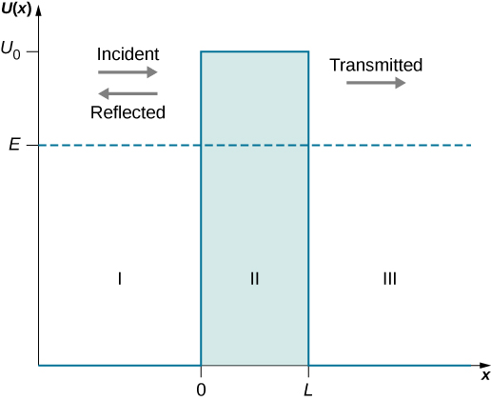

**FIGURE 1**

A potential energy barrier of height **U0** creates three physical regions with three different wave behaviors. In region I where x<0, an incident wave packet (incident particle) moves in a potential-free zone and coexists with a reflected wave packet (reflected particle). In region II, a part of the incident wave that has not been reflected at x=0 moves as a transmitted wave in a constant potential U(x)=+**U0** and tunnels through to region III at x=**L**. In region III for x>0, a wave packet (transmitted particle) that has tunneled through the potential barrier moves as a free particle in potential-free zone. The energy **E** of the incident particle is indicated by the horizontal line.

Suppose a uniform and time-independent beam of electrons or other quantum particles with energy **E** traveling along the x-axis (in the positive direction to the right) encounters a potential barrier described by [(Figure 1)](https://opentextbc.ca/universityphysicsv3openstax/chapter/the-quantum-tunneling-of-particles-through-potential-barriers/#fs-id1170901493570). The question is: What is the probability that an individual particle in the beam will tunnel through the potential barrier? The answer can be found by solving the boundary-value problem for the time-independent Schrödinger equation for a particle in the beam. The general form of this equation is given by

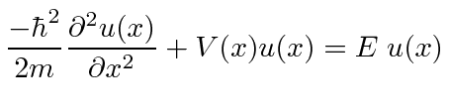

In upper equation, the potential function V(x) is defined by [(Figure 1)](https://opentextbc.ca/universityphysicsv3openstax/chapter/the-quantum-tunneling-of-particles-through-potential-barriers/#fs-id1170901493570). We assume that the given energy **E** of the incoming particle is smaller than the height **U0** of the potential barrier, **E<U0**, because this is the interesting physical case. Knowing the energy **E** of the incoming particle, our task is to solve upper equation for a function u(x) that is continuous and has continuous first derivatives for all x.

Earlier we discussed about the probability of going through the barrier which is also known as ‘Tunneling Probability’ or ‘Transmission Probability’. As we go through some calculation with upper equation we came to know about various results regarding the exact value of this probability.

There are Three types of solutions to the stationary Schrödinger equation for the quantum-tunneling problem: Oscillatory behavior in regions I and III where a quantum particle moves freely, and exponential-decay behavior in region II (the barrier region) where the particle moves in the potential **U0**.

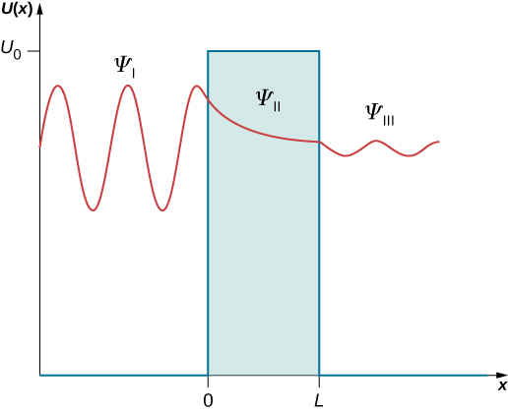

After some more calculations we get to a result with far more accuracy to explain the phenomena correctly

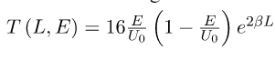

We can also write it as

T(L,E) = e-2bl(approx.)

Where

T=Tunneling Probability

E=Energy of electron

U0=Height of barrier

L=length of barrier

b = 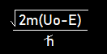

So, as a conclusion for the work we can say when we emit any energized quantum particle towards a barrier whose width is very small(in nanometers), there is a slight probability(aka tunneling probability) that we will find the particle at the other side of the barrier.

Now let us talk about the applications and profits we gain from this miraculous effect.

Applications

1. **A new ultra-Microscope:**A new class of microscopes (with atomic resolution) that exploit the tunneling current between a specimen and a very sharp tip has been developed. The sequence of three figures 2 below show the tunneling tip of a scanning tunneling microscope (STM), the scanning principle, and an image at atomic resolution of a silicon crystal surface.

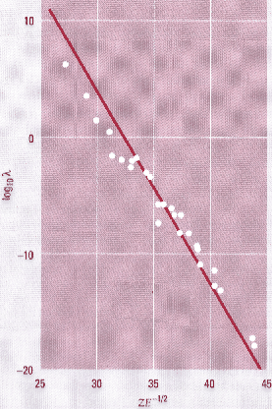

FIGURE 2

1. **Alpha particle decay :**The explanation of alpha particle decay as the tunneling of an alpha particle out of the nucleus (figure 3) explained the tremendous variation of alpha-particle lifetimes (25 orders of magnitude, figure 4) as being due to the rather small differences in barrier parameters. This remains one of the most impressive ranges of applicability of a single theory in physics.

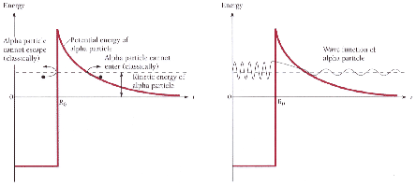

FIGURE 3



FIGURE 4

1. **The end of the road for the classical computer:**So far, miniaturization and very large scale integration of microchips has proceeded by pushing engineering technology boundaries. How far can we continue this game? It turns out that the tunneling process represents a physics limit for the miniaturization of feature size on a chip. No technological process can go beyond this boundary without changing the physical basis of the computational device. From this point on, we are in the realm of the quantum computer, and the classical computer can go no further. The tunneling could be between neighboring wires or across the gate of a transistor or some other feature where the quantum behavior is manifested.

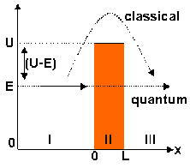

**Computer Program**

To illustrate the effects and showing the very small value of the probability a computer program is designed in C language which calculates the value of probability when potential height and width is provided as input.

#include<stdio.h>

#include<math.h>

main()

{

printf("Tunneling Probability:-\n\n");

double h,l,e,b,t;

printf("Value of total energy of electron:- ");

scanf("%lf",&e);

printf("\nEnter the height of the potential barrier:- ");

scanf("%lf",&h);

printf("\nEnter the width of the potential barrier:- ");

scanf("%lf",&l);

b=sqrt(26.254*(h-e));

t=exp(-2*b*l);

if(e<h)

{

printf("\n\nApproximate Tunneling Probability is :- %0.11lf",t);

}

else

{

printf("\n\nApproximate Tunneling Probability is :- 1");

}

}

**Output: -**

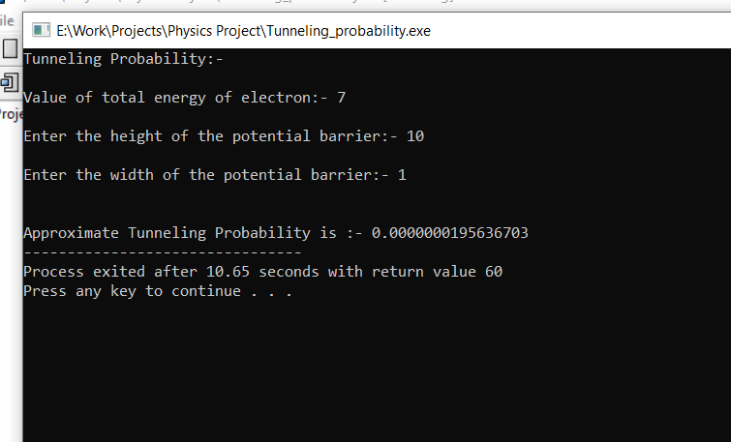

the following output gives an idea about how small amount of chances are there of tunneling.

As we reached to the end of report, I would like to conclude by stating the brief about the whole report. As we have now acknowledged about the terms like quantum tunneling, Schrödinger equation, TIR, tunneling probability etc. We came to know about the slight chances to cross a barrier or tunnel through it is possible but only in quantum world because as we increase the width of the barrier the chances decrease exponentially. We also discovered the application of this exciting phenomena and how we are growing in this little atomic world rapidly.