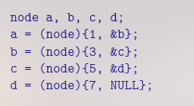
#include <stdio.h>
void bigX(const unsigned int n)
{
for (unsigned int i = 0; i < n; ++i) {
for (unsigned int j = 0; j < n; ++j)
printf((i == j || i == n - 1 - j) ? "X" : " ");
puts("");
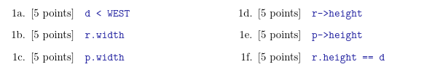
}
}
int main(void)
{
bigX(5);
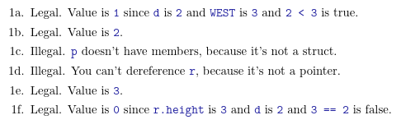
bigX(8);
}

%c Character
%d Signed decimal integer
%i Signed decimal integer
%e Scientific notation[e]
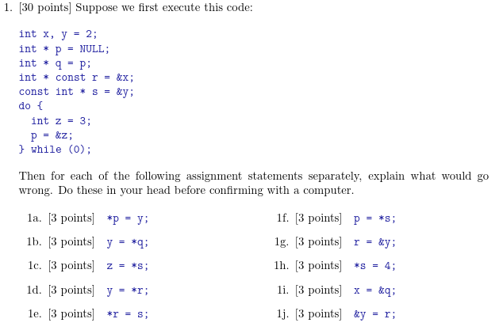
%E Scientific notation[E]
%f Decimal floating point
%o unsigned octal
%s String of character
%u unsigned decimal integer
%x unsigned Hexadecimal (lower)
%X unsigned Hexadecimal (upper)
%p display a pointer
%% print a %

scanf("Format string",&variable,&variable,...);
Address of - &
Value of address - *

#include <stdio.h>
#include <stdlib.h>

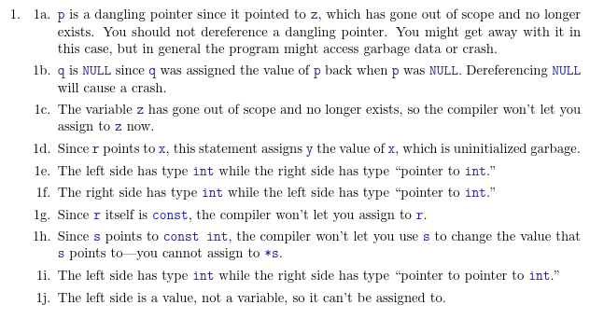
int comp(const void * p, const void * q);

int main(void)
{
double x[] = {2.7, 1.8, 3.4, 1.9, 3.6, 2.5};

qsort(x, (sizeof x) / (sizeof x[0]), sizeof x[0], comp);

for (size_t i = 0; i < (sizeof x) / (sizeof x[0]); ++i)
printf("%0.1lf ", x[i]);
}

int comp(const void * p, const void * q)
{
double y = *((double *)p), z = *((double *)q);
int yi = y, zi = z; // implicit cast from (double) to (int) rounds toward 0
if (yi < zi) return -1;
if (yi > zi) return 1;
if (y < z) return 1;
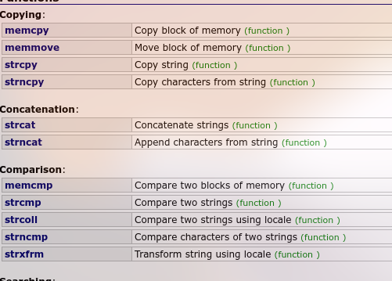
if (y > z) return -1;
return 0;
}

char ch_arr[3][10] = {
"spike",
"tom",
"jerry"
};
strcmp
#include<string.h>

