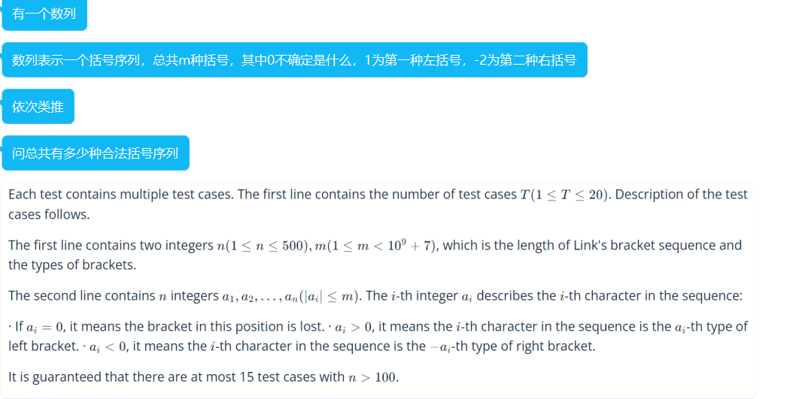

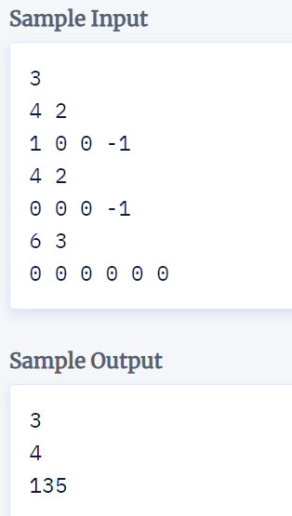

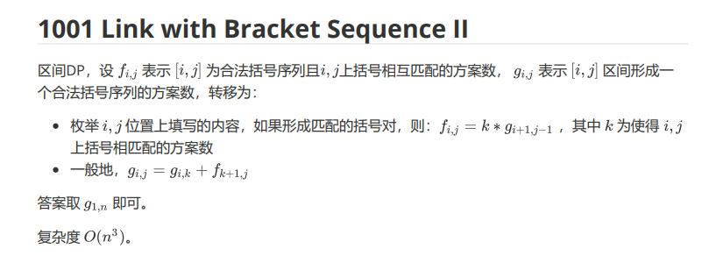

勘误:上面那里应该是g[i,j]= ∑g[I,k]\*f[k+1,j]

const int N=505;

const int MOD=1e9+7;

int n,m,a[N];

long long g[N][N],f[N][N];

inline int p(int l,int r){

if(a[l]==0&&a[r]==0)return m;

if(a[l]<0||a[r]>0)return 0;

if(a[l]>0&&a[r]<0&&a[l]+a[r]!=0)return 0;

return 1;

}

void solve(){

cin>>n>>m;

rep(i,1,n)cin>>a[i];

rep(i,1,n)g[i][i+1]=f[i][i+1]=p(i,i+1);

for(int len=4;len<=n;len+=2)rep(l,1,n+1-len){

int r=l+len-1;

g[l][r]=f[l][r]=g[l+1][r-1]\*p(l,r)%MOD;

rep(k,l+1,r-1)g[l][r]=(g[l][r]+g[l][k]\*f[k+1][r])%MOD;

}

cout<<g[1][n]<<endl;

}

int main(){

fastio;

int T;cin>>T;

rep(tc,1,T)solve();

return 0;

}