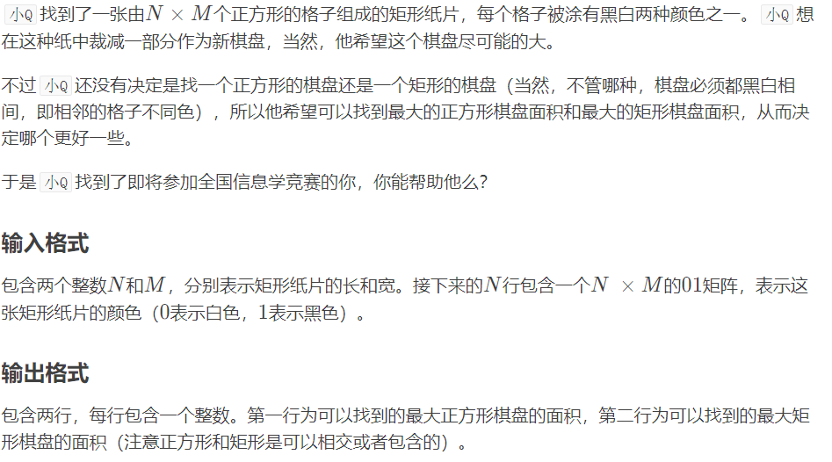

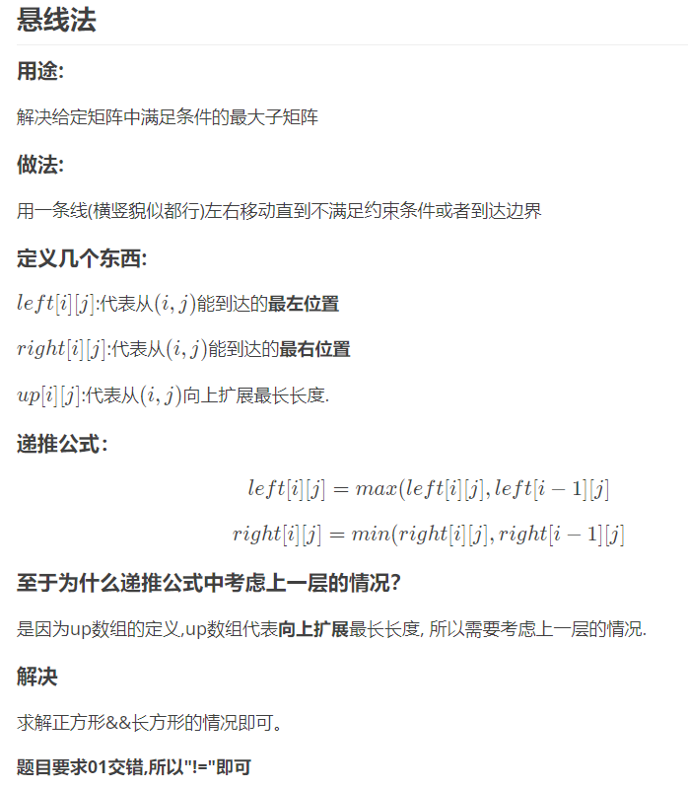

#include<bits/stdc++.h>

#pragma GCC optimize(3)

#define ll int////

#define inf 1e18

#define mn 2005

using namespace std;

ll a[mn][mn],r[mn][mn],l[mn][mn],up[mn][mn],

ans1=0,ans2=0,cnt=0,n,m,p;

int main()

{

ll te,x,y,i,j,k,z;

char ch;

cin>>n>>m;

for(i=1;i<=n;i++)

for(j=1;j<=m;j++)

{

scanf("%d",&a[i][j]);

r[i][j]=l[i][j]=j;

up[i][j]=1;

}

for(i=1;i<=n;i++)

for(j=2;j<=m;j++)

if(a[i][j]!=a[i][j-1])

l[i][j]=l[i][j-1];

for(i=1;i<=n;i++)

for(j=m-1;j>=1;j--)

if(a[i][j]!=a[i][j+1])

r[i][j]=r[i][j+1];

for(i=1;i<=n;i++)

for(j=1;j<=m;j++)

{

if(i>1&&a[i][j]!=a[i-1][j])

{

l[i][j]=max(l[i][j],l[i-1][j]);

r[i][j]=min(r[i][j],r[i-1][j]);

up[i][j]=up[i-1][j]+1;

}

x=r[i][j]-l[i][j]+1;

y=min(x,up[i][j]);

ans1=max(y\*y,ans1);

ans2=max(ans2,x\*up[i][j]);

}

cout<<ans1<<endl<<ans2;

return 0;

}