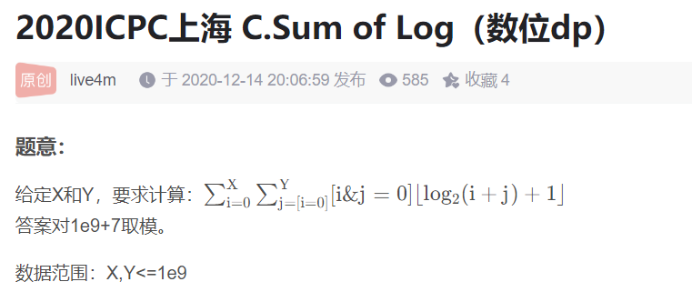数位dp.

由于i&j=0,所以(i+j)一定不会进位,log2(i+j)一定是他们的最高位1的位置.

令d[len][limit1][limit2][zero]表示:

当前长度为len,i的高位限制,j的高位限制,当前已枚举的值是否是0,的贡献.

枚举下一个数,dp一下即可.

#include<bits/stdc++.h>

#define ll long long

#define inf 1e18

#define mn 100005

using namespace std;

const ll mod=1e9+7;

ll ans[mn],c[mn],d[mn],f[40][2][2][2],n,m;

ll dfs(ll x,ll l1,ll l2,ll ze)

{ll i,ma,ma2,j,s=0;

if(x==0)return 1;

if(~f[x][l1][l2][ze])return f[x][l1][l2][ze];

if(l1==0)ma=1;else ma=c[x];

if(l2==0)ma2=1;else ma2=d[x];

for(i=0;i<=ma;i++)

for(j=0;j<=ma2;j++)

if((i&j)==0)

{

if(ze==0&&(i|j))s=(s+x\*dfs(x-1,l1&&i==ma,l2&&j==ma2,ze||(i|j)))%mod;

else s=(s+dfs(x-1,l1&&i==ma,l2&&j==ma2,ze||(i|j)))%mod;

}

f[x][l1][l2][ze]=s;

return s;

}

ll ask(ll x,ll y)

{

memset(f,-1,sizeof(f));

c[0]=0;d[0]=0;

while(x||y)

{

c[++c[0]]=x%2;x/=2;

d[++d[0]]=y%2;y/=2;

}

return dfs(max(c[0],d[0]),1,1,0);

}

int main()

{

ll t,x,y,z,i,j,k;

char ch;

cin>>t;

while(t--)

{

scanf("%lld%lld",&x,&y);

printf("%lld\n",(ask(x,y)-1+mod)%mod);

}

return 0;

}