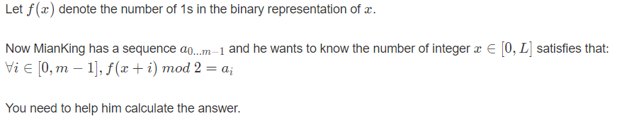

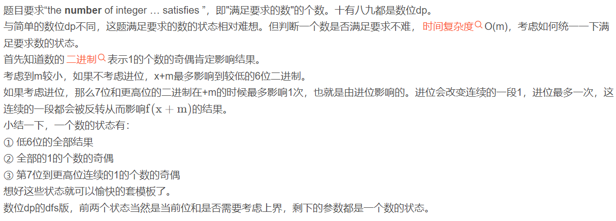

#include<iostream>

#include<algorithm>

#include<cstring>

#define rep(i,a,b) for(int i=a;i<b;i++)

#define mem(a,b) memset(a,b,sizeof(a))

using ll=long long;

using namespace std;

ll dp[64][2][2][2]={},x;

int bi[64]={},am[109]={},m;

ll calc(int lim,int s,int t){

int res=0,hi=lim?x%128:127;

for(int i=0;i<=hi;i++){//枚举低6位

int f=1;

for(int j=0;j<m&&f;j++)//O(m)逐一检查,注意到模2意义下加减都相当于异或

if(i+j<128) f&=(__builtin_parity(i+j)^s)==am[j];

else f&=(__builtin_parity(i+j)^s^t)==am[j];

res+=f;

}

return res;

}

ll dfs(int pos,int lim,int s,int t){

ll&res=dp[pos][lim][s][t];

if(res!=-1) return res;

if(pos<=6) return res=calc(lim,s,t);

res=0;

int up=lim?bi[pos]:1;

for(int i=0;i<=up;i++) //注意到模2意义下加减都相当于异或

res+=dfs(pos-1,lim&&i==up,s^i,i&(!t));

return res;

}

ll solve(){

mem(dp,-1);

int len=0;

for(ll xi=x;xi;xi>>=1) bi[len++]=xi&1;

return dfs(len-1,1,0,0);

}

int main() {

int ___;

for(scanf("%d",&___);___--;){

scanf("%d%lld",&m,&x);

rep(i,0,m) scanf("%d",&am[i]);

printf("%lld\n",solve());

}

}