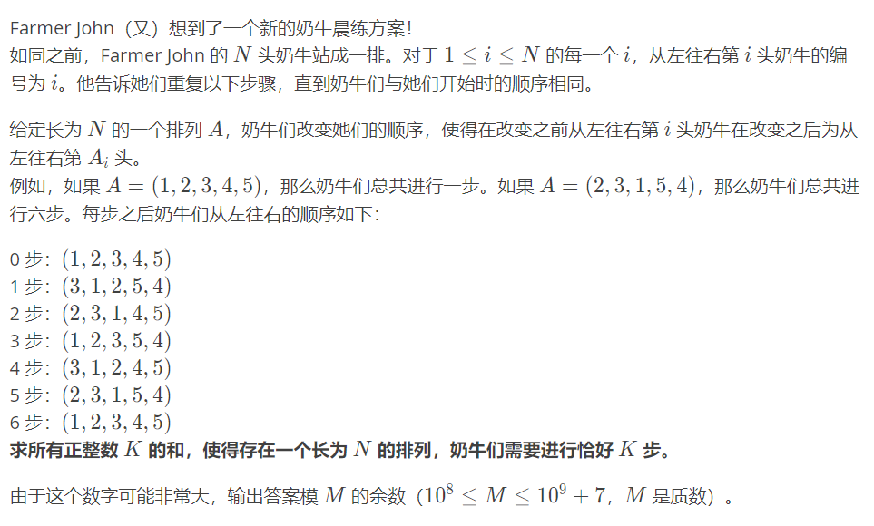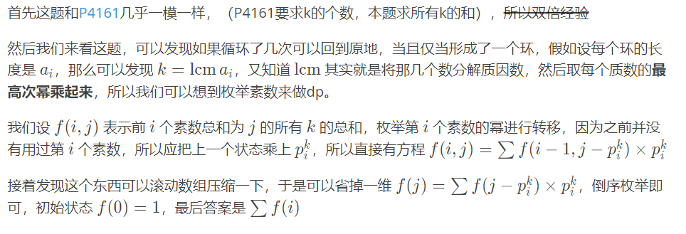#include <bits/stdc++.h>

#define ll long long//注意开long long

using namespace std;

const int N = 1e4 + 3;

bool vis[N]; vector<int> p;

ll f[N] = {1}, m;int n;

int main (){

p.push_back(0);//让素数的下标从一开始，使后面的转移更简洁

cin >> n >> m;

for (int i = 2; i <= n; i++){

if (!vis[i])p.push_back(i);

for (int j = i * i; j <= n; j += i)vis[j] = 1;

}//埃筛筛素数

for (int i = 1; i < p.size(); i++)

for (int j = n; j >= p[i]; j--){

int tmp = p[i];

while(tmp <= j)

f[j] = (f[j] + f[j - tmp] * tmp % m) % m, tmp *= p[i];

}

ll Ans = 0;

for (int i = 0; i <= n; i++)Ans = (Ans + f[i]) % m;

cout << Ans << endl;

return 0;

}