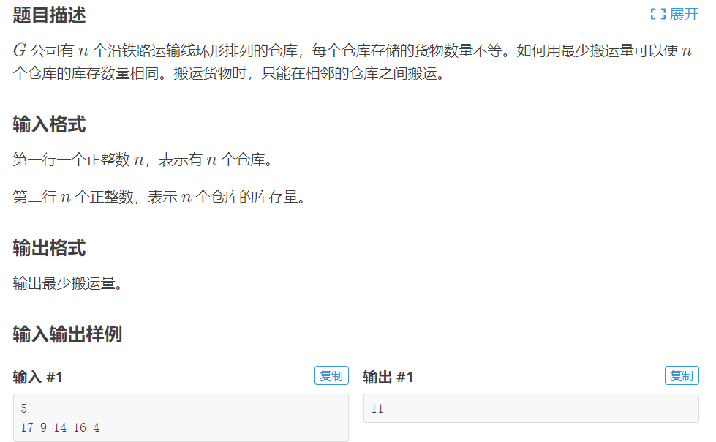

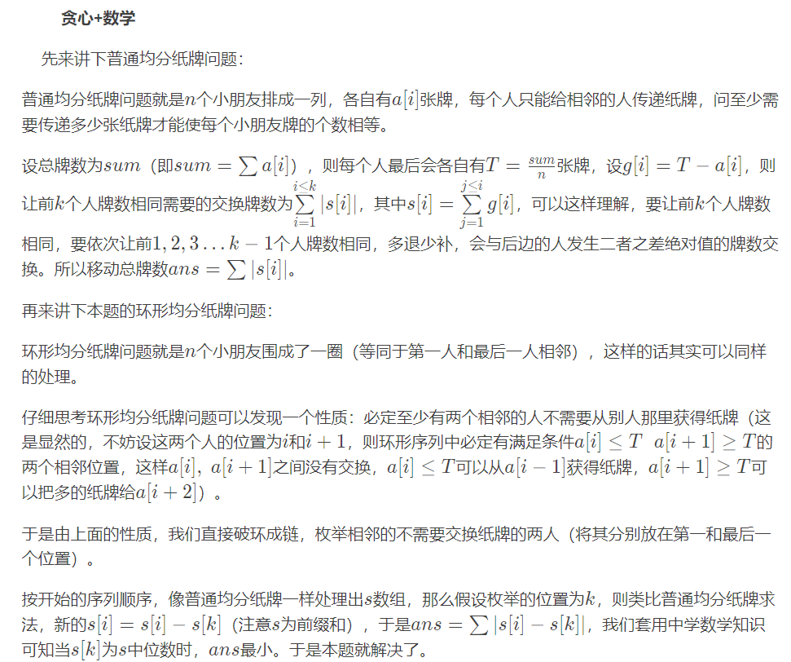

#include<bits/stdc++.h>

#define il inline

#define ll long long

using namespace std;

const int N=105;

ll n,a[N],sum,s[N];

int main()

{

ios::sync_with_stdio(0);

cin>>n;

for(int i=1;i<=n;i++)cin>>a[i],sum+=a[i];

sum/=n;

for(int i=1;i<=n;i++)a[i]-=sum,s[i]=s[i-1]+a[i];

sort(s+1,s+n+1);

sum=0;

for(int i=1;i<=n;i++)sum+=abs(s[n/2+1]-s[i]);

cout<<sum;

return 0;

}

当然，也可以用费用流求解

