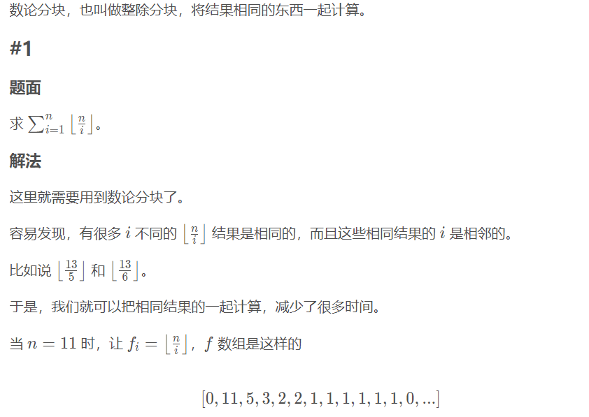

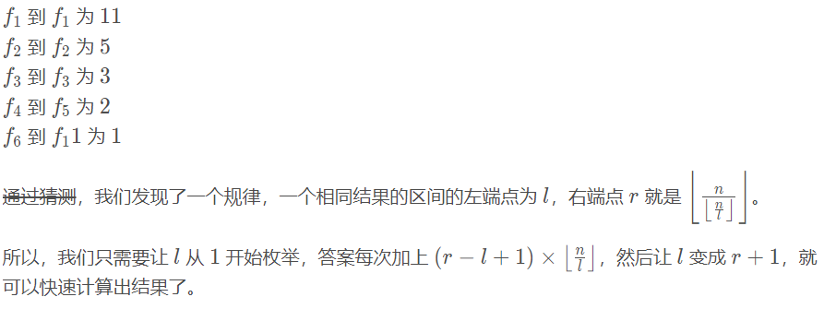int ans = 0;

for(int l = 1, r = 0; l <= n; l = r + 1) {

r = n / (n / l); // 求区间的右端，这是一个数学规律

ans += (r - l + 1) * (n / l);

}

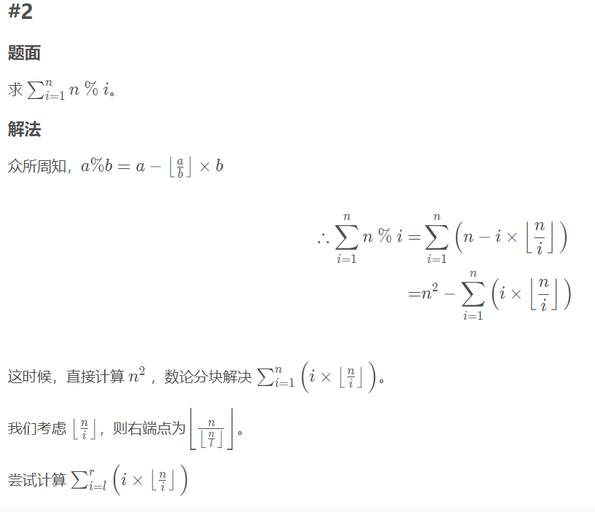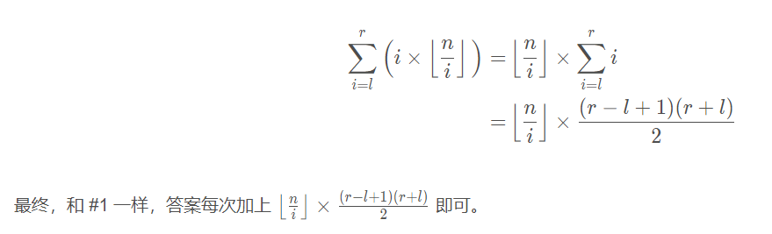

int main()

{

ios::sync_with_stdio(false);cin.tie(0);cout.tie(0);

cin>>n>>k;

ll ans = n * k;

for(ll l=1,r;l<=n;l=r+1)

{

if(k/l!=0) r = min(k/(k/l),n);

else r = n;

ans -= (r-l+1)*(l+r)*(k/l)/2;

}

cout<<ans;

return 0;

}