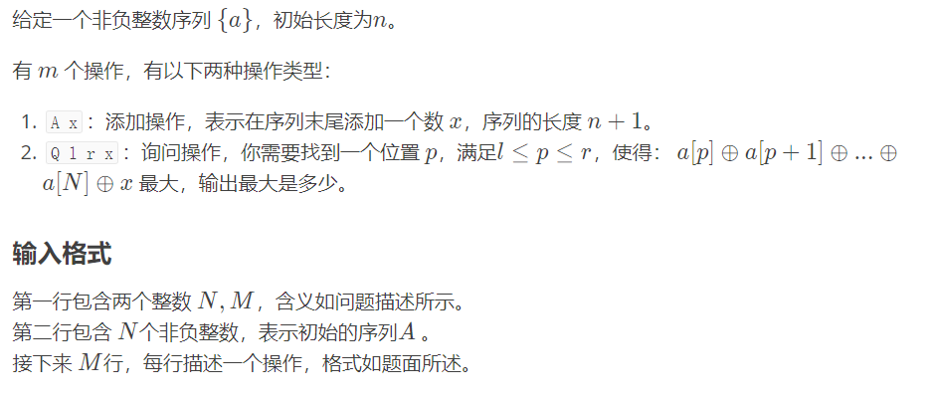

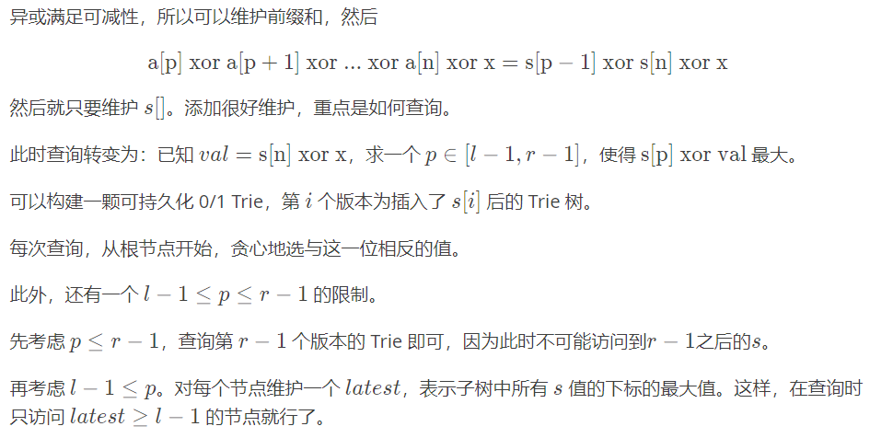

#include <bits/stdc++.h>

#define ll long long

#define inf 1e18

#define mn 600005

using namespace std;

ll rt[mn],tim[mn\*28],ch[mn\*28][2],qz[mn],tt=1,n,m;

void ins(ll a,ll b,ll t,ll x)

{

if(t<0)return;

ll i=(x>>t)&1;

ch[a][!i]=ch[b][!i];

ch[a][i]=tt++;

tim[ch[a][i]]=tim[ch[b][i]]+1;

ins(ch[a][i],ch[b][i],t-1,x);

}

ll ask(ll a,ll b,ll t,ll x)

{

if(t<0)return 0;

ll i=(x>>t)&1;

if(tim[ch[b][!i]]>tim[ch[a][!i]])return (1<<t)+ask(ch[a][!i],ch[b][!i],t-1,x);

else return ask(ch[a][i],ch[b][i],t-1,x);

}

int main()

{

ll a,b,c,i,j;

char s[5];

scanf("%lld%lld",&n,&m);

rt[0]=tt++;

ins(rt[0],0,25,0);

for(a=1;a<=n;a++)

{

scanf("%lld",&b);

qz[a]=qz[a-1]^b;

rt[a]=tt++;

ins(rt[a],rt[a-1],25,qz[a]);

}

for(a=1;a<=m;a++)

{

scanf("%s",s);

if(s[0]=='A')

{

scanf("%lld",&b);

n++;

qz[n]=qz[n-1]^b;

rt[n]=tt++;

ins(rt[n],rt[n-1],25,qz[n]);

}

else

{

scanf("%lld%lld%lld",&i,&j,&b);

i--;j--;

if(i==0)printf("%lld\n",ask(0,rt[j],25,b^qz[n]));//25这个数取决于log2(ai)的大小

else printf("%lld\n",ask(rt[i-1],rt[j],25,b^qz[n]));

}

}

return 0;

}