P2661 [NOIP2015 提高组] 信息传递

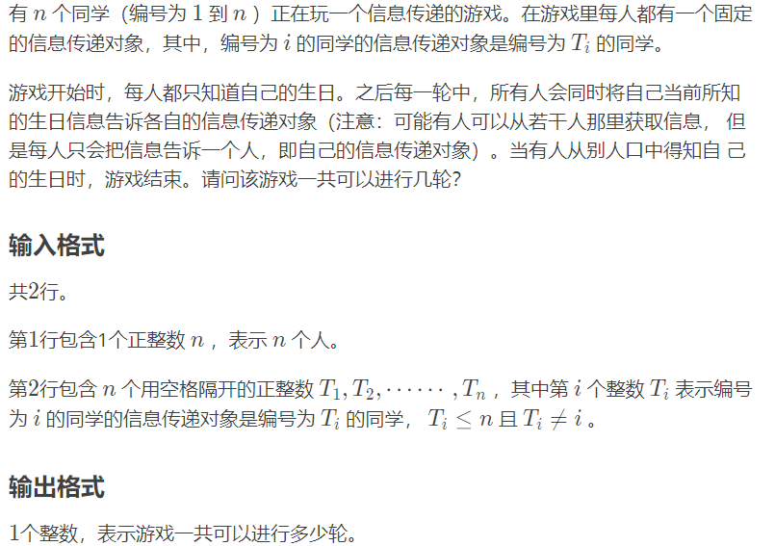

也就是告诉你每个节点的连接方向，叫你求出整个有向图中的最小环

#include<bits/stdc++.h>

#pragma GCC optimize(3)

#define ll long long

#define inf 1e18

#define mn 200005

using namespace std;

ll minn=inf,d[mn],prt[mn],

ans=inf,cnt=0,n,m,p;

ll gf(ll x)//有一点加权并查集的思想

{

if(prt[x]==x)return x;

ll last=prt[x];

prt[x]=gf(prt[x]);

d[x]+=d[last];

return prt[x];

}

void check(ll a,ll b)

{ll x=gf(a),y=gf(b);

if(x!=y){prt[x]=y;d[a]=d[b]+1;}

else minn=min(minn,d[a]+d[b]+1);

return ;

}

int main()

{

ll te,x,y,i,j,k,z;

char ch;

cin>>n;

for(i=1;i<=n;i++)

prt[i]=i;

minn=inf;

for(i=1;i<=n;i++)

{

scanf("%lld",&x);

check(i,x);

}

cout<<minn;

return 0;

}