1. Explain the difference between frontend, backend, and full-stack development with suitable real-world examples.
Frontend development is the part of a website that a user sees and interacts with directly. It includes everything from the text and images to buttons and navigation. Think of it as the visible part of an iceberg. It's built with HTML (the structure), CSS (the style), and JavaScript (the interactivity). A good example is the user interface of Facebook, where you see your news feed, profile, and friends' posts.
Backend development is the server-side logic that powers a website and users don't see. It's the hidden, submerged part of the iceberg. The backend handles data storage, security, and communication with the database. For Facebook, the backend stores user data, authenticates logins, and fetches the posts for your news feed.
Full-stack development involves working on both the frontend and backend. A full-stack developer can build a complete, end-to-end application. They are skilled in both client-side and server-side technologies.

2. Create a simple diagram showing how the client-server model works in web architecture.
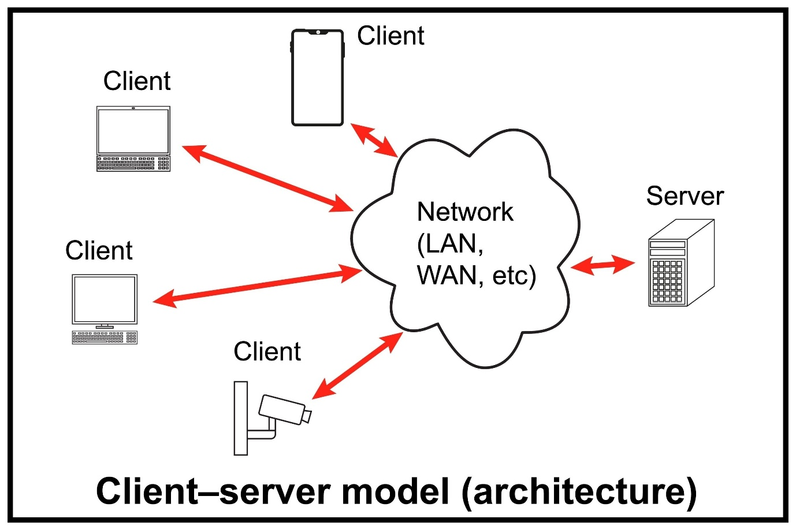
In this model, a client (like your web browser) sends a request to a server. The server then processes the request and sends a response back to the client. This is how websites, emails, and online games work.

3. Describe how a browser requests and displays a web page from a web server.
- Request: When a user types a URL (e.g., www.example.com) into their browser, the browser sends a request to a DNS server to find the IP address of the website's server.
- Connection: The browser uses the IP address to connect to the web server and sends an HTTP request for the page's files.
- Response: The server receives the request, retrieves the necessary files (HTML, CSS, JavaScript), and sends them back to the browser in an HTTP response.
- Rendering: The browser's rendering engine reads the HTML to build the page's structure (the DOM), applies the styling from the CSS, and executes any JavaScript for interactive elements. The final, styled page is then displayed to the user.

4. Identify and list the tools required to set up a web development environment. Explain the purpose of each.
- Code Editor: A program used to write and edit code. VS Code is a popular choice because it's customizable and has powerful extensions.
- Web Browser: Used to view web pages and debug your code. Google Chrome or Firefox are recommended for their robust developer tools.
- Version Control System: A tool that tracks changes to your code over time, allowing you to easily collaborate and revert to previous versions. Git is the industry standard.
- Terminal/Command Line: A text-based interface to run commands, manage Git, and use development tools.

5. Explain what a web server is and give examples of commonly used servers.
A web server is a program that stores website files and delivers them to users' browsers. It listens for requests, processes them, and sends back the appropriate files. Essentially, it's the bridge between the client and the website's data.
Commonly used web servers include:
- Apache HTTP Server
- Nginx
- Microsoft Internet Information Services (IIS)
- Node.js (often with frameworks like Express)

6. Define the roles of a frontend developer, backend developer, and database administrator in a project.
- A frontend developer is responsible for the user interface and user experience. They focus on what the user sees and how they interact with the application, using technologies like HTML, CSS, and JavaScript.
- A backend developer builds and maintains the server-side logic, including databases, APIs, and business rules. They ensure the application's core functionality and security.
- A database administrator (DBA) designs, manages, and secures the database. They ensure data is stored efficiently and can be accessed reliably by the backend.

7. Install VS Code and configure it for HTML, CSS, and JavaScript development. Take a screenshot of the setup.
- Download and Install: Download VS Code from the official website and follow the installation steps.
- Install Extensions: Go to the Extensions view (Ctrl+Shift+X) and install useful extensions like:
  - Live Server: Launches a local development server for live previews.
  - Prettier: Automatically formats your code.
  - ESLint: Analyzes your JavaScript for potential errors.
  - Path Intellisense: Autocompletes filenames in your code.
- Configure Settings: Adjust settings to your preference (e.g., font size, color theme).
- Screenshot of Setup:

8. Explain the difference between static and dynamic websites. Provide an example of each.
- A static website delivers the same content to every user. The pages are pre-built and don't change unless a developer manually updates the files.
  - Example: A simple personal portfolio or a small business brochure site.
- A dynamic website generates content on the fly based on user interaction, database information, or other variables. The content changes with each user or visit.
  - Example: A social media platform like Facebook or an e-commerce site like Amazon, where the content is personalized for each user.

9. Research and list five web browsers. Explain how rendering engines differ between them.
- Google Chrome: Uses the Blink rendering engine.
- Mozilla Firefox: Uses the Gecko rendering engine.
- Safari: Uses the WebKit rendering engine.
- Microsoft Edge: Uses the Blink rendering engine.
- Opera: Uses the Blink rendering engine.
Rendering engines are the core software components of a browser that interpret and display web content. The primary difference is how they parse and render HTML and CSS. While all engines strive to follow web standards, they may have slight variations in their implementation, which can sometimes cause minor differences in how a website appears or behaves across different browsers.

10. Draw a labeled diagram showing the basic web architecture flow — client, server, database, and APIs.
- Client: The user's device (e.g., browser). It sends a request to the server.
- Server: Receives the request, processes the logic, and communicates with the database and other services.
- Database: Stores and manages all the data for the application.
- APIs (Application Programming Interfaces): A set of rules that allow the server to communicate with the database and other external services (like payment gateways or weather data providers).

