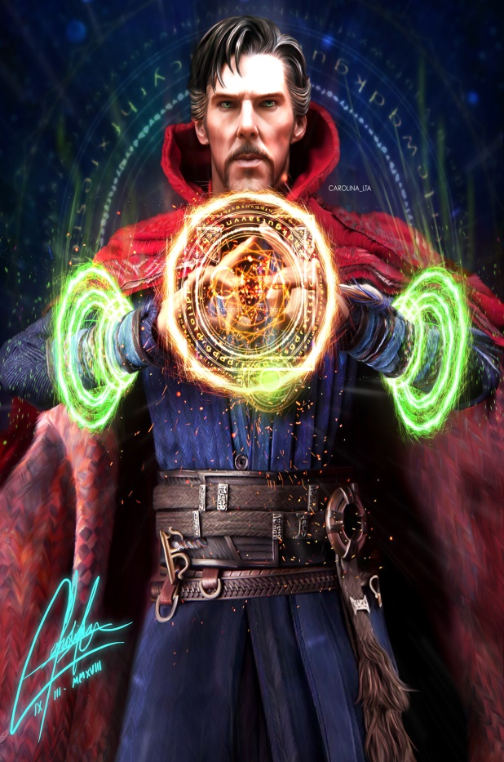

Stephen Strange was a skilled neurosurgeon, too in love with his operation and infinitely confident in himself. A terrible traffic accident deprived the doctor's hand of its former sensitivity. Having lost the meaning of life, the hero set out in search of means of healing the body and soul and many years later became one of the most powerful magicians of the Earth.In addition to his enormous magical power, Doctor Strange is also practically immortal.