Game Design Document

Fill up the following document

1. Write the title of your project

Air Balloon Game________________________________________________________

1. What is the goal of the game?

To collect all the stars_____________________________________________________

1. Write a brief story about the game.

Zachy always wanted to fly an air balloon, when he was 18 he finally managed to get one. But it was a magic air balloon so he was transported to a game where he had to control the air balloon to make the stars become yellow without hitting the birds._______

1. Which are the playing characters of this game?

* Playing characters are the ones who respond to the user based on the input from the user
* Cars, monkeys, dinos, wizards, etc., are the playing characters in the game

| Number | Character Name | What can this character do |
| --- | --- | --- |
| 1 | Air Balloon | Move around and make the stars yellow |

1. Which are the non-playing characters of this game?

* Non-playing characters are the ones who don’t have an action or behaviour when the user interacts with the game.
* Hurdles, stones, bananas, coins, etc., are non-playing characters in the game

| Number | Character Name | What can this character do |
| --- | --- | --- |
| 1 | Star | They become yellow if the air balloon touches them |
| 2 | Bird | If the air balloon touches them the user loses the game |

What is your imagination of the game?

* Draw the game either on your computer or on paper
* Add images of the game scenes to show each of the playing and non-playing characters at least once

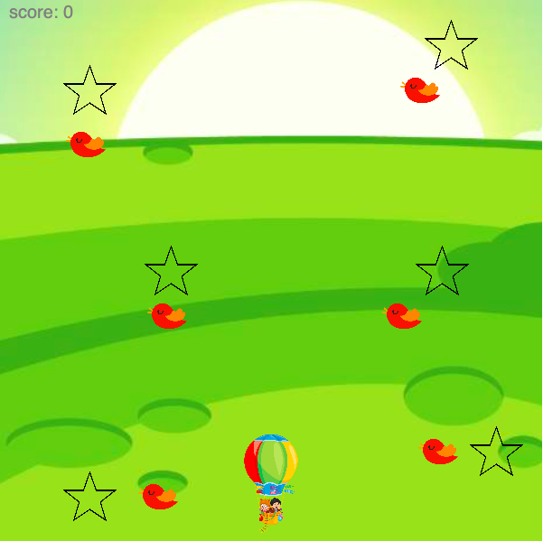

How do you plan to make your game engaging?

I plan to make my game engaging by making it hard but small