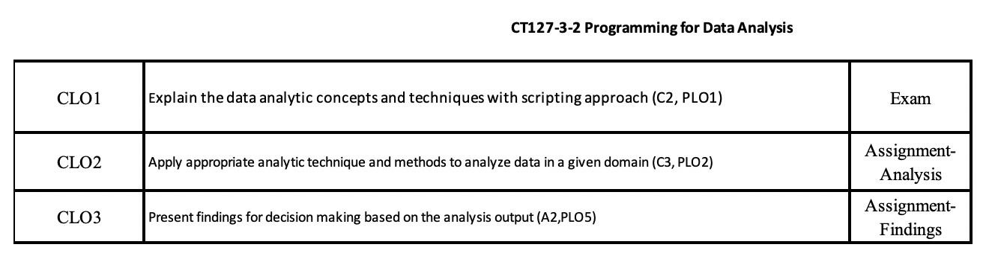
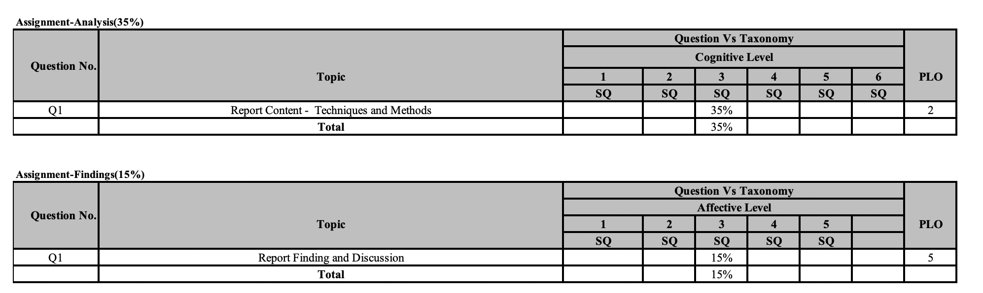

ANALYSIS (70%)  [CLO2-PLO2] |  |  | Fail | Marginal Fail | Pass | Credit | Distinction
ANALYSIS (70%)  [CLO2-PLO2] | ANALYSIS TECHNIQUES (Methodology) |  | 0 - 3 | 4 | 5-6 | 7 | 8-10
ANALYSIS (70%)  [CLO2-PLO2] |  |  | - Not done  - Complete out of the scope  - Irrelevant techniques proposed. | - Inappropriate techniques proposed.  - Just mentioned the technique without any description. | - Appropriate techniques proposed with brief description | - Appropriate techniques proposed with description  - Minimal justification provided. | - Good techniques proposed with detailed description  - Excellent justification provided
ANALYSIS (70%)  [CLO2-PLO2] |  |  | 0-11 | 12-14 | 15-19 | 20-22 | 23-30
ANALYSIS (70%)  [CLO2-PLO2] | ANALYSIS METHODS | Complexity | - Not done  - Incomplete work.  - Very basic RScript provided without any analysis. | - Minimal analysis done.  - Some mixture of exploration and visualization process.  - Some data pre-processing requires but not done.  - Poor programming practices | - A good mixture of exploration and visualization process.  - Incorporate many basic concepts (descriptive analysis only)  - Analysis and visualization done by executing existing functions with original data.  - Basic statistical analysis carried out  - Basic programming practices shown. | - Good mixture of exploration, manipulation and visualization process.  - Incorporate many intermediate concept / knowledge/analysis methods (from descriptive to predictive analysis)  - Good programming practices shown. | - A good mixture of exploration, manipulation and visualization process implemented  - Incorporate many advanced concepts / knowledge/analysis methods (from descriptive to prescriptive analysis).  - Full coverage without any omission or limitations.  - Excellent programming practices and analysis done.
ANALYSIS (70%)  [CLO2-PLO2] | ANALYSIS METHODS | Supporting Document | 0 - 2 | 8 - 9 | 10 - 12 | 13 – 14 | 15 – 20
ANALYSIS (70%)  [CLO2-PLO2] | ANALYSIS METHODS | Supporting Document | - Not available  - Irrelevant explanation / supporting documents provided | - Just mentioned the analysis method or concepts applied.  - Minimal explanation / supporting documents provided | - Brief explanation of the concepts, analysis method applied  - Some screenshots attached with brief explanation. | - Good explanation of the concepts, analysis method applied  - All screenshots attached with explanation. | - Excellent explanation of the concepts, analysis method applied  - All screenshots attached with detailed explanation.  - No weakness identified.
ANALYSIS (70%)  [CLO2-PLO2] |  |  | 0 - 3 | 4 | 5-6 | 7 | 8-10
ANALYSIS (70%)  [CLO2-PLO2] | ADDITIONAL FEATURES |  | - No additional features  - Additional features added to the existing analysis are meaningless. | - Additional features do not enhance the result of the analysis. | - One additional feature included to enhance the result of the analysis | - Two additional features included to enhance the result of the analysis | - Three additional features included to enhance the result of the analysis.  - Additional features implemented ease the analysis process.
ANALYSIS (70%)  [CLO2-PLO2] |  |  |  |  |  |  | /50

FINDING AND DISCUSSION (30%)  [CLO2-PLO5] |  | Fail | Marginal Fail | Pass | Credit | Distinction
FINDING AND DISCUSSION (30%)  [CLO2-PLO5] |  | 0 - 7 | 8 - 9 | 10 - 12 | 13 - 14 | 15 - 20
FINDING AND DISCUSSION (30%)  [CLO2-PLO5] | Finding and Discussion | - Not done.  - Describe the results only.  - Irrelevant discussion | - Describe the results only.  - Poor / minimal discussion / interpretation of the result obtained. | - Finding were discussed briefly without any recommendation. | - Good discussion on the finding.  - Objectives identified were reviewed.  - Some recommendation provided | - Detailed discussion on the finding based on the objectives identified.  - Provided a detailed view on future direction  - Effective interpretation done with professional quality recommendation
FINDING AND DISCUSSION (30%)  [CLO2-PLO5] |  | 0 - 3 | 4 | 5-6 | 7 | 8-10
FINDING AND DISCUSSION (30%)  [CLO2-PLO5] | Project Introduction and report structure and standard | - Documentation not done.  - Mostly poor documentation standards with most of the contents / components are missing.  - Very poor command of the language, etc.  - Irrelevant domain and scenario. | - Some missing components  - Poor documentation standards and works are messy.  - Poor command of the language. | - Overall average documentation standards.  - No missing sections / components.  - Brief content.  - Average command of the language and flow of information from one section to another section. | - Good documentation standards.  - Good explanation and description shown in the content.  - Good flow of information from one section to another section. | - Very good documentation standards.  - Detailed explanation and description shown in the content.  - Clear information and precise content with good information flow.  - Overall documentation has a professional outlook.
FINDING AND DISCUSSION (30%)  [CLO2-PLO5] |  |  |  |  |  | /30

