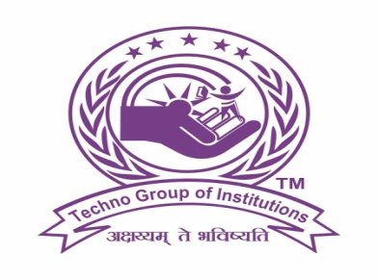

**TECHNO INSTITUTE OF HIGHER STUDIES**

**Associated with University of Lucknow**

**Assignment**

**On**

**Computer Fundamentals & Programming in C**

**(BCA-104)**

**Batch: 2022-2026**

**Session: 2022-2023**

**BCA 1st Year 1st Semester**

**Submitted by: Submitted to:-**

***Shivam Gautam Mr. Ashish Nigam***

**BCA 1st Year 1st  Semester Assistant Professor**

**Roll No. of Computer Science**

**Acknowledgment**

I would like to express my special thanks of gratitude to my teacher **Mr. Ashish Nigam** as well as our principal **Dr. SC Shukla** who gave me the golden opportunity to do this wonderful project on the topic **Computer Fundamentals and Programming in C**, which also helped me in doing a lot of Research and i came to know about so many new things I am really thankful to them. Secondly i would also like to thank my parents and friends who helped me a lot in finalizing this project within the limited time frame.

**Bibliography**

**Internet references:**

[**www.google.com/**](http://www.google.com/)

[**http://www.geeksforgeeg.com**](http://www.geeksforgeeg.com)

[**http://www.slideshare.com/**](http://www.slideshare.com/)