Ans:1 - Two values possible in the Boolean datatype are ‘True and ‘False’. In python, it is like ‘and’,’ or’ and ‘not’.
Ans:2 - The three Boolean types are: AND, OR and NOT.
And:3 – Truth table for AND – (A.B)
OR = A+B
NOT = ā
A | A | A.B
0 | 1 | 0
1 | 0 | 0
0 | 0 | 0
1 | 1 | 1
A | A | A+B
0 | 1 | 1
1 | 0 | 1
0 | 0 | 0
1 | 1 | 1
a | ā
0 | 1
1 | 0

Ans:4 - (5 > 4) and (3 == 5) -> False
not (5 > 4) -> False
(5 > 4) or (3 == 5) -> True
not ((5 > 4) or (3 == 5)) -> False
(True and True) and (True == False) -> False
(not False) or (not True) -> False
Ans:5 - Six comparison operators in python which include less than, greater than, less than or equal to, greater than or equal to, equal to, and not equal to.
Ans:6 - The “ = ” is an assignment operator is used to assign the value on the right to the variable on the left. The ‘==’ operator checks whether the two given operands are equal or not.
E.g. In the if-else condition the double equal to assignment is used, while assigning a value to the variable the single equal sign is used.
Ans:7 – the code will execute in the else section as it is not satisfy the if and else if condition.

Ans: 8 - 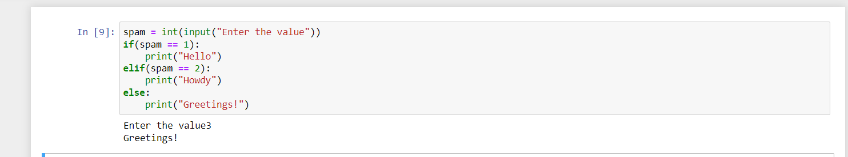
Ans:9 – CTRL + C will end the infinite loop
Ans:10 - Break keyword terminates the rest of remaining iterations of the loop. On the contrary, the continue keyword terminates only the current iteration of the loop.
Ans:11 – range(10) – this will generate the number from 0 to 9, 10 is excluded.
range(0,10) – the 0 is showing the starting point and the 10 is represent the end point. The generation of number like (start, stop-1).
Range(0,10,1) – here the 1 is for the step increment size

Ans:12 - 1 to 10 using for loop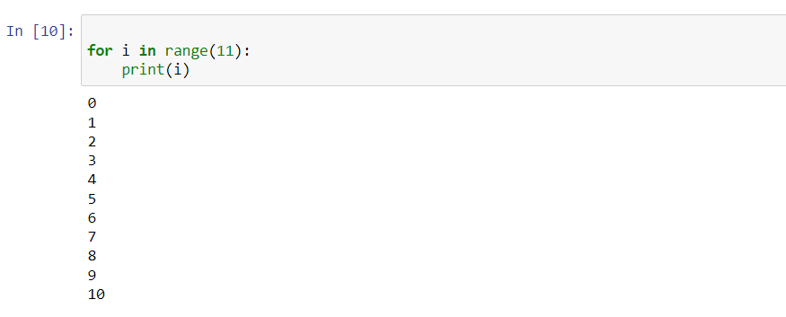
1 to 10 using while loop:
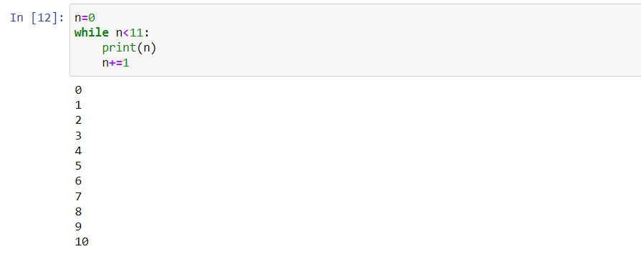

Ans:13 – Below expression can be used to call the bacon function
spam.bacon()

