

National Textile University
Department of Computer Science
Subject
Operating System

Submitted to:
Sir Nasir Mahmood

Submitted by:
Ahsan Ali

Registration Number
23-NTU-CS-1130

Lab No.
10

Semester
5th

TASK1: Parking Lot Simulation
#include <stdio.h>
#include <pthread.h>
#include <semaphore.h>
#include <unistd.h>
#define BUFFER_SIZE 5
int buffer[BUFFER_SIZE];
int in = 0; // Producer index
int out = 0; // Consumer index
sem_t empty; // Counts empty slots
sem_t full; // Counts full slots
pthread_mutex_t mutex;
void *producer(void *arg)
{
int id = *(int *)arg;
for (int i = 0; i < 3; i++)
{ // Each producer makes 3 items
int item = id * 100 + i;
// TODO: Wait for empty slot
sem_wait(&empty);
// TODO: Lock the buffer
pthread_mutex_lock(&mutex);
// Add item to buffer
buffer[in] = item;
printf("Producer %d produced item %d at position %d\n",
id, item, in);
in = (in + 1) % BUFFER_SIZE;
// TODO: Unlock the buffer
pthread_mutex_unlock(&mutex);
// TODO: Signal that buffer has a full slot
sem_post(&full);
sleep(1);
}
return NULL;
}
void *consumer(void *arg)
{
int id = *(int *)arg;
for (int i = 0; i < 3; i++)
{
// TODO: Students complete this similar to producer
sem_wait(&full);
pthread_mutex_lock(&mutex);
int item = buffer[out];
printf("Consumer %d consumed item %d from position %d\n",
id, item, out);
out = (out + 1) % BUFFER_SIZE;
pthread_mutex_unlock(&mutex);
sem_post(&empty);
sleep(2); // Consumers are slower
}
return NULL;
}
int main()
{
pthread_t prod[2], cons[2];
int ids[2] = {1, 2};
// Initialize semaphores
sem_init(&empty, 0, BUFFER_SIZE); // All slots empty initially
sem_init(&full, 0, 0); // No slots full initially
pthread_mutex_init(&mutex, NULL);
// Create producers and consumers
for (int i = 0; i < 2; i++)
{
pthread_create(&prod[i], NULL, producer, &ids[i]);
pthread_create(&cons[i], NULL, consumer, &ids[i]);
}
// Wait for completion
for (int i = 0; i < 2; i++)
{
pthread_join(prod[i], NULL);
pthread_join(cons[i], NULL);
}
// Cleanup
sem_destroy(&empty);
sem_destroy(&full);
pthread_mutex_destroy(&mutex);
return 0;
}

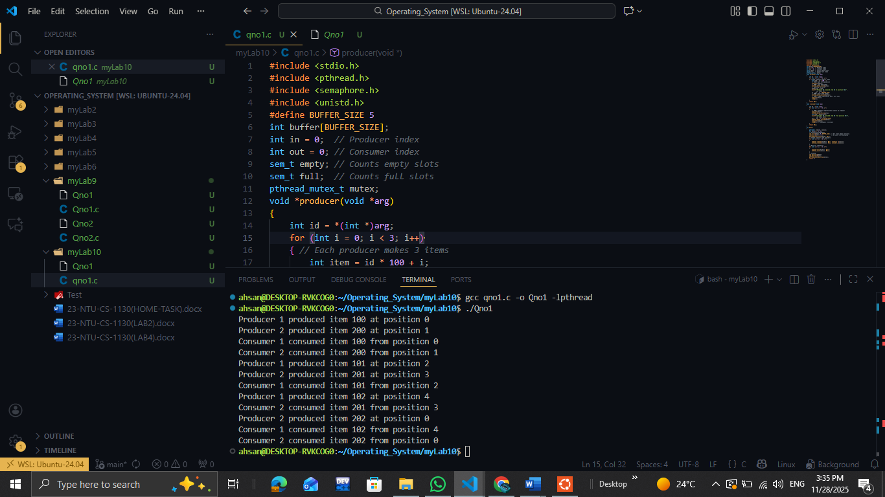

Description:
In this task, we have a buffer size of 5 and two counting semaphores:
- empty (initialized to 5), representing the available empty slots in the buffer
- full (initialized to 0), representing the number of filled slots
We also use a mutex to protect the critical section.There are 4 total threads: two producers and two consumers.
At the start, all buffer slots are empty, so consumer threads must wait because full = 0. They remain blocked until a producer adds an item. Each producer thread, when running, enters a loop and produces 3 items. Since we have two producers, the total items produced are 6. Similarly, each consumer consumes 3 items, making a total of 6 items consumed.
These operations occur concurrently, but the synchronization rules stay the same:
- Producer Workflow
- wait(empty) → decreases the empty-slot count
- mutex lock → ensures only one producer accesses the critical section at a time
- produce item and place it in the buffer
- mutex unlock
- post(full) → increases the full-slot count
- Consumer Workflow
- wait(full) → waits until there is at least one filled slot
- mutex lock → ensures exclusive access
- remove item from the buffer
- mutex unlock
- post(empty) → increases the empty-slot count

