

National Textile University
Department of Computer Science
Subject
Operating System

Submitted to:
Sir Nasir Mahmood

Submitted by:
Ahsan Ali

Registration Number
23-NTU-CS-1130

Lab No.
09

Semester
5th

TASK1: Semaphore
PART1:
#include <stdio.h>
#include <pthread.h>
#include <semaphore.h>
#include <unistd.h>
sem_t mutex; // Binary semaphore
int counter = 0;
void *thread_function(void *arg)
{
int id = *(int *)arg;
for (int i = 0; i < 5; i++)
{
printf("Thread %d: Waiting...\n", id);
sem_wait(&mutex); // Acquire
// Critical section
counter++;
printf("Thread %d: In critical section | Counter = %d\n", id,
counter);
sleep(1);
// sem_post(&mutex); // Release
sleep(1);
}
return NULL;
}
int main()
{
sem_init(&mutex, 0, 1); // Binary semaphore initialized to 1
pthread_t t1, t2;
int id1 = 1, id2 = 2;
pthread_create(&t1, NULL, thread_function, &id1);
pthread_create(&t2, NULL, thread_function, &id2);
pthread_join(t1, NULL);
pthread_join(t2, NULL);
printf("Final Counter Value: %d\n", counter);
sem_destroy(&mutex);
return 0;
}

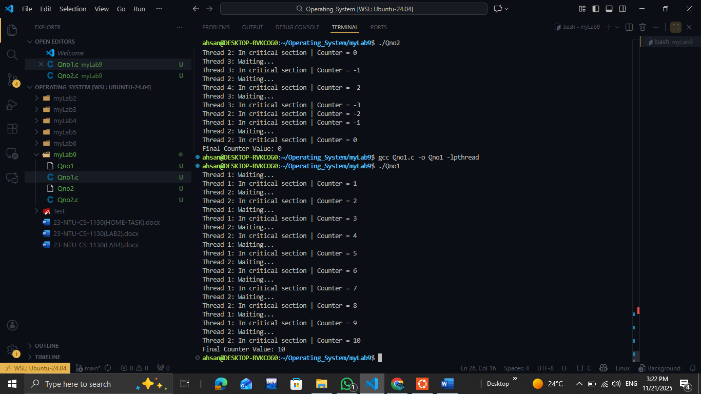
PART2:
#include <stdio.h>
#include <pthread.h>
#include <semaphore.h>
#include <unistd.h>
sem_t mutex; // Binary semaphore
int counter = 0;
void *thread_function(void *arg)
{
int id = *(int *)arg;
for (int i = 0; i < 5; i++)
{
printf("Thread %d: Waiting...\n", id);
sem_wait(&mutex); // Acquire
// Critical section
counter++;
printf("Thread %d: In critical section | Counter = %d\n", id,
counter);
sleep(1);
// sem_post(&mutex); // Release
sleep(1);
}
return NULL;
}
int main()
{
sem_init(&mutex, 0, 1); // Binary semaphore initialized to 1
pthread_t t1, t2;
int id1 = 1, id2 = 2;
pthread_create(&t1, NULL, thread_function, &id1);
pthread_create(&t2, NULL, thread_function, &id2);
pthread_join(t1, NULL);
pthread_join(t2, NULL);
printf("Final Counter Value: %d\n", counter);
sem_destroy(&mutex);
return 0;
}

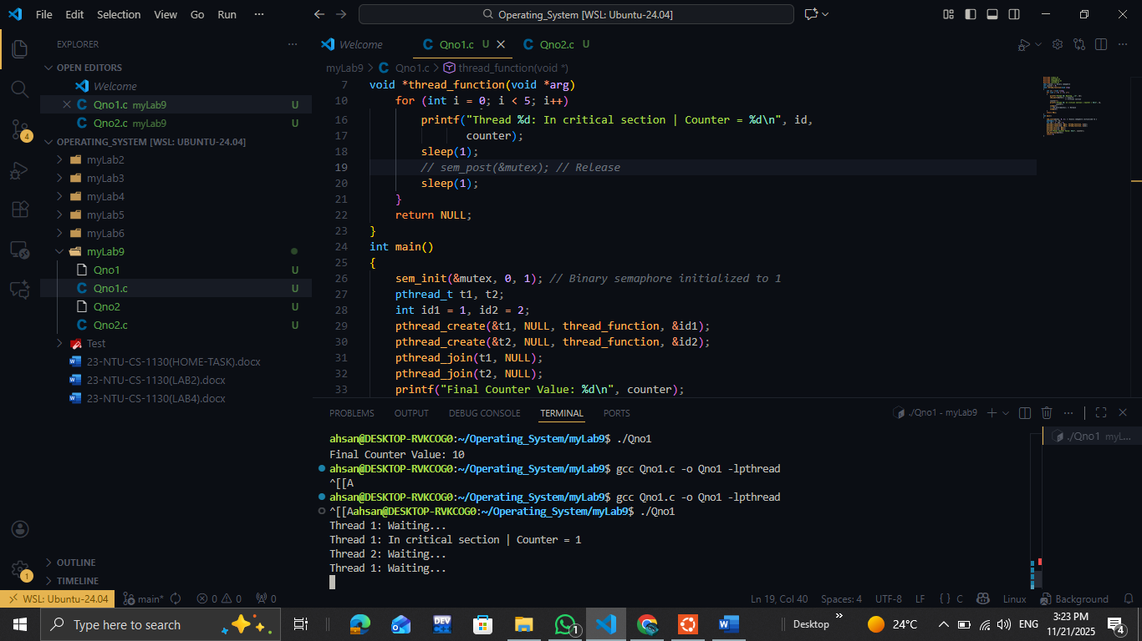
Comments:
- In this code we comment out the sem_post which increase the s by 1 and allow next to come but here as it got comment out so it cannot update value from zero to 1 which cause the thread to w8 and stop working
PART3:
#include <stdio.h>
#include <pthread.h>
#include <semaphore.h>
#include <unistd.h>
sem_t mutex; // Binary semaphore
int counter = 0;
void *thread_function(void *arg)
{
int id = *(int *)arg;
for (int i = 0; i < 5; i++)
{
printf("Thread %d: Waiting...\n", id);
// sem_wait(&mutex); // Acquire
// Critical section
counter++;
printf("Thread %d: In critical section | Counter = %d\n", id,
counter);
sleep(1);
sem_post(&mutex); // Release
sleep(1);
}
return NULL;
}
int main()
{
sem_init(&mutex, 0, 1); // Binary semaphore initialized to 1
pthread_t t1, t2;
int id1 = 1, id2 = 2;
pthread_create(&t1, NULL, thread_function, &id1);
pthread_create(&t2, NULL, thread_function, &id2);
pthread_join(t1, NULL);
pthread_join(t2, NULL);
printf("Final Counter Value: %d\n", counter);
sem_destroy(&mutex);
return 0;
}
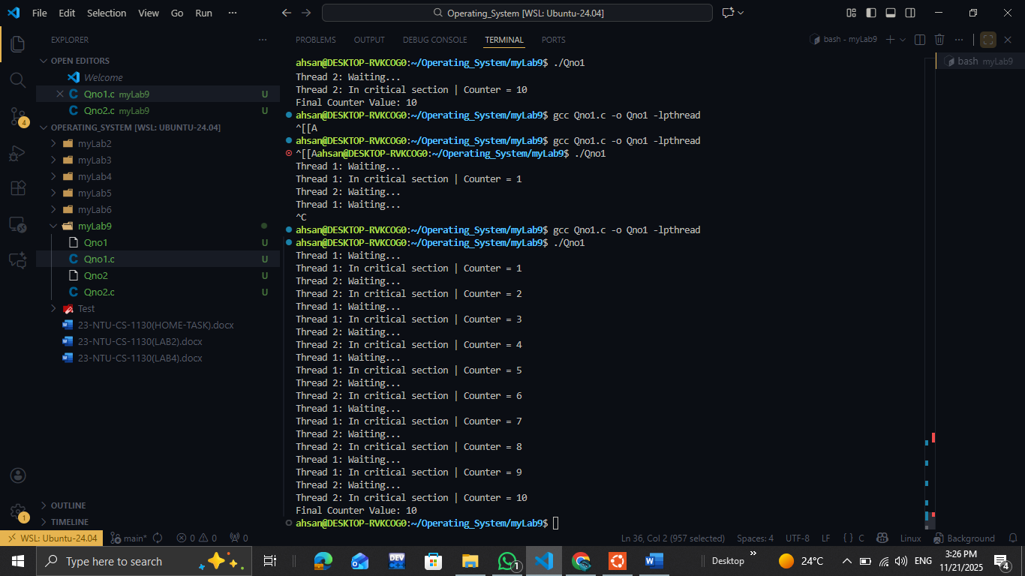
COMMENT:
- When we comment out the wait from the code then the synchronization got not work here and out put cause race condition

TASK2: 2 functions with 4 thread one is increment and other is decrement
#include <stdio.h>
#include <pthread.h>
#include <semaphore.h>
#include <unistd.h>
sem_t mutex; // Binary semaphore
int counter = 0;
void *thread_function(void *arg)
{
int id = *(int *)arg;
for (int i = 0; i < 5; i++)
{
printf("Thread %d: Waiting...\n", id);
sem_wait(&mutex); // Acquire
// Critical section
counter++;
printf("Thread %d: In critical section | Counter = %d\n", id,
counter);
sleep(1);
sem_post(&mutex); // Release
sleep(1);
}
return NULL;
}
void *thread_function1(void *arg)
{
int id = *(int *)arg;
for (int i = 0; i <5; i++)
{
printf("Thread %d: Waiting...\n", id);
sem_wait(&mutex); // Acquire
// Critical section
counter--;
printf("Thread %d: In critical section | Counter = %d\n", id,
counter);
sleep(1);
sem_post(&mutex); // Release
sleep(1);
}
return NULL;
}
int main()
{
sem_init(&mutex, 0, 1); // Binary semaphore initialized to 1
pthread_t t1,t2,t3,t4;
int id1 = 1, id2 = 2, id3 = 3, id4 =4 ;

pthread_create(&t1, NULL, thread_function, &id1);
pthread_create(&t2, NULL, thread_function, &id2);
pthread_create(&t3, NULL, thread_function1, &id3);
pthread_create(&t4, NULL, thread_function1, &id4);
pthread_join(t1, NULL);

pthread_join(t2, NULL);
pthread_join(t3, NULL);
pthread_join(t4, NULL);
printf("Final Counter Value: %d\n", counter);
sem_destroy(&mutex);
return 0;
}

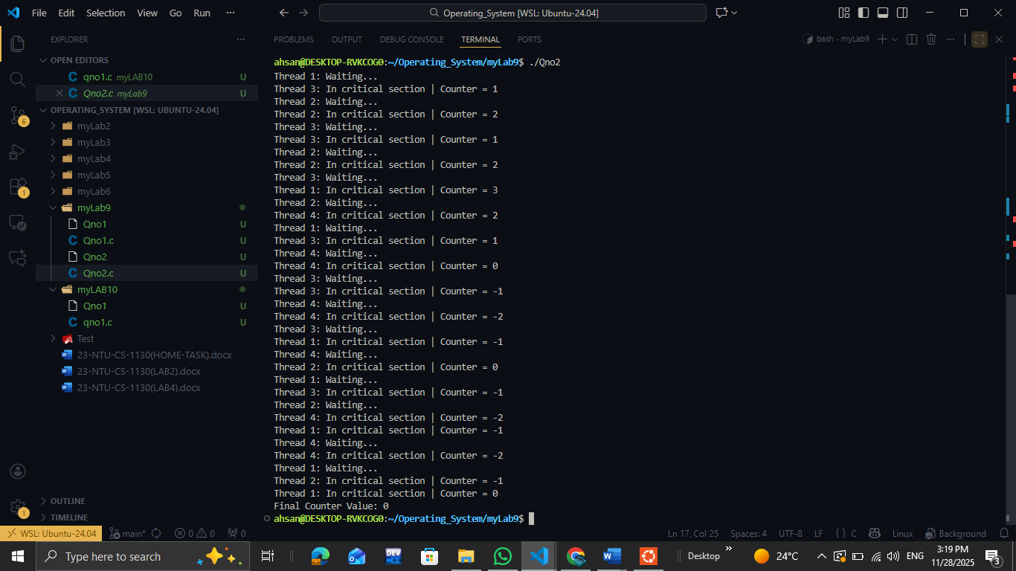
TASK3:comparison between mutex and semaphore
Mutex vs Semaphore — Full Comparison
1. Basic Definition
Mutex
A mutex is a lock.
Only one thread can own it at a time.
It is used for mutual exclusion.
Semaphore
A semaphore is a counter.
It allows N threads to access a resource.
It is used for resource counting or signaling.
2. Ownership
Mutex
Has an owner (the thread that locked it).
Only the owner can unlock it.
Semaphore
Has no owner.
Any thread can signal (increment) it.
3. Value
Mutex
Always 1 (binary).
Semaphore
Binary semaphore (0 or 1)
Counting semaphore (0 to N)
4. Usage Purpose
Mutex
Strictly for mutual exclusion.
Ensures only 1 thread enters a critical section.
Semaphore
Mutual exclusion (binary)
Resource management (counting)
Thread communication (signal/wait)
5. Example Scenarios
Mutex Example
Protecting a shared variable:
Only one thread can update a shared counter at a time.
Counting Semaphore Example
Limiting access to:
A pool of 3 database connections
A pool of 5 printers
6. Behavior
Mutex
If another thread tries to lock it → it blocks.
Deadlock is possible if not handled properly.
Semaphore
If value > 0 → thread enters.
If value = 0 → thread waits.
7. Analogy
Mutex
A single key to a room.
Only one person can enter.
Only the person inside can unlock it.

