

National Textile University
Department of Computer Science
Subject
Operating System

Submitted to:
Sir Nasir Mahmood

Submitted by:
Ahsan Ali

Registration Number
23-NTU-CS-1130

Lab No.
02

Semester
5th

1.1: Basic Commands:
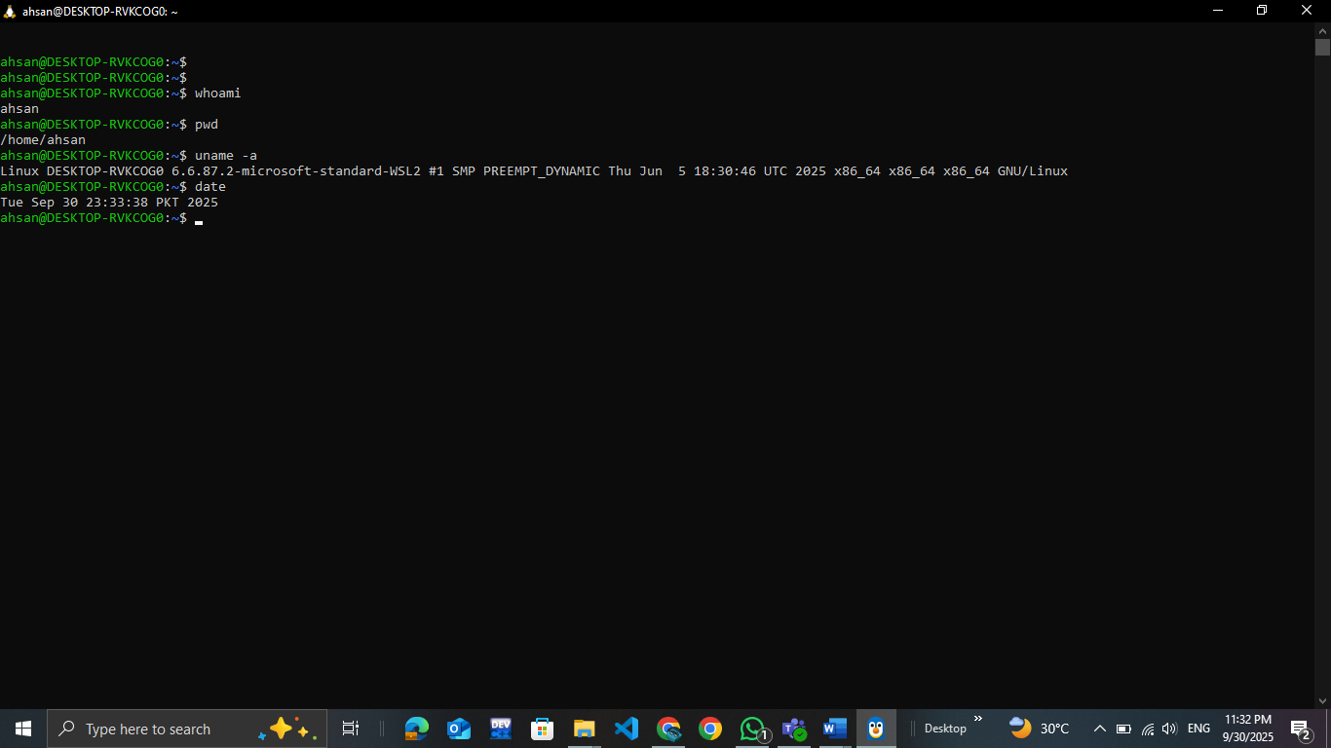
1.2: Getting Help in Linux:
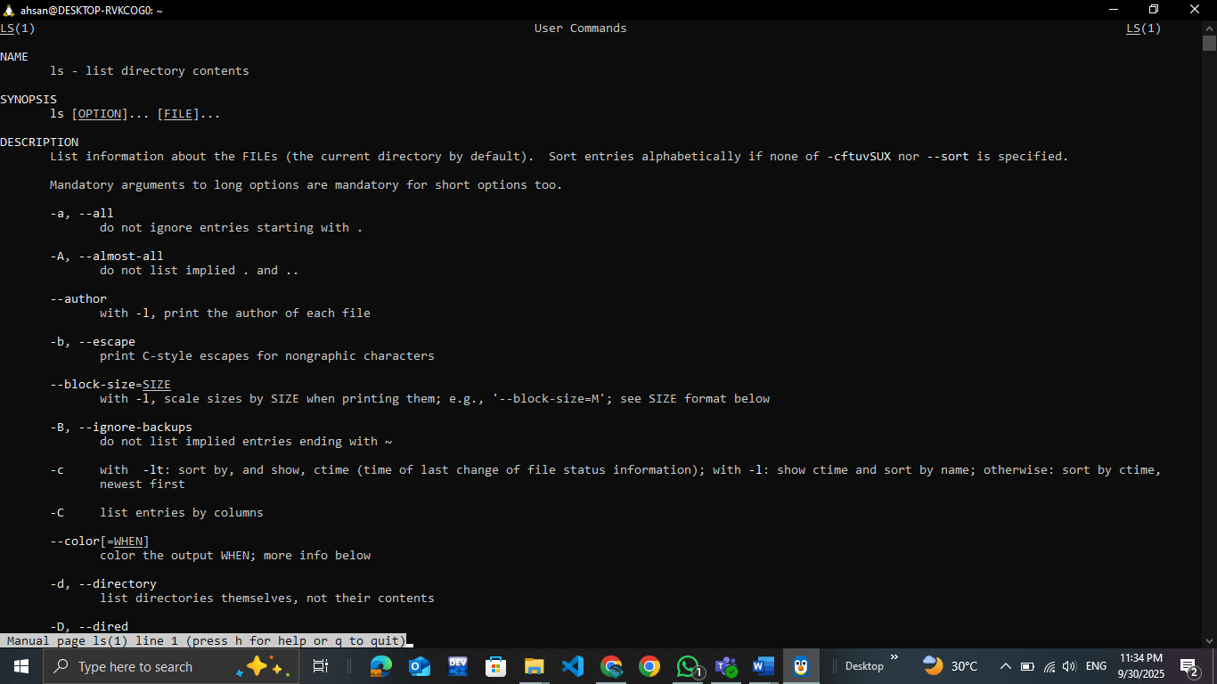

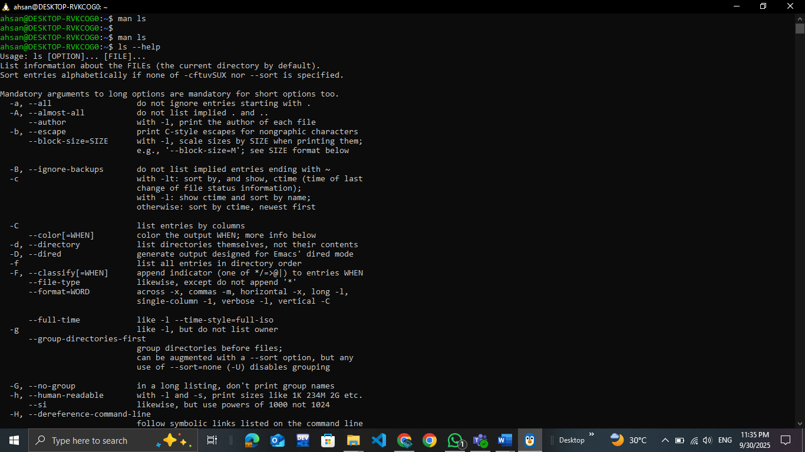
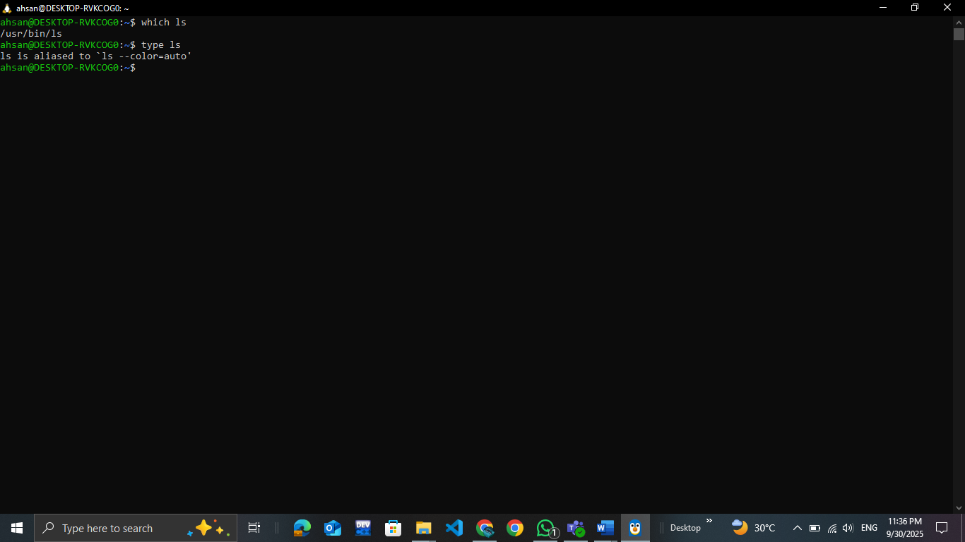
2.1: Linux directory Structure:
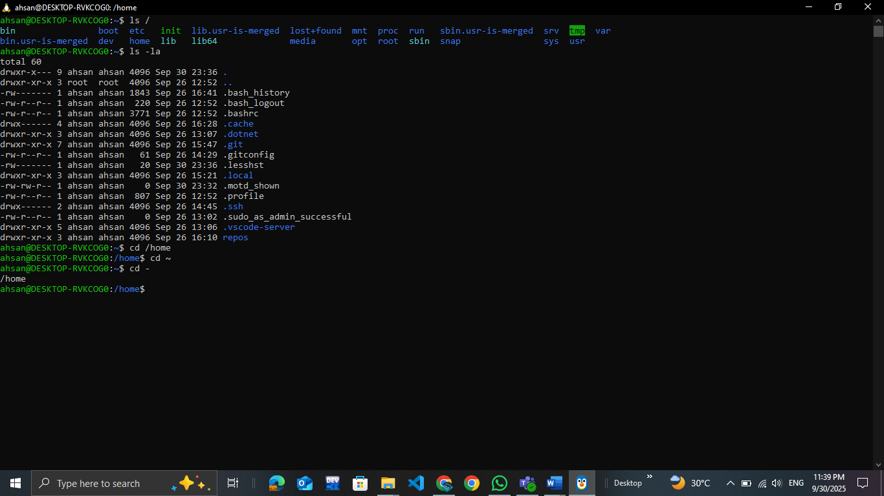
2.2: Basic Navigation:
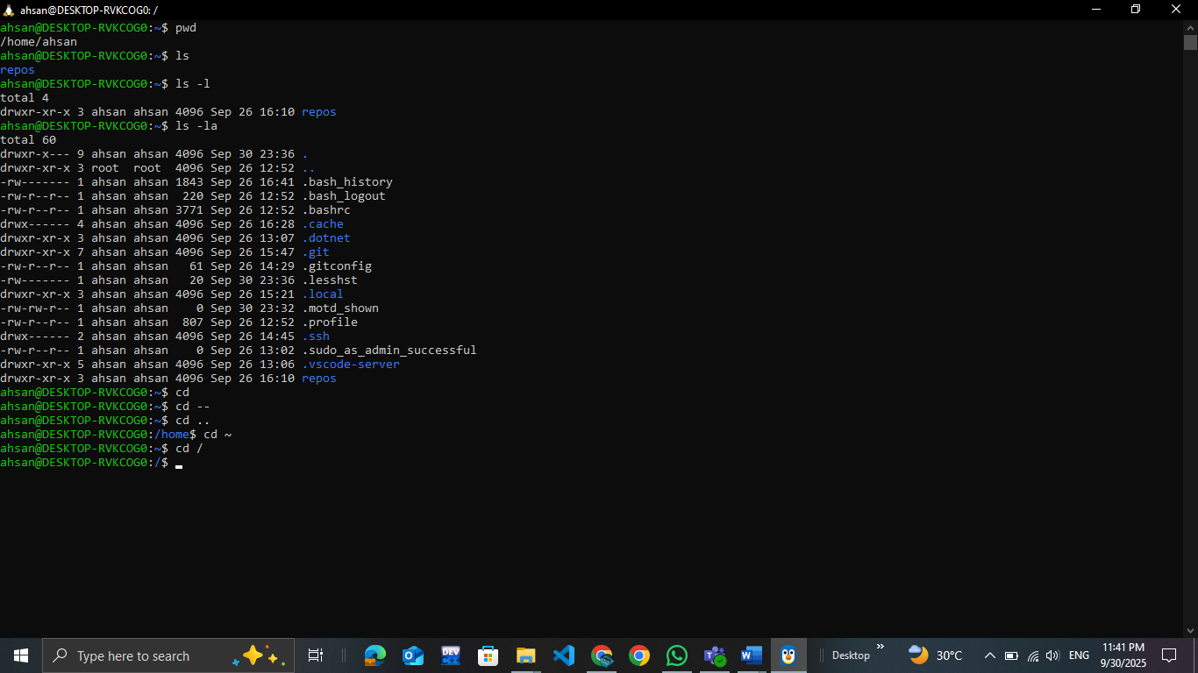
3.1: Linux Directory Operations:
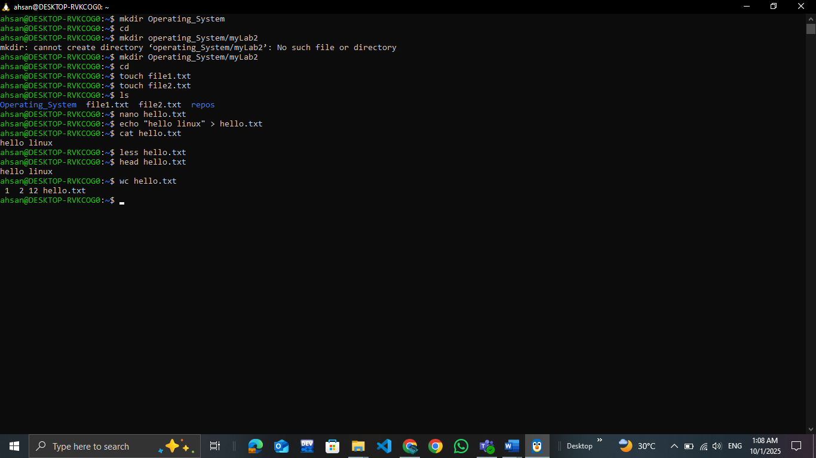
3.2: Copying , Moving and Deleting:
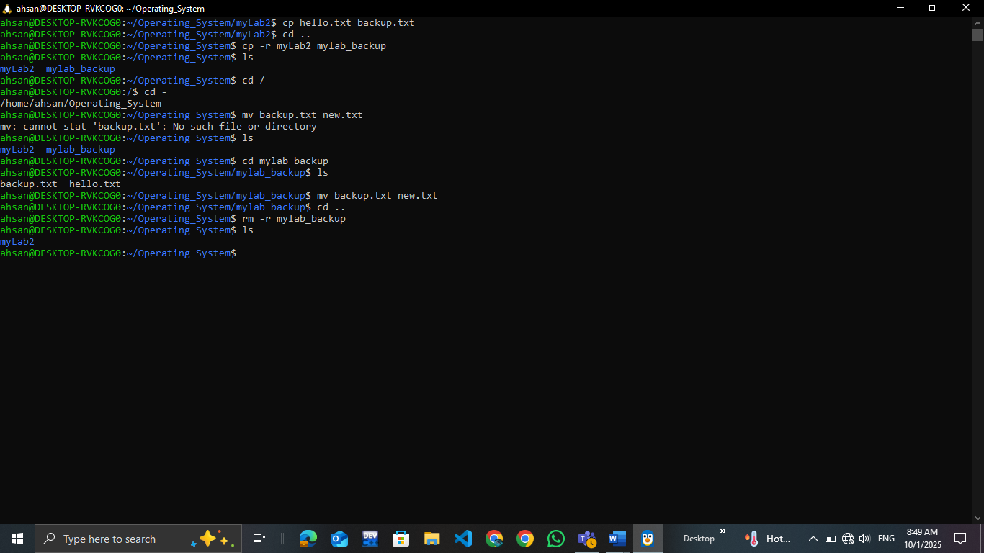

4.1: Understanding File Permissions:
