

National Textile University
Department of Computer Science
Subject
Operating System

Submitted to:
Sir Nasir Mahmood

Submitted by:
Ahsan Ali

Registration Number
23-NTU-CS-1130

Lab No.
04

Semester
5th

3. C Programs with Threads

Program 1: Creating a Simple Thread
Objective: Create a thread and print messages from both main thread and new thread.
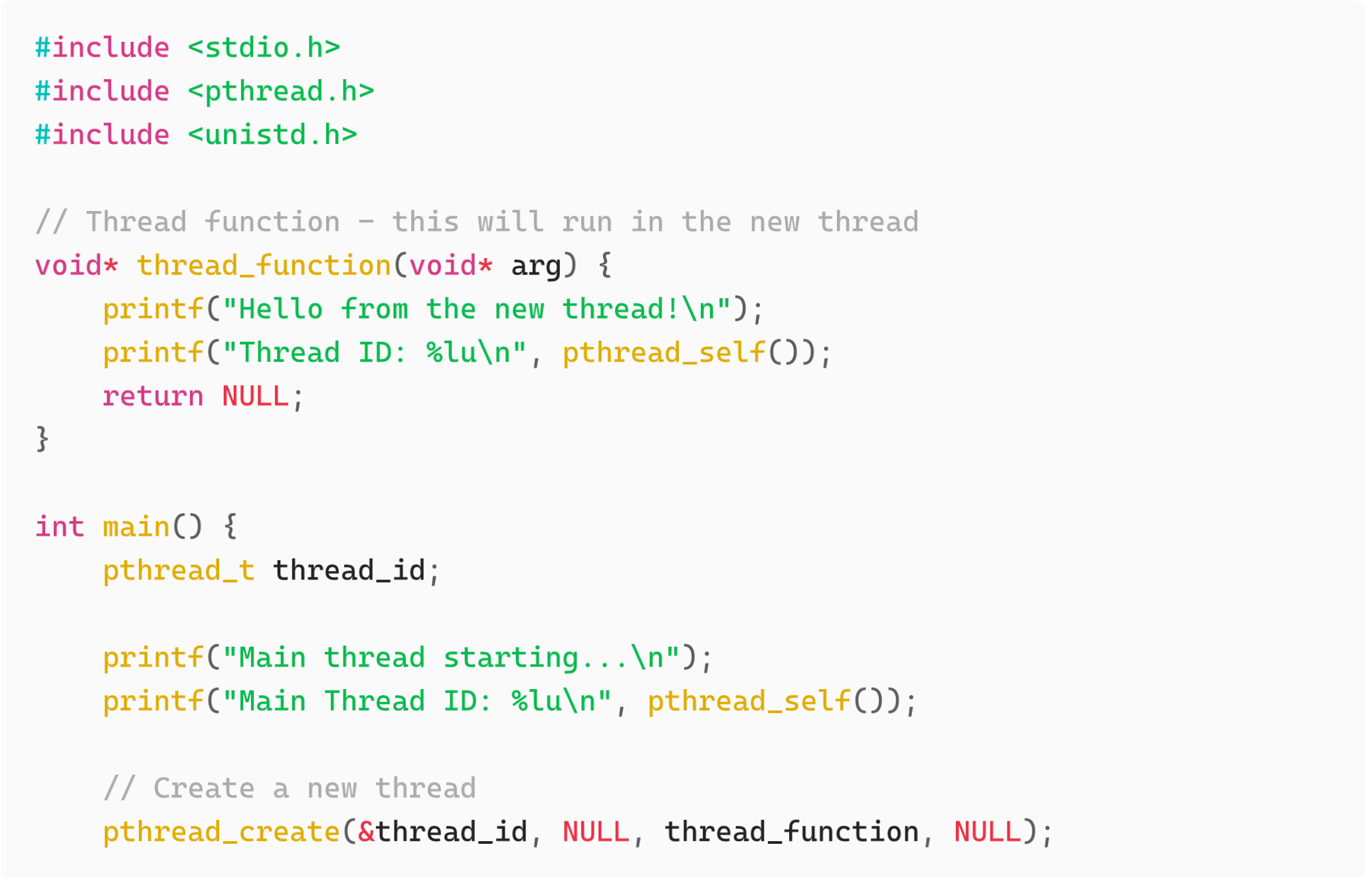
//
Wa
it

for

the

thre
a
d

to

finish
pthre
a
d
_
join
(
thre
a
d
_
id
,
NULL
)
;
printf
(
"
Ma
in

thre
a
d

exiting
...\
n
"
)
;
return
0
;
}

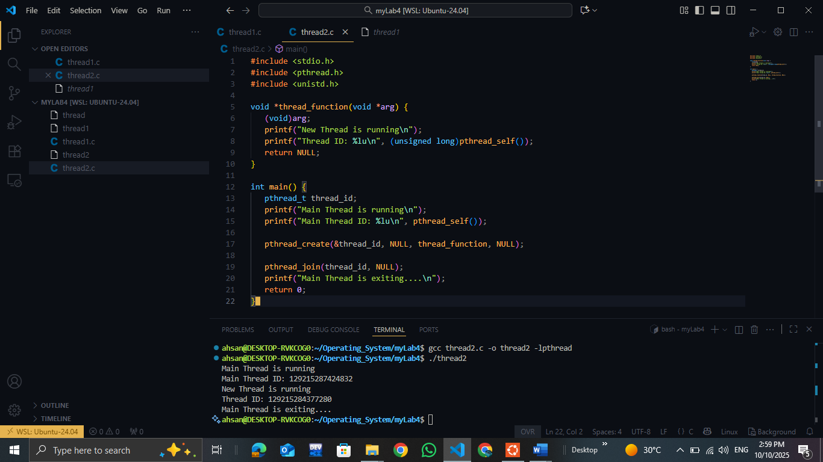

Program 2: Passing Arguments to Threads
Objective: Pass data to a thread function.
#
in
c
lude
<
stdio
.
h
>
#
in
c
lude
<
pthre
a
d
.
h
>
void
*
print
_
num
b
er
(
void
*

a
rg
)
{
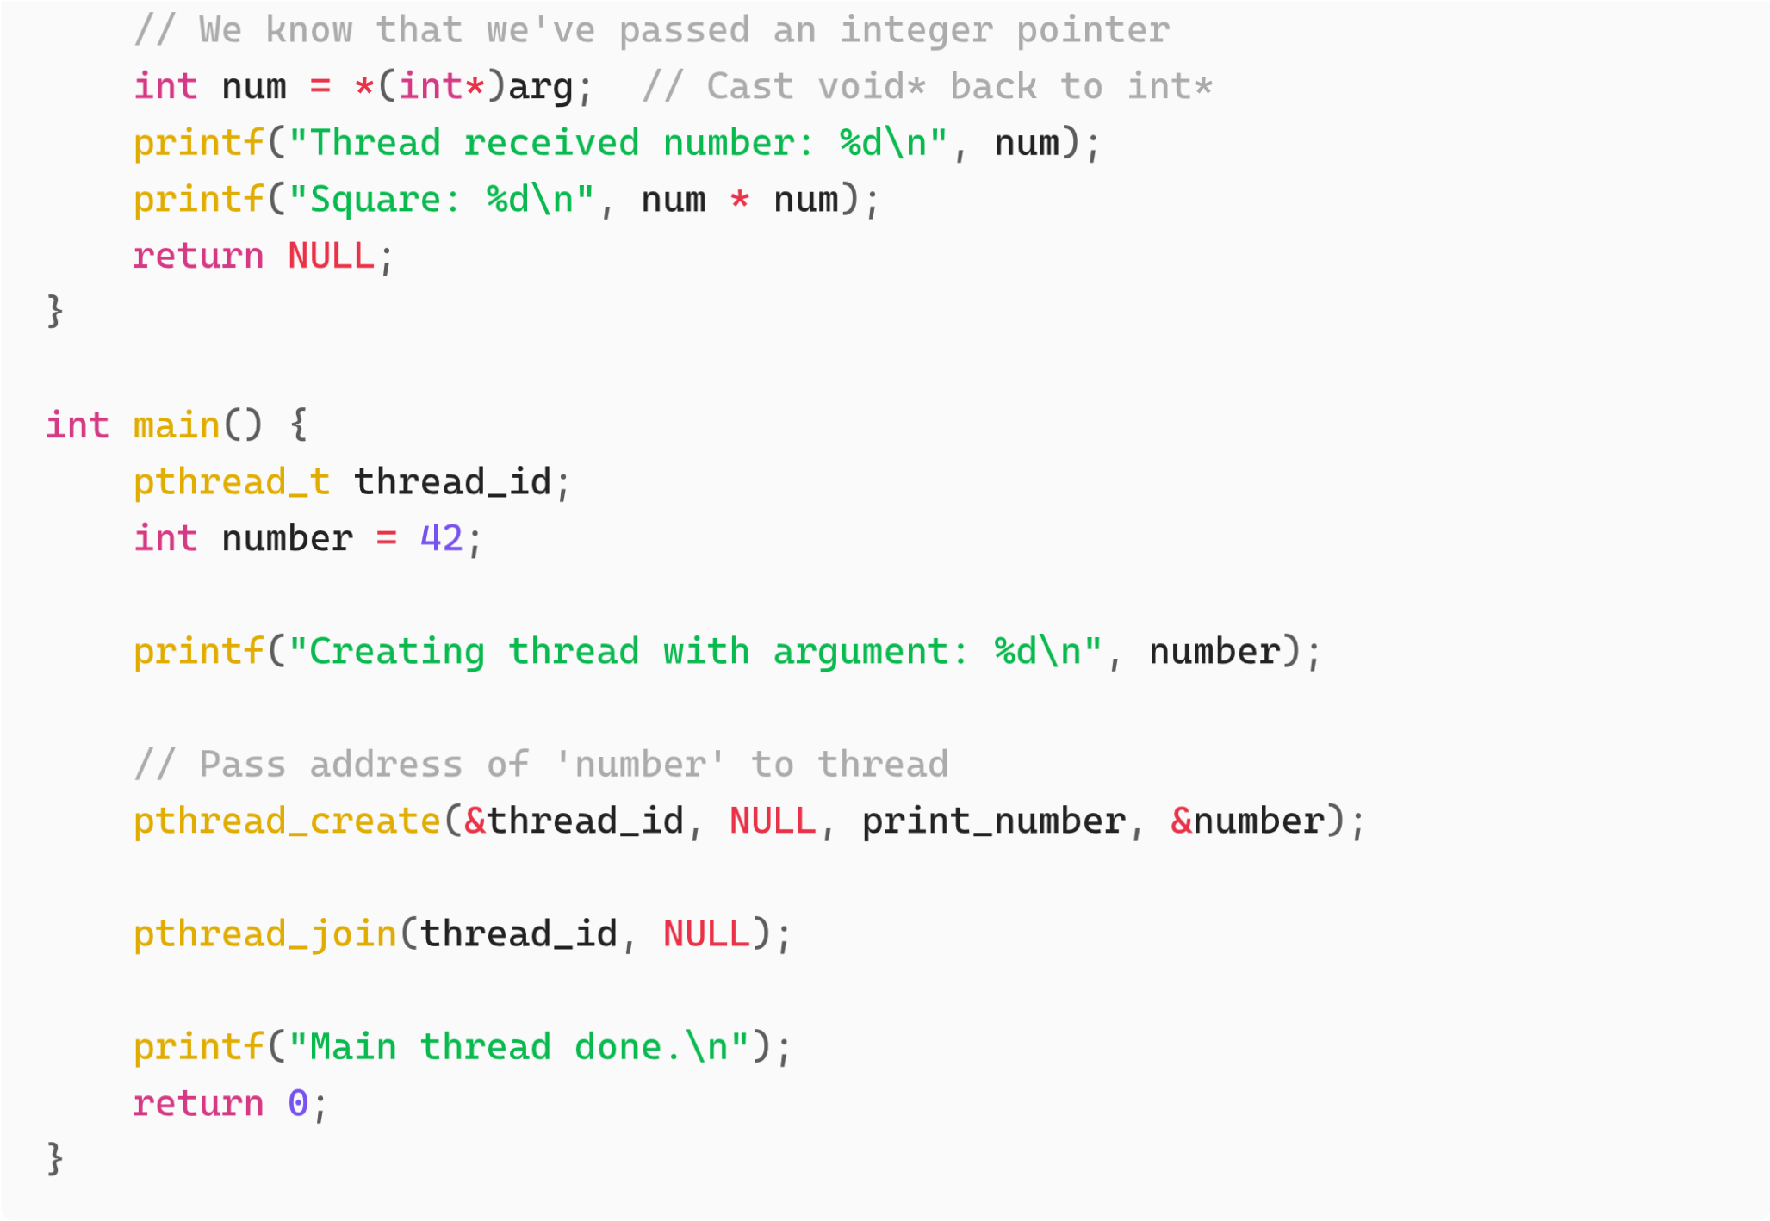
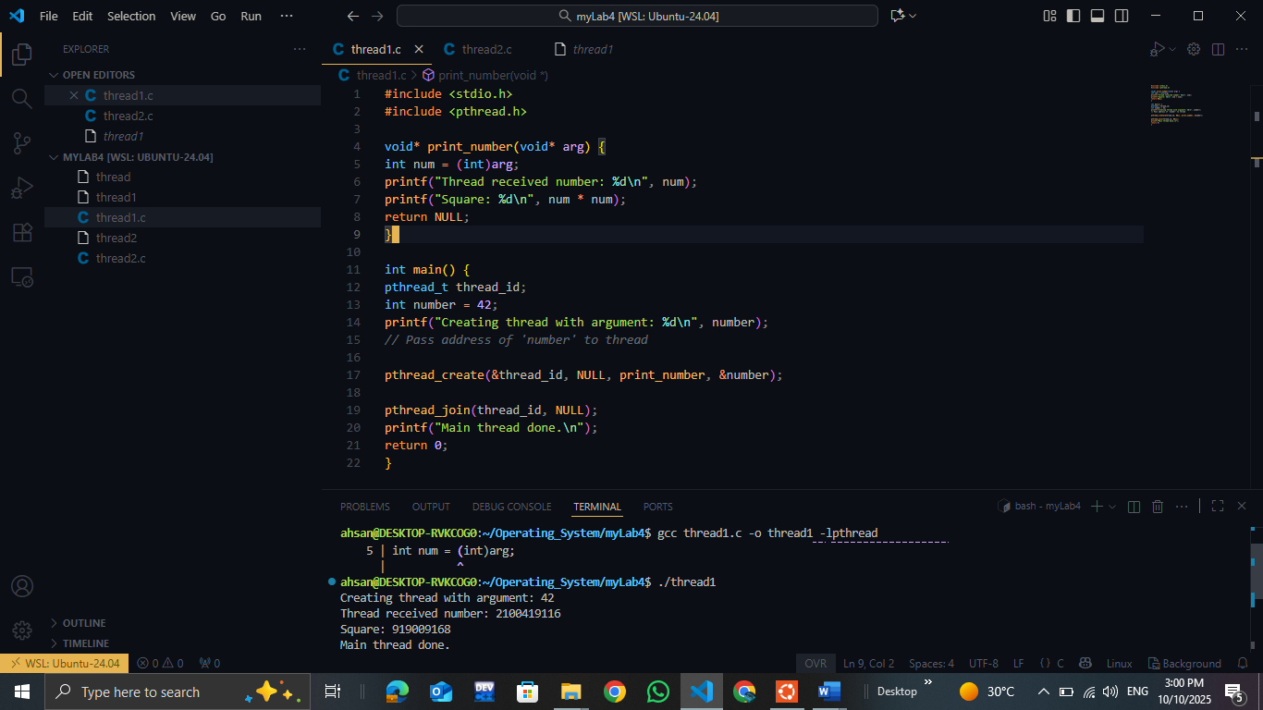

GITHUB PUSH:

