HOTEL MANAGEMENT REPORT
KPI & Business Intelligence Analysis

Transforming Hotel Data into Actionable Business Insights

Prepared By: Arpit Kumar
Institute: Lovely Professional University, Punjab
Domain: Data Science (Computer Science & Engineering)
Project Type: Data Analytics | Placement Portfolio Project

Tool Used: Microsoft Power BI Desktop
Tools & Technologies: Power BI, DAX, Excel

Project Duration: May 2026 – May 2026
Academic Year: 2025 – 2026

Dataset Source: Public Hotel Booking Dataset

Skills Demonstrated:
Power BI, Data Visualization, DAX, Business Analysis, Dashboard Design



1. Introduction

The hospitality industry is one of the most data-intensive sectors in the world. Hotels generate enormous amounts of data every day — from room bookings and cancellations to customer preferences and revenue patterns. However, most of this data remains unused because hotel managers do not have the right tools to understand and act on it quickly.

This project was developed as part of my placement portfolio to demonstrate my ability to work with real business data, build meaningful dashboards, and generate actionable insights using Microsoft Power BI. The project focuses on a hotel management dataset covering two hotels — City Hotel and Resort Hotel — over multiple years (2015, 2016, and 2017).

This project provides a comprehensive analysis of hotel performance using interactive dashboards. It helps in understanding key business metrics in a clear and structured way. The dashboards are designed to present complex data in a simple and visually appealing format.

The analysis focuses on important aspects such as revenue generation, customer behaviour, and booking patterns. It enables better understanding of how different factors impact hotel performance over time. The comparison between City Hotel and Resort Hotel highlights differences in demand and operational trends.

The project also helps identify patterns in customer preferences and seasonal variations in bookings. These insights can support better planning and decision-making for hotel management. The use of Power BI makes the dashboard dynamic and easy to explore through filters and visuals.
Overall, this project demonstrates how data visualization can transform raw data into meaningful business insights. It reflects the practical application of data analytics in solving real-world business problems.

The final report is organized into five analytical dashboards, each answering a specific business question related to hotel operations. Together, these dashboards give a 360-degree view of hotel performance.

1.1 About the Tool Used
Microsoft Power BI is a leading business intelligence and data visualization tool used by companies worldwide. For this project, I used Power BI Desktop to:
- Connect and clean the hotel dataset
- Build a custom Date Table for time intelligence
- Write DAX measures for all KPIs
- Design five interactive dashboard pages
- Add slicers and filters for dynamic exploration

2. Problem Statement

Hotel management teams face several critical challenges in their day-to-day operations that directly affect revenue and customer satisfaction. This project addresses the following key problems:

These challenges highlight the need for a centralized and interactive analytical solution that can provide real-time insights into hotel operations. Without proper visualization tools, decision-making becomes slow, reactive, and less effective.

The lack of integrated data analysis also makes it difficult to identify hidden patterns and correlations between different business factors such as pricing, demand, and cancellations. As a result, opportunities for revenue optimization and cost reduction are often missed.

Moreover, manual analysis of large datasets is time-consuming and prone to errors, which further impacts the accuracy of business decisions. Hotel managers require a system that can simplify data interpretation and present key insights in an easily understandable format.

Addressing these problems is essential for improving operational efficiency, maximizing revenue, and enhancing overall customer experience. Therefore, this project aims to bridge the gap between raw data and actionable insights through an effective dashboard solution.

Core Business Problem
Hotel managers struggle to monitor performance across multiple KPIs in real time. Without a centralized dashboard, they cannot quickly identify revenue trends, high cancellation rates, peak seasons, or underperforming room types — leading to poor business decisions.

Specific Problems Identified:
- High Cancellation Rate: The hotel is experiencing a 37% cancellation rate, which directly leads to revenue loss of 4.50 Million. There is no clear visibility into which market segments or room types are driving these cancellations.
- Revenue Visibility Gap: Management lacks a consolidated view of monthly and yearly revenue trends, making it difficult to plan pricing strategies and seasonal promotions.
- Customer Behaviour Unknown: Without analysing customer stay patterns, repeat guest rates, and booking lead times, the hotel cannot personalize its services or target the right customer segments.
- Occupancy Optimization: With an average occupancy rate of only 63%, there is significant room capacity going unused. Management needs to understand which months, room types, and hotel types perform best.
- Pricing Strategy Gap: ADR (Average Daily Rate) of $102 and RevPAR of $64 need to be monitored monthly to adjust pricing during peak and off-peak periods.

3. Project Objectives

The primary objective of this project is to build an interactive, multi-page Power BI dashboard that helps hotel management make data-driven decisions. The specific objectives are:

# | Objective | Dashboard Page
1 | Create a single-view KPI Summary for quick performance monitoring | Page 1 – KPI Summary
2 | Analyse total revenue, ADR, and RevPAR trends over time | Page 2 – Revenue Analysis
3 | Understand customer booking behaviour and stay patterns | Page 3 – Customer Behaviour
4 | Identify root causes of high cancellation rates | Page 4 – Cancellation Analysis
5 | Monitor occupancy rate by month, room type, and hotel | Page 5 – Occupancy Analysis

In addition to the above objectives, the project aims to simplify complex datasets into meaningful and easy-to-understand visual insights. The dashboards are designed to support quick analysis and help management identify key trends without requiring deep technical knowledge.

Another important objective is to enable comparison between different hotel types, time periods, and customer segments to uncover performance differences. This helps in identifying strong and weak areas of the business.

The project also focuses on improving decision-making by providing clear visibility into important metrics and patterns. With interactive filters and visuals, users can explore the data from multiple perspectives based on their requirements.

Furthermore, the dashboard aims to assist in strategic planning by highlighting seasonal trends, demand fluctuations, and revenue opportunities. This can help management take proactive actions rather than reactive decisions.
Overall, the objective is to demonstrate the practical use of data analytics and visualization tools in solving real-world business problems in the hospitality industry.

4. Why I Designed This Project

I chose the hotel management domain for this project for several important reasons:

This project also allowed me to enhance my data storytelling skills by presenting insights in a clear and structured manner. Instead of just showing numbers, the focus was on explaining what the data means for the business and how it can be used for better decision-making.

Another reason for choosing this project was to gain hands-on experience in designing professional dashboards that follow industry standards. This includes maintaining consistency in layout, choosing appropriate visuals, and ensuring a clean and user-friendly interface.
The project helped me understand how different business metrics are interconnected, such as how occupancy rate, pricing, and cancellations collectively impact overall revenue. This holistic understanding is essential for solving real-world business problems.

4.1 Industry Relevance
The hospitality industry is a major contributor to the global economy. Data analytics is becoming increasingly important in this sector as hotels compete for customers through personalized pricing, targeted marketing, and operational efficiency. Building a dashboard for this domain demonstrates real-world applicability of my skills.

4.2 Complexity of Data
The hotel dataset contains 30+ columns covering bookings, cancellations, customers, rooms, revenue, and stay patterns across two different hotel types. This complexity allowed me to demonstrate advanced Power BI skills including:
- DAX formula writing for 15+ custom measures
- Date Table creation for time intelligence functions
- Relationship modelling between fact and dimension tables
- Cross-filter behaviour management across multiple visuals

4.3 Business Impact
Every dashboard page in this project directly answers a question that a hotel General Manager or Revenue Manager would ask on a daily basis. This shows that I understand not just how to use Power BI, but also how to think like a business analyst.

4.4 Placement Portfolio Value
For my placement interview, I wanted a project that would demonstrate end-to-end analytical thinking — from identifying a business problem to building a solution and extracting insights. This project covers the full cycle and is relevant to any industry that deals with customer data, revenue management, and operational KPIs.

5. Data Model & Technical Setup

Before building the dashboards, I set up a clean and well-structured data model in Power BI. This is the foundation of any good analytics project.

5.1 Dataset Overview
The primary dataset is the Hotel Data table which contains the following key fields:

Category | Columns | Purpose
Booking Info | Arrival Date, Lead Time, Booking Changes, Deposit Type | Understand when and how bookings are made
Guest Info | Adults, Children, Babies, Customer Type, Country | Segment customers by type and demographics
Room Info | Assigned Room, Reserved Room, Room ID | Analyse room utilisation and mismatches
Revenue Info | ADR, Rev | Calculate pricing KPIs and total revenue
Stay Info | Stays in Weekdays/Weekends, Total Days | Understand length and pattern of stays
Cancellation | Is Cancelled, Previous Cancellations, Previous Bookings | Track and predict cancellations
Segmentation | Market Segment, Distribution Channel, Meal, Hotel | Filter data by business category

5.2 Date Table
I created a dedicated Date Table in Power BI with the following columns: Date, Month, Month Number, Quarter, Quarter Name, Week, and Year. This is an industry best practice that enables time intelligence calculations such as month-over-month comparisons, yearly totals, and weekly averages. Without a proper Date Table, many DAX time functions do not work correctly.

5.3 Custom DAX Measures
I wrote 15+ custom DAX measures organized in a separate 'All Measures' table. Key measures include:

Measure Name | What It Calculates
Occupancy Rate | Percentage of rooms occupied out of total available rooms
Average Daily Rate (ADR) | Average revenue earned per occupied room per night
Rev PAR | Revenue per available room — key hotel industry KPI
Cancellation % | Percentage of total bookings that were cancelled
Revenue Loss | Estimated revenue lost due to cancellations
Total Revenue | Sum of all revenue generated across bookings
Total Rooms Booked | Count of all rooms booked (cancelled + non-cancelled)
Total Cancelled Bookings | Count of all cancelled reservations
Avg Day of Stay | Average number of nights guests stay per booking
Week Nights Revenue | Revenue generated from weekday stays only
Weekend Nights Revenue | Revenue generated from weekend stays only
Avg Week Occupied Room | Average number of rooms occupied per week
Total Days of Bookings | Total nights booked across all reservations
Total Weekday Nights | Total weekday nights booked
Total Weekend Nights | Total weekend nights booked

5.4 Slicers & Filters
I added dynamic slicers across all pages so that stakeholders can filter data by: Select Period, Year, Room Type, Market Segment, Meal Plan, Hotel Type, Date, Customer Type, and Reserved Room Type. This makes the dashboard fully interactive and usable for real business decision-making.

Special attention was given to maintaining data consistency across visuals so that all KPIs reflect accurate values when filters or slicers are applied. This helps in building trust in the dashboard outputs.
The use of a dedicated measures table improves organization and makes it easier to manage and update calculations as the project evolves. It also enhances readability for anyone reviewing the Power BI file.
In addition, I ensured that the dashboard performance remains optimized by using efficient DAX formulas and avoiding unnecessary complexity in calculations. This results in faster loading times and a smoother user experience.

The slicers were carefully placed and standardized across pages to maintain a consistent user interface, allowing users to navigate seamlessly between different sections of the dashboard.
Overall, the technical setup ensures that the dashboard is scalable, easy to maintain, and aligned with industry best practices in data modelling and visualization.

6. Dashboard Pages — Detailed Analysis

Page 1: KPI Summary Analysis
This is the main landing page of the dashboard. Its purpose is to give hotel management a quick, at-a-glance view of all critical performance numbers in one place — without having to dig into multiple reports.

Key Metrics Displayed:

KPI | Value | What It Means
Occupancy Rate | 63% | 63 out of every 100 available rooms are filled
Total Days of Bookings | 255K | Total nights booked across all reservations
Total Occupied Rooms | 75K | Total rooms that were actually used by guests
Total Weekend Nights | 70K | Total weekend bookings across the period
Average Daily Rate (ADR) | $102 | Average room price charged per night
Total Weekday Nights | 185K | Weekday bookings dominate the overall volume
Rev PAR | $64 | Revenue earned per available room
Total Cancelled Bookings | 44K | A critically high number of cancelled reservations

Design Choices:
- Mini sparkline charts under each KPI card show trends at a glance
- Two bar charts on the right show Total Revenue by Week and Total Occupied Rooms by Week
- Six dropdown slicers (Period, Year, Room Type, Market Segment, Meal, Hotel) allow instant filtering
- Dark navy and orange color scheme chosen for professional look and readability

Business Insight from This Page:
Key Insight
The 44K cancelled bookings against 75K occupied rooms is alarming — it means for every 2 rooms successfully occupied, almost 1 booking was cancelled. This immediately signals a need for a deeper cancellation analysis.

Page 2: Revenue Analysis
This page focuses entirely on understanding revenue performance — how much money the hotel is making, when it peaks, which segments generate the most revenue, and how weekday vs. weekend revenue compares.

Key Metrics Displayed:

KPI | Value | Significance
Total Revenue | 26M | Overall revenue across all years and hotels
ADR | $102 | Average price charged per room per night
Rev PAR | $64 | Revenue per available room — efficiency metric
Avg Weekly Revenue | 806K | Revenue generated per week on average
Week Nights Revenue | 19M | 73% of total revenue comes from weekday stays
Weekend Nights Revenue | 7M | 27% of revenue from weekend stays

Charts & Visuals:
- Total Revenue by Month (Line Chart): Revenue peaks sharply in July-August, showing clear summer seasonality. Revenue is lowest in January-February.
- Total Revenue by Year (Bar Chart): 2016 was the highest revenue year at 11.7M, compared to 9.8M in 2017 and 4.5M in 2015 (partial year data).
- Rev PAR by Month (Line Chart): RevPAR peaks around August at approximately $80, and stays above $60 from April to November.
- Weekday vs Weekend Revenue by Month (Stacked Bar): Weekday revenue consistently exceeds weekend revenue in every month, confirming that business travellers dominate the customer base.
- Revenue by Market Segment (Donut Chart): Online Travel Agencies (OTA) generate 53% of total revenue (14M), followed by Offline TA/TO at 22% (6M), Direct bookings at 16% (4M), and Groups at 7% (2M).

Business Insights:
Key Insight 1 — Seasonal Strategy
Revenue peaks in July-August. The hotel should implement dynamic pricing (higher rates) in these months and run promotional campaigns in January-February to fill rooms during low season.

Key Insight 2 — OTA Dependency Risk
53% of revenue coming through Online TAs (like Booking.com) is a risk. If the platform changes its commission or algorithm, revenue could drop significantly. The hotel should invest in growing Direct bookings (currently only 16%).

Page 3: Customer Behaviour Analysis
Understanding who the customers are and how they behave is essential for any hotel's marketing and service strategy. This page breaks down customer types, booking patterns, and stay behaviour.

Key Metrics Displayed:

KPI | Value | Meaning
Total Rooms Booked | 119K | Total reservation records in the dataset
Avg Day of Stay | 3.43 | Guests stay an average of 3.43 nights per visit
Total Weekday Nights | 185K | Majority of stays happen on weekdays
Total Weekend Nights | 70K | Weekend stays are about 38% of weekday volume
Total Days of Bookings | 255K | All nights across all booking types

Charts & Visuals:
- Total Rooms Booked & Avg Day of Stay by Month (Combo Chart): Booking volumes are highest from May to October. Avg day of stay peaks in June-July at around 3.7 nights, showing guests stay longer in summer.
- Customer Stay Pattern — Weekday vs Weekend Nights (Stacked Bar): Weekday nights dominate in all months. However, weekend nights are proportionally higher in summer months, suggesting leisure travellers increase in peak season.
- Avg Day of Stay by Market Segment (Horizontal Bar): Offline TA/TO and Aviation customers have the longest average stays (close to 4 nights), while Corporate and Direct customers stay shorter (around 2-3 nights).
- Total Rooms Booked by Customer Type (Donut Chart): Transient customers account for 75.06% (90K bookings), Transient-Party at 21.04% (25K), Contract at 3.41% (4K), and Group bookings are minimal.
- Repeated Customers by Month (Line Chart): Repeat guest numbers fluctuate between 257 and 390 per month, with a peak in March (390) and a low in November (257).

Business Insights:
Key Insight 1 — Transient Customer Dominance
75% of all bookings are from individual transient customers. This means personalization, loyalty programs, and direct booking incentives would have the highest impact on revenue and retention.

Key Insight 2 — Low Repeat Rate
Repeat customers number only 257-390 per month out of thousands of bookings. This is a very low retention rate, suggesting the hotel needs a stronger loyalty or follow-up strategy to encourage return visits.

Page 4: Cancellation Booking Analysis
This is one of the most critical pages in the entire dashboard. With a 37% cancellation rate, understanding why and where cancellations happen is essential for protecting hotel revenue.

Key Metrics Displayed:

KPI | Value | Business Impact
Total Cancelled Bookings | 44K | 44,000 reservations were never fulfilled
Cancellation Rate | 37% | More than 1 in 3 bookings gets cancelled
Revenue Loss | 4.50M | 4.5 Million in revenue was lost to cancellations
Total Rooms Booked | 119K | Base for calculating cancellation percentage
Total Revenue | 26M | Actual revenue earned (after cancellations)
Previous Cancellations | 10K | Guests with history of cancelling before

Charts & Visuals:
- Cancelled vs Booked Rooms by Month (Line Chart): Both total bookings and cancellations follow a similar pattern — they peak between May and September. This suggests that peak season bookings come with a higher risk of cancellation.
- Total Cancelled Bookings by Market Segment (Horizontal Bar): Online TA leads with 20.7K cancellations, followed by Groups at 12.1K, and Offline TA/TO at 8.3K. Direct and Corporate segments have very low cancellation volumes.
- Total Cancelled Bookings by Reserved Room Type (Bar Chart): Room Type A has the highest cancellations at 34K, significantly more than Type D (6K) and Type E (2K). This suggests Type A rooms (likely standard rooms) are over-booked or poorly managed.
- Cancellation per Hotel (Bar Chart): City Hotel accounts for 33K cancellations vs 11K for Resort Hotel. City Hotel has 3 times more cancellations despite likely similar booking volumes.
- Total Rooms Booked by Is Cancelled (Donut Chart): 44K (37.04%) bookings are cancelled while 75K (62.96%) were successfully fulfilled.

Business Insights:
Key Insight 1 — OTA Cancellation Problem
Online TA brings the most revenue (53%) but also causes the most cancellations (20.7K). This is because OTA bookings often have free cancellation policies. The hotel should negotiate stricter cancellation terms with OTA partners or offer incentives for non-refundable bookings.

Key Insight 2 — City Hotel Alert
City Hotel has 3x more cancellations than Resort Hotel. This requires a dedicated investigation — it may be related to the customer mix, pricing policy, or proximity to competitor hotels in the city.

Key Insight 3 — Room Type A Risk
34K out of 44K total cancellations involve Room Type A. This room type needs a special review — perhaps it is being overbooked as a default, or the room quality does not match guest expectations set during booking.

Page 5: Occupancy Analysis
Occupancy is the most fundamental metric in hotel management. An empty room is lost revenue that can never be recovered. This page analyses occupancy rate across multiple dimensions to help management maximise room utilisation.

Key Metrics Displayed:

KPI | Value | Significance
Occupancy Rate | 63% | On average, 63% of rooms are filled at any time
Total Occupied Rooms | 75K | Total rooms that had paying guests
Total Cancelled Bookings | 44K | Rooms that were booked but never occupied
Avg Weekly Occupied Rooms | 1.42K | About 1,420 rooms occupied each week on average
Total Rooms Booked | 119K | Total demand for rooms across the period
Number of Companies | 10 | Corporate clients contributing to occupancy

Charts & Visuals:
- Occupancy Rate & ADR by Month (Combo Chart): Occupancy rate is highest from May to September (60-70%+). ADR peaks in August at around $120, showing the hotel charges more when demand is high. In December, ADR drops to about $85 while occupancy also falls, confirming the need for off-season promotions.
- Occupation Pattern across Months & Room Type (Matrix Table): This table shows occupancy % for every room type (A to L) across each month. Room Type F consistently achieves the highest occupancy (70%+) while Room Type A and L show lower performance (around 59-61%). Total occupancy across all months averages 63%.
- Location-based Occupancy (Map Visual): Shows the geographic spread of hotel guests, confirming that bookings come from multiple countries and continents, with concentration in Europe.
- Occupancy Rate by Month and Hotel (Grouped Bar): Resort Hotel generally maintains higher occupancy than City Hotel in summer months. City Hotel has more consistent year-round occupancy but peaks lower.
- Occupancy Distribution by Room Type (Treemap): Room Type E (71%), F (70%), D (68%), and C (67%) are the top performing room types. Room Type A and B have the lowest occupancy at 59-61%, despite being likely the most common room type.

Business Insights:
Key Insight 1 — Summer Peak Strategy
May to September consistently shows peak occupancy. The hotel should use this window to maximize revenue through dynamic pricing — raising ADR further during July-August when demand is highest.

Key Insight 2 — Room Type A Underperformance
Room Type A has both the highest cancellations AND lowest occupancy. This is a double problem. The hotel should review the pricing, quality, and marketing of Room Type A immediately.

Key Insight 3 — Off-Season Gap
January-February shows the lowest occupancy (around 50-55%). The hotel should design targeted offers, packages, or corporate contracts for this period to improve occupancy during slow months.

7. Overall Business Insights & Recommendations

Across all five dashboard pages, the following major insights emerged from the analysis:

# | Insight | Recommendation
1 | 37% cancellation rate with 4.5M revenue loss | Introduce non-refundable discount rates and stricter OTA cancellation policies
2 | Online TA drives 53% revenue but 47% of all cancellations | Negotiate cancellation terms with OTA partners; grow direct booking channel
3 | Revenue peaks sharply in July-August | Implement surge pricing in summer; offer early-bird discounts to extend peak season
4 | City Hotel has 3x more cancellations than Resort Hotel | Audit City Hotel's booking process, pricing model, and room allocation strategy
5 | Room Type A: highest cancellations + lowest occupancy | Review Room Type A pricing, quality, and how it is presented during online booking
6 | Repeat guest rate is extremely low (257-390/month) | Launch a loyalty program to encourage repeat visits and reduce acquisition cost
7 | January-February occupancy drops significantly | Create off-season packages, corporate contracts, and promotional campaigns
8 | 75% of bookings are individual transient customers | Personalise guest communication and create individual loyalty incentives
9 | Weekday revenue (19M) far exceeds weekend revenue (7M) | Target leisure weekend packages to grow the smaller but improvable weekend segment
10 | Geographic data shows strong European customer base | Focus marketing budget on European markets with multi-language booking support

These insights clearly show that both revenue growth and operational efficiency can be significantly improved through data-driven strategies. By addressing high cancellation rates and optimizing pricing models, the hotel can reduce revenue loss and improve profitability.

The analysis also highlights the importance of understanding customer behaviour and booking patterns. This enables the hotel to design targeted marketing campaigns and personalized services that enhance customer satisfaction.

Seasonal trends observed in the data suggest that proactive planning is essential to balance demand during peak and off-peak periods. Implementing dynamic pricing strategies can help maximize revenue throughout the year.

Additionally, focusing on customer retention through loyalty programs can reduce dependency on third-party booking platforms and lower customer acquisition costs.

8. Conclusion

This Hotel Management Power BI project demonstrates a complete end-to-end business intelligence workflow — from raw data to actionable insights. Starting with a complex 30+ column hotel dataset, I built a structured data model, wrote custom DAX measures, created a proper Date Table, and designed five interactive dashboard pages covering every major area of hotel performance.

The project goes beyond simply displaying numbers — each dashboard answers a specific business question, and each insight is backed by data. The most critical finding is the 37% cancellation rate causing 4.5M in revenue loss, primarily driven by Online TA bookings and concentrated in Room Type A and City Hotel. These findings, if acted upon, could significantly improve hotel profitability.

For my placement interviews, this project demonstrates the following skills that employers look for in a Data Analyst or Business Intelligence role:

Technical Skills | Business Skills
Power BI Dashboard Design | Problem identification & framing
DAX Measure Writing (15+ measures) | Business KPI understanding
Data Modelling & Relationships | Revenue management concepts
Date Table & Time Intelligence | Customer segmentation thinking
Interactive Slicers & Filters | Actionable insight generation
Multi-page Report Design | Stakeholder-focused communication

This project also reflects my ability to present data in a structured and meaningful way, ensuring that insights are easy to understand and directly useful for decision-making. It highlights my focus on not just technical implementation, but also business impact.

Through this project, I gained practical experience in working with real-world datasets and understanding how data can drive strategic decisions in an organization. It strengthened my ability to think from a business perspective and apply analytical tools effectively.

Overall, this project serves as a strong demonstration of my skills in data analytics, visualization, and business intelligence. It showcases my readiness to contribute to data-driven decision-making in a professional environment and adds significant value to my placement portfolio.

This project also demonstrates my ability to work with structured datasets and convert them into meaningful visual stories that support business decisions. It reflects my understanding of how key performance indicators are interconnected and how they influence overall business outcomes.

The insights generated from this analysis can be directly applied in real-world hotel operations to improve efficiency, optimize pricing strategies, and enhance customer experience. This shows the practical relevance of the project beyond academic learning.

9. Report

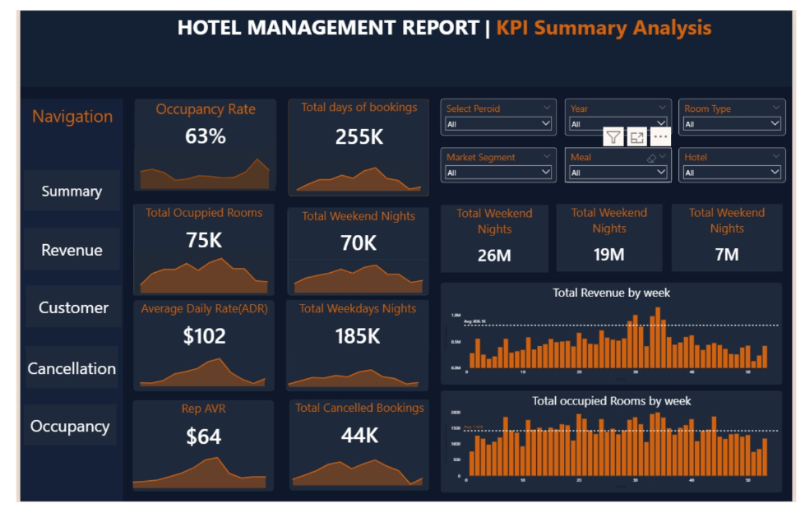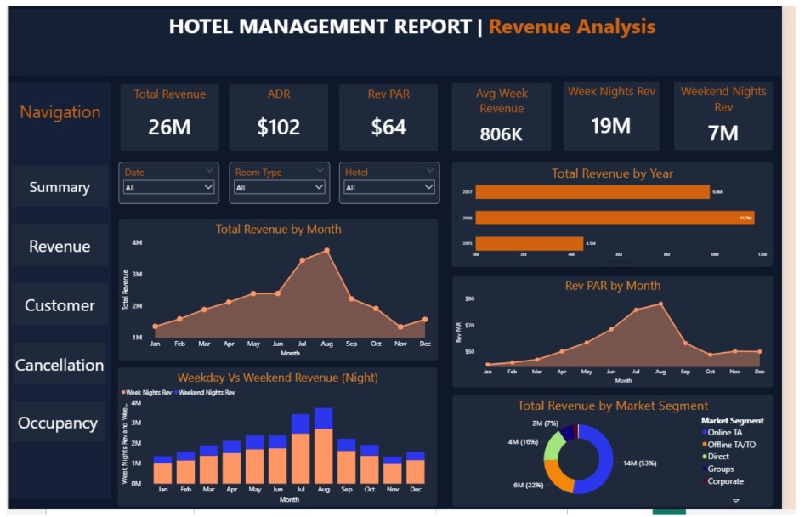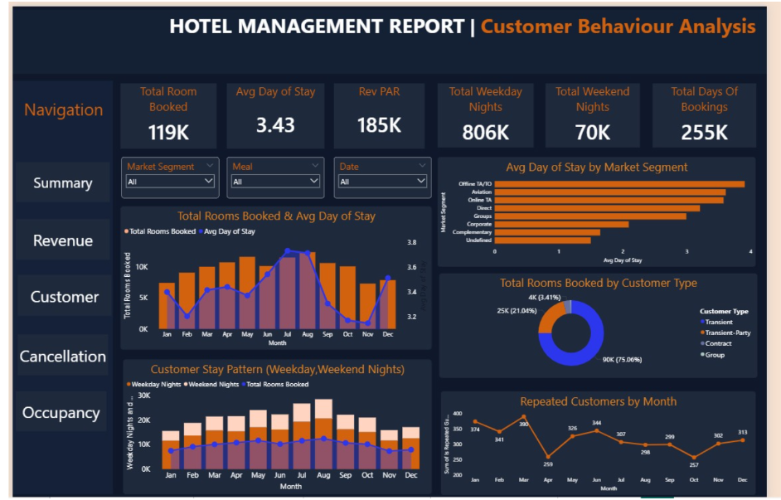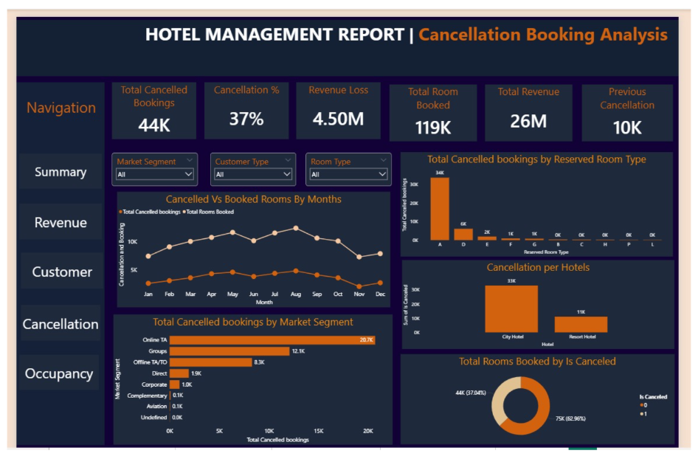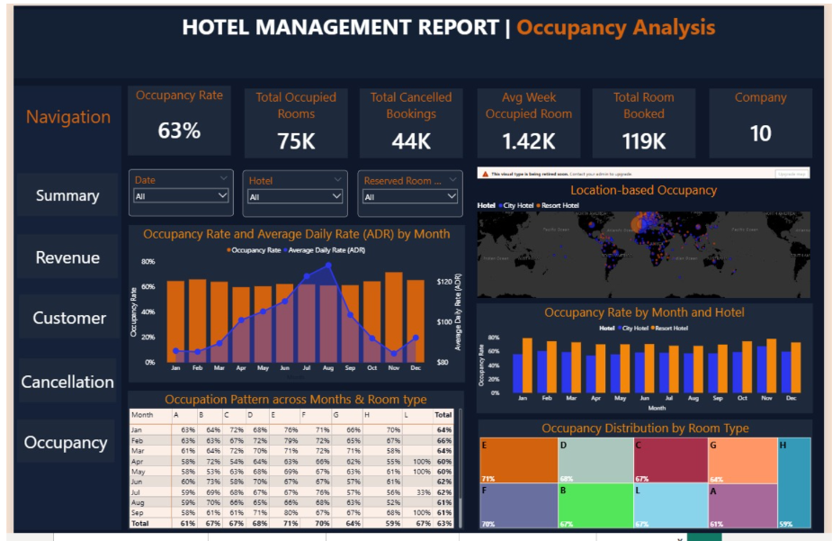

10- Thank You

THANK YOU

Thank You for Your Time and Attention

I sincerely appreciate you taking the time to review this project.

This dashboard reflects my effort to apply data analytics and business intelligence concepts to solve real-world problems in the hospitality industry.

I hope this analysis provides meaningful insights and demonstrates my ability to transform data into actionable business decisions.

Prepared By:

Arpit Kumar

