MoodMotion: Combining Emotion Detection, Physical Activity, and Location Data to Motivate Users to Engage in Activities that Promote Well-Being through Mood Points

Axel Luca

BS/MS in Computer Science  
100 Institute Road, Worcester, MA 01609  
aluca@wpi.edu

Jackson Balcazar

BS/MS in Computer Science and Data Science  
100 Institute Road, Worcester, MA 01609  
jmartinezbalcaza@wpi.edu

Ashkan Ganj  
Ph.D. in Computer Science  
100 Institute Road, Worcester, MA 01609  
aganj@wpi.edu

Mahir Sowad

BS/MS in Computer Science and Data Science  
100 Institute Road, Worcester, MA 01609  
jmartinezbalcaza@wpi.edu

**ABSTRACT**

College students often experience high levels of stress and lead sedentary lifestyles due to academic demands, negatively impacting both their physical and mental health. In this project, we present a mobile application designed to promote wellness among students at Worcester Polytechnic Institute (WPI) by encouraging movement and mood awareness. Our app uses built-in smartphone sensors and APIs to track steps, detect smiles, monitor physical activity, and log visits to specific campus locations. A gamified “Mood Points” system rewards users for engaging in healthy behaviors such as walking, running, and smiling in photos. The application leverages technologies including CameraX, MLKit, Google’s Geofencing API, and Room Database, with an intuitive user interface built using Jetpack Compose. Through internal testing, we validated the accuracy and functionality of each feature. Our work demonstrates the potential of ubiquitous and mobile computing to enhance student well-being through passive, personalized, and context-aware engagement.

**Keywords**

Ubiquitous computing, mobile health, emotion detection, physical activity tracking, Android development, user-centered design, geofencing, step counting, mood tracking, wellness technology.

# 1. INTRODUCTION

## General Problem and Background

College students face increasing levels of stress, with studies showing that approximately 94% of American college students feel overwhelmed by their academic workload [1]. This pressure often results in highly sedentary lifestyles, as students spend prolonged periods indoors and are inactive. Physical inactivity is associated with a range of negative outcomes, including obesity, cardiovascular disease, and mental health issues. Despite growing awareness, over 50% of university students in the U.S., Canada, and China are still considered insufficiently active, highlighting a critical need for interventions that promote student wellness [2].

## Specific Problem and Context

At Worcester Polytechnic Institute (WPI), students are no exception. The 7-week term schedule and the academic rigor confine many to study spaces, reducing students’ abilities to exercise and untimely, can affect their mental health. There is a lack of accessible and engaging tools to help students track their physical and emotional well-being beyond the requirements for gym classes. For example, a student may spend an entire day moving only between dorm rooms and classrooms without realizing how little physical activity they’ve had, or how their mood has declined. We aim to solve this by providing a personalized and motivating approach to fitness and mood tracking.

## Our Approach and Key Results

To address this problem, we developed a mobile application tailored to WPI students that encourages physical activity and mood awareness through a daily point system called Mood Points. The app integrates smile detection, geofencing for campus locations, activity recognition, and step tracking using built-in phone sensors and APIs. Users are rewarded for smiling in photos, visiting designated buildings like the Rec Center, walking or running, and reaching daily step goals. Internal testing demonstrated that the app accurately tracked all parameters and responded correctly to changes in activity, location, and time-of-day transitions.

## Related Work and Novelty

Prior work in ubiquitous and mobile computing has explored activity tracking, mental health monitoring, and fitness apps. However, most existing applications focus on one domain – either physical activity or emotional well-being – and few are tailored to the daily routines and environments of college students. Our work is novel in combining emotion detection, geolocation, and physical ،activity metrics into a single platform specifically designed to support the needs, constraints, and lifestyle of WPI students.

## Challenges

This problem presents many different challenges due to the need to integrate multiple sensing modalities (camera, GPS, step detector with cadence) while preserving usability and battery efficiency. Additionally, encouraging user engagement over time, dealing with permission management on Android, and accurately classifying human activity and emotions in real time added further technical complexity.

## Contributions

The main contributions of our work are:

* A mobile app that uses emotion detection, geolocation, and step/activity tracking to promote student wellness.
* A unique Mood Points scoring system that gamifies physical and emotional health tracking.
* Integrating Google APIs and MLKit to enable real-time, passive monitoring of user behavior.
* A comprehensive user interface built with Jetpack Compose for intuitive user interaction.
* An evaluation framework demonstrating the systems effectiveness in real-world student scenarios.

## Paper Outline

The rest of the paper is organized as follows. Firstly, Section 2 reviews related work in mobile and ubiquitous wellness applications. Section 3 outlines our approach, system architecture, and methodology of our application. Section 4 describes the system design and implementation of our application. Section 5 presents the evaluation methodology and key results. Section 6 outlines our key findings as well as limitations. Finally, Section 7 concludes our paper and goes over future work.

# RELATED WORK

## Mood-tracking apps built on self-report.

Journaling tools such as *Daylio* let users tag each day with an emotion icon and short note, then show streaks and trend charts [3]. While convenient, this approach hinges on deliberate, retrospective input; missing entries and recall bias can blur the picture of a student’s moment-to-moment well-being. Recent surveys of mood-tracking apps echo this limitation, calling for passive sensing that lightens the annotation burden and improves ecological validity.

## ****Activity trackers that stop at steps.****

A large body of evidence links moderate-intensity movement—walking to class, jogging, gym sessions—to lower perceived stress and better affect [4]. Mainstream platforms such as Google Fit and Apple Health convert accelerometer data into step counts, distance, and “move minutes,” successfully encouraging physical activity but leaving the emotional dimension untouched. Users therefore must juggle a separate mood diary if they want to see how exercise and feelings interact.

## Camera-based affect sensing comes of age.

Advances in on-device computer vision have made real-time facial-expression analysis feasible with commodity phones. Multiple studies now show that smile intensity, brow tension, and other micro-expressions correlate with valence and arousal scores captured by ecological momentary assessment [2, 4]. Yet most emotion-recognition prototypes remain stand-alone demos; few are woven into broader wellness workflows that also consider behavior and context.

## Place matters, but few systems notice.

Research suggests that visiting preferred locations—green spaces, common rooms, recreation centers—predicts higher self-reported happiness among students. Geofencing APIs can detect such visits with minimal battery drain, but location remains an under-used signal in student-wellness apps [5].

In short, existing solutions cover individual slices—manual mood logs, step tracking, facial affect, or location—but no single application to date integrates all four streams into one gamified, context-aware experience for college students. Our work addresses this missing synthesis.

# SYSTEM ARCHICTECTURE

## 3.1 System Overview

The aim of our mobile application is to improve the well-being of WPI students by encouraging physical activity, monitoring emotional states, and monitoring the kinds of places they visit. Through a combination of sensors and APIs, the app tracks physical activities (walking, running, and being still), detects emotions (smiling vs. not smiling), and records visits to certain specific locations on campus (see Figure 1). The system then calculates Mood Points daily based on the user's actions taken during the day in order to offer feedback and encourage further positive behavior (see Figure 1). User data, including daily activity, total number of pictures taken, total number of pictures taken smiling, and mood points, is stored in a Room local database to allow users to track their progress over time and provide insights on how they can adjust their behavior if needed (see Figure 1). The main assumption we’re making for our overall application is that users are honest when they take their pictures in the sense that they should only be taking a picture while smiling if they really are in a good mood.

Figure 1. Application System Design Diagram

.

## 3.2 Individual System Components and their Functions

### 3.2.1 Emotion Detection (Smiling vs. Not Smiling)

The Emotion Detection (Smiling vs. not smiling) component of our application’s system takes photos captured by the user as input. The system then processes these photos to determine whether the user is smiling or not. Each time a photo is taken, the number of pictures taken is incremented, and if the user is smiling, the number of photos taken smiling is also incremented. Whenever these values change, the data automatically gets updated in the Room local database to properly allow users to track their daily progress in real time regarding this overall component of our system. As mentioned before, it is expected that users are honest when they take their pictures in the sense that they should only be taking a picture while smiling if they really are in a good mood.

### 3.2.2 Activity Detection

The Activity Detection component of our application’s system uses the device's step detector to count the user’s steps throughout the day. Using cadence calculation, the system determines the type of activity the user is performing, classifying it as either still, walking, or running, based on their step frequency. Whenever the user transitions between activities, the total time spent for walking and running is updated in the Room local database. In addition to this, each time a step is detected, the step count is incremented, and the updated count is also stored in the database. By incorporating this real-time tracking of steps taken and time spent walking and running, the system allows users to monitor their daily physical activity and make the adjustments they see fit regarding those metrics.

### 3.2.3 Location Tracking and Geofencing

The Location Tracking and Geofencing component of our application’s system uses Google’s Geolocation and Geofencing APIs to track the user’s location through a combination of cellular device data, cell tower data, and Wi-Fi access point data [6]. The system continuously monitors the user’s movements and checks if they enter specific, predefined geofenced areas on campus. When the user enters one of these geofenced areas and stays inside it for a brief period of time, the designated location flag in the database updates to indicate that the user has visited that location. This update triggers the app's display to switch the status from "not visited" to "visited" for that location on the user’s interface. Thanks to this, the users can easily check which of the geofenced location they have visited on campus during the day and which ones they have yet to visit.

### 3.2.4 Mood Points

The Mood Points component of our application’s system calculates daily points based on its 3 components above. The Smile Detection component contributes points based on the number of pictures taken with a smile out of the total number of pictures taken. Additionally, the Location Tracking and Geofencing component awards points for visiting specific locations on campus, such as the Rec Center, Campus Center, and Morgan Hall. Moreover, the Activity Detection component provides points based on the user’s physical activity, including walking time, running time, and step count. Whenever the user starts a new day, the Mood Points for the previous day are updated in the Room local database and displayed to the user accordingly. By storing all this data in the Room local database, users can gain insights on their daily engagement with both physical and emotional activities, which they can use to figure out how to make the right adjustments in order to improve their overall well-being.

### 3.2.5 Room Local Database

The Room Local Database is responsible for storing and managing all user data within the application for each day. This includes data such as the total number of pictures taken, number of pictures taken smiling, step count, time spent walking and running, and location visits, and the number of mood points earned the day. The database’s main role in our application’s system is to provide persistent storage to allow the system to track users’ progress over time. Each time new data is captured by any of the system’s other components, the database is automatically updated to ensure that the data presented to the users reflects their real-time progress regarding those components. This is essential as these components are what is used to calculate their daily mood points. In addition to this, by ensuring that the data presented to the users reflects their real-time progress regarding the other components of the application’s system, users can accurately reflect on their actions throughout certain days and understand how those actions influenced their overall well-being. By offering this feature, users can then use the data to take the appropriate steps to improve their well-being if needed.

# IMPLEMENTATION

Our Android app is organized around four sensing pipelines—camera, motion, location, and time—wrapped in a scoring layer and backed by a lightweight on-device database. All components run on commodity phones (API 31+) and require no cloud connectivity, making the intervention frictionless and privacy-preserving for students.

## Scoring system

Every 24-hour cycle the app assembles a single *Mood Points* value on a 0-to-350 scale, and we are using this Mood Points to show user’s overall mood during the day. Bellow we are describing our scoring system based on each individual component and features.

**Smile detection (max 80 pts)**

User must take at least 5 pictures to receive any points for the smile proportionality. If the user has taken fewer than 5 photos during the day, this channel awards 0 points (prevents small-sample noise).

**Building visits (max 90 pts)**

For this we selected 3 main buildings on WPI campus:

* Sports & Recreation Center
* Campus Center
* Morgan Hall

and reward the users with *+30 pts* for visiting each of three geofenced zones. It should be noted that the reasons why we chose these 3 WPI buildings as the buildings that we wanted the students to visit are as follows. To begin, we picked the Campus Center because in addition to being a place where students can get food, it’s also a place where students commonly go to hang out. Additionally, the reason why we picked the Sports & Recreation Center is because this is where students can perform a variety of physical exercises, as well as either walk or run around the track. Now, the reason why we also selected Morgan Hall was because in addition to being another building where students can go get food, it is also the building where the Center for Well-Being is located.

**Activity type (max 120 pts)**

App reward users for running and walking and users can earn up to *+60 pts* from each activity bellow you can see the equations we are using for calculating the rewards:

**Step count (max 60 pts)**

The app also rewards users for walking so we are using the bellow equation for calculating the score pts for user based on the number of steps they are talking throughout each day.

## Implementation Details

### 4.2.1 Emotion Detection

The application’s emotion detection module captures live camera frames using Android’s **CameraX** library. We configure an ImageAnalysis use case to deliver each frame to ML Kit’s Face Detection API (com.google.mlkit:face-detection) with classification enabled (CLASSIFICATION_ALL). For every detected face, we read the smilingProbability score. To prevent spurious detections, the system waits until at least five frames have been processed before awarding any “smile points.” Thereafter, each qualifying smiling frame increments the daily smile counter.

### 4.2.2 Step Counter

To track the user’s steps, we register a listener for the device’s built-in Step Detector sensor (Sensor.TYPE_STEP_DETECTOR) through Android’s SensorManager. The is accumulated in a persistent daily total.

### 4.2.3 Activity Recognition

The activity recognition logic registers Android’s built-in step detector sensor and timestamps each step event into a small rolling buffer of intervals. Every new interval triggers a calculation of average cadence (steps per second) over the last few intervals, and the user is classified as “Still,” “Walking,” or “Running” based on simple thresholds.

### 4.2.4 Location Tracking and Geofencing

We implemented the location tracking and geofencing part of our application with the help of Google’s Geolocation and Geofencing APIs. By using those API’s, we were able to include a map on one of the screens with a pointer representing the user’s exact location so that the user can accurately track their exact location in real time. In addition to this, Google’s geofencing API allowed us to use the latitudinal and longitudinal coordinates of WPI’s Campus Center, Sports & Recreation Center, and Morgan Hall to be able to place uniquely identified geofences around those areas with a 50-meter radius each. Once that was done, we were able to make further usage of these 2 APIs as they allowed us to draw a circle with a radius of 50 meters around the 3 geofenced areas on the map that lets the user see their exact location. By incorporating this, we allowed users to accurately track both whether they are inside any of the geofenced areas and whether they are actively approaching and getting closer to them. Moreover, another thing that using Google’s geofencing API allowed us to do was ensure that the user stayed inside each of the geofenced areas for a brief period of time (approximately 5 seconds) before confirming they have successfully visited those areas.

### 4.2.5 Midnight Flag

We implemented a midnight flag via Android’s AlarmManager. Whenever the time of the day reaches midnight, the flag will toggle on and this will help them to start a new day and make sure that data gets captured for each day as they pass instead of having all of the data being captured for just one day.

### 4.2.6 Room Local Database

For database we are using a room persistent database. The app persists all of its daily metrics in a single table called DailyRecord, where each entry stores the user’s step count, accumulated walking and running time, total pictures taken and smiling pictures detected (via ML Kit’s face detector), composite mood points, and boolean flags for visits to the Recreation Center, Campus Center, and Morgan Hall. User can easily fetch all the data from up to last 4 days. Room provides an abstraction layer over SQLite but with simpler and less error-prone method of querying and manipulating data.

# EVALUATION

## Overview and Methodology

The overall development of our application took significantly longer than originally anticipated. Because of this, our main tool for its evaluation had to be restricted to a user study within the four members of our group. Throughout this study, all four members of the group would periodically take time to go through all of the app's key features to test whether they work the way it was expected. While doing so, we would each report any bugs we detected regarding those features. It should be noted that the most reported bug among the four members of our group was the application not working because we forgot to allow the appropriate permissions.

## Face and Smile Detection Evaluation

To test the functionality of the face and smile detection feature of our application, we took 3 separate pictures. To be more precise, we took 1 selfie with us smiling at the camera, 1 selfie with us not smiling, and 1 picture without any face in it. When we took the selfie with us smiling, there was a bounding box drawn around the detected face successfully, a message saying the user was smiling successfully appeared, and both the number of pictures taken and pictures taken smiling successfully incremented (see Figure 2 and Figure 3).

Figure 2. Screenshot before the selfie with us smiling was taken

.

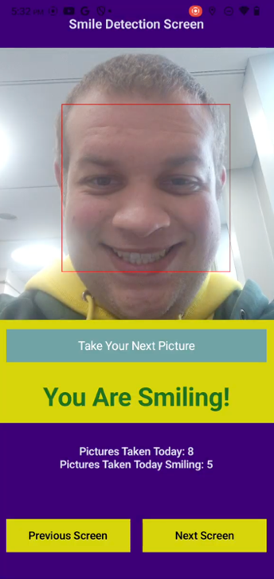

Figure 3. Screenshot after the selfie with us smiling was taken

.

Following that up, when we took the selfie with us not smiling, there was a face box drawn around the detected face successfully, a message saying the user was not smiling successfully appeared, and while the number of pictures taken incremented successfully, not the number of pictures taken while smiling (see Figure 4 and Figure 5).

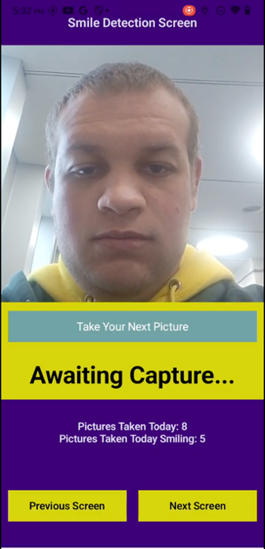

Figure 4. Screenshot before the selfie with us not smiling was taken

.

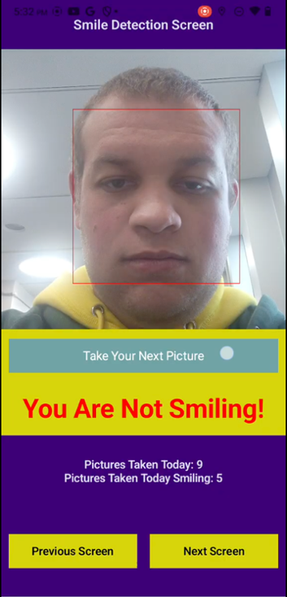

Figure 5. Screenshot after the selfie with us not smiling was taken

.

Finally, when we took the picture with no face in it, no bounding box was drawn, as message saying the user was not smiling was displayed as that is what we considered the default case when taking pictures, and while the number of pictures taken incremented successfully, not the number of pictures taken while smiling (see Figure 6 and Figure 7).

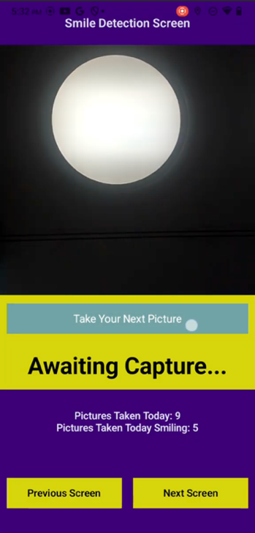

Figure 6. Screenshot before the picture with no face was taken

.

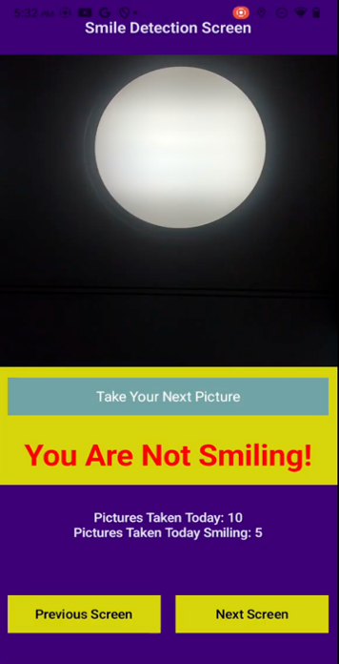

Figure 7. Screenshot after the picture with no face was taken

.

## Location and Geofencing Evaluation

In order to evaluate that this aspect of our application worked as expected, we walked a short distance from our current location to inside one of the geofences we implemented. While conducting our evaluation, we noticed that the pointer representing our location on the screen successfully continuously updated as we moved. On top of this, we also noticed that the screen confirmed that we visited the designated location after staying within its geofence for a short period (see Figure 8 and Figure 9).

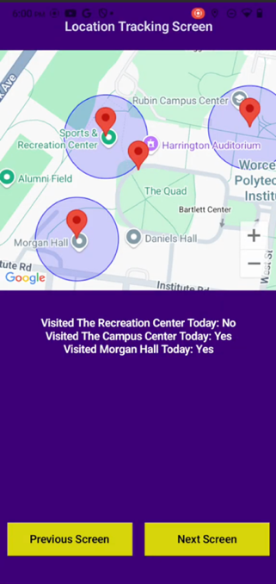

Figure 8. Screenshot before entering the chosen geofence for testing

.

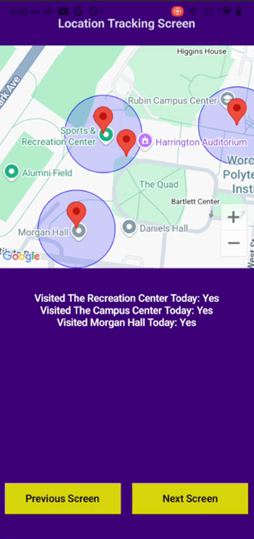

Figure 9. Screenshot after entering the chosen geofence for testing and staying inside it for a brief moment

.

## Step Counting and Activity Detection Evaluation

The way we tested the step counting and activity detection functionalities of our app was by taking steps with the device with the app installed and adjusting our moving pace for being still, walking, and running. While doing so, we first confirmed that the step count increased with our movement (See Figure 10).

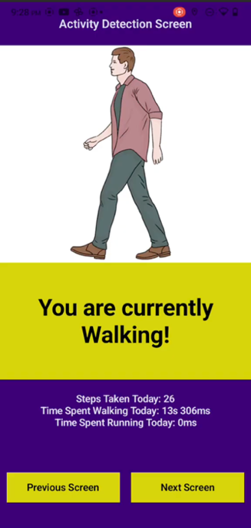

Figure 10. Screenshot after taking several steps while walking

.

Additionally, we also confirmed that activity status would successfully update between still, walking, and running based on our moving pace and cadence, and that the total time spent walking or running updated correctly when transitioning between activity states (See Figure 10, Figure 11, Figure 12, and Figure 13).

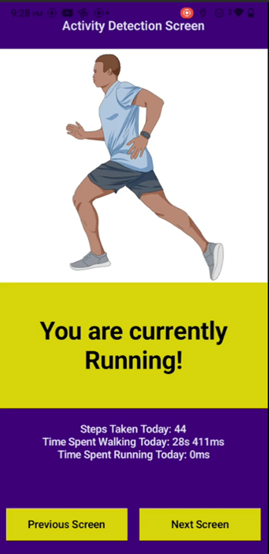

Figure 11. Screenshot after transitioning from walking to running activity states

.

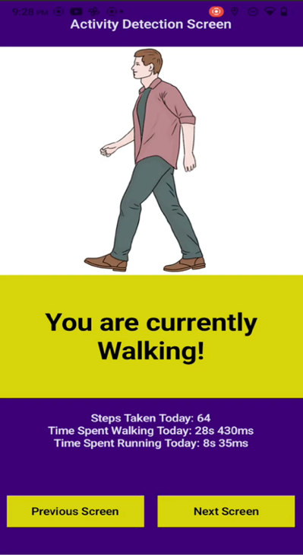

Figure 12. Screenshot after transitioning from running back to walking activity states

.

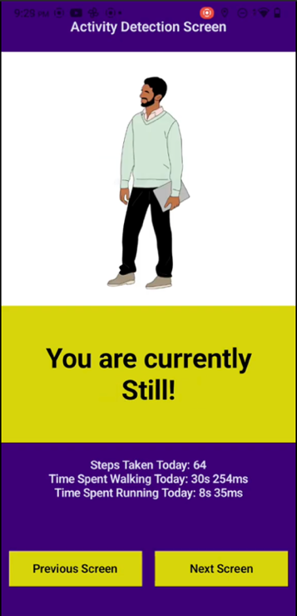

Figure 13. Screenshot after transitioning from walking back to still activity states

.

## Midnight Flag Evaluation

When testing the midnight flag feature of our application, the first thing we did was open the application approximately 1-2 minutes before midnight (see Figure 14).

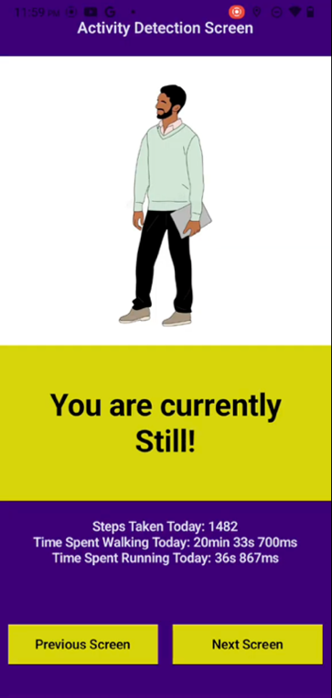

Figure 14. Screenshot of moments right before midnight

.

When the time became midnight, we confirmed our implemented midnight flag turned on as a message telling us that the current day was over and that we needed to refresh the app to start the new day would show up. On top of that, the following was done to validate that no further data was being recorded for the day. Firstly, we verified that number of steps detected, the time spent walking, and the time spent running would no longer increment. Secondly, we verified that activity detected would not transition from "Still" (see Figure 15).

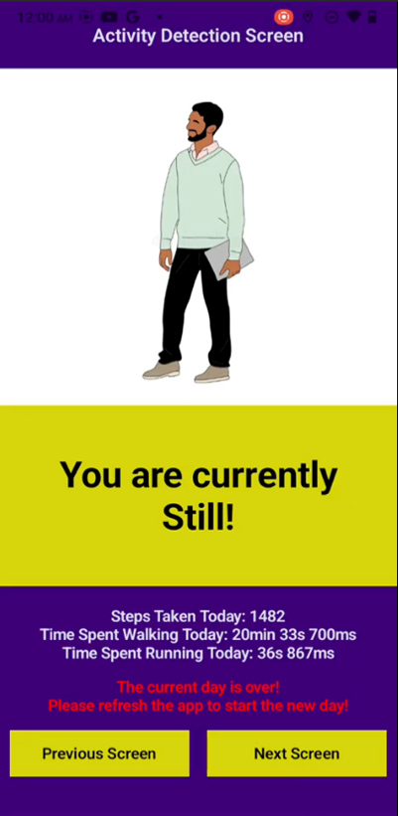

Figure 15. Screenshot after midnight showing midnight message along with the activity status, time spent doing each, and step count no longer changing

.

## Evaluation for Starting the New Day

The first thing we did to begin testing the aspect of the app was refresh the application after validating the functionality of the midnight worked as expected. Upon reopening the app, we confirmed the midnight flag turned off as the message from the previous screenshot no longer appeared. On top of that, we confirmed that the mood points from the previous day became available and were calculated using the previously mentioned equation (see Figure 16 and Figure 17).

Figure 16. Screenshot after midnight before refreshing the app showing midnight message and not displaying the mood points for the current day

.

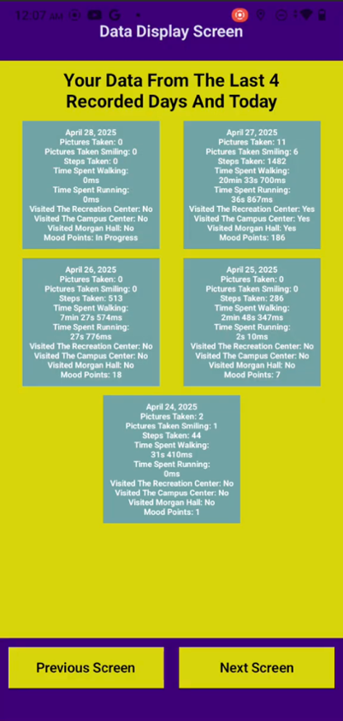

Figure 17. Screenshot after midnight after refreshing the app no longer showing midnight message and now displaying the mood points for the previous day

.

Lastly, we verified that the data for the new day would successfully record as step counting and activity detection worked again as mentioned before (see Figure 18).

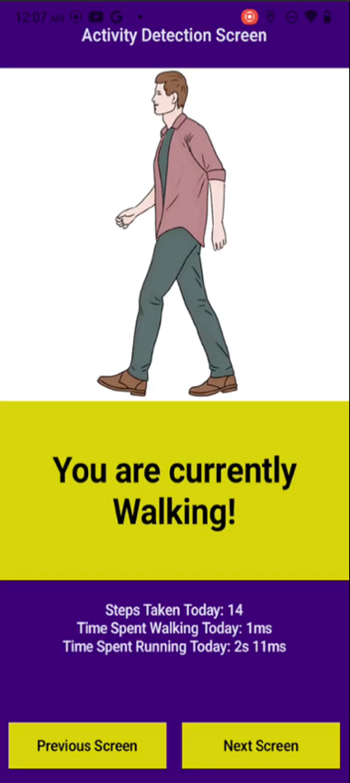

Figure 18. Screenshot after midnight after refreshing the app showing data being successfully recorded again for the new day

.

# DISCUSSION

## Main Takeaways

As previously discussed, all the main components of the application were tested and verified to be working properly. The face and smile detection correctly detected the face if a face was in the camera frame, correctly identified whether the face was smiling or not, and correctly identified that there were no smiling faces when there was no face at all in the frame. The number of faces detected, and the number of smiling faces detected are incremented accordingly and accurately. The location and geofencing features also seem to be working correctly from their respective evaluation as the location pin pointer updates properly, and the information regarding whether the geofences have been visited or not gets updated properly after a certain duration of the person remaining within the geofence. The step counting and activity detection were also confirmed to be working properly after verifying that the number of steps incremented appropriately and the activity status changed to still, walking, and running in correspondence with those activities being performed. The midnight flag and new days were also verified to be working properly. In combination, these elements were utilized to calculate the Mood Points for the day and display relevant statistics to the user that can inform them of what areas they can improve in order to raise their Mood Points for future days.

## Limitations

One of the limitations of our application, as previously mentioned, is the assumption that the user is honest when taking pictures for the smile detection component. In real life, however, it is not always the case that if someone is smiling, then they are in a good mood. They could be smiling outwardly but suffer from depressive feelings internally. It could also be the case that the user is generally someone who has an uplifted spirit, but maybe they are very tired on a particular day due to a lack of sufficient sleep or exhausted from a long day of work, so they may not be smiling as frequently on that particular day, which may not necessarily indicate that they are in a bad mood. For the activity detection and step counting component, these metrics are accurate as long as the user remembers to always have the phone on them physically or bring their phone along with them for any short trips during the day in between them working. Similarly, for the location tracking and geofencing component, it is only accurate if the user remembers to bring it along with them for short trips throughout the day. If, for instance, the user decides to go to the Campus Center to get a snack from Dunkin Donuts while taking a break from their work and forgets / decides not to bring their phone with them for such a short trip, the fact that they visited the Campus Center that day will not be accurately reflected in the application. In addition, the data collected for the location and geofences component may suffer from confounding variables that may not be aligned with the user’s genuine interest in going to a particular point of interest. For instance, a student may be going to the Recreation Center not because of his own interest in going there but due to being required to take Wellness and Physical Education (WPE) courses as part of his graduation requirement. In another example, a person may be going to Morgan in order to have some food, which everyone must have on a daily basis in order to survive and function, regardless of whether they happen to be in a good mood or not. A further example would be that a person might be going to the Campus Center to pick up mail or a package or perhaps to get coffee from Dunkin Donuts. At the current moment, our application has not implemented a method for delineating the intention behind people’s visits to the points of interests designated by the geofences.

## Encountered Bugs

In terms of major bugs that we are aware of in our application, the user has to remember to go to settings manually to enable all the necessary permissions for the application. If they forget to do so, some or all of the components of the application may not work.

# CONCLUSION AND FUTURE WORK

## Conclusion

The application tackles the problem of tracking WPI students’ mood and giving them relevant insights on various metrics that they can aim to improve if desired. The application integrates three primary components: the face and smile detection component, the activity detection and step counter component, and the location and geofencing component. Data collected through these three components are then fed to the Mood Points equation discussed previously to yield a Mood Points score for each day. These components were each individually tested for correct functionality and accurate data collection, so it can be asserted with a high degree of confidence that the combination of these components also function correctly.

## Future Work

If given more time, more robust mechanisms should be devised to delineate users’ intentions behind going to the designated points of interest by the geofences. Having methods that can do this will reduce the effect of confounding variables in terms of their true intention / purpose for visiting certain locations. This will improve how closely the Mood Points reflect their true mood for the day. Furthermore, a custom deep learning model could be trained to detect more moods beyond smiling and not smiling provided by ML Kit’s Face Detection API, expanding the range of moods detected by the application to more closely align with the high variability of human emotions in real life. Additionally, the application can potentially seek out real-life sponsors and partnerships to offer real-life rewards and discounts on purchases at certain locations to participants who manage to attain high streaks of high-mood-point days.

# REFERENCES

1. Transforming education. (2024, September 10). *Student Stress Statistics [2024 Update] - Transforming Education for People*. Transforming Education for People; Transforming Education. <https://transformingeducation.org/student-stress-statistics/>
2. ‌Wikipedia Contributors. (2019, March 14). College health. Wikipedia; Wikimedia Foundation. <https://en.wikipedia.org/wiki/College_health>
3. Daylio. (2021). Daylio - Journal, Diary and Mood Tracker. Daylio. <https://daylio.net/>
4. Mahindru, A., Patil, P., & Agrawal, V. (2023). Role of Physical Activity on Mental Health and Well-Being: A Review. Cureus, 15(1), e33475. <https://assets.cureus.com/uploads/review_article/pdf/121652/20240724-319105-j7fpue.pdf>
5. Cortina, J., & Hardin, S. (2023). The Geography of Mental Health, Urbanicity, and Affluence. *International journal of environmental research and public health*, *20*(8), 5440. <https://doi.org/10.3390/ijerph20085440>
6. 3 Overview | Geolocation API. (n.d.). Google Developers. <https://developers.google.com/maps/documentation/geolocation/overview> ‌