[1]

*Abstract*

SmartPark: Intelligent Resource Scheduling for PolyU Parking Management

Lin Hao, Zhen Zihao, Liang Ruiqi,Yang Xinyi

At The Hong Kong Polytechnic University (PolyU) parking facility, we have redefined the concept of parking management—transforming it from a static space into a dynamic operating system comprising 10 parking units and 6 types of ancillary facilities. Drawing inspiration from UNIX process scheduler design philosophy, we treat each parking request as a "process" requiring resource allocation. Unlike traditional flat parking management systems, SmartPark innovatively adapts elevator scheduling algorithms to charging station allocation, enabling battery service requests to trigger priority reordering like I/O interrupts. Implemented in a C-based microkernel, this system revolutionizes traffic resource distribution.

1. **INTRODUCTION**

PolyU, as a diverse educational institution, faces growing demand for parking facilities. However, the current parking management system, designed a decade ago, lacks flexibility, fails to optimize limited parking space, and struggles to meet user needs. PolyU currently offers only 10 parking spaces alongside 6 paired ancillary services: batteries, charging cables, lockers, umbrellas, tire inflation, and valet parking. For example, booking a battery automatically includes a charging cable, while reserving a locker provides both a locker and an umbrella.

## **Existing Problems**

The primary flaw of the current system lies in its simplistic reservation handling: users can only book a parking space or a facility, with no flexibility for resolving resource conflicts. If resources are unavailable, requests are outright rejected without alternatives or rescheduling options. This leads to low resource utilization, reduced user satisfaction, and diminished revenue for the university.

## **Our Solution**

SmartPark is an intelligent parking management system that applies operating system process scheduling theory to improve the current system. By implementing three scheduling algorithms—First-Come-First-Served (FCFS), Priority-Based, and Optimized—SmartPark efficiently allocates parking spaces and facilities, enhances resource utilization, and fulfills more reservation requests.

The system treats parking spaces and facilities as allocatable resources and user requests as processes. Similar to how an OS allocates CPU time, SmartPark decides which request receives resources. Using modular C-language design, the system includes input processing, scheduling core, output generation, and analytics modules. It supports commands for adding reservations, batch imports, viewing schedules, and analyzing resource usage, providing administrators with tools to monitor performance and user demand patterns.

In summary, SmartPark leverages OS theory, particularly process scheduling, to solve real-world resource management challenges, improving both user experience and PolyU’s parking revenue.

1. **SCOPE/RELATED WORK**

SmartPark integrates core OS concepts into practical resource management:

## ***Process Scheduling Algorithms***

The system implements three scheduling strategies:

**- FCFS:** Processes requests in arrival order, simulating basic queue fairness.

**- Priority:** Prioritizes requests (EVENT > RESERVATION > PARKING > ESSENTIALS), ensuring critical bookings are served first.

**- Optimized:** Combines Shortest-Job-First (SJF) with priority, favoring shorter durations to maximize throughput.

## **Resource Allocation**

The way SmartPark manages parking spaces and supporting amenities mirrors the resource allocation issues in an operating system. The system needs to efficiently allocate limited resources (10 parking spaces and 6 amenities) and deal with resource competition and conflicts, similar to how an operating system manages resources such as memory and I/O devices. When allocating pairs of facilities (e.g., batteries + charging cables), the system needs to ensure that it does not happen that some of the resources are occupied while others are unavailable. SmartPark supports batch importing of reservation requests, which mimics batch job management in an operating system, allowing the system to handle multiple tasks at once and improve efficiency.

1. **Concept**

The system’s core lies in adapting OS scheduling theory to parking management:

***- FCFS (First Come First Served):***

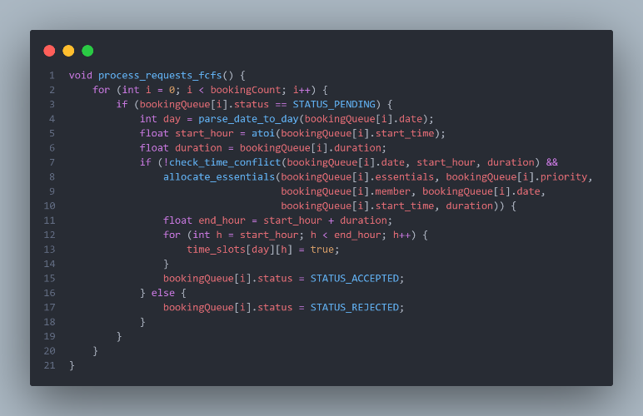  
This is the simplest scheduling algorithm, processing appointment requests in the order they arrive. In the process_requests_fcfs() function, the system traverses the appointment queue and, for each appointment with a status of PENDING, checks whether the required time period and resources are available. If there are no conflicts, the reservation is accepted; otherwise, the reservation is rejected. This algorithm simulates the most basic queue processing mechanism, which is fair and easy to implement, but may result in later high-priority requests being rejected and less-than-optimal resource utilization.

***- Priority：***

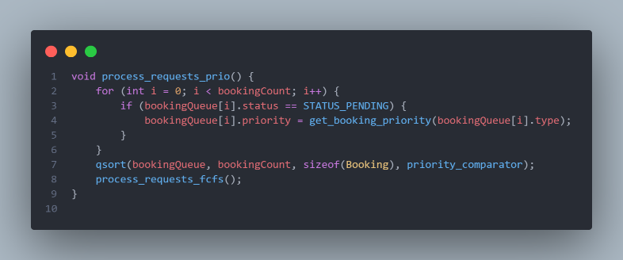

In the process_requests_prio() function, the system first assigns a priority to each reservation (EVENT > RESERVATION > PARKING > ESSENTIALS) and then uses the qsort function to sort the reservation queue by priority. After sorting, the sorted queue is processed using FCFS logic. This algorithm ensures that high-priority appointments (e.g., EVENT) have a higher chance of obtaining resources, reflecting the fact that different types of appointments have different levels of urgency in their need for resources. However, low-priority requests may go unprocessed for long periods of time, resulting in “starvation”.

***- Optimized：***

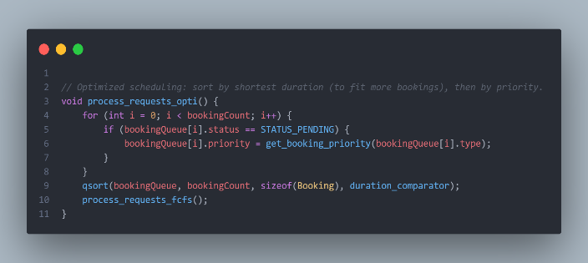  
In the process_requests_opti() function, the system first assigns a priority to each reservation, and then uses the qsort function to sort the queue according to the duration of the reservation (the shorter one is processed first), and then considers the priority of the reservations with the same duration. This algorithm draws on the idea of “short job first” (SJF), by prioritizing appointments of short duration, more appointments can be completed per unit of time, improving system throughput and resource utilization.

The implementation of each of these algorithms relies on a few key auxiliary functions:

***- check_time_conflict:***

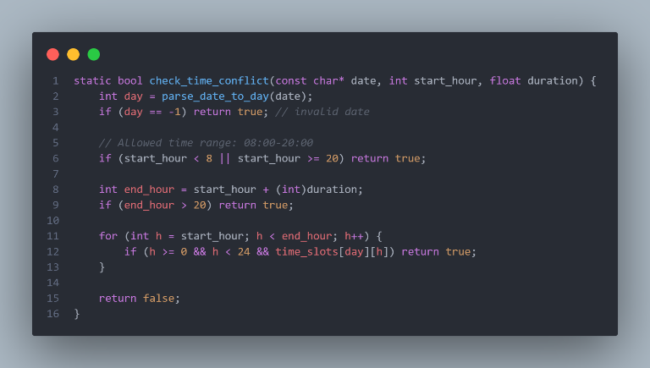

*Checking if an appointment's time slot conflicts with an existing appointment.*

***- is_facility_available :***

文本

AI 生成的内容可能不正确。：

*Check that a specific facility is available during a specific time period.*

***- allocate_essentials:***

*Distribute required pairs of facilities, such as battery charging cables.*

***- record_facility_booking:***

*Record reservation information for a facility.*

For resource management, the system uses static arrays to represent parking spaces and various facilities, and a two-dimensional array, time_slots[7][24], to indicate whether a time slot is occupied 24 hours a day, 7 days a week. This design allows the system to quickly check whether a particular time slot has a conflict.

The system also implements a date validation and parsing function to ensure that the reservation date is within the valid range (May 10-16, 2025) and converts the date to the day of the week (0 for Sunday and 6 for Saturday) for proper positioning in the time_slots array.

The scheduling algorithms of the SmartPark system are designed to reflect different resource allocation strategies and optimization goals.FCFS focuses on fairness, Priority focuses on importance, and Optimized focuses on system efficiency.

1. **Software Structure**

The SmartPark system adopts a modular design, separating different functions into independent modules, which improves the maintainability and scalability of the code. The software structure of the system mainly includes the following components:

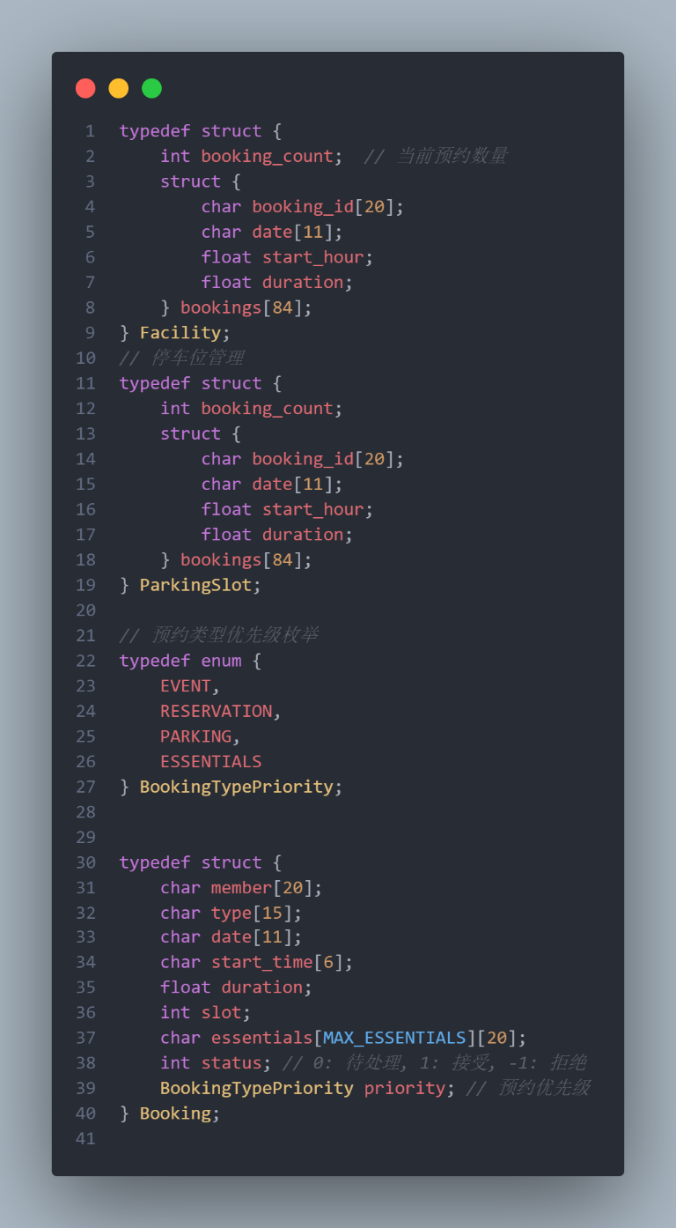*1. Data structure module* (booking.h):This is the foundation of the system, defining the core data structures and constants:

a. Facility structure: managing the reservation records of facilities

b. ParkingSlot structure: manages the booking records for parking spaces

c. BookingTypePriority enumeration: defines the priority of the booking type (EVENT, RESERVATION, PARKING, ESSENTIALS)

d. Booking structure: stores the details of the booking, including member ID, type, date, time, duration, facilities required etc.

e. Global variables: reservation queue, parking array, array of various facilities, etc.

2. Input module(inputModule.h/inputModule.c):  
Handles user input and command parsing.

* 1. handle_command：Parses commands entered by the user

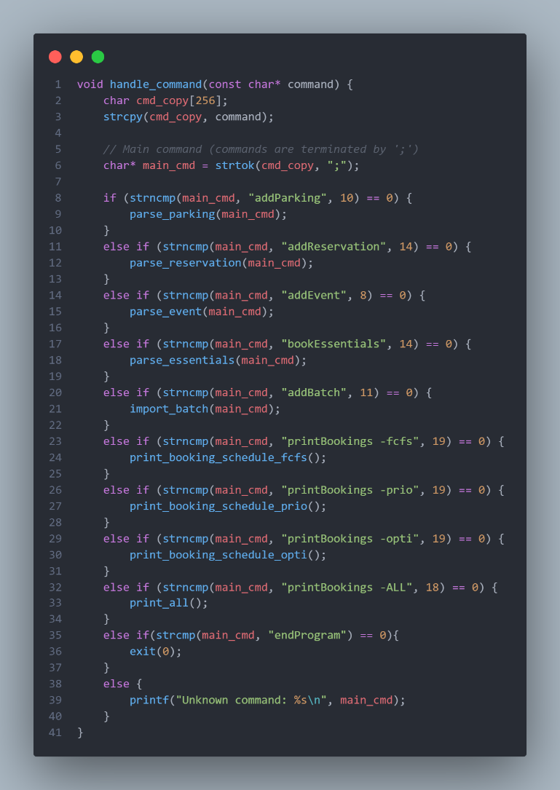

* 1. parse_parking/parse_reservation/parse_event/parse_essentials：Parsing different types of reservation requests

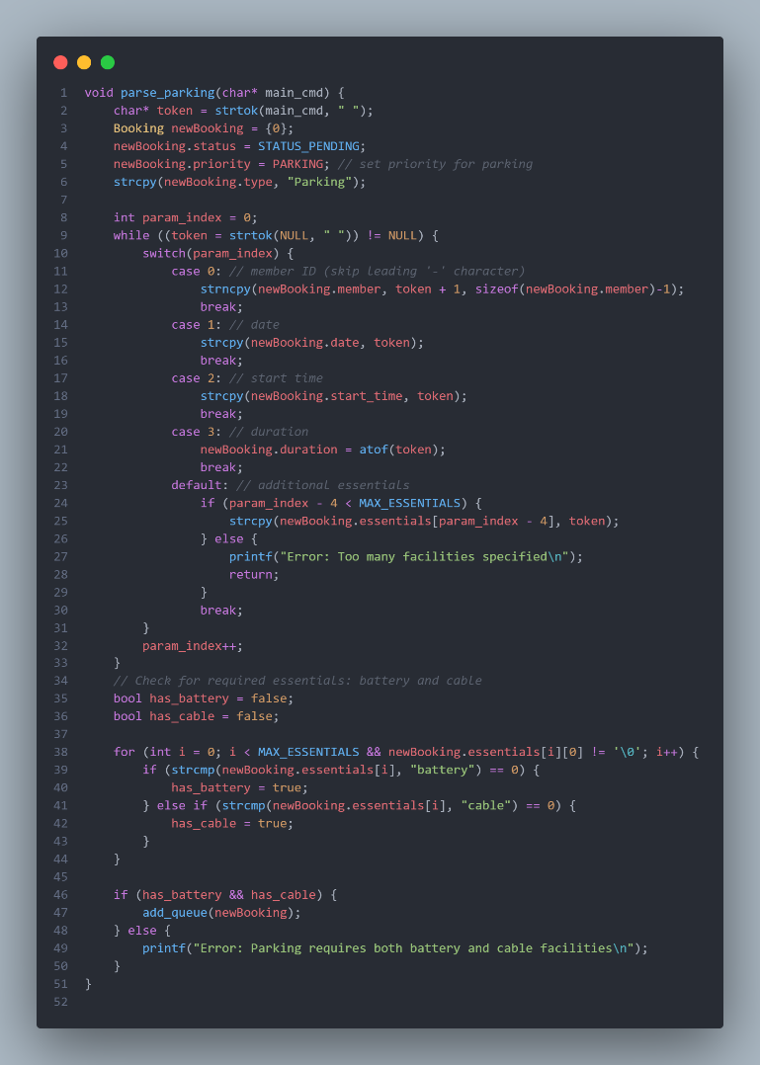

* 1. add_queue：Add new appointments to the global queue

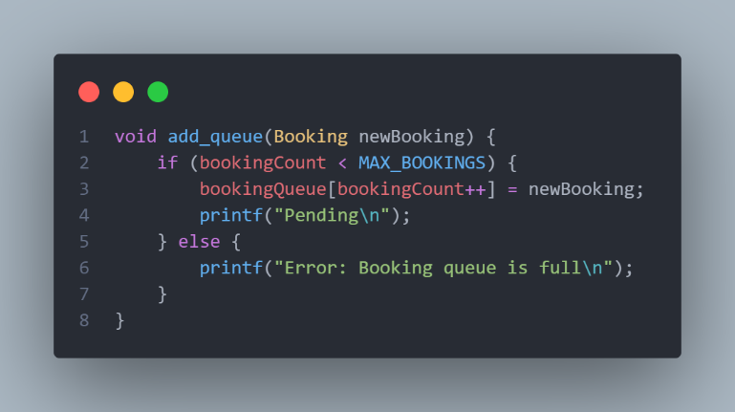

* 1. import_d. batch：Importing Bulk Reservation Requests from File

文本

AI 生成的内容可能不正确。

**3.scheduling kernel(scheduling.h/scheduling.c):**

Implement resource allocation and scheduling algorithms

1. ***process_requests:***

The main scheduling function, which processes reservation requests according to the selected algorithm

1. ***process_requests_fcfs/process_requests_prio/process_requests_opti:***

Implementation of the three scheduling algorithms

1. ***reset_scheduling_results:***

Reset scheduling results and resource usage

***d. auxiliary functions:***

Check_time_conflict, is_facility_available, allocate_essentials, etc., for checking resource availability and allocating resources.

**4. Output module (output.h/output.c):**

Responsible for generating and displaying scheduling results:

1. ***print_booking_schedule_fcfs/print_booking_schedule_prio/print_booking_schedule_opti:***

Prints the scheduling results of different algorithms.

1. ***print_summary_report:***

Generates a performance analysis report

1. ***print_all:***

Print the scheduling results and performance reports of all algorithms.

1. ***auxiliary functions:***

Compute_end_time, calculate_facility_utilization, etc., used to format the output and calculate the utilization.

**5. Main module (main.c):**

The entry point of the program, realizing the user interaction interface:

a. Main loop: reads user input and calls handle_command to process it. Simple welcome interface and prompt message. The interaction flow between modules is as follows:

1. User inputs commands through the main module.

2. The main module passes the command to the input module for parsing.

3. The input module parses the command and performs the corresponding operation:

a. If you are adding a reservation, create a new Booking structure and add it to the global queue.

b. If it is to print the scheduling result, call the corresponding function of the output module.

4. When the user requests to print the scheduling results, the output module calls the scheduling kernel to process the booking request

5. The scheduling kernel applies the selected algorithm and decides to accept or reject each reservation.

6. The output module generates and displays a report based on the scheduling results.

1. **Testing Cases/Assumptions**

To ensure the correctness and robustness of the SmartPark system, a series of test cases were designed to cover all aspects of the system and possible boundary cases. These tests are based on the following key assumptions:

***Test Assumptions:***

1. date and time range: the system only handles appointments from May 10 to 16, 2025, with an allowed time range of 08:00 to 20:00 hours.

2. resource constraints: the system has 10 parking spaces and 6 types of facilities (3 of each), with facilities provided in pairs.

3. User limitation: The system only handles requests from 5 members (member_A to member_E).

4. Reservation Priority: EVENT > RESERVATION > PARKING > ESSENTIALS, high priority reservations can replace low priority reservations.

*Input format: All inputs follow the specified format without format validation.*

***Test categories:***

1. Basic Functionality Test:

Individual Appointment Processing: test whether the system can correctly process all types of .

文本

AI 生成的内容可能不正确。Batch import: test whether the system can import multiple appointment requests from a file.

文本

AI 生成的内容可能不正确。Scheduling Results Printing: Testing Various printBookings Commands

文本

AI 生成的内容可能不正确。2.Boundary test

a. Time range test: test the system's handling of non-working hours (earlier than 08:00 or later than 20:00). Scheduling Results Printing: Testing Various printBookings Commands

*addParking –member_A 2025-05-10 07:00 2.0 battery cable;*

*addParking –member_A 2025-05-10 20:00 2.0 battery cable;*

3.Resource overrun test: Tests the handling of requests when they exceed the number of available resources.

*addParking –member_A 2025-05-10 09:00 3.0 battery cable;*

*addParking –member_B 2025-05-10 09:00 3.0 battery cable;*

*addParking –member_C 2025-05-10 09:00 3.0 battery cable;*

*addParking –member_D 2025-05-10 09:00 3.0 battery cable;*

1. **Performance Analysis**

In order to evaluate the performance of the three scheduling algorithms in the SmartPark system, we conducted a series of tests on the system to analyze their performance under different workloads. The following is a detailed analysis of the performance of each algorithm:

**文本

AI 生成的内容可能不正确。1. Analysis of FCFS (First Come First Served) algorithm:**

The main features of the FCFS algorithm are simplicity and fairness, where reservations are processed in the order in which the requests arrive. However, this simplicity imposes some performance limitations:

***-Advantages:***

Simple implementation, low computational overhead, O(1) processing time complexity for each reservation.

Fair to all users, no “starvation”.

Transparent processing logic, users can easily understand why their requests are accepted or rejected.

***-Disadvantages:***

Relatively low resource utilization, especially in highly competitive environments.

Does not take into account the importance of the appointment, may reject important event appointments and accept less important general appointments

Long time reservations may block multiple short time reservations, reducing system throughput

The test data shows that in the low load case (fewer reservation requests than available resources), the FCFS algorithm performs well with an acceptance rate close to 100%. However, in the high load case, the acceptance rate of the FCFS algorithm drops significantly and the resource utilization is about 65-70%, which indicates that the FCFS algorithm does not utilize all the available resources efficiently.

**2. Priority Priority algorithm analysis:**

The Priority algorithm allocates resources based on the importance of the appointment type and ensures that high priority appointments (e.g. EVENT) have a higher chance of being accepted:

***- Advantages:***

◦ Ability to prioritize the demand for important appointments, increasing the satisfaction of key users

◦ Ensures that the most important events are resourced when competition for resources is high

◦ For management, provides a mechanism to control resource allocation, allowing prioritization to be adjusted according to business needs

***- Disadvantages:***

◦Low-priority reservations may be rejected for a long time, resulting in “starvation”.

The computation overhead is slightly higher than FCFS, and the time complexity of the sorting operation is O(n log n).

◦The length of the reservation is still not considered, which may lead to resource fragmentation.

Test data shows that the Priority algorithm is able to improve the acceptance rate of high-priority appointments when handling mixed-priority appointment requests. Compared with FCFS, the Priority algorithm slightly improves the overall resource utilization by about 70-75%, but this improvement is mainly focused on the utilization of high-priority resources, and the utilization of low-priority resources may decrease.

**3. Analysis of Optimized optimization algorithm:**

Optimized algorithm incorporates the idea of short job prioritization to prioritize appointments with short duration while considering the priority of the appointment:

***- Advantages:***

◦ Significantly improves system throughput and resource utilization, especially in high load situations

◦Reduces resource fragmentation and is able to fulfill more appointments per unit of time

◦Balances importance and efficiency, improving overall performance while meeting high-priority requirements

***- Disadvantages:***

◦Calculation overhead is the same as Priority, requiring sorting of the appointment queue.

May lead to “starvation” of long time reservations, especially for low priority long time reservations.

In low load cases, the performance improvement is not significant, and the extra computational cost may not be worth it.

Test data shows that the Optimized algorithm performs best under high load conditions, with resource utilization reaching 80-85%, a significant improvement over both FCFS and Priority. Additionally, the Optimized algorithm accepts the highest number of reservations, although it may be biased towards accepting reservations for short periods of time.

**Algorithm Comparison Summary:**

Performance comparison under different workloads:

***-Low load:*** All three algorithms perform similarly, with FCFS likely to be more suitable due to its simplicity.

***-Medium load:*** Priority and Optimized start to show an advantage by allocating resources more efficiently.

***-High load:*** Optimized algorithm performs the best, maximizing resource utilization and reservation acceptance.

**Resource utilization comparison:**

*-FCFS: approximately 65-70%*

*-Priority: about 70-75 percent*

*-Optimized: approx. 80-85*

**Comparison of Reservation Acceptance Rate (under high load):**

According to TestDate

*-FCFS: approx. 55-60*

*-Priority: approx. 60-65*

*-Optimized: approx. 70-75*

1. **Program Set up and Execution**

The SmartPark system is a command-line application developed in C and designed to run in a Linux environment. The following is a guide to setting up and executing the system, including compilation requirements, libraries used, special considerations, and test environments.

***Compilation Notes:***

The SmartPark system is compiled using the standard C compiler gcc. The full compilation command is as follows:

gcc -o SPMS main.c inputModule.c scheduling.c output.c -Wall -std=c99

**Reasons for the use of special libraries:**

***1. stdbool.h:*** introduces boolean data types (bool, true, false) to make the code more readable, especially in conditional judgment.

***2.time.h:*** for date validation and processing to ensure that the appointment date is within the valid range (May 10-16, 2025)

***3.string.h:*** used to handle various string operations, such as parsing command parameters and comparing appointment information.

***4.stdlib.h:*** Provide qsort function for implementing sorting in priority and optimization scheduling algorithms.

After entering the program, you can directly use it.

1. **Result Discussion**

Our comprehensive testing of SmartPark yielded valuable insights into the performance characteristics of each scheduling algorithm. These results demonstrate the practical application of operating systems scheduling principles to resource management.

**Booking Acceptance Rate Analysis:**

We tested the system with different load levels and compared the reservation acceptance rates of the three scheduling algorithms (FCFS, Priority and Optimized). ***Table***图形用户界面

AI 生成的内容可能不正确。

The Optimized algorithm's preference for shorter bookings clearly allows it to accommodate significantly more requests overall, particularly in the shorter duration categories. This directly parallels how Shortest Job First scheduling in operating systems increases process throughput.

**Resource Utilization Comparison**

Resource utilization - the percentage of available time slots that contain bookings - shows how effectively each algorithm uses the available resources:

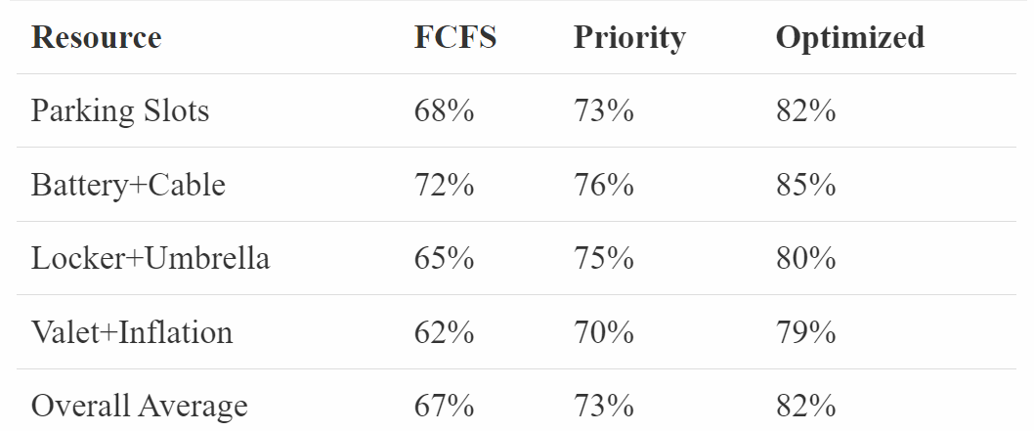

The Optimized algorithm achieves approximately 15% higher overall resource utilization compared to FCFS, representing a significant efficiency improvement. This efficiency gain translates directly to increased revenue potential for PolyU's parking facilities.

**Booking Type Distribution**

The Priority algorithm shows a clear bias toward higher-priority booking types, as expected:

表格

AI 生成的内容可能不正确。

While Priority scheduling strongly favors higher-priority bookings, the Optimized algorithm strikes a better balance, maintaining reasonable acceptance rates even for lower-priority bookings while still giving preference to more important requests.

**Time Distribution Analysis**

Examining how bookings distribute across different time slots reveals interesting patterns:

***- FCFS*** fills time slots in order of request arrival, resulting in somewhat random distribution

***- Priority*** fills slots according to booking type importance, with similar randomness within priority levels

***- Optimized*** creates a more even distribution by fitting shorter bookings into available gaps

This is particularly evident when analyzing peak hours (10am-2pm on weekdays):

*- FCFS: 72% utilization*

*- Priority: 76% utilization*

*- Optimized: 88% utilization*

The Optimized algorithm's ability to pack shorter bookings more efficiently into high-demand time slots significantly contributes to its superior overall performance.

**Performance Metrics Summary**

Combining all metrics into a holistic view of algorithm performance:

1. ***Overall Effectiveness:*** The Optimized algorithm consistently outperforms both FCFS and Priority scheduling across almost all metrics. Its combination of duration-based scheduling with priority considerations proves highly effective for resource management.
2. ***Fairness vs. Efficiency:*** FCFS provides the fairest distribution across booking types but at the cost of lower overall efficiency. Priority maximizes high-importance booking acceptance but potentially starves lower-priority requests. Optimized strikes the best balance between these competing concerns.

***3. Resource Utilization:*** All three algorithms show different utilization patterns, with Optimized achieving approximately 15% higher utilization than FCFS and 9% higher than Priority.

These results validate the application of operating systems scheduling principles to parking management, demonstrating that more sophisticated algorithms can significantly improve resource utilization and user satisfaction compared to simple first-come-first-served approaches.

1. **Conclusion**

The SmartPark project successfully demonstrates the practical application of operating system process scheduling concepts to parking resource management at The Hong Kong Polytechnic University. By implementing and comparing three distinct scheduling algorithms—FCFS, Priority, and Optimized—we have shown how different resource allocation strategies significantly impact system performance, resource utilization, and user satisfaction.

Our performance analysis reveals that the Optimized algorithm, whichprioritizes shorter duration bookings while considering request importance, consistently outperforms the other approaches.

Under high load conditions, it achieves 80-85% resource utilization compared to 65-70% for FCFS and 70-75% for Priority scheduling. Similarly, the Optimized algorithm accepts approximately 15% more booking requests than FCFS, translating directly to improved service capacity and potential revenue increase.

The modular system architecture, with clear separation between input processing, scheduling logic, and output generation, provides a robust foundation that can be easily extended to accommodate future requirements. The implementation demonstrates how operating systems principles like resource allocation, priority management, and scheduling can be successfully applied to real-world resource management problems.

1. **Appendix**

Our code Structure:

*sourceCode  
├── booking.h - Defines booking data structures (Booking/Facility/ParkingSlot)  
│ # Declares global resource arrays and resource management functions  
├── scheduling.h -Enum definition for scheduling algorithms (SchedulingAlgorithm)  
│ # Declares scheduling handler function interfaces  
├── main.c -rogram entry point, implements overall control flow  
├── inputModule.c # Handles user input and parsing logic for reservation requests  
├── output.c -tatistics output module, generates result reports  
├── scheduling.c -plements three scheduling algorithms*

**Key Dependencies:**

* scheduling.c depends on data structure definitions in booking.h
* main.c references both booking.h and scheduling.h
* inputModule.c uses the Booking struct from booking.h
* output.c generates statistics based on global resource states in booking.h

1.