COMP3423 Group Project Report
Redesigning the PolyULife mobile application

Name | Student ID | Role | Key tasks
RenYiXiao (Group leader) |  | Project coordination · Apps | 1, 4.1
LinHao |  | User research · Calendar | 2, 4.2
ZhouHongRui |  | Interaction rules · Room | 3, 4.3
FengTaiYang |  | Visual system · Food | 3, 4.4
XueBoChen |  | Accessibility · Testing · Map | 4.5, 5

1. Introduction

1.3.x Map — the last mile
The shipping map answers "where is a toilet in this building" but never "which floor, which door". We rebuilt that last mile in eight screens and two start-point overlays: a campus map that groups facilities by building, a truthful empty state on the arrival floor, a floor plan that lists results by distance, a detail page with a route, and a turn-by-turn view. The floor number is derived from the room code that the app already displays, so the redesign needs no new data (Section 4.5).

2. Related Work

3. Overall Design

4. Feature Details

4.1 Apps

4.2 Calendar

4.3 Room

4.4 Food

4.5 Map — from “a pin on a map” to “which floor, then which door”
Responsible member: XueBoChen (Accessibility & Evaluation Lead)
4.5.1 What we observed
In the shipping PolyULife Map, a student who wants the nearest toilet has to answer three questions the interface never asks: which building, which floor, which room. We logged four behaviours from the live app and annotated each screen capture accordingly (Fig. 1a–1c).
Observation | Detail
O1 | Category encoding is lost — every facility type uses the same pink droplet. With three filters active the map rendered roughly forty identical pins (Fig. 1a).
O2 | The list adds no information — each row repeats the building name twice: “Toilet (Core H)” followed by “Core H” and again “Core H” (Fig. 1b).
O3 | The floor is never shown — the detail screen offers a building-level 3-D view in which only rooftops are visible (Fig. 1c).
O4 | Filtering is invisible in the list — selecting a category updates the map but not the list, so the two views disagree about the current result set.
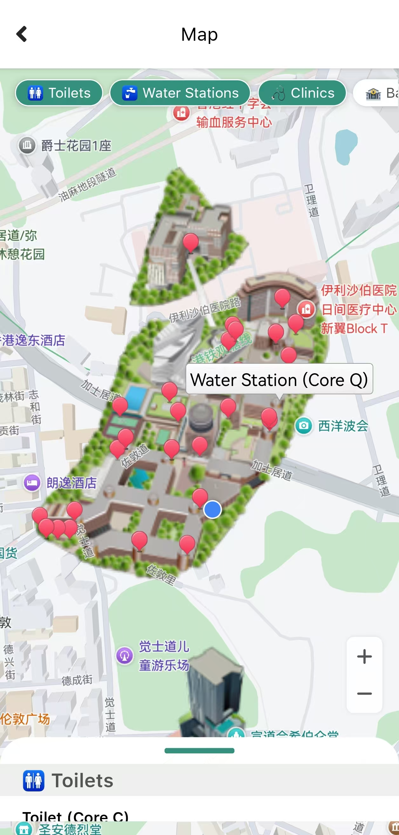 | 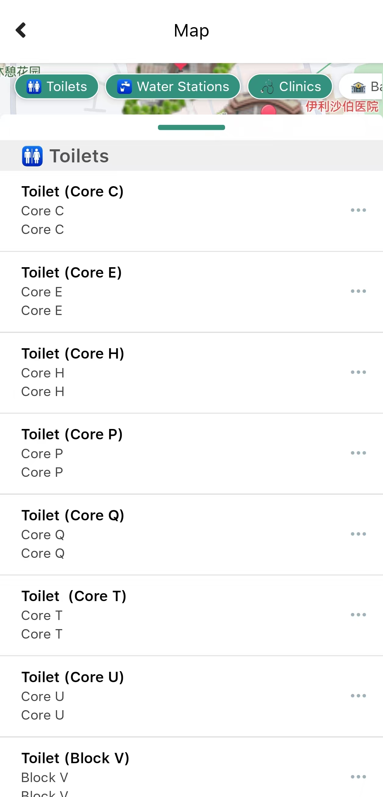 | 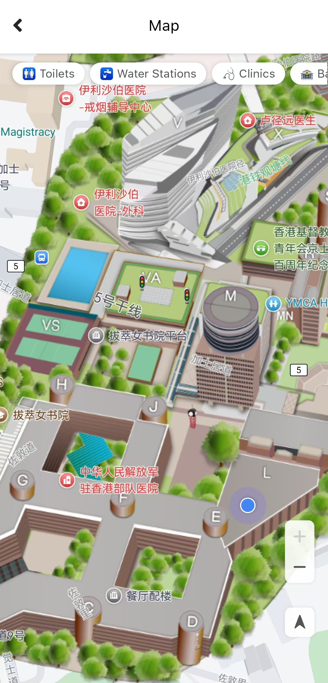
Fig. 1a — Every category uses the same pink droplet. | Fig. 1b — The row repeats the building name twice. | Fig. 1c — The detail view is a rooftop view; no floor is shown.

4.5.2 Principles violated
Each behaviour maps to a documented usability heuristic (Nielsen, 1994):
Observation | Violated principle
O1, O4 | Visibility of system status (Nielsen #1) — the result set changes with no feedback
O1, O2 | Recognition rather than recall (#6) — identical pins force the user to remember the filter
O3 | Match between the system and the real world (#2) — students navigate by floor and room, not by rooftop
4.5.3 The redesign
Ten frames: eight screens (Fig. 2a–2g) and two start-point overlays (Fig. 2h). One idea holds the flow together:
Building first, floor second. The user's question changes when they walk through the door.
The structure follows progressive disclosure (Nielsen, 2006): the user moves from buildings to floors to rooms, and the bottom sheet expands only when it is needed.
- Campus map (F0) — buildings as cards grouped by distance, with category chips carrying live counts (Toilets 12 · nearest 10 m). Outdoor wayfinding is delegated to Google Maps, which the shipping app already opens through its “View on Google Maps” button; the redesign owns the last mile (Fig. 2a).
- Arrival floor (F1) — the user enters on P/F and is told the truth: “No toilets on this level. The nearest ones are on 3/F”, with a count badge on the 3F floor button and a single primary action, “Show me 3/F” (Fig. 2b).
- Floor plan with results (F2) — categories keep an icon as well as a colour, so the map never relies on colour alone (W3C, 2023). The sheet shows the two nearest results plus one line, “3 more on this floor”, that opens the full list (Fig. 2c).
- Two categories active (F2b) — the map and the list change together, so the two views never disagree about the current result set (Fig. 2d).
- Expanded sheet (F3, F3b) — the same screen with the sheet pulled up; the map stays visible above and rows are sorted by distance (Fig. 2e).
- Detail (F4) — floor, room, walking time, step-free access and the first three steps of the route (Fig. 2f).
- Turn-by-turn (F5) — the same floor plan with the walk broken into three named steps, one highlighted at a time (Fig. 2g).
- Start-point overlays (F1-Start, F2-Start) — a sheet lists the entrance or the nearby rooms, and dismisses by tapping the scrim, dragging the 24 px handle, or choosing an option (Fig. 2h).
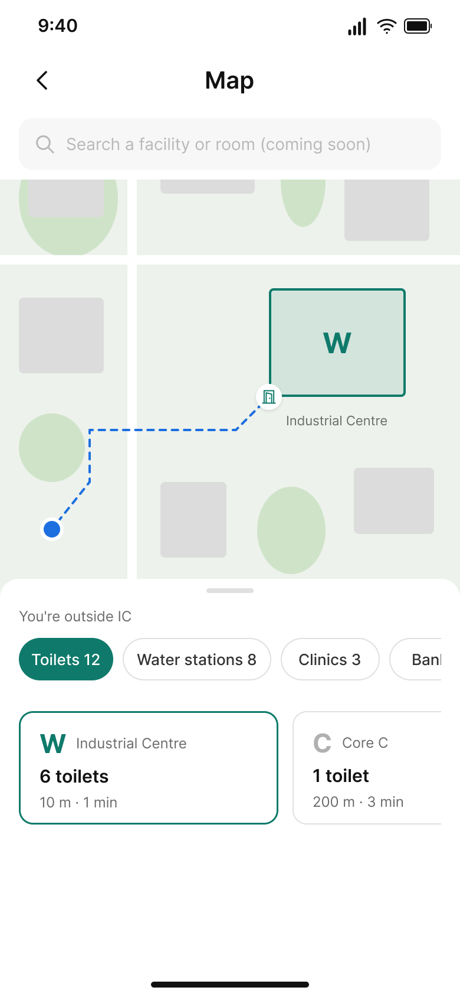 | 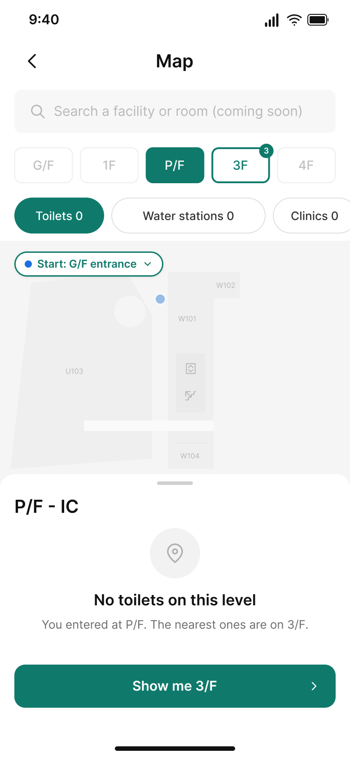 | 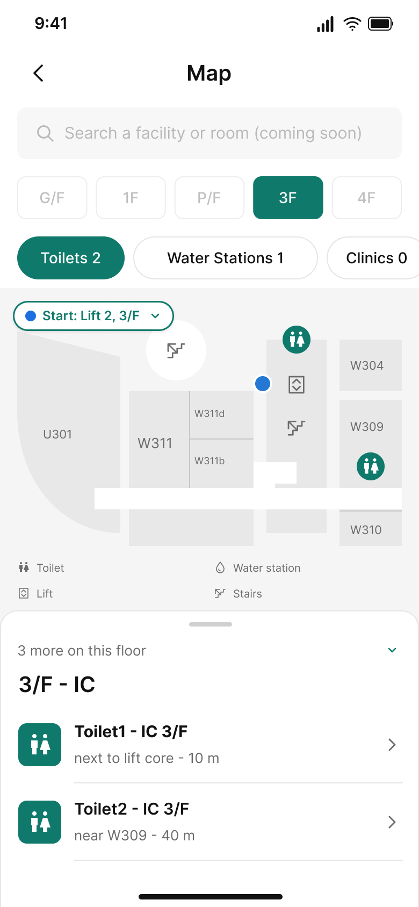 | 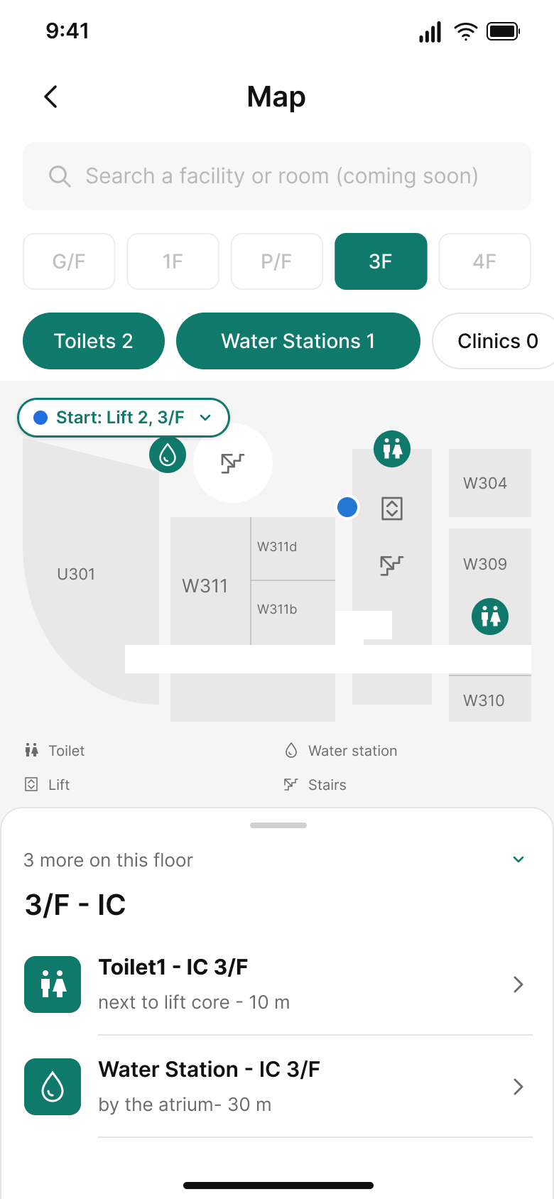
Fig. 2a — Campus map; buildings ranked by distance. | Fig. 2b — Arrival floor: nothing here, one way out. | Fig. 2c — Floor plan with results and a preview list. | Fig. 2d — Two categories active; map and list agree.

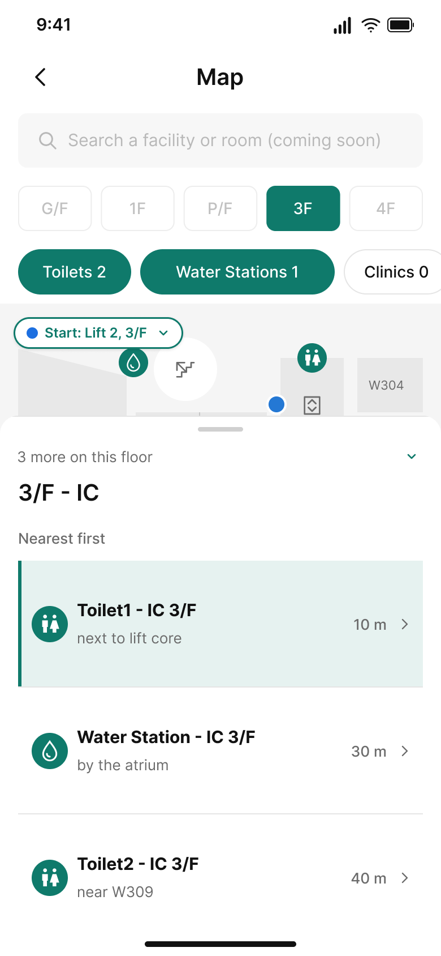 | 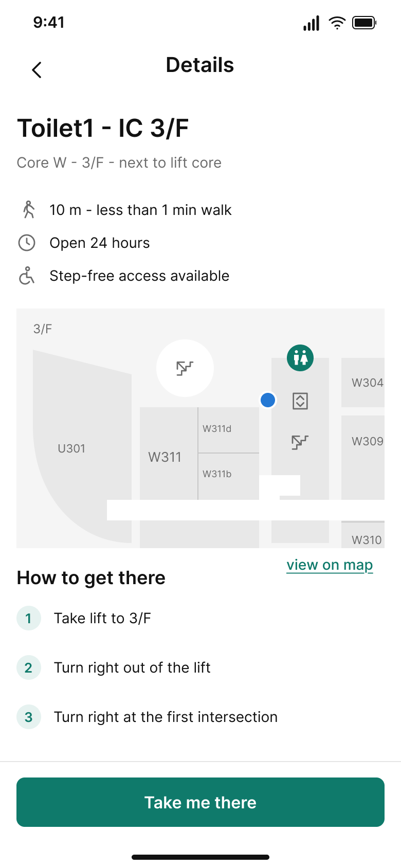 | 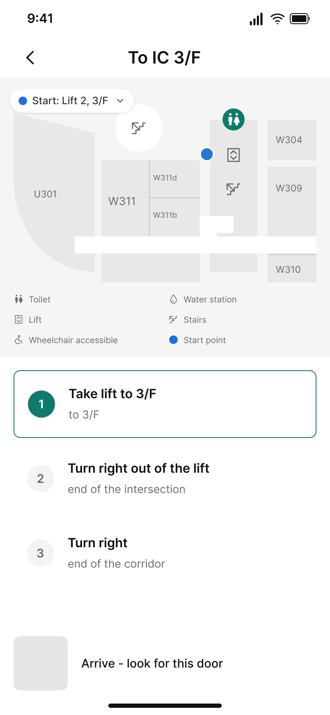 | 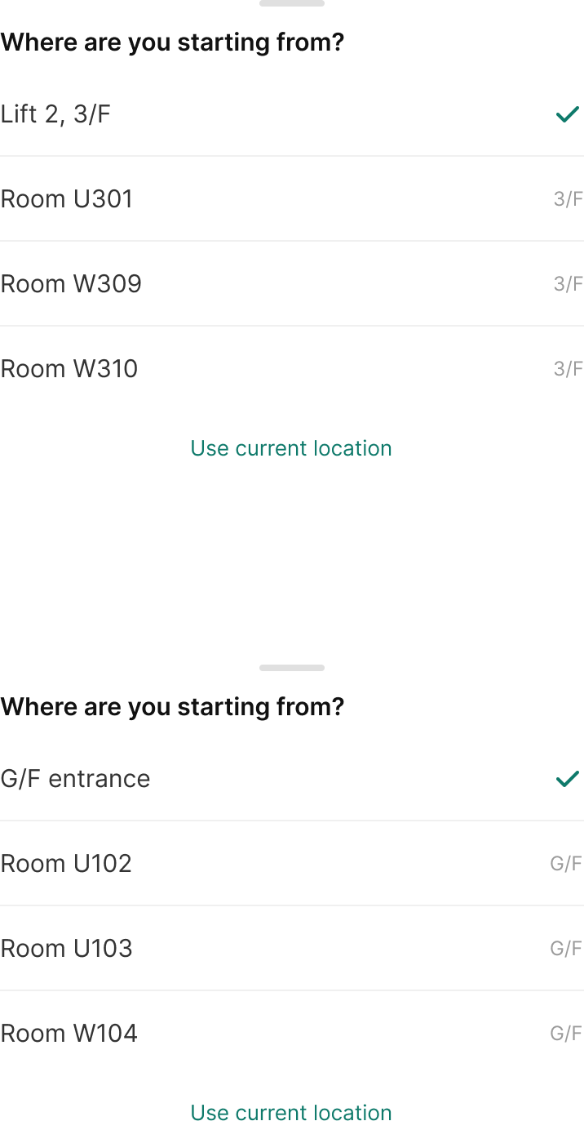
Fig. 2e — Expanded sheet; the map stays visible. | Fig. 2f — Detail: floor, room, time, step-free access. | Fig. 2g — Turn-by-turn; three named steps. | Fig. 2h — Start-point overlays (F1-Start, F2-Start).

4.5.4 Design decisions
Decision | Why
Map and list are complementary | The map answers “where”; the list answers “which one, how far”. Neither is sufficient alone, so one screen carries both.
The empty state names the next step | On P/F the screen answers three questions at once: what happened (“No toilets on this level”), where the results are (“nearest ones are on 3/F”), and what to do next (“Show me 3/F”).
The start point is visible and adjustable | GPS cannot resolve a floor and the campus publishes no indoor positioning, so the blue dot is a starting point the user confirms through a chip, not a false “you are here”.
State is encoded more than once | Floors differ by fill, weight, text colour and a count badge; categories keep an icon as well as a colour. No single channel carries the meaning.
Disclosure is staged | Overview, then detail, then route. The user is not asked to read opening hours before knowing which floor they need.
4.5.5 The key decision: the floor is already inside the room code
“W305” encodes Industrial Centre, 3/F, room 05. The floor, however, is already inside the room code — so the redesign derives it (W305 → 3/F) instead of requesting new data, building a 3-D model, or asking students to photograph corridors. This is why we rejected the obvious alternatives:
Option | Cost | Answers “which floor?” | Verdict
3-D model of the campus | 3–5 days | No — still a top-down view | Rejected
Photograph every entrance | Half a day | Partially | Rejected
Floor plan + floor switcher | 2–3 hours | Yes | Chosen
AR indoor navigation | Not achievable | Yes | Future work
The start point is explicit and editable — “Start: Lift 2, 3/F · Change” — rather than a false “you are here”: the campus publishes no indoor positioning, and GPS cannot resolve a floor.
4.5.6 Scope and limitation
The prototype is a design demonstration, not a working application. The start-point sheet does not recompute the route, the search field is shown as “coming soon”, and “Use current location” is not wired to any positioning service. The turn-by-turn screen is a static walkthrough rather than live navigation, and its first step assumes the user arrives by lift.
The worked example is the Industrial Centre (IC), because it is the only PolyU building for which official per-floor plans are publicly available. Core buildings share the same information structure but publish no floor plans, so the design is demonstrated on IC. Indoor positioning is listed as future work rather than claimed as implemented.

5. Testing

5.5 Map
5.5.1 Method
The Map prototype was tested as an unmoderated remote prototype test in Maze, using the public Figma prototype. Five participants outside the team completed four missions in sequence; one stopped after Mission 1, so Missions 2–4 have four responses each. Each mission had a fixed starting screen and an expected destination screen, and Maze recorded success, drop-off, misclicks and duration per participant per mission, plus one rating question and one open question. Participants were told the prototype was not the real app and that there were no wrong answers.
5.5.2 Results
Mission | n | Success | Drop-off | Misclicks | Avg. time
M1 From outside IC, find the nearest toilet | 5 | 100% | 0% | 69.3% | 56.3 s
M2 Select Water stations, then open the full list | 4 | 50% | 50% | 60.8% | 202.0 s
M3 Open the details of the toilet near W309 | 4 | 100% | 0% | 63.6% | 10.5 s
M4 Follow the directions to the door | 4 | 50% | 50% | 36.4% | 6.6 s
Ease of use was rated “so-so” by two of four participants, “easy” by one and “hard” by one. The high misclick rate on the successful missions reflects Maze counting every non-target tap, including exploratory taps on the map and attempts to scroll, rather than failed goals.
5.5.3 What participants said
- “I can't understand some words exactly.” — the labels assume the reader knows the building.
- “Do not know how to open the detailed list.” — the expandable sheet was not discovered.
- “寻找水站时打开详情页那一步略有卡顿” — hesitation when moving from the chip to the list.
5.5.4 Discussion
Mission 1 succeeded for everyone but took almost a minute: the click heatmap shows the search field as the first target, so participants tried to search before scanning the map. The only genuine failure was Mission 2: half the participants abandoned it after more than three minutes, and both the quote and the heatmap point to the same cause — the collapsed sheet gave no sign that it could be expanded. Missions 3 and 4 were fast and accurate, which suggests the detail and route screens are doing their job once the user has found a result.
5.5.5 Iteration after testing
Five changes followed directly from the test data:
- The sheet now ends with “3 more on this floor” above the two preview rows, and the row area is tappable, so the full list is discoverable without knowing the drag gesture.
- The start point became a bordered chip that opens a picker — in both rounds it was the most tapped dead element on the screen, and the report previously claimed it was editable.
- The P/F screen gained a count badge on the 3F floor button and a single primary action, “Show me 3/F”.
- Floor buttons that lead nowhere were given a disabled appearance, and the meaningless “Clear” control was removed.
- The search field became visibly inactive (“coming soon”) instead of looking usable, because it was the most-tapped element on the first screen.

References
Nielsen, J. (1994). Heuristic evaluation. In J. Nielsen & R. L. Mack (Eds.), Usability Inspection Methods. Wiley.
Nielsen, J. (2006). Progressive disclosure. Nielsen Norman Group.
W3C (2023). Web Content Accessibility Guidelines (WCAG) 2.2. World Wide Web Consortium.

Appendix A — Map study materials
- A1. Maze dashboard (task success, drop-off, misclicks, time on task).
- A2. Task script: the four missions, fixed start and expected destination screens.
- A3. Figma prototype URL: https://www.figma.com/design/ulBuuteCRdzdBsHAaiqyUr/ (Map flow starts at node 65:2).
- A4. Click heatmaps for F0 (campus map) and F2 (floor plan).

