SonarQube Integration

Project Title
NexGuard-SecureFlow

About the Project
NexGuard-SecureFlow is a group DevSecOps project developed to automate the software delivery lifecycle using AWS and CI/CD practices. My contribution focused on integrating SonarQube into the Jenkins CI/CD pipeline for automated static code analysis and Quality Gate validation.

What is SonarQube?
SonarQube is an open-source Static Application Security Testing (SAST) platform that analyzes source code without executing it. It detects bugs, vulnerabilities, code smells, duplicated code, and code coverage issues.

Step 1: Generated SonarQube Authentication Token
Generated a SonarQube authentication token for secure communication between Jenkins and SonarQube.
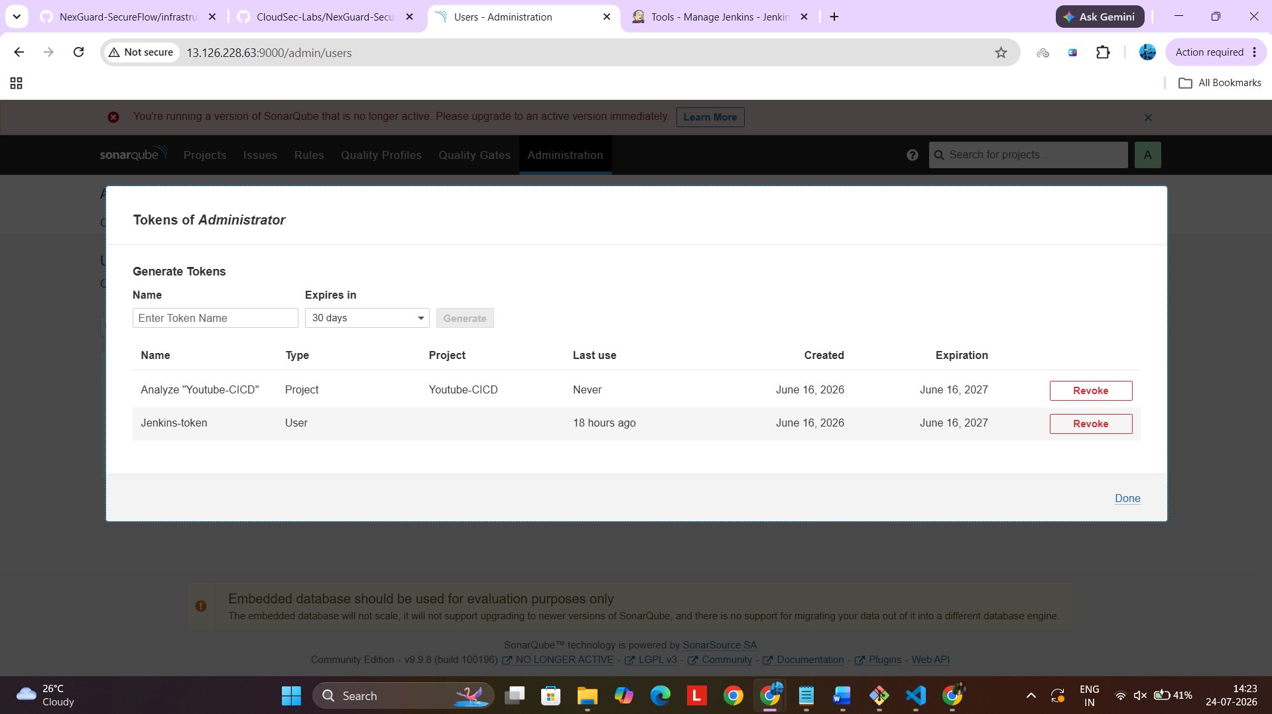

Step 2: Configured SonarQube Credentials in Jenkins
Stored the generated token in Jenkins Credentials using Secret Text.
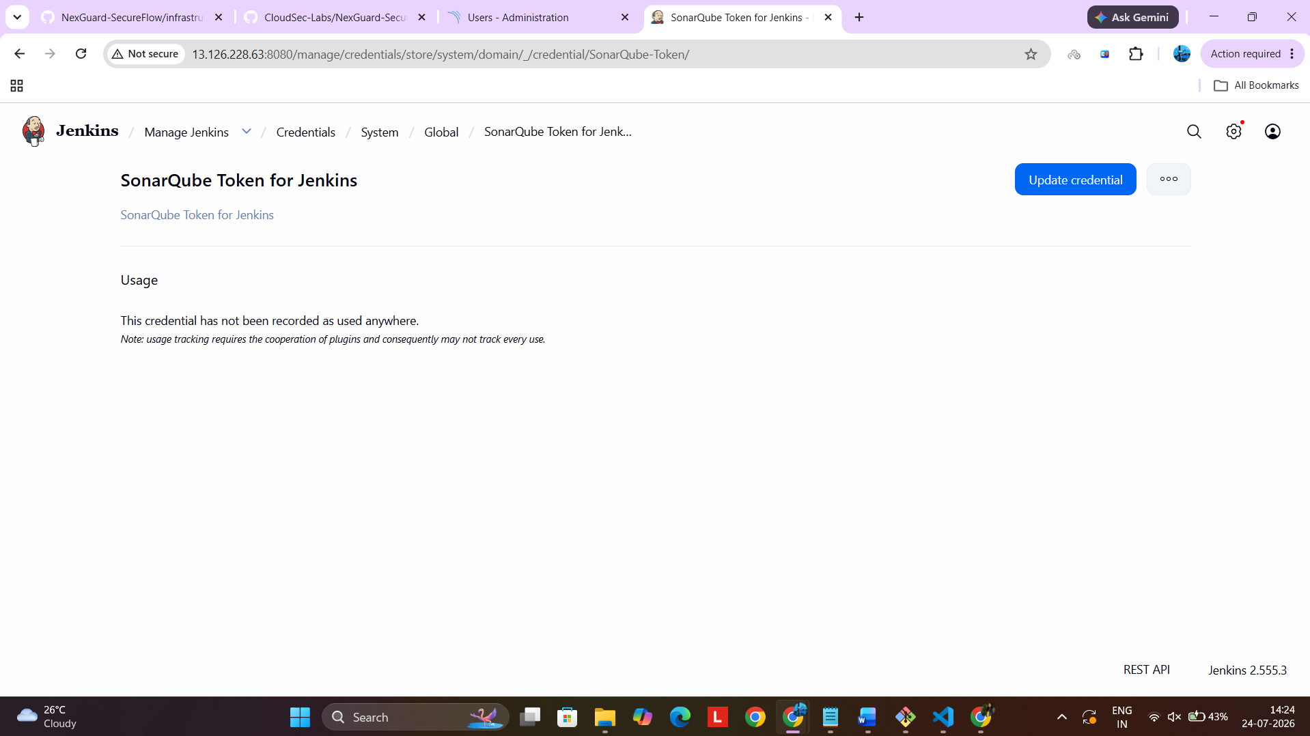

Step 3: Configured the Quality Gate
Configured the default Quality Gate with code quality conditions.
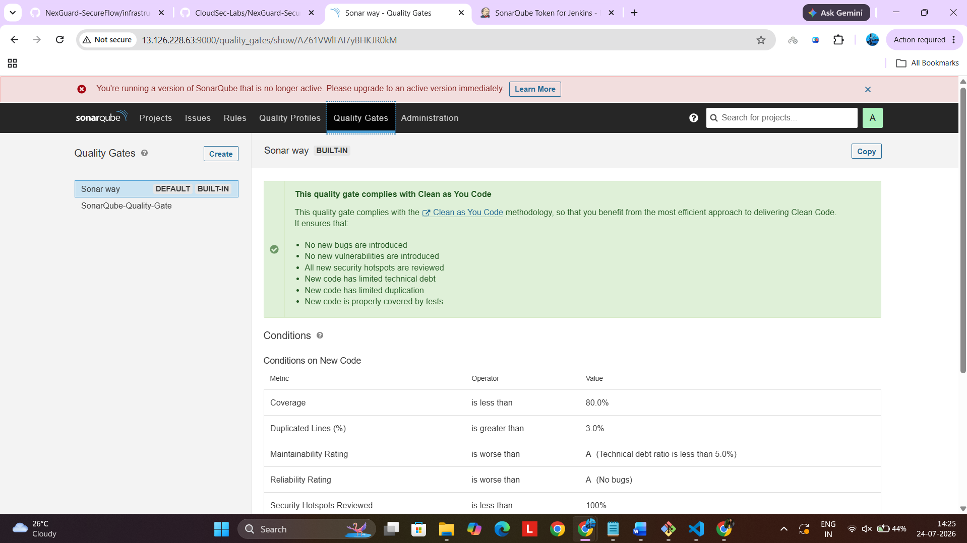

Step 4: Reviewed Quality Gate Conditions
Verified coverage, reliability, maintainability, security, and duplication thresholds.
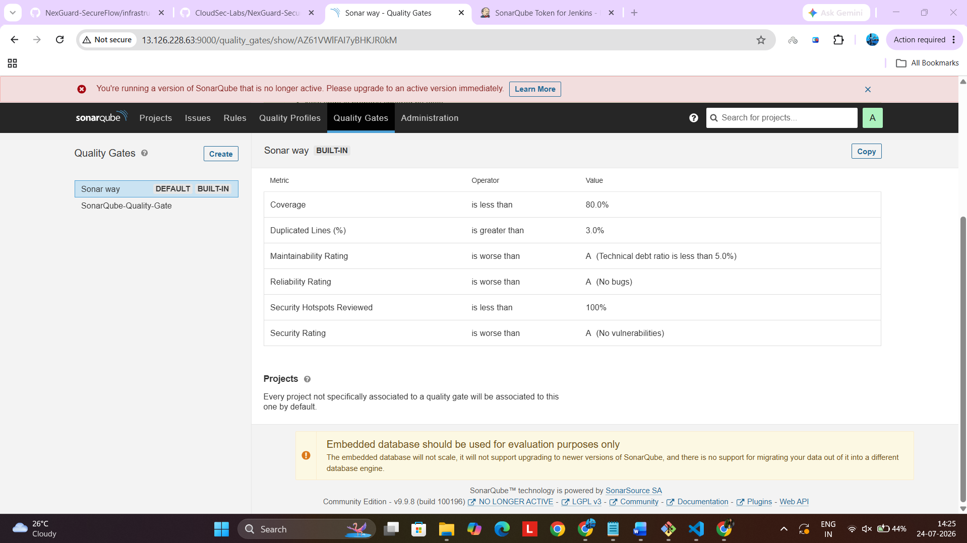

Step 5: Configured SonarQube Webhook
Configured the webhook to notify Jenkins after analysis completion.
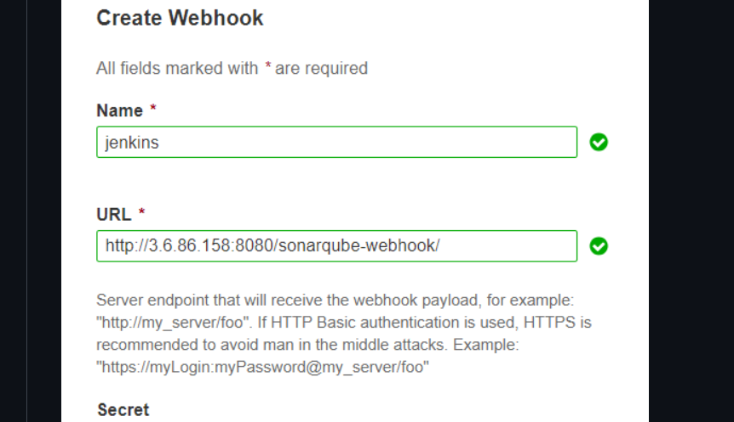

Step 6: Integrated SonarQube Analysis
Integrated SonarScanner into the Jenkins pipeline using withSonarQubeEnv().
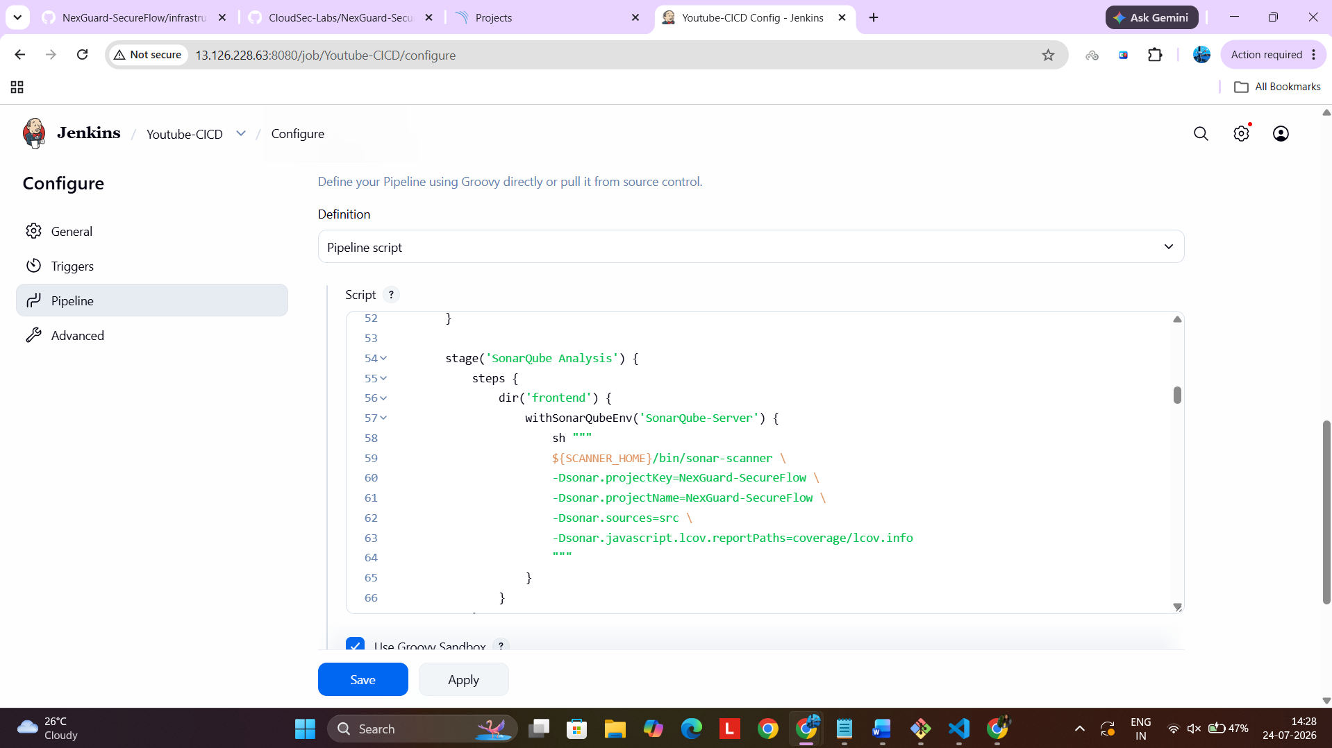

Step 7: Configured Quality Gate Stage
Configured waitForQualityGate() in the Jenkins pipeline.
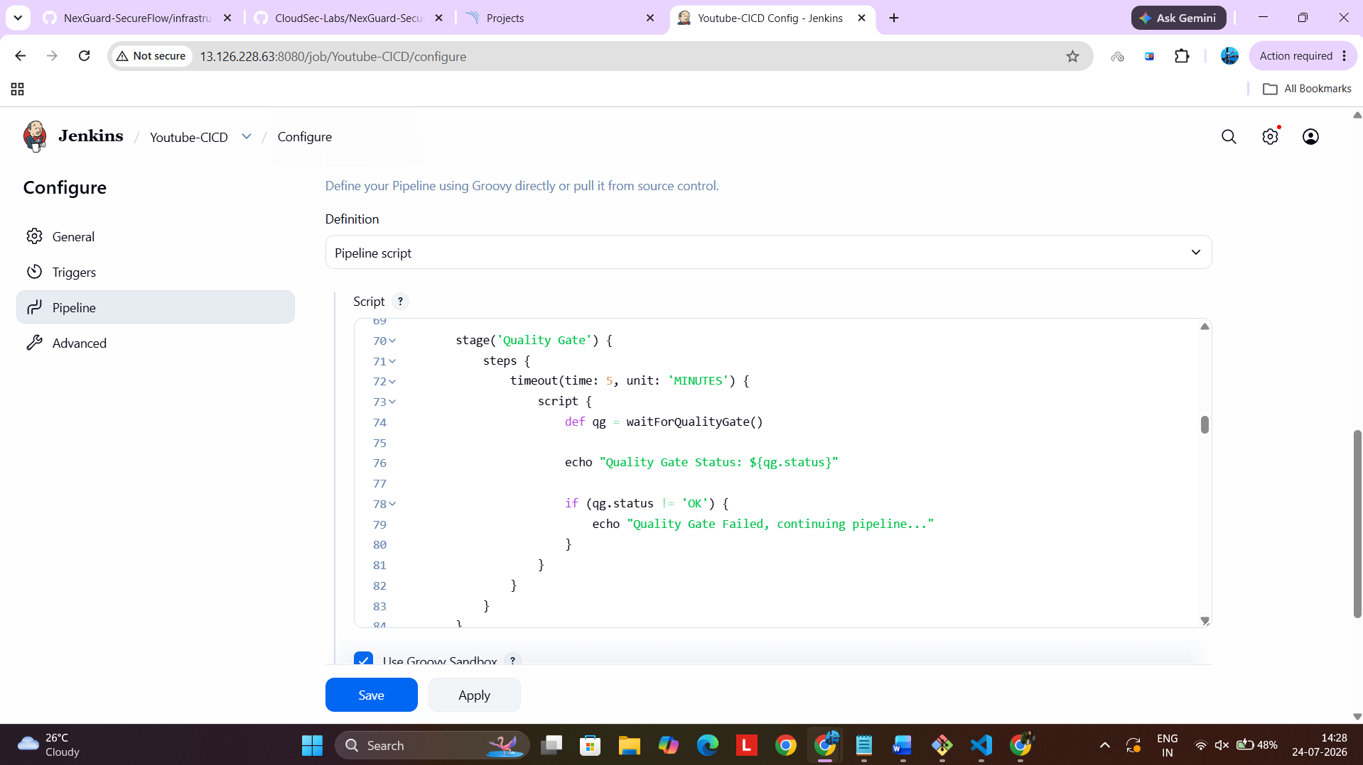

Step 8: Reviewed SonarQube Dashboard
Reviewed the analysis report, code coverage, and Quality Gate status.
